CME 433 Lab 6 Report
Tyrel Kostyk, tck290, 11216033
Thursday, December 5th, 2019

matrixMul

4 x 4 matrixMul (CPU) output:

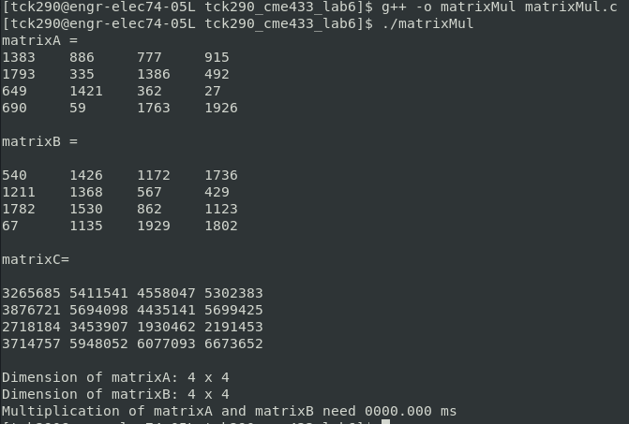

4 x 4 matrixMul MATLAB verification:

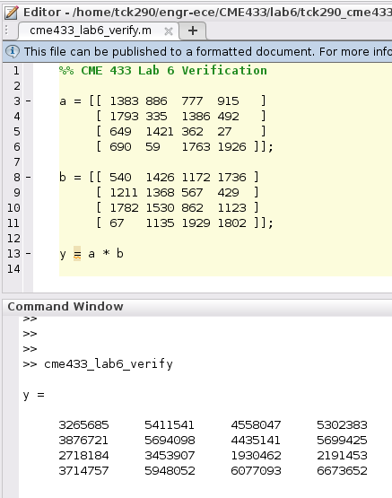

12 x 12 matrixMul (CPU) output:

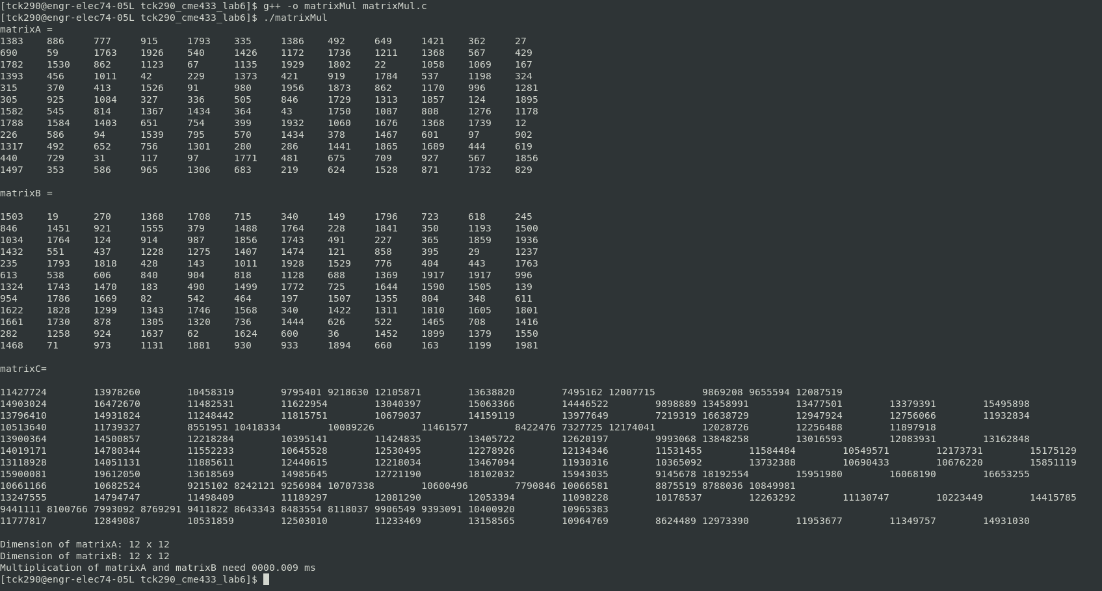

12 x 12 matrixMul MATLAB verification:

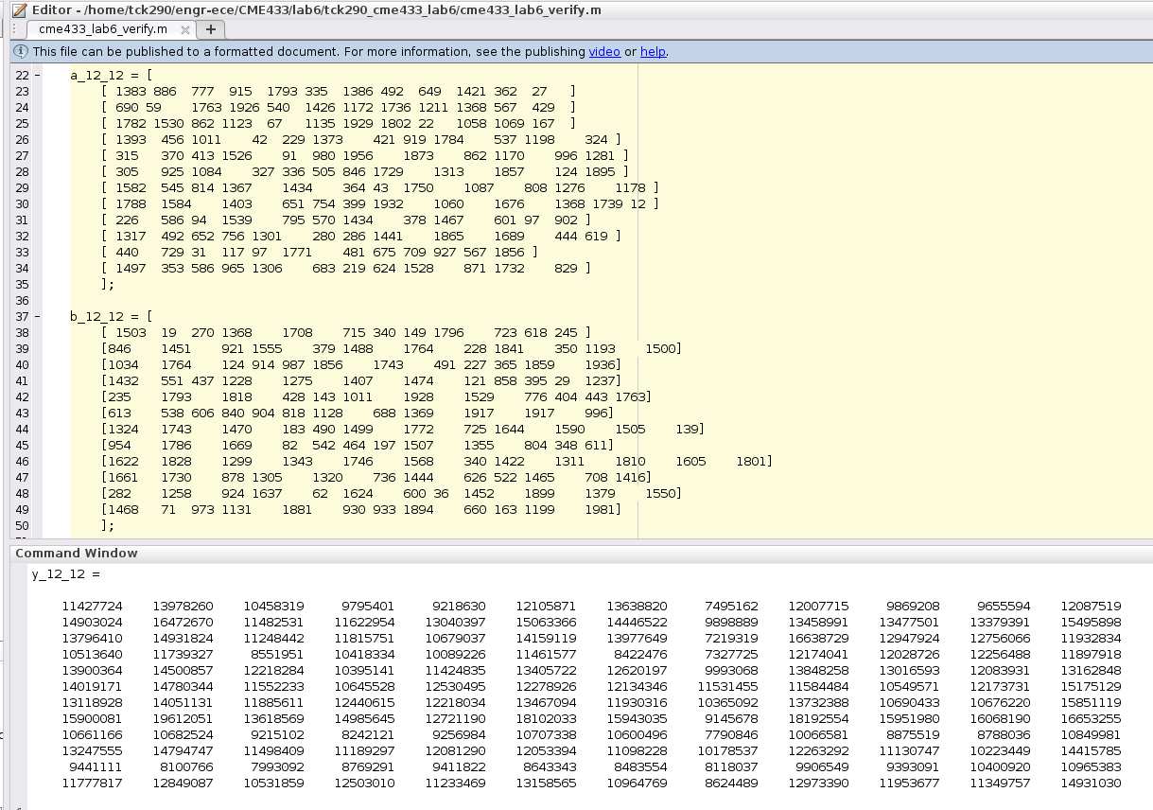

256 x 256 matrixMul output (only showing last page of output):

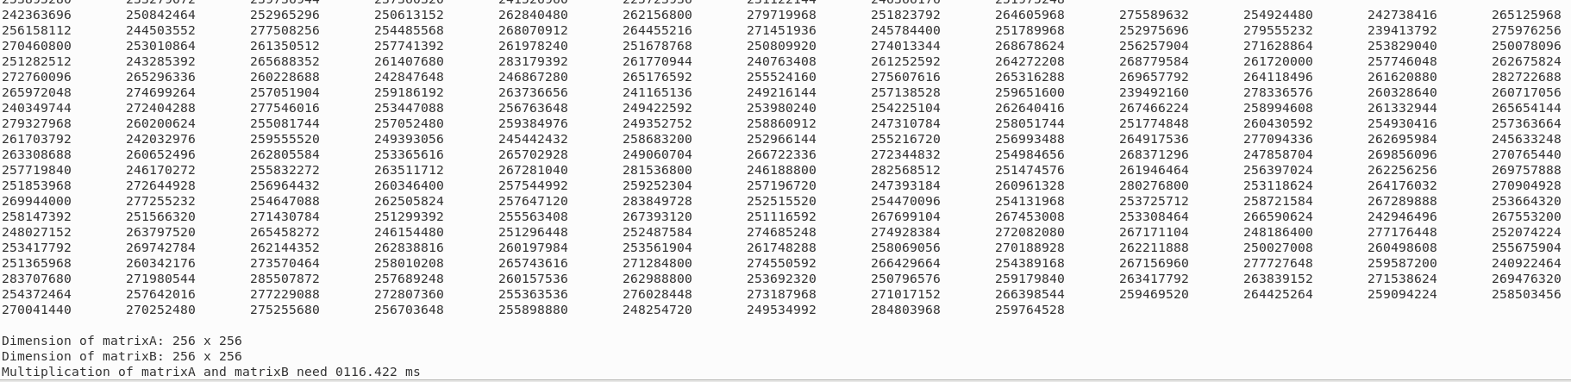
512 x 512 matrixMul output (only showing last page of output):

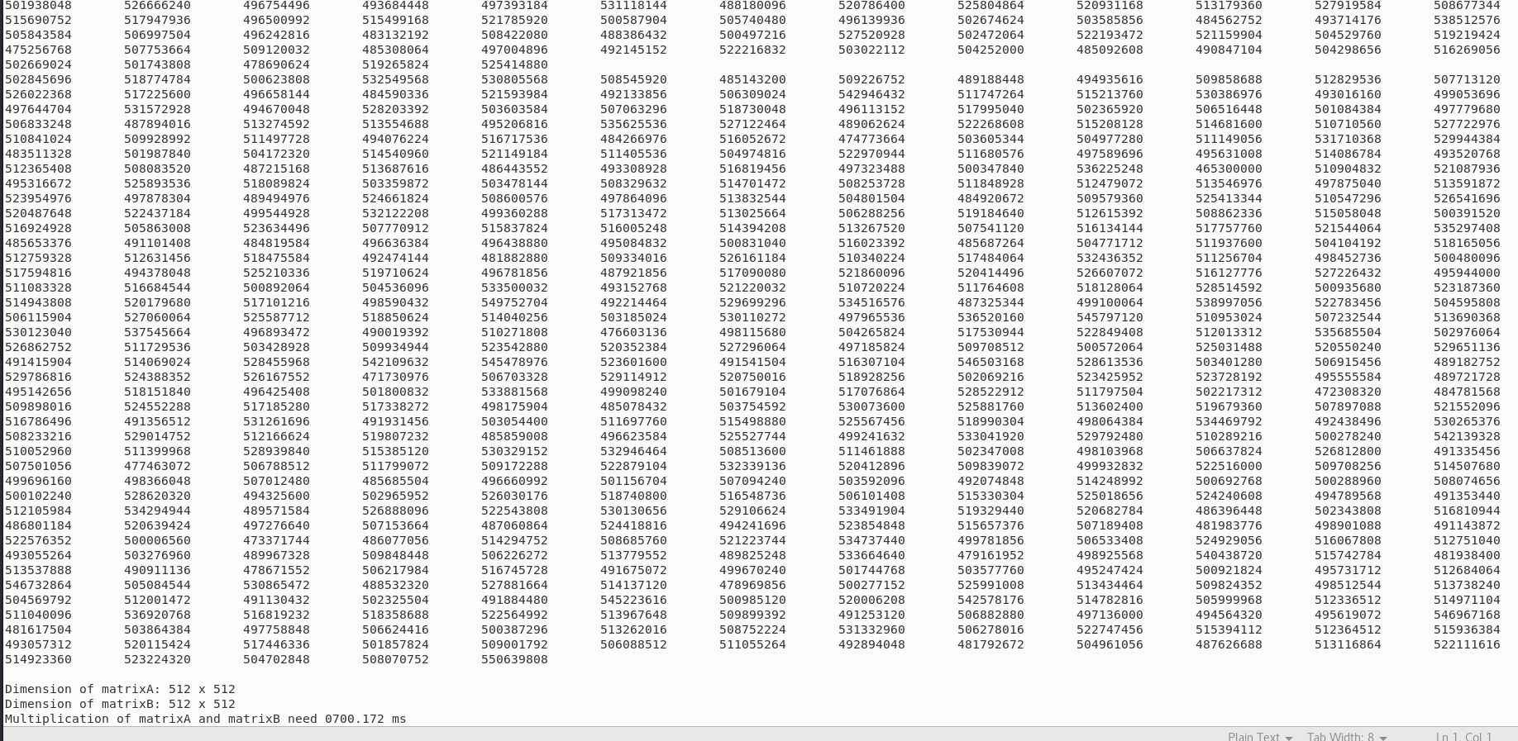
Simulation times for matrixMul (CPU Implementation)

Matrix Size | Calculation Time (ms) [debug turned off]
4 x 4 | 0.000
12 x 12 | 0.009
256 x 256 | 63.017
512 x 512 | 571.987

4 x 4 hostMatrixMul (GPU) output:

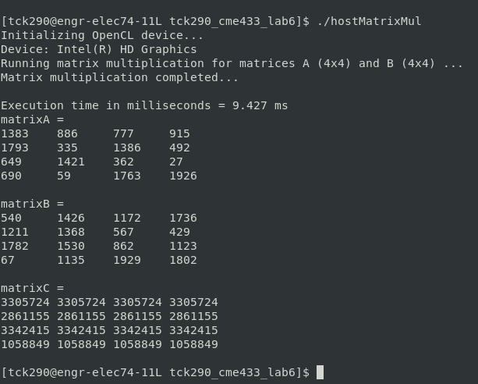

12 x 12 hostMatrixMul (GPU) output:

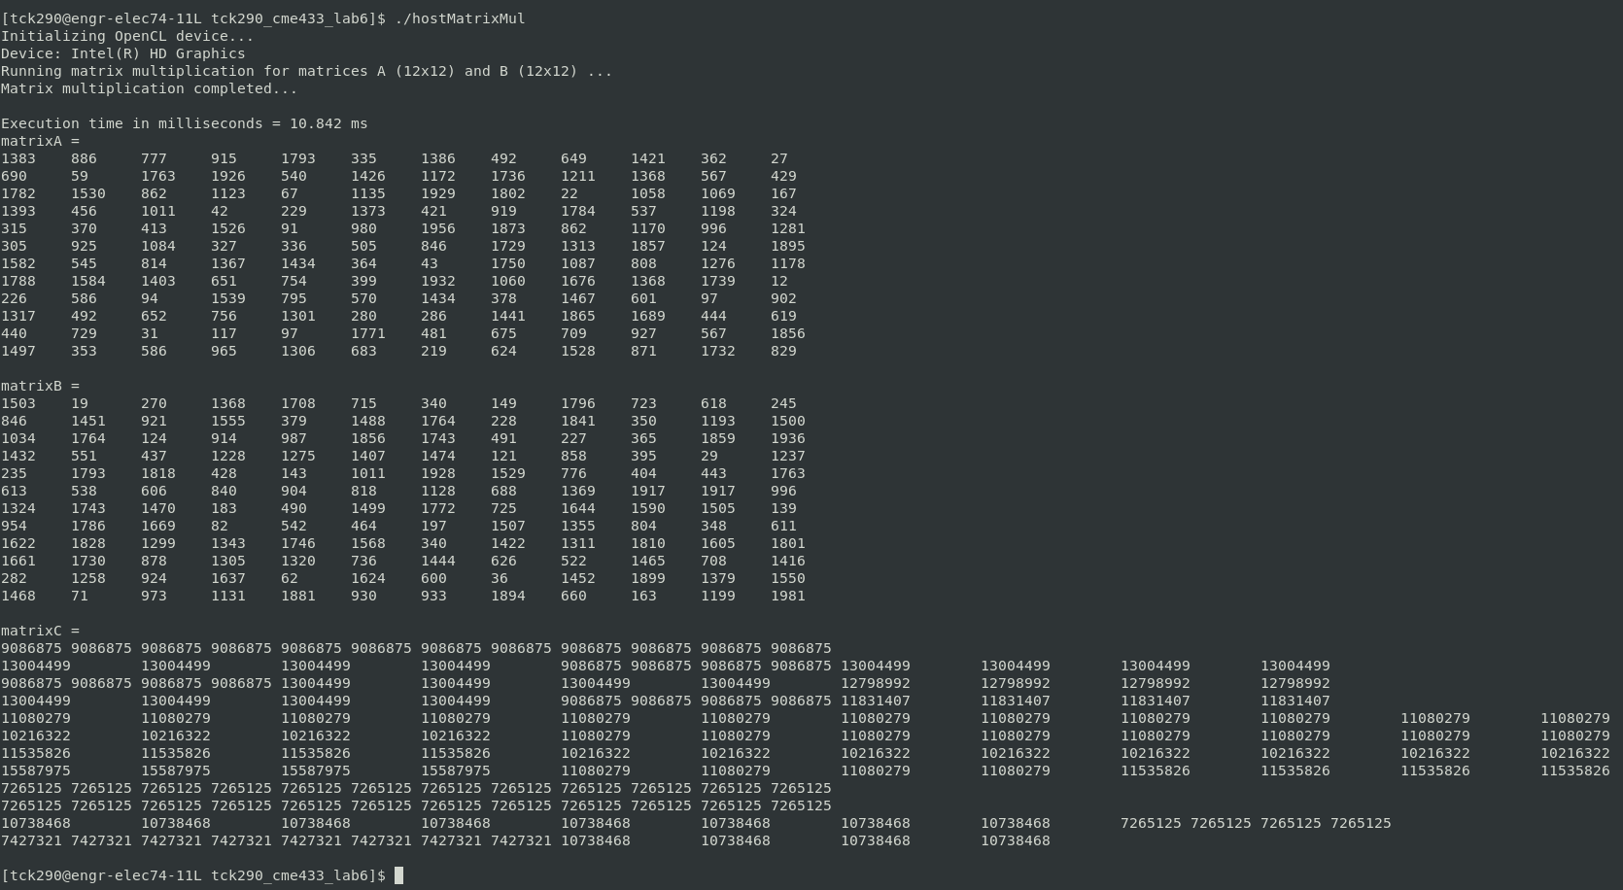

Simulation times for Both Implementations (Comparisons)

Matrix Size | Calculation Time (ms) – CPU | Calculation Time (ms) – GPU
4 x 4 | 0.000 | 9.236
12 x 12 | 0.009 | 10.409
256 x 256 | 63.017 | 47.209
512 x 512 | 571.987 | 95.238

