A Gradient-Boosted Inference Framework for Missing Contextual Labels in Nutritional Surveys: Validation via Leave-One-Year-Out and Simulated Missingness

Abstract
Objective:
Contextual variables such as urban–rural residence are frequently missing or inconsistently recorded in large dietary surveys. We developed and evaluated a gradient-boosted inference framework for recovering missing contextual labels from macronutrient composition and spatiotemporal covariates.
Design:
Using the China Health and Nutrition Survey (1991–2011; n = 101,926) as an illustrative cohort with complete administrative labels (T2), we defined a three-category outcome combining administrative urban–rural classification with a transitional dietary stratum (fat energy ratio 23–30%). A class-weighted XGBoost classifier was evaluated under simulated label missingness (10%–70%), leave-one-year-out temporal holdout, comparator imputation methods, calibration analysis, and downstream effect-preservation assessment.
Setting:
China Health and Nutrition Survey (1991–2011).
Participants:
101,926 observations from Chinese adults across multiple provinces and survey waves.
Results:
Under 30% simulated missingness, the proposed framework achieved accuracy 0.786 and macro-F1 0.770, exceeding KNN imputation (accuracy 0.721) and random forest imputation (accuracy 0.777). Performance was stable from 10% to 70% missingness (accuracy range 0.781–0.787). Leave-one-year-out accuracy averaged 0.776 (SD 0.019). Category-specific accuracy was high for Rural (0.879) and Transitional (0.993) but lower for Urban (0.421), reflecting greater dietary heterogeneity in administratively urban areas. Downstream urban–rural contrasts preserved direction and statistical significance (P < 0.001) for all macronutrient features, with moderate inflation of Cohen's d (22–32%).
Conclusions:
Macronutrient profiles together with survey year and province provide non-trivial information for inferring missing administrative contextual labels under a statistically principled evaluation protocol. The framework offers a template for assessing label-imputation methods when ground-truth contextual variables are available for internal validation.

Introduction
Urban–rural disparities in dietary intake remain a central concern in nutritional epidemiology, particularly in countries undergoing rapid socioeconomic transformation. Urbanisation is associated with substantial changes in food environments, including increased availability of processed and animal-source foods and reduced reliance on traditional staple-based diets^{(1–3)}. These shifts—commonly described as the nutrition transition—are closely linked to rising burdens of obesity and diet-related non-communicable diseases worldwide ^{(4–6)}. As a key contextual determinant of dietary patterns, urban–rural status plays a critical role in controlling confounding, examining population inequalities, and interpreting temporal dietary trends^{(7,8)}.
China provides a particularly informative setting for examining these dynamics. Over the past four decades, rapid urbanisation has been accompanied by marked dietary change, characterised by increasing fat intake, declining carbohydrate consumption, and diversification of food sources across both urban and rural populations ^{(9–11)}. Longitudinal evidence suggests that these changes are heterogeneous across regions and over time, reflecting the complex interplay between economic development, food environments, and sociocultural dietary practices ^{(12,13)}. Importantly, differences in the pace and nature of dietary change between urban and rural populations reinforce the need to explicitly account for contextual factors in analyses of nutrition transition.
Despite its importance, urban–rural context is not always readily usable in dietary datasets. Even in well-established cohort studies such as CHNS, challenges may arise in the operationalisation and consistent use of urban–rural classification due to changes in administrative definitions, population mobility, or differences in data availability across survey waves^{(13,14)}. More broadly, many widely used dietary datasets—including large-scale surveys in both high- and low-income settings—lack harmonised or consistently accessible indicators of urbanicity^{(15,16)}. These limitations create a data usability challenge resulting in otherwise valuable dietary observations being underutilised for analyses of nutrition transition and health inequalities. Incomplete or inconsistently applied contextual variables may lead to reduced sample size, limited comparability across studies, and potential bias when observations are excluded ^{(17,18)}.
Existing approaches to addressing such limitations are typically not designed to infer contextual variables from dietary data. Conventional methods such as simple imputation or k-nearest neighbours (KNN) may be less suitable in settings where relationships between dietary patterns and contextual factors are complex and non-linear^{(19,20)}. While multiple imputation approaches provide greater flexibility, they often rely on assumptions that may not hold for categorical variables derived from behavioural data ⁽²¹⁾. Moreover, these methods generally treat contextual variables as independent inputs, rather than recognising that dietary patterns themselves may encode information about underlying social and environmental conditions.
Recent advances in machine learning provide new opportunities to address this challenge. Ensemble learning methods, particularly gradient-boosted decision trees, have demonstrated strong performance in modelling complex, high-dimensional health data and capturing non-linear feature interactions^{(22,23)}. In nutritional epidemiology, such approaches have been increasingly applied to dietary pattern recognition, risk prediction, and food environment analysis^{(24–26)}. However, their potential to enhance the usability of dietary datasets—by inferring contextual variables from dietary information—remains underexplored.
The present study addresses this gap by developing and evaluating a statistical framework to infer missing administrative urban–rural labels from routinely collected dietary information. Using longitudinal CHNS data (1991–2011) with complete T2 administrative labels as reference standard, we assess whether macronutrient composition and spatiotemporal covariates support reliable label recovery under simulated missingness, temporal holdout, and downstream epidemiological use-cases.

Methods
The proposed framework infers urban–rural context from dietary patterns through four sequential stages: data preparation and quality control, dietary pattern representation, predictive modelling, and multi-dimensional evaluation. An overview is provided in Figure 1, with details described below.
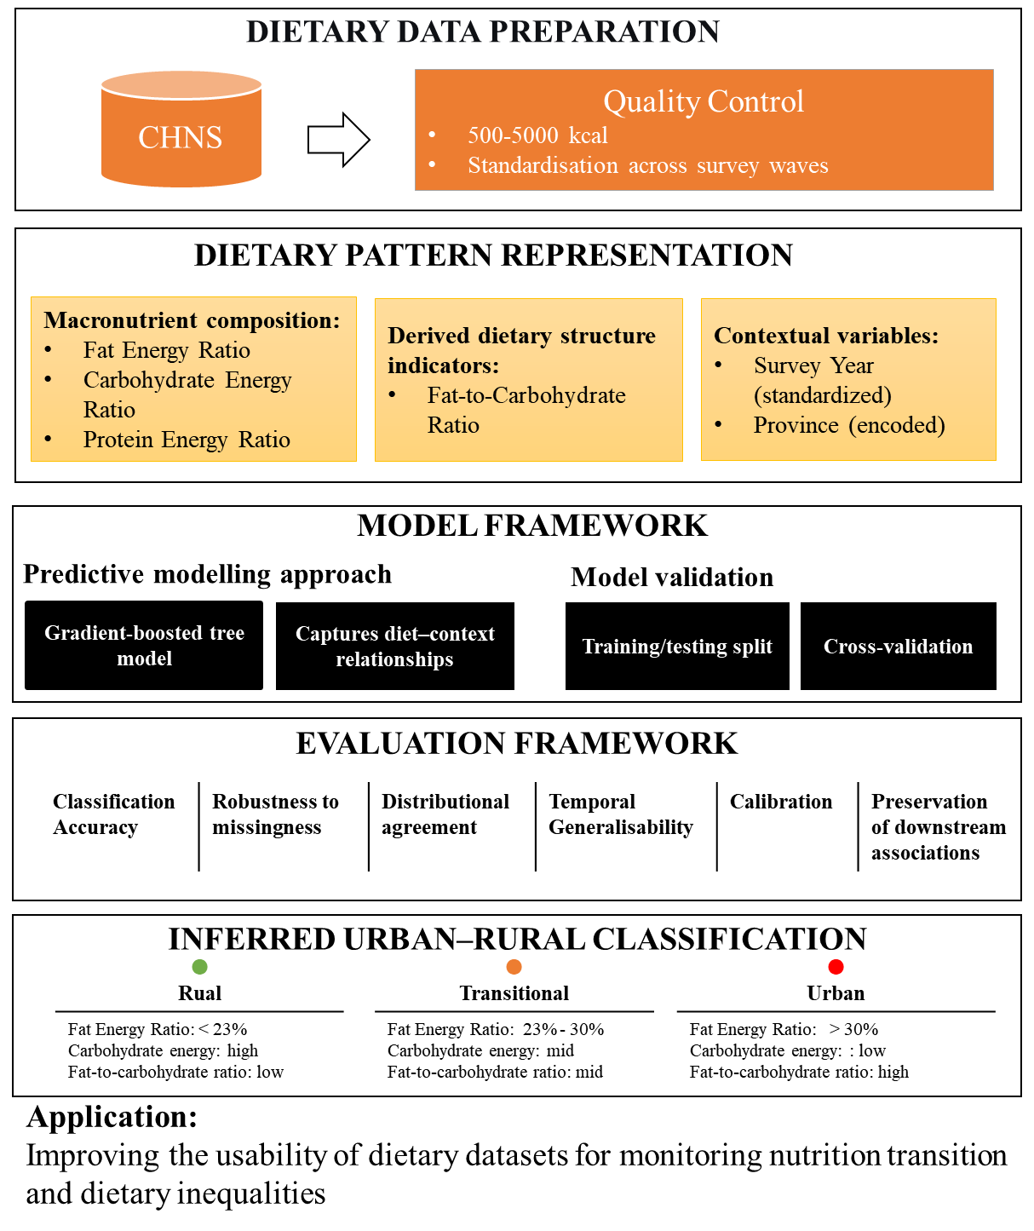
Figure 1. Overview of the framework for inferring urban–rural classification from dietary patterns. The workflow includes four components.
(1) Dietary data preparation: exclusion of implausible energy intake (500–5,000 kcal/day) and harmonisation across survey waves.
(2) Dietary pattern representation: transformation of dietary intake into macronutrient composition indicators (fat, carbohydrate, and protein energy ratios; fat-to-carbohydrate ratio), alongside contextual variables (survey year and province).
(3) Model framework: a gradient-boosted decision tree model trained on 80% of the data (n = 81,540), with five-fold cross-validation and class weighting to account for imbalance.
(4) Evaluation framework: performance assessed on the held-out test set (n = 20,386) under simulated missingness, including classification accuracy, robustness across missing rates, distributional agreement, temporal generalisability, calibration, and preservation of downstream epidemiological associations.
The output is a three-category contextual classification: Rural and Urban follow the CHNS administrative indicator (T2), with a Transitional stratum defined by fat energy ratio between 23% and 30% to capture intermediate dietary composition within either administrative group.

Study Design and Data Source
We conducted a methodological study to develop and evaluate a data-driven approach for inferring urban–rural classification from routinely collected dietary data. The analysis used data from the China Health and Nutrition Survey (CHNS), an ongoing longitudinal cohort examining the effects of social and economic change on nutrition and health in China⁽²⁴⁾.
The CHNS employs a multistage, random cluster sampling design across diverse provinces and municipalities that vary in geography and economic development. For this study, we used eight survey waves (1991–2011). Dietary intake was assessed using three consecutive 24-hour recalls, from which average daily nutrient intakes were calculated using the China Food Composition Tables⁽²⁵⁾. The analytic sample was restricted to adults aged 18 years and older with complete data on key nutrient variables.

Data Quality Control
Two criteria were applied. First, observations with missing values in key nutrient variables were excluded. Second, total energy intake was restricted to 500–5,000 kcal/day to remove implausible values⁽²⁶⁾. The final sample included 101,926 observations.

Outcome Definition: Three-Category Urban–Rural Classification
The CHNS includes an administrative urban–rural indicator (T2: 1 = urban, 2 = rural). We used this variable as the reference standard for Rural and Urban categories, reflecting the primary inferential target when contextual residence labels are missing in external datasets.
To retain a three-category structure that also captures intermediate dietary composition, we overlaid a Transitional stratum defined by fat energy ratio (FatER) between 23% and 30%, consistent with prior nutrition transition research in China. Observations in this band were assigned to Transitional regardless of T2.
Categories were defined as:
- Rural: T2 = rural (2), unless FatER is 23–30% (Transitional)
- Transitional: FatER 23–30% (overrides T2 assignment)
- Urban: T2 = urban (1), unless FatER is 23–30% (Transitional)
Because Transitional is defined using FatER and macronutrient predictors are included in the feature set, partial definitional overlap exists for this category and high Transitional accuracy should be interpreted accordingly. The primary administrative inference task—discriminating T2-based Rural from Urban when not in the transitional band—does not use FatER in the label definition. We report category-specific metrics and conducted feature-set ablation (Supplementary Table S4): full six-feature accuracy was 0.782 versus 0.769 with macronutrients only and 0.518 with year and province alone.

Dietary Pattern Representation
Dietary patterns were represented using macronutrient composition measures independent of total energy intake, facilitating comparability across individuals. The following indicators were calculated:
Fat Energy Ratio (FatER) represents the proportion of total energy derived from dietary fat:
$$\text{FatER}=\frac{\text{Fat (g)}×9}{\text{Total Energy (kcal)}} (1)$$
Carbohydrate Energy Ratio (CarbER) represents the proportion of total energy derived from carbohydrates:
$$\text{CarbER}=\frac{\text{Carbohydrate (g)}×4}{\text{Total Energy (kcal)}} (2)$$
Protein Energy Ratio (ProtER) represents the proportion of total energy derived from protein:
$$\text{ProtER}=\frac{\text{Protein (g)}×4}{\text{Total Energy (kcal)}} (3)$$
Fat-to-Carbohydrate Ratio (FCR) captures the balance between fat and carbohydrate intake, reflecting the macronutrient substitution that characterises the nutrition transition:
$$\text{FCR}=\frac{\text{Fat (g)}}{\text{Carbohydrate (g)}+ϵ} (4)$$
where $ϵ={10}^{-6}$ is a small constant to prevent division by zero in cases where carbohydrate intake is recorded as zero.
In addition, survey year and province were included to capture temporal and geographic variation. Continuous variables were standardised prior to modelling.

Predictive Modelling
We applied a gradient-boosted decision tree approach to model the relationship between dietary patterns and urban–rural classification. This method was selected for its ability to capture complex, non-linear relationships in high-dimensional data.
To address class imbalance, category weights were incorporated during model training. The dataset was split into training (80%) and test (20%) sets using stratified sampling. Model parameters were selected using five-fold cross-validation. The full configuration is provided in Supplementary Table S6.

Baseline Methods for Comparison
We compared the proposed approach with commonly used methods:
Majority Category Imputation assigns all unobserved values to the most frequent category (Rural), representing the simplest possible strategy and providing a lower bound on acceptable performance.
k-Nearest Neighbours (KNN) Imputation identifies the $k=5$ most similar complete cases in feature space and assigns the modal category among those neighbours. KNN is widely used in food-frequency questionnaire missing data handling⁽¹⁷⁾ and provides a non-parametric baseline that requires no distributional assumptions.
Multiple Imputation by Chained Equations (MICE) uses iterative regression to impute missing values based on all other variables. We implemented MICE via the IterativeImputer with 10 iterations and Bayesian ridge regression as the underlying estimator, representing a statistical standard for missing data handling in epidemiological research⁽¹⁹⁾.
Random Forest Imputation (RF-Imputer) uses an ensemble of decision trees to iteratively predict missing values. This method shares the ensemble structure of the proposed framework but lacks category-balancing and the specific regularisation strategy, providing a direct test of whether the proposed architectural modifications confer meaningful performance advantages.
These methods represent standard approaches for handling categorical missing data in epidemiological research.

Evaluation Framework
We evaluated performance under simulated missingness, leveraging the complete CHNS labels as ground truth. Key components:

Inference Accuracy Under Simulated Missingness
To evaluate inference accuracy, we randomly masked 30% of urban–rural labels in the held-out test set, simulating a scenario where geographic context is unavailable for a substantial proportion of observations. Inference accuracy, macro-averaged F1 score, and Cohen's $κ$ were computed by comparing inferred labels against the known true labels. This simulation was repeated across missing rates ranging from 10% to 70% (in 10-percentage-point increments) to assess sensitivity to the degree of missingness.

Distributional Agreement
Preserving population-level dietary distributions is critical for epidemiological analyses, as distortion of category proportions could bias prevalence estimates and subsequent inferences. We quantified distributional fidelity using Jensen–Shannon (JS) divergence between the true and inferred category distributions. We also report the maximum absolute difference between true and inferred category proportions as an interpretable summary measure.

Temporal Generalisability: Leave-One-Year-Out
To assess generalisability to unseen time periods—a critical requirement for application to future survey waves or other datasets spanning different time frames—we conducted leave-one-year-out (LOYO) validation. In each of eight iterations, the framework was trained on observations from seven survey waves and evaluated on the held-out eighth wave. This design simulates the real-world scenario of applying the framework to newly collected dietary data from periods not represented in the training sample. Mean accuracy, macro-F1, and Cohen's $κ$ were computed across the eight held-out waves.

Calibration
For the framework to support probabilistic inference (e.g., assigning fractional weights rather than deterministic labels in sensitivity analyses), predicted probabilities must be well-calibrated—that is, a predicted probability of 0.8 should correspond to an empirical success rate of approximately 80%. We assessed calibration using the Expected Calibration Error (ECE) and Brier score for each outcome category. ECE measures the weighted average difference between predicted confidence and observed accuracy across probability bins, with lower values indicating better calibration. Brier score quantifies the mean squared difference between predicted probabilities and binary outcomes, where 0 represents perfect calibration and 0.25 represents an uninformative model for three-category prediction. Calibration curves comparing predicted probabilities against observed frequencies were constructed for visual assessment.

Preservation of Downstream Epidemiological Associations
The ultimate test of inference quality is whether it preserves epidemiological conclusions. We compared effect size estimates for urban–rural dietary differences computed using true labels versus inferred labels (under 30% simulated missingness). For each macronutrient feature, we calculated the mean difference between Urban and Rural categories, Cohen's $d$ as a standardised effect size measure, and associated P-values from independent samples t-tests. Bias was quantified as the absolute and relative difference between true and inferred effect sizes. Consistency of statistical significance (whether both analyses yielded P < 0.05 with the same direction of effect) was recorded as a binary indicator of inferential preservation.

Statistical Significance of Performance Differences
To formally test whether observed performance differences between methods were statistically significant, we conducted a paired bootstrap difference test with 2,000 resamples. For each bootstrap sample, both the proposed framework and the best-performing baseline were evaluated on the identical set of simulated missing values, and the within-sample difference in accuracy and macro-F1 was recorded. The null hypothesis of no difference was rejected if the 95% confidence interval of the difference excluded zero. Bootstrap 95% confidence intervals for all primary performance metrics were also computed to quantify estimation uncertainty.

Software and Reproducibility
All analyses were performed using Python version 3.11 with the following open-source libraries: XGBoost (version 1.7) for gradient boosting, scikit-learn (version 1.3) for baseline methods and evaluation metrics, and SHAP (version 0.42) for model interpretation. Data processing scripts, model training code, and evaluation pipelines are publicly available at https://github.com/tyrone1979/nutri2-urban to facilitate reproducibility and adoption by other researchers. The pre-trained model is also available for direct application to new datasets without requiring retraining.

Results

Sample Characteristics
The analytic sample comprised 101,926 dietary recall observations from eight survey waves (1991–2011). Overall, 51.3% were classified as Rural, 22.5% as Transitional, and 26.2% as Urban (Table 1), using the T2 administrative indicator with transitional FatER overlay. The proportion of Urban-classified observations increased over time, from 22.6% in 1991 to 33.3% in 2011.
Transitional observations were consistently observed across all survey waves and provinces, comprising between 18.8% and 29.5% of observations across waves. This indicates that intermediate dietary patterns are a persistent feature rather than a transient or isolated phenomenon.
Table 1. Sample Characteristics by Survey Wave
Wave | Year | N | Rural (%) | Transitional (%) | Urban (%)
1 | 1991 | 13,446 | 7,629 (56.7) | 2,774 (20.6) | 3,043 (22.6)
2 | 1993 | 12,632 | 7,108 (56.3) | 2,755 (21.8) | 2,769 (21.9)
3 | 1997 | 12,743 | 6,624 (52.0) | 2,866 (22.5) | 3,253 (25.5)
4 | 2000 | 13,530 | 6,916 (51.1) | 3,199 (23.6) | 3,415 (25.2)
5 | 2004 | 11,783 | 5,776 (49.0) | 2,921 (24.8) | 3,086 (26.2)
6 | 2006 | 11,328 | 5,730 (50.6) | 2,493 (22.0) | 3,105 (27.4)
7 | 2009 | 11,566 | 5,702 (49.3) | 2,802 (24.2) | 3,062 (26.5)
8 | 2011 | 14,898 | 6,772 (45.5) | 3,172 (21.3) | 4,954 (33.3)
Total |  | 101,926 | 52,257 (51.3) | 22,982 (22.5) | 26,687 (26.2)
Macronutrient composition differed substantially across the three categories (Table 2). Fat energy ratio increased progressively from Rural (mean 0.180) to Transitional (0.264) and Urban (0.357), while carbohydrate energy ratio showed the opposite trend. Protein energy ratio varied minimally across categories. All pairwise differences were statistically significant (P < 0.001), supporting the construct validity of the three-category classification.
Table 2. Macronutrient Profiles by Urban–Rural Category
Feature | Rural  (n=52,257) |  | Transitional  (n=22,982) |  | Urban  (n=26,687)
 | Mean | SD | Mean | SD | Mean | SD
Fat energy ratio | 0.250 | 0.130 | 0.265 | 0.020 | 0.331 | 0.129
Carbohydrate energy ratio | 0.626 | 0.133 | 0.602 | 0.047 | 0.532 | 0.133
Protein energy ratio | 0.119 | 0.025 | 0.125 | 0.028 | 0.132 | 0.031
Fat-to-carbohydrate ratio | 0.212 | 0.181 | 0.198 | 0.031 | 0.324 | 0.212
All pairwise differences between categories are significant at P < 0.001 (ANOVA with Bonferroni correction).

Inference Accuracy Under Simulated Missingness
Under the primary evaluation scenario (30% simulated missingness), the proposed framework achieved accuracy 0.786 and macro-F1 0.770, outperforming KNN imputation (accuracy 0.721) and MICE (accuracy 0.393) (Table 3). Random forest imputation achieved comparable performance (accuracy 0.777; macro-F1 0.759).

The absolute performance gain over the strongest non-proposed comparator (random forest imputation) was modest (Δ accuracy ≈ 0.9 percentage points) but persisted across missing rates.
Table 3. Inference Performance Comparison (30% Missing Rate)
Method | Accuracy | Macro-F1 | Cohen's κ | JS Divergence
Majority category | 0.516 | 0.227 | 0.000 | 0.104
MICE | 0.393 | 0.308 | 0.152 | 0.132
KNN (k = 5) | 0.721 | 0.707 | 0.539 | 0.014
RF-Imputer | 0.777 | 0.759 | 0.623 | 0.025
Proposed framework | 0.786 | 0.770 | 0.638 | 0.023
JS: Jensen–Shannon. 95% confidence intervals from bootstrap resampling (n = 2,000) are reported in text.
Category-specific performance under 30% simulated missingness showed high accuracy for Rural (0.879) and Transitional (0.993) observations, while Urban accuracy was lower (0.421) (Table 4). High Transitional accuracy reflects the explicit FatER-based definition of this stratum; lower Urban accuracy indicates substantial dietary heterogeneity among administratively urban participants and supports interpretation of Urban/Rural inference as a non-trivial statistical problem rather than deterministic classification.
Table 4. Category-Specific Inference Accuracy (30% Missing Rate)
Category | n (masked) | Majority | MICE | KNN | RF-Imputer | Proposed
Rural | 3,150 | 1.000 | 0.333 | 0.782 | 0.876 | 0.879
Transitional | 1,364 | 0.000 | 0.975 | 0.932 | 1.000 | 0.993
Urban | 1,586 | 0.000 | 0.009 | 0.417 | 0.388 | 0.421

Robustness Across Missing Rates and Distributional Agreement
Model performance remained stable across missing rates from 10% to 70%. Accuracy varied by less than 0.6 percentage points across this range (0.781–0.787), whereas KNN performance declined progressively as missingness increased (Figure 2).
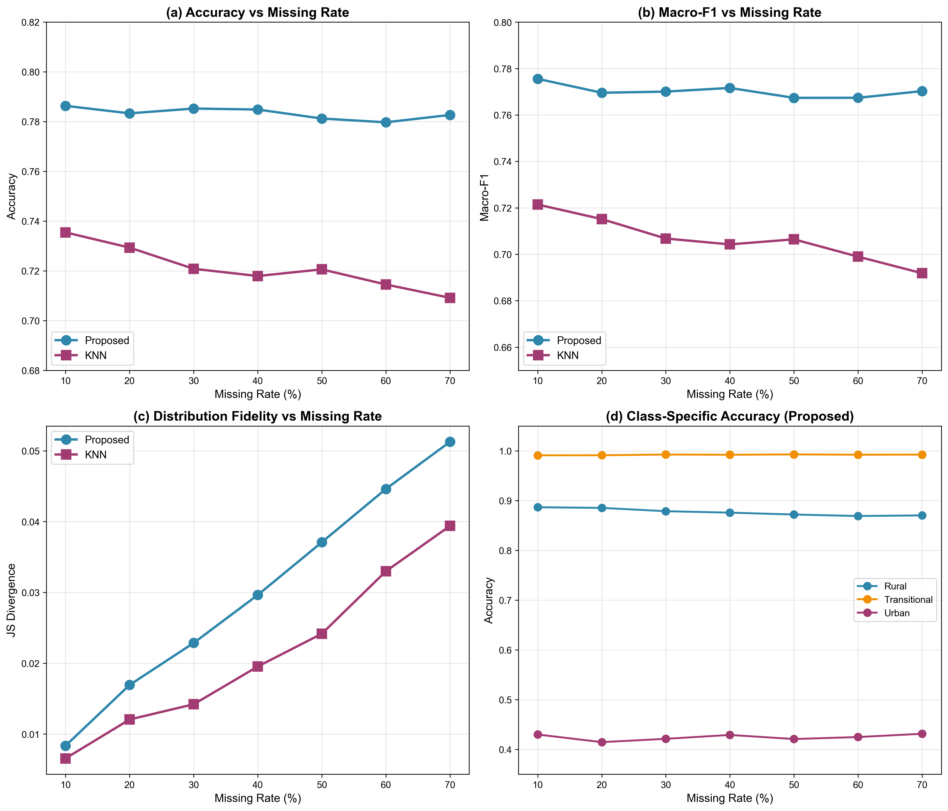
Figure 2. Robustness of inference performance across missing rates (10–70%). (a) Inference accuracy and (b) macro-averaged F1 score for the proposed framework and KNN imputation. (c) Distributional fidelity assessed by Jensen–Shannon divergence (lower values indicate better preservation of population structure). (d) Category-specific inference accuracy of the proposed framework (Rural, Transitional, Urban). Error bars represent 95% confidence intervals from bootstrap resampling (n = 2,000).
Distributional agreement between observed and inferred category proportions was acceptable. Jensen–Shannon divergence remained below 0.052 at 70% missingness, and maximum category proportion deviation was 4.3% at 50% missingness (Table 5).
Table 5. Distributional Fidelity Across Missing Rates (Proposed Framework)
Missing Rate | JS Divergence | Max Category Difference (%) | Transitional Difference (%)
10% | 0.008 | 1.0 | < 5
20% | 0.017 | 2.0 | < 5
30% | 0.023 | 2.7 | < 5
40% | 0.030 | 3.4 | < 5
50% | 0.037 | 4.3 | < 5
JS: Jensen–Shannon divergence (lower values indicate better fidelity).

Temporal Generalisability: Leave-One-Year-Out
Leave-one-year-out validation demonstrated consistent performance across survey waves, with mean accuracy of 0.776 (SD 0.019) and macro-F1 of 0.759 (SD 0.020) (Table 6; Figure 3).
Figure 3. Leave-one-year-out temporal validation results across eight survey waves (1991–2011). (a) Inference accuracy for each held-out wave. Mean accuracy was 0.776 (SD 0.019). (b) Macro-averaged F1 score for each held-out wave.
Performance was lower in earlier waves and improved in later years, likely reflecting increasing differentiation of dietary patterns over time. These findings suggest that the framework generalises across temporal contexts while remaining sensitive to underlying dietary shifts.
Table 6. Leave-One-Year-Out Temporal Validation
Test Year | Training Waves | N | Accuracy | Macro-F1 | Cohen's κ
1991 | 1993–2011 | 13,446 | 0.782 | 0.721 | 0.595
1993 | 1991,1997–2011 | 12,632 | 0.795 | 0.752 | 0.631
1997 | 1991–1993, 2000–2011 | 12,743 | 0.793 | 0.776 | 0.649
2000 | 1991–1997, 2004–2011 | 13,530 | 0.788 | 0.780 | 0.651
2004 | 1991–2000, 2006–2011 | 11,783 | 0.767 | 0.743 | 0.618
2006 | 1991–2004, 2009–2011 | 11,328 | 0.762 | 0.759 | 0.601
2009 | 1991–2006,2011 | 11,566 | 0.780 | 0.770 | 0.636
2011 | 1991–2009 | 14,898 | 0.740 | 0.770 | 0.589
Mean±SD |  |  | 0.776±0.019 | 0.759±0.020 | 0.621±0.024

Calibration
Predicted probabilities were reasonably calibrated across categories (Figure 4). Expected calibration error was below 0.01 for all categories, and Brier scores indicated good agreement between predicted and observed outcomes (Table 7).
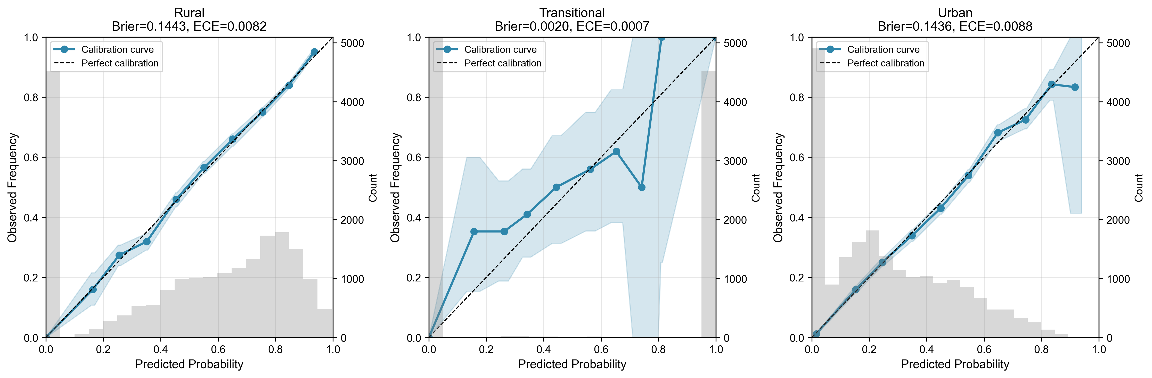
Figure 4. Calibration curves for the three outcome categories: (a) Rural, (b) Transitional, and (c) Urban. The diagonal dashed line represents perfect calibration. Histograms show the distribution of predicted probabilities. Shaded regions represent 95% confidence intervals from bootstrap resampling (n = 2,000).
This supports the use of probabilistic outputs for sensitivity analyses and uncertainty-aware applications.
Table 7. Calibration Metrics by Category
Category | Brier Score | ECE | Mean Predicted | True Prevalence | Δ
Rural | 0.144 | 0.0075 | 0.512 | 0.513 | -0.001
Transitional | 0.002 | 0.0011 | 0.225 | 0.225 | -0.000
Urban | 0.144 | 0.0077 | 0.263 | 0.262 | +0.002
ECE: Expected Calibration Error (lower values indicate better calibration). Δ: difference between mean predicted probability and true prevalence.

Preservation of Downstream Epidemiological Associations
Analyses using inferred labels preserved the direction and statistical significance of urban–rural differences across all dietary indicators (Table 8; Figure 5). Effect sizes were moderately larger when using inferred labels (relative difference 22–32%), reflecting clearer separation between comparison groups when Transitional observations were assigned; no changes in statistical significance or direction were observed.
Analyses using inferred labels preserved the direction and statistical significance of urban–rural differences across all dietary indicators (Table 8; Figure 5). Effect sizes were moderately larger when using inferred labels (relative difference 22–32%), reflecting clearer separation between comparison groups when Transitional observations were assigned; no changes in statistical significance or direction were observed.
Table 8. Downstream Epidemiological Bias Assessment (30% Missing Rate)
Feature | True Difference | Inferred Difference | Bias (%) | Cohen's d  (True) | Cohen's d  (Inferred) | Significance Consistent
Fat energy ratio | 0.0817 | 0.0991 | 21.3 | 0.631 | 0.782 | Yes
Carbohydrate energy ratio | -0.0944 | -0.1150 | 21.8 | -0.710 | -0.887 | Yes
Protein energy ratio | 0.0120 | 0.0158 | 31.9 | 0.430 | 0.566 | Yes
Fat-to-carbohydrate ratio | 0.1141 | 0.1414 | 24.0 | 0.586 | 0.731 | Yes
All differences significant at P < 0.001 in both true and inferred analyses. Bias (%) = |inferred − true| / |true| × 100.
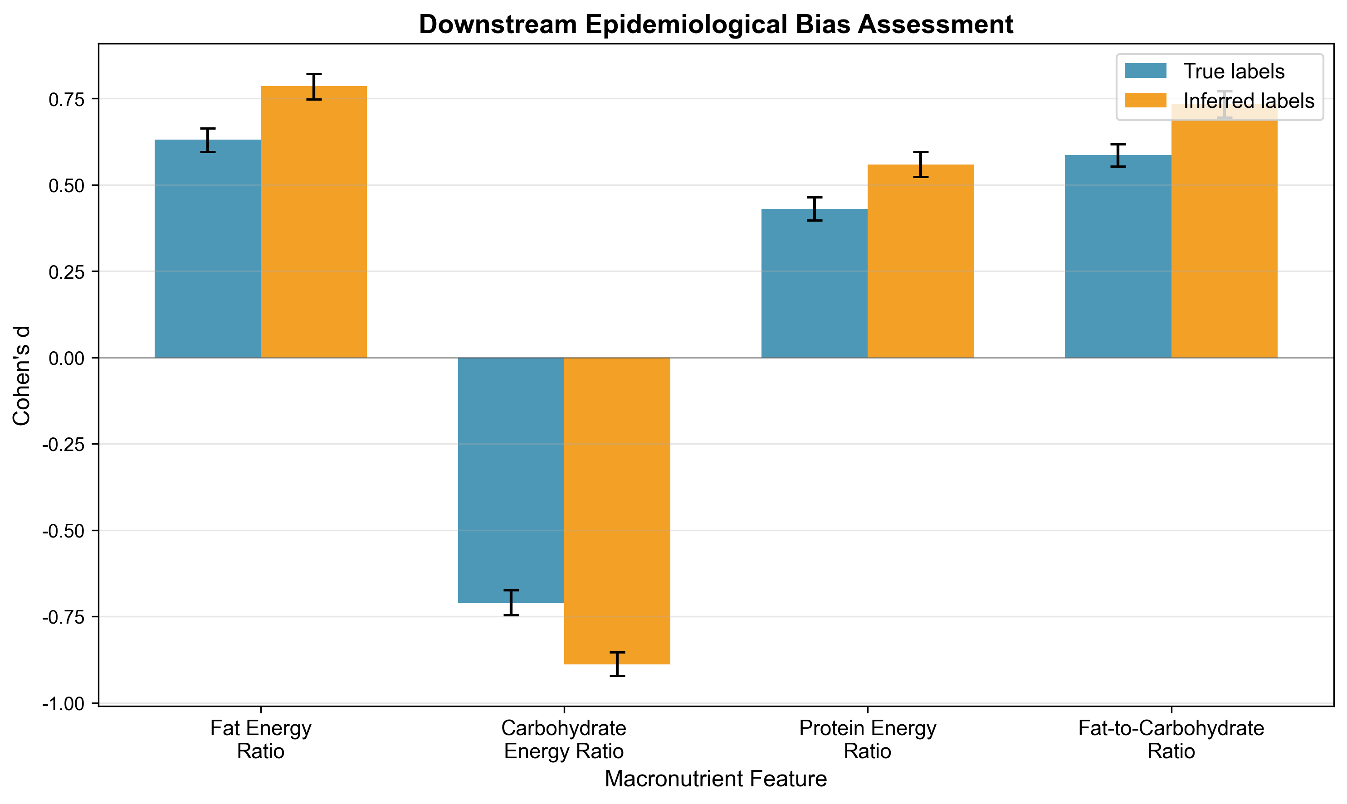
Figure 5. Downstream epidemiological bias assessment under 30% simulated missingness. Comparison of urban–rural effect sizes (Cohen's d) computed using true labels versus inferred labels for four macronutrient features. Error bars represent 95% confidence intervals from bootstrap resampling (n = 2,000).

Supplementary Analyses
Feature-set ablation showed that macronutrients and spatiotemporal covariates contributed jointly to performance (full model accuracy 0.782; macronutrients only 0.769; year and province only 0.518; Supplementary Table S4).

Feature importance analysis showed that multiple macronutrient indicators contributed to classification (Supplementary Table S1), with fat energy ratio being the most influential (mean |SHAP| = 0.554), followed by carbohydrate energy ratio (0.148) and protein energy ratio (0.144). The SHAP summary plot illustrates the directional effects of each feature on Urban classification (Supplementary Figure S1). Interaction analysis revealed that 19.8% of the framework's predictive power derived from pairwise feature interactions, with the strongest interaction between fat and carbohydrate energy ratios (interaction strength = 0.051; Supplementary Table S2).
Leave-one-province-out validation demonstrated spatial generalisability, with mean accuracy 0.737 (SD 0.052) across provinces (Supplementary Table S3). Category-specific accuracy remained stable across missing rates (Supplementary Table S5).

Discussion

Principal Findings
In this study, we developed and evaluated a statistical framework for inferring missing administrative urban–rural labels from dietary survey data. Using CHNS as an illustrative cohort with complete T2 labels, we showed that inference accuracy under masked labels was moderate and stable across missingness levels and survey years (accuracy approximately 0.78–0.79 under primary scenarios). Downstream analyses preserved direction and statistical significance of urban–rural contrasts, although effect sizes were moderately inflated.
Three findings are particularly relevant for methodological applications in survey statistics.
First, the framework demonstrated stable performance under realistic data constraints. Inference accuracy varied minimally across missing rates from 10% to 70%, and temporal validation indicated mean leave-one-year-out accuracy of 0.776. These results support application in incomplete longitudinal dietary datasets.
Second, the Transitional stratum captures intermediate macronutrient profiles within both administrative Rural and Urban groups. Because this stratum is defined by a FatER band, high Transitional inference accuracy should be interpreted alongside the more challenging Urban administrative classification (accuracy 0.421 under 30% simulated missingness).
Third, downstream analyses preserved the direction and statistical significance of dietary differences, with moderate inflation of Cohen's d (22–32%). Substantive conclusions were unchanged under the evaluation protocol used here.

Comparison with Existing Approaches
Most prior approaches to missing data in nutritional epidemiology have focused on imputing nutrient values rather than contextual variables. Common methods, including simple imputation and k-nearest neighbours, rely on local similarity or distributional assumptions that may not fully capture the complex relationships between diet and contextual factors.
In this study, the proposed framework showed modest but consistent improvements over conventional imputation methods under simulated label missingness. Performance gains were largest relative to KNN and MICE; differences versus random forest imputation were small but persisted across missing rates.
An important distinction is that the framework leverages global dietary structure, incorporating both nutrient composition and contextual variables such as time and location. This allows it to account for broader patterns of dietary change that may not be captured by local similarity-based methods. The results also suggest that contextual features contribute meaningfully to inference, highlighting the importance of considering time and place when interpreting dietary data.
More broadly, this study extends methodological work in the field by addressing the inference of contextual variables and by adopting a multi-dimensional evaluation framework that includes distributional fidelity, temporal generalisability, and preservation of epidemiological associations.

Methodologically, the framework is intended for datasets where administrative contextual labels are missing but macronutrient and spatiotemporal fields are available. It supports sensitivity analyses and partial recovery of sample size rather than direct policy classification.

Strengths and Limitations
This study has several strengths. The large sample size and longitudinal design enabled robust evaluation across time. The use of a multi-tiered evaluation framework provides a comprehensive assessment of performance beyond simple accuracy metrics, including distributional agreement and preservation of epidemiological associations. The inclusion of multiple baseline methods allows meaningful comparison with existing approaches.
Several limitations should also be considered. First, the framework was developed using data from a single country. Although internal validation suggests robustness across time and regions within China, external validation in other populations is needed.
Second, the three-category outcome combines administrative T2 labels with a FatER-defined transitional stratum. Transitional accuracy is partially tautological when macronutrient predictors are used; primary interpretation should emphasise T2-based Rural/Urban discrimination and category-specific metrics.
Third, the approach focuses on urban–rural classification and does not address other contextual variables that may be missing or inconsistently recorded. Extending this framework to additional dimensions of context represents an important area for future research.
Fourth, dietary intake was assessed using short-term recall data, which may not fully reflect habitual intake. However, the use of multiple recall days aligns with standard practice in large-scale surveys.
Inferred labels are probabilistic proxies for administrative residence when labels are missing; they should not be treated as replacements for T2 in settings where administrative classification is available.

Future Directions
Future work should prioritise external validation in diverse datasets, including those from different stages of nutrition transition. This would clarify the generalisability of both the inference framework and the three-category classification.
Further methodological development could explore the inclusion of additional dietary indicators, such as food group intake or dietary quality scores, which may enhance performance. Extending the framework to infer other contextual variables—such as socioeconomic status or food environment characteristics—may also broaden its applicability.
Finally, evaluating the impact of this approach in applied epidemiological studies will be important. Comparative analyses examining how different methods of handling missing contextual data affect study conclusions would provide practical guidance for researchers.

Conclusions
Administrative urban–rural context can be inferred from dietary and spatiotemporal information with moderate, non-trivial accuracy under a transparent evaluation protocol. The proposed framework provides a reproducible template for assessing label-imputation methods in nutritional surveys when contextual variables are incomplete.

Data Availability
Analysis scripts and the pre-trained model are available at https://github.com/tyrone1979/nutri2-urban.

References
1. Popkin BM & Ng SW (2022) The nutrition transition to a stage of high obesity and noncommunicable disease prevalence dominated by ultra-processed foods is not inevitable. Obesity Reviews 23, e13366.
2. von Braun J, Afsana K, Fresco LO, et al. (2021) Food system concepts and definitions for science and political action. Nature Food 2, 748–750.
3. Turner C, Kalamatianou S, Drewnowski A, et al. (2020) Food Environment Research in Low- and Middle-Income Countries: A Systematic Scoping Review. Advances in Nutrition 11, 387–397.
4. Vandevijvere S, Jaacks LM, Monteiro CA, et al. (2019) Global trends in ultraprocessed food and drink product sales and their association with adult body mass index trajectories. Obesity Reviews 20, 10–19.
5. Murray CJL, Aravkin AY, Zheng P, et al. (2020) Global burden of 87 risk factors in 204 countries and territories, 1990–2019: a systematic analysis for the Global Burden of Disease Study 2019. The Lancet 396, 1223–1249. Elsevier.
6. Afshin A, Sur PJ, Fay KA, et al. (2019) Health effects of dietary risks in 195 countries, 1990–2017: a systematic analysis for the Global Burden of Disease Study 2017. The Lancet 393, 1958–1972. Elsevier.
7. Turner C, Aggarwal A, Walls H, et al. (2018) Concepts and critical perspectives for food environment research: A global framework with implications for action in low- and middle-income countries. Global Food Security 18, 93–101.
8. Zhai FY, Du SF, Wang ZH, et al. (2014) Dynamics of the Chinese diet and the role of urbanicity, 1991–2011. Obesity Reviews 15, 16–26.
9. Zhao J, Zuo L, Sun J, et al. (2023) Geographic and urban–rural disparities in dietary energy and macronutrient composition among women of childbearing age: findings from the China health and nutrition survey,1991–2015. Nutrition Journal 22, 23.
10. Huang L, Wang L, Jiang H, et al. (2023) Trends in dietary carbohydrates, protein and fat intake and diet quality among Chinese adults, 1991–2015: results from the China Health and Nutrition Survey. Public Health Nutrition 26, 2022/10/05 edn, 834–843. Cambridge University Press.
11. Zhang B, Zhai F, Du S, et al. (2014) The China Health and Nutrition Survey, 1989-2011. Obesity Reviews 15, 2–7. Wiley Online Library.
12. National Center for Health Statistics (2024) NCHS Geographic Variables: Urban-Rural Classification. Centers for Disease Control and Prevention.
13. Brooks MM, Mueller JT & Thiede BC (2020) County Reclassifications and Rural–Urban Mortality Disparities in the United States (1970–2018). Am J Public Health 110, 1814–1816. American Public Health Association.
14. Song Y, Deziel NC & Bell ML (2024) Delineating Urbanicity and Rurality: Impact on Environmental Exposure Assessment. Environ. Sci. Technol. 58, 19178–19188. American Chemical Society.
15. Wright C, Riva S, Crichton M, et al. (2026) Measuring cancer equity globally: harmonising international rural-urban classifications for exploring cancer outcomes. The Lancet Regional Health – Western Pacific 66. Elsevier.
16. Meadows RJ, Paskett ED, Bower JK, et al. (2024) Socio-demographic differences in the dietary inflammatory index from National Health and Nutrition Examination Survey 2005–2018: a comparison of multiple imputation versus complete case analysis. Public Health Nutrition 27, 2024/09/27 edn, e184. Cambridge University Press.
17. Beretta L & Santaniello A (2016) Nearest neighbor imputation algorithms: a critical evaluation. BMC Medical Informatics and Decision Making 16, 74.
18. Sterne JAC, White IR, Carlin JB, et al. (2009) Multiple imputation for missing data in epidemiological and clinical research: potential and pitfalls. BMJ 338, b2393.
19. White IR, Royston P & Wood AM (2011) Multiple imputation using chained equations: Issues and guidance for practice. Statistics in Medicine 30, 377–399.
20. Chen T & Guestrin C (2016) XGBoost: A Scalable Tree Boosting System. In Proceedings of the 22nd ACM SIGKDD International Conference on Knowledge Discovery and Data Mining, pp. 785–794. New York, NY, USA: Association for Computing Machinery.
21. Lundberg S & Lee S-I (2017) A Unified Approach to Interpreting Model Predictions. .
22. Sharma IK, Di Prima S, Essink D, et al. (2021) Nutrition-Sensitive Agriculture: A Systematic Review of Impact Pathways to Nutrition Outcomes. Advances in Nutrition 12, 251–275.
23. Kirk D, Kok E, Tufano M, et al. (2022) Machine Learning in Nutrition Research. Advances in Nutrition 13, 2573–2589.
24. Popkin BM, Du S, Zhai F, et al. (2010) Cohort Profile: The China Health and Nutrition Survey—monitoring and understanding socio-economic and health change in China, 1989–2011. International Journal of Epidemiology 39, 1435–1440.
25. Yang Y (editor) (2018) China Food Composition Tables, Book 1: Standard Edition. 6th edn. Beijing, China: Peking University Medical Press.
26. Seidelmann SB, Claggett B, Cheng S, et al. (2018) Dietary carbohydrate intake and mortality: a prospective cohort study and meta-analysis. The Lancet Public Health 3, e419–e428. Elsevier.
27. Jones-Smith JC & Popkin BM (2010) Understanding community context and adult health changes in China: Development of an urbanicity scale. Social Science & Medicine 71, 1436–1446.

