CSCI 4330: Homework Assignment 2

Student Name: Tyrone Darby

Course: CSCI 4330 Algorithm Design and Analysis

Assignment: Homework 2

Problem 1

b. Experimental Results

Input Array Elements | Size | Hoare Number of Key Comparisons | Hoare Number of Swaps | Lomuto Number of Key Comparisons | Lomuto Number of Swaps
(1) Distinct numbers in ascending order | 100 | 5,148 | 0 | 4,950 | 5,049
 | 1,000 | 501,498 | 0 | 499,500 | 500,499
 | 10,000 | 50,014,998 | 0 | 49,995,000 | 50,004,999
(2) Distinct numbers in descending order | 100 | 5,198 | 50 | 4,950 | 2,549
 | 1,000 | 501,998 | 500 | 499,500 | 250,499
 | 10,000 | 50,019,998 | 5,000 | 49,995,000 | 25,004,999
(3) All the same number | 100 | 830 | 316 | 4,950 | 5,049
 | 1,000 | 11,862 | 4,932 | 499,500 | 500,499
 | 10,000 | 149,214 | 64,608 | 49,995,000 | 50,004,999
(4) Random numbers between 1 and 100,000 | 100 | 942 | 173 | 679 | 446
 | 1,000 | 15,279 | 2,325 | 10,834 | 5,258
 | 10,000 | 213,167 | 31,182 | 147,999 | 78,297

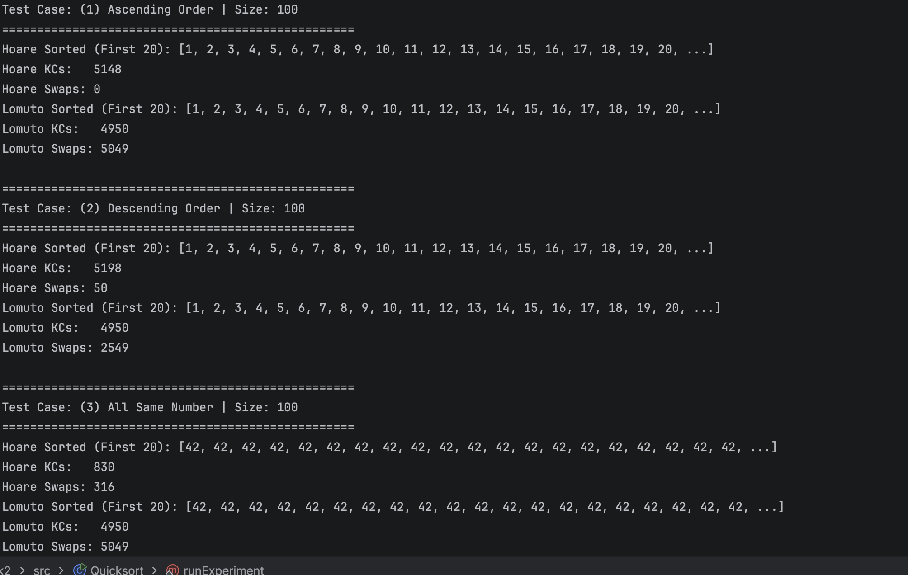

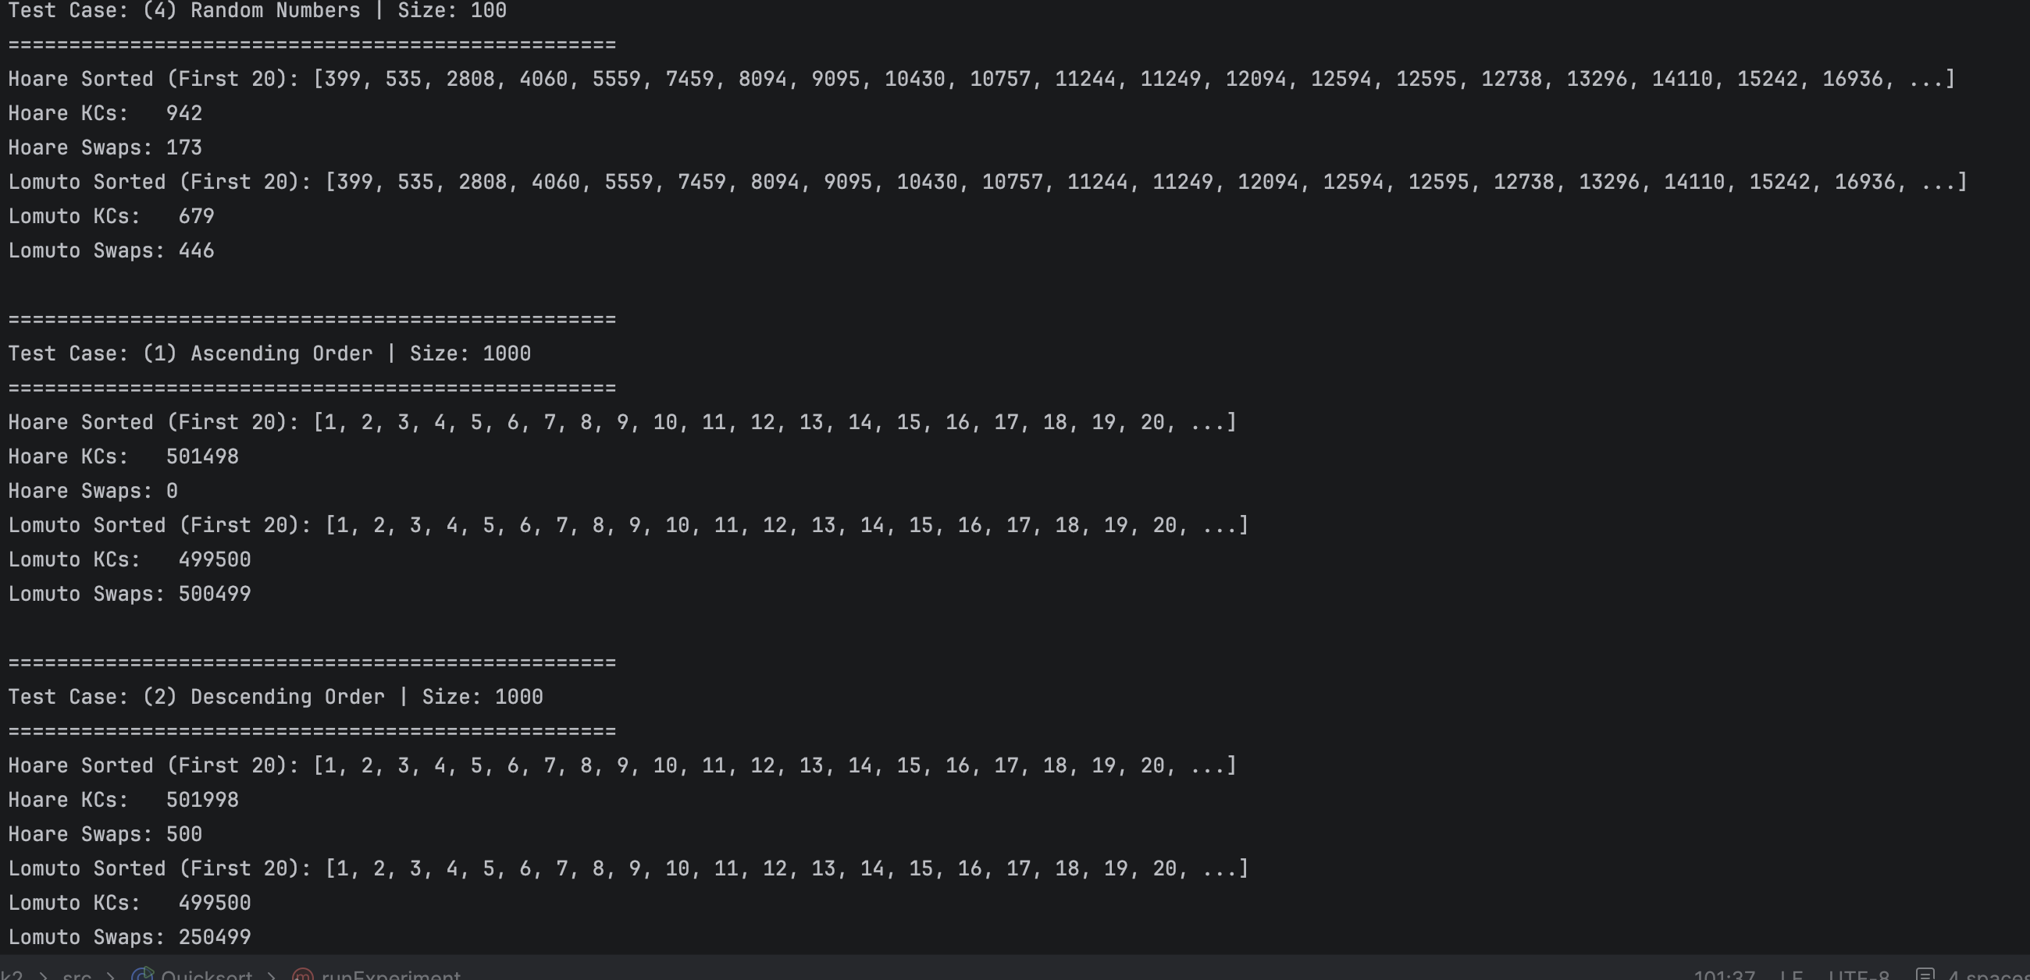

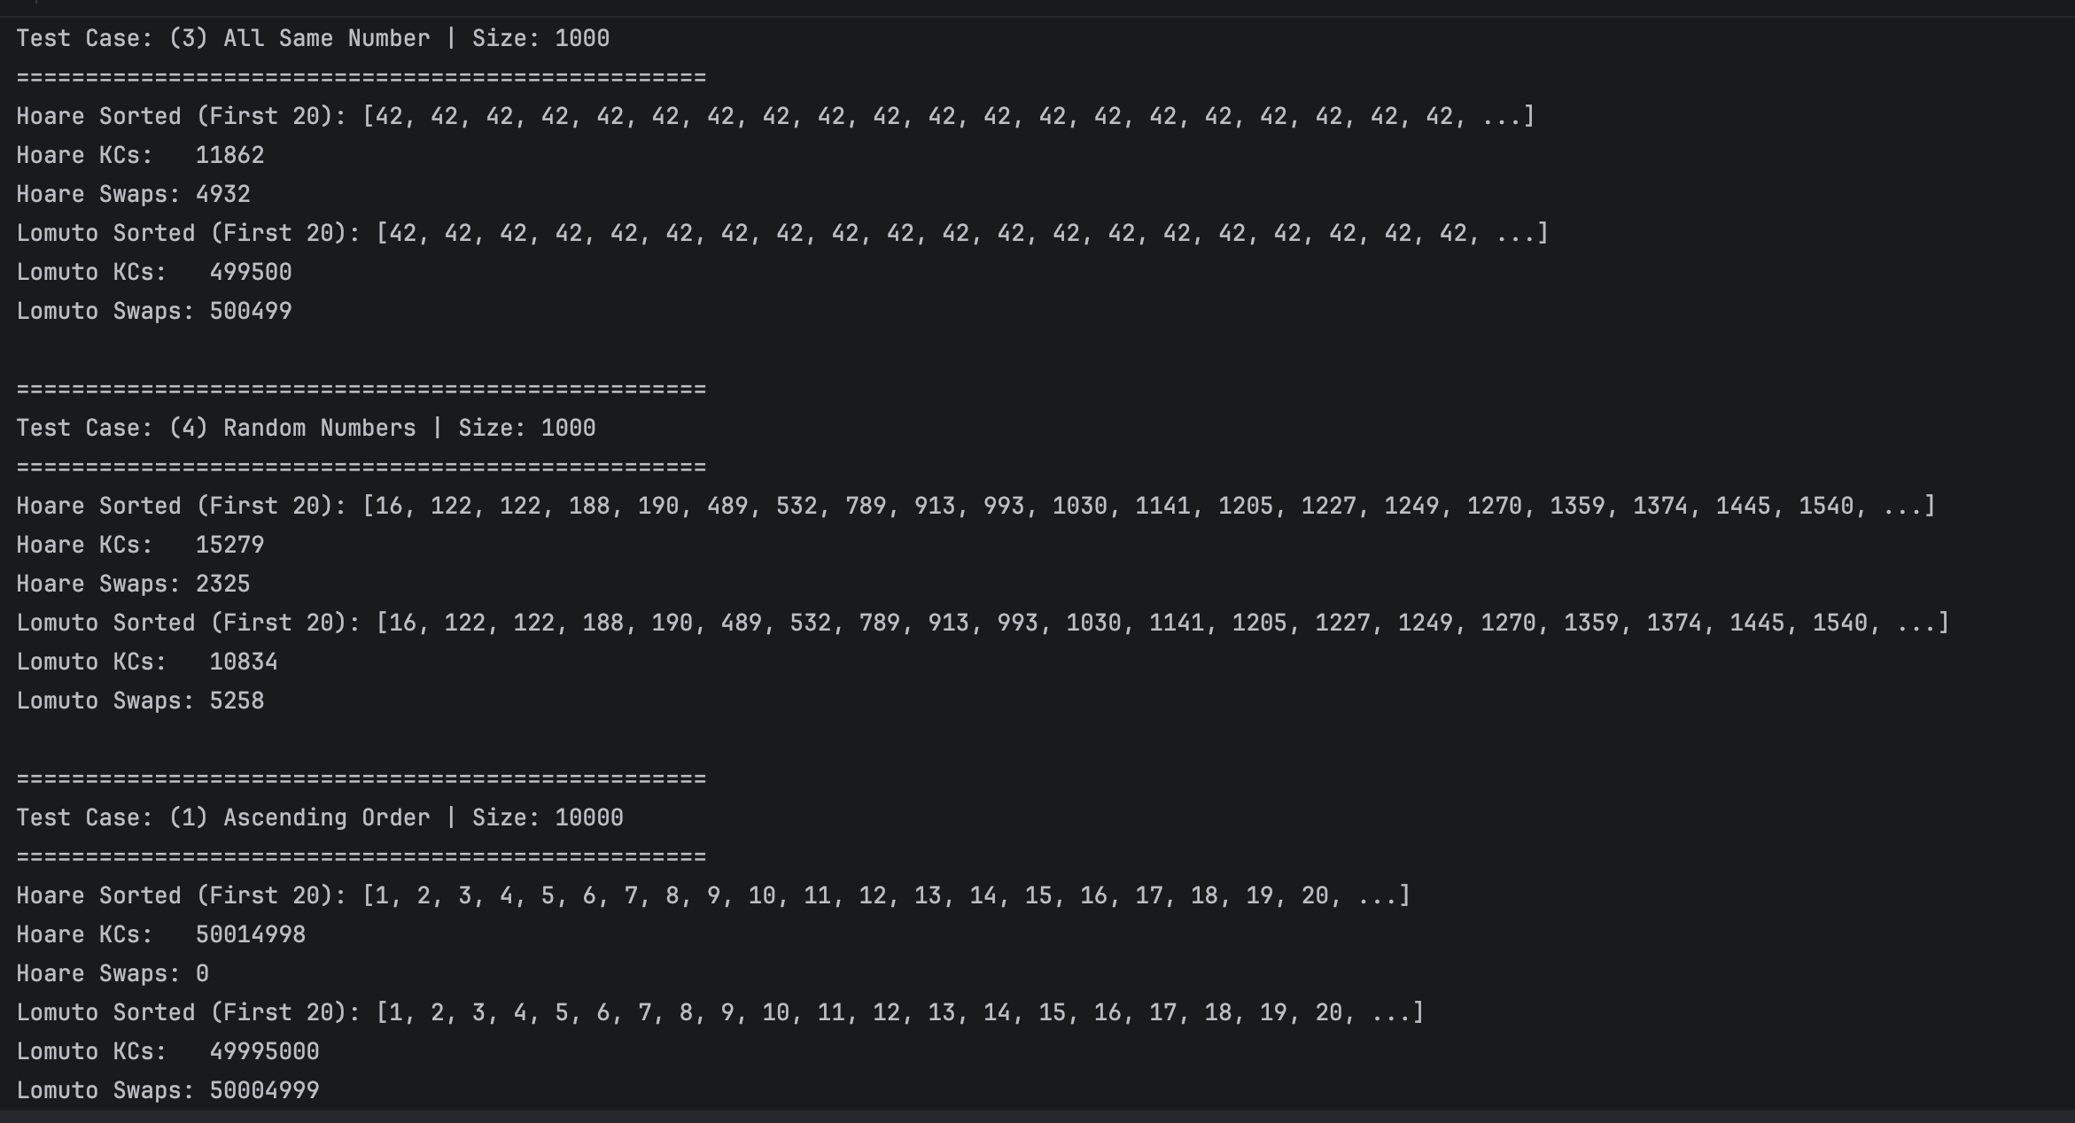

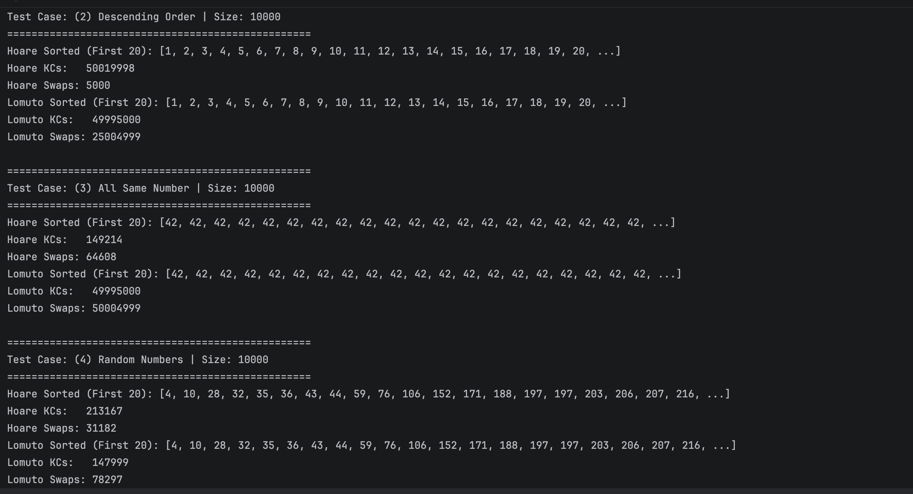

c. Comparative Analysis

- Cases where one algorithm uses both fewer key comparisons and fewer swaps:

  - All the same number: Hoare-Quicksort uses dramatically fewer key comparisons and fewer swaps across every array size (100, 1,000, and 10,000). For example, at size 10,000, Hoare requires only 149,214 comparisons and 64,608 swaps, whereas Lomuto degrades into its worst-case behavior with 49,995,000 comparisons and 50,004,999 swaps.

- Does either algorithm outperform the other on both measures in every case?
  - No. Neither algorithm dominates across all four scenarios.

  - In the ascending order and descending order cases, Lomuto-Quicksort uses slightly fewer key comparisons than Hoare (for example, 4,950 vs. 5,148 at size 100), but Hoare executes far fewer swaps (0 swaps for ascending and only 50 swaps for descending, compared to thousands of swaps in Lomuto).

  - In the random numbers case, Lomuto-Quicksort consistently performs fewer key comparisons (for instance, 147,999 vs. 213,167 at size 10,000), but Hoare-Quicksort consistently executes fewer swaps (31,182 vs. 78,297).

Problem 2

(1) Recurrence Formulation and Justification

Let n represent the number of elements in the current subarray, calculated as right minus left plus one.

- Base Case: When n equals 1 (or when left is greater than or equal to right), lines 1 and 2 check the bounds and return false in constant time, which we denote by a constant amount of work c0. Therefore, T(1) = c0.

- Recursive Step: In the worst-case scenario, lines 3 through 6 evaluate the target sum and perform comparisons that do not result in early termination. This overhead takes constant time, denoted by c1. The algorithm then either increments left by 1 on line 7 or decrements right by 1 on line 9. In either branch, exactly one recursive call is made on a subarray whose size is reduced from n to n minus 1.

Thus, the recurrence relation is:

- T(1) = c0 for the base case where n equals 1.

- T(n) = T(n - 1) + c1 for all n greater than 1.

(2) Guess-and-Prove Method

Step 1: Formulating the Guess

Unrolling the recurrence repeatedly gives:

- T(n) = T(n - 1) + c1.

- Substituting further gives T(n - 2) + 2 * c1, continuing down to T(1) + (n - 1) * c1.

- Expanding this yields c1 * n + (c0 - c1).

Since the dominant term grows linearly with n, we guess that the worst-case running time T(n) is bounded above by d * n and bounded below by k * n for positive constants d and k, indicating a tight asymptotic bound of Theta(n).

Step 2: Proof by Mathematical Induction

- Base Case:

For n equals 1, T(1) = c0. The upper bound condition requires c0 to be less than or equal to d * 1, which holds true for any chosen constant d greater than or equal to c0.

- Inductive Hypothesis:

Assume that T(m) is less than or equal to d * m for all positive integers m strictly less than n.

- Inductive Step:

We want to show that T(n) is less than or equal to d * n.

From the recurrence relation, T(n) = T(n - 1) + c1.

Applying our induction hypothesis to T(n - 1) gives an upper bound of d * (n - 1) + c1, which simplifies to d * n - d + c1.

For this expression to be less than or equal to d * n, the remaining terms (-d + c1) must be less than or equal to zero. This condition is satisfied whenever d is greater than or equal to c1.

- Conclusion:

By choosing the constant d to be the maximum of c0 and c1, both the base case and the inductive step hold true, establishing that T(n) is O(n).

A matching lower bound proof using a constant k equal to the minimum of c0 and c1 confirms that T(n) is Omega(n).

Combining these two results yields the tight asymptotic bound:

T(n) is Theta(n).

Problem 3

a. FIND-ROTATION

(1) Recurrence Formulation and Justification

Let n represent the number of elements in the current range, where n is a power of 2.

- Base Case: When left equals right (meaning n equals 1), lines 1 and 2 check the condition and return the index in constant time c0, giving T(1) = c0.

- Recursive Step: When n is greater than 1, lines 3 and 4 compute the middle index and perform a single comparison between the middle element and the rightmost element in constant time c1. The algorithm then executes exactly one recursive call: either on the range from middle plus 1 to right, or from left to middle. Because n is a power of 2, the chosen half contains exactly n / 2 elements.

The recurrence relation is:

- T(1) = c0 when n equals 1.

- T(n) = T(n / 2) + c1 when n is greater than 1.

(2) Master Theorem Solution

The recurrence matches the standard Master Theorem form T(n) = a * T(n / b) + f(n), with:

- Number of subproblems a = 1.

- Subproblem size reduction factor b = 2.

- Non-recursive overhead f(n) = c1, which is of order Theta(1) or Theta(n to the power of 0).

Evaluating the critical exponent:

- n raised to the power of log base b of a equals n raised to log base 2 of 1, which simplifies to n to the power of 0, or 1.

- Comparing f(n) to this critical value shows that f(n) is Theta(1), which asymptotically matches n raised to the power of log base b of a.

This satisfies Case 2 of the Master Theorem. Multiplying the critical term by a logarithmic factor produces the tight asymptotic bound:

T(n) is Theta(log n).

b. TRANSPOSE

(1) Recurrence Formulation and Justification

Let n represent the side length of the matrix, where n is a power of 2.

- Base Case: When size equals 1 (meaning n equals 1), lines 1 and 2 execute and return in constant time c0, giving T(1) = c0.

- Recursive Step: When n is greater than 1, line 3 calculates half as n / 2. Lines 4 and 5 invoke two recursive calls, each operating on a submatrix of side length n / 2. This produces two subproblems, so a = 2 and the subproblem size is n / 2.

- Lines 6 through 8 consist of two nested loops. The outer loop and inner loop each run half times (n / 2 iterations). The element swap inside executes (n / 2) multiplied by (n / 2) times, which equals (n squared) / 4 total executions. Because each element swap runs in constant time, the non-recursive overhead f(n) is of order Theta(n squared).

The recurrence relation is:

- T(1) = c0 when n equals 1.

- T(n) = 2 * T(n / 2) + c2 * (n squared) when n is greater than 1.

(2) Master Theorem Solution

The recurrence matches the standard form T(n) = a * T(n / b) + f(n), with:

- Number of recursive calls a = 2.

- Dimension reduction factor b = 2.

- Non-recursive overhead f(n) is of order Theta(n squared).

- Calculate the critical value:

n raised to the power of log base b of a equals n raised to log base 2 of 2, which simplifies to n to the power of 1, or n.

- Compare f(n) with the critical value:

Because f(n) grows as n squared, it is Omega(n to the power of (1 + epsilon)), where choosing epsilon equal to 1 makes the exponent 2.

- Verify the Regularity Condition for Case 3:

We check whether a * f(n / b) is less than or equal to a constant factor k * f(n) for some constant k strictly less than 1.

Evaluating the expression: 2 * f(n / 2) equals 2 * c2 * (n / 2) squared, which equals 2 * c2 * ((n squared) / 4), simplifying to (1 / 2) * c2 * (n squared).

Since this equals (1 / 2) * f(n), choosing the constant k equal to 1 / 2 satisfies the condition (1 / 2) * f(n) <= k * f(n) for all positive integers n.

- Conclusion:

All requirements for Case 3 of the Master Theorem are satisfied. The overall runtime is dominated by the non-recursive overhead f(n), yielding the tight asymptotic bound:

T(n) is Theta(n squared).

Problem 4: Generative AI Tool Statement

