**­­­Tutorial 01 – Version 8.1 – [**21 | 36**]   
  
Acquire Web Host Accounts:**

Students are required to have access to a Shared Web Host cPanel account that they use to create and manage multiple CMS websites. In our first IT320 class, during class students sign up for a shared web host cPanel account, like Namecheap or register for a Pantheon.io account.   
The second web host to register for is a cloud web host account. In IT320 students register for a Codeanywhere account.   
  
In this tutorial, you will record information about your accounts and use each of them to create your first two WordPress CMS sites.   
  
Additionally, we will do a few PHP problems, to test your understanding of the PHP material we covered in class.   
  
If you have difficulties completing this assignment, please inform the instructor and consider working with DePaul tutors.

**Instructions for completing template:***Replace* **[bracketed red text]** *with the requested information and change the* ***red text to black text.*** *Do not include full screen shot images, or full screen shots that are reduced in size. Use a snippet tool to capture parts of the screen and insert those images into the template.  
Please answer all questions.***Please do not alter template numbering.**

**PART A – Getting started Student Contact Information**

**1. Student Name: Wesley Wu [A.1]**

**2. Student Contact Information:   
wwu36@depaul.edu [A.2]  
3124792868 [A.3]**

**Go back to the tutorial instructions and begin working on part B.**

**Part B.1 – Review Shared Web Host cPanel account options**No screen captures for Part B**.1  
Go back to the tutorial instructions and begin working on part B.2.**

**Part B.2 – Select and acquire a Shared Web Host cPanel account**

1. Did you purchase a shared web host cPanel account for this class?  
   [B.2.1]

**Yes**

1. If you answer No to [**B.2.1], please return to the instructions and continue with Part C.**
2. **If you purchased a cPanel shared web host account please answer the following questions about your new cPanel shared web host account below.**
   1. **What is name of the shared web host company name?   
      [B.2.2]  
      Namecheap**
   2. **When did you sign up for your new account?   
      [B.2.3]  
      4/3/2024**
   3. **Are you using this account for another class or work?   
      [B.2.4]  
      No**
3. **Take a screen capture of your new shared web host cPanel account dashboard   
   [B.2.5]**

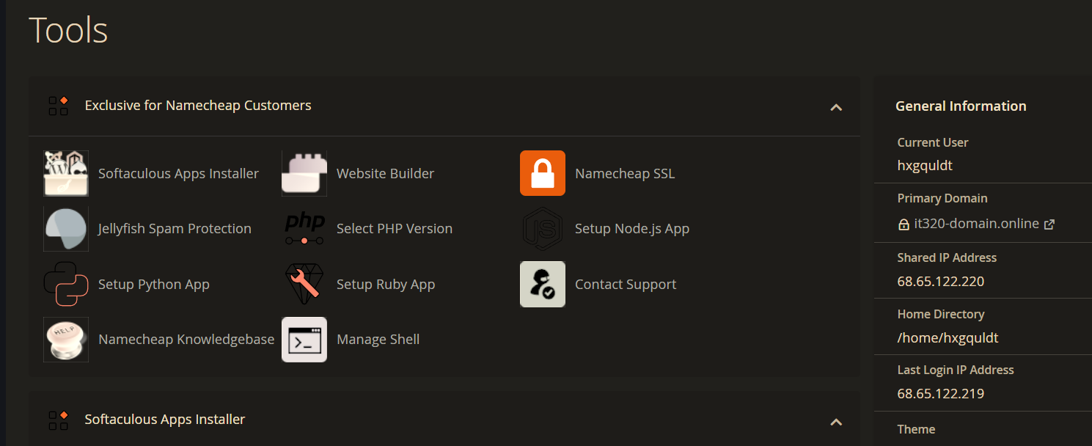

**Part B.3 – Configure your new Shared Web Host cPanel account**

1. Verify an admin email account exists and add it if it does not
   1. What is your domain name? [B.3.1]   
      [it320-domain.online](https://it320-domain.online/)
   2. Record a screen capture of your email account page showing an admin email [B.3.2]

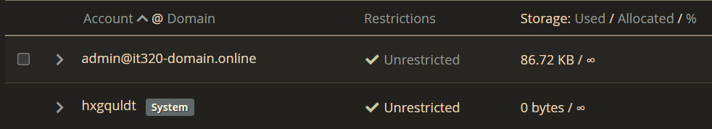

1. Add a forwarder email account for the admin email account
   1. What is the email you added as a forwarder?   
      [B.3.3]   
      wesleywu9@gmail.com
   2. Record a screen capture of your email forwarders page showing Email Account Forwarders   
      [B.3.4]

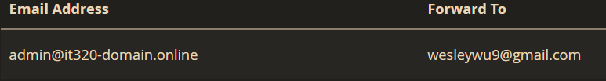

1. Set the PHP version – To at least 8.1
   1. What was the initial PHP version listed?   
      [B.3.5]   
      8.1
   2. What did you set the PHP version to?   
      [B.3.6]   
      8.3
   3. Record a screen capture of your Select PHP Version page   
      [B.3.7]

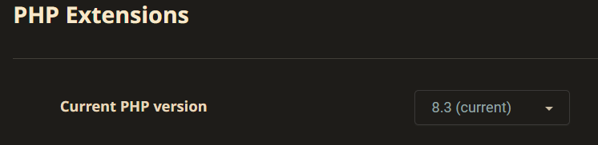

1. Configure settings, so the Terminal icon is visible on the cPanel
   1. Was the Terminal icon originally visible? [  
      B.3.8]   
      No
   2. Record a screen capture of your cPanel Manage Shell page, with Enable SSH access ENABLED.   
      [B.3.9]

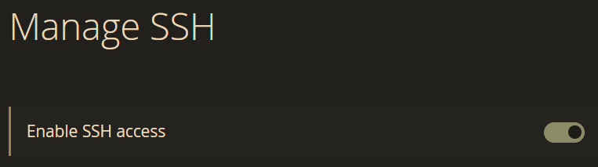

* 1. Record a screen capture of your cPanel Advanced panel showing the Terminal icon visible on the panel   
     [B.3.10]

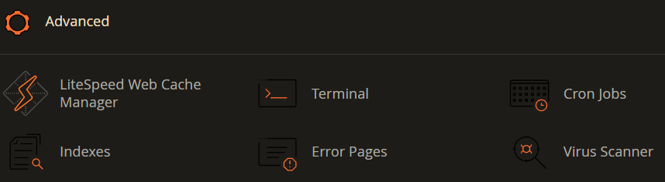

1. Secure Socket Layer (SSL)  
   Were you able to successfully install and active the SSL? [B.3.11]   
   Yes. But for some reason, it was already installed.  
   *Note : if your answer was NO. Please contact Namecheap tech support for help and work with them to get an SSL on your domain ASAP.
2. Overview of how to correctly disable LiteSpeed Cache   
   No screen captures for this part.
3. **Go back to the instructions and begin working on part D.**

**Part C – Register for your own Pantheon.io account**

1. If you are unable to purchase a shared web host cPanel account, please answer the following questions:
   1. Do you understand that using a Pantheon.io account requires a significantly more time to get your class work done?  
       **[C.1.1]**[A YES answer is required here – if not, then get a cPanel account]
   2. Do you understand that using a Pantheon.io account requires you to install an learn several software tools on your home computer or laptop?   
      **[C.1.2]**  
      [A YES answer is required here – if not, then get a cPanel account]
   3. After answering questions in **[C.1]** if you still wish to register for a Pantheon.io account, please do so at this time.
2. After registering and verifying your Pantheon.io account, login and take a screen capture of your Patheaon.io dashboard. **[C.2]  
   [**Your pantheon.io dashboard capture here**]**
3. **Go back to the instructions and begin working on part D.**

**Part D – Signup for a Codeanywhere account**

1. **Signup** account using Google, Facebook, GitHub or Bitbucket.
   1. We recommend signing up using Google.
   2. We recommend purchasing a Codeanywhere **STANDARD** or **PREMIUM** account.
2. After registering and verifying your Codeanywhere account, login and take a screen capture of your Codeanywhere dashboard where we don’t see the Account has not been verified message. **[D.1]**

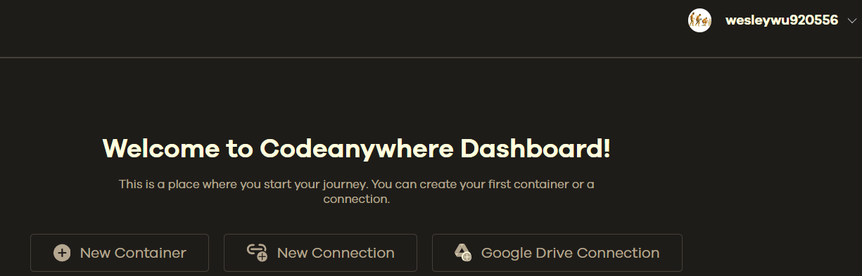

1. **Go back to the instructions and continue at Part E.**

**Part E–** PHP Web Emulator Review

1. What are names (URLS) of the PHP emulators reviewed? **[E01]**  
   **phptester**

**sandbox.onlinephpfunctions**

1. Why am I recommending you use PHP web emulators that support embedded HTML for this class? **[E02]**

**Because emulators which support embedded HTML will display the results of applying those HTML tags.**

**Part F –** PHP QUESTIONS

1. How many **values** can a PHP variable hold?
   1. One
   2. Two
   3. Three
   4. Infinite

**[F01]** a. One

1. Of the following PHP variables, which are valid and which are invalid?   
   **If the variable is invalid, please list why it is invalid?  
   (HINT: there may be more than 1 error on the variable) [F02]**

|  |  |  |  |
| --- | --- | --- | --- |
| **No.** | **Variable** | **Is Valid (Yes/No)** | **If invalid, reason why** |
| **a.** | **$xyx** | **Yes** |  |
| **b.** | **$ abc** | **Invalid** | **Contains space** |
| **c.** | **$U & Me** | **Invalid** | **Contains space** |
| **d.** | **$UandMe@** | **Invalid** | **Contains special character (@)** |
| **e.** | **$U+Me** | **Invalid** | **Contains special character (+)** |
| **f.** | **$U%Me** | **Invalid** | **Contains special character (%)** |
| **g.** | **$@@name** | **Invalid** | **Contains special character (@)** |
| **h.** | **$MyName** | **Valid** |  |
| **i** | **$Your-Name** | **Invalid** | **Contains special character (-)** |
| **j.** | **$Your_Name** | **Valid** |  |
| **k.** | **$%&&xyz** | **Invalid** | **Contains special character (%)** |
| **l.** | **$$xxx** | **Invalid** | **Contains special character ($)** |
| **m.** | **$YourName** | **Valid** |  |

1. Write PHP code to declare and define an INTEGER variable named $value and assign $value the **INTEGER** value of 104.  
   For help on this question, find, open and examine the PHP Example program file php_variables.php

**[F03]**$value = 104;

**Part G- Review Assignment 01 – Instructions, Template, and Rubric  
No questions or screen captures for Part G.**

**Part H – Wrap Up**

**No questions or screen captures for Part H.**Submit your completed tutorial template to D2L submission folder for tutorial 01.If you prefer not to navigate by hand to the D2L submission folder, take advantage of the submission link inthe D2L Module 01 Tutorial 01 section. This link will take you to the correct tutorial submission folder.

**If you have questions or issues about this tutorial, please email the instructor**