Tutorial 10 Template – Version 8.3 – [30]   
**Instructions:**Replace **[bracketed red text]** with the requested information or screen capture.  
Replace **bracketed red text with black text**.  
**PLEASE do not include full page, full window screen shot images**, or full screen shots that have been reduced in size.   
Use a snippet tool to capture parts of the screen and insert those images into the template.  
**Do not remove tags from this template. An example of a tag is [C01]. All fields are required.***Please do not alter template formatting or delete parts of this template.*

Part A - Student Information: [A]  
 **1. Student Name:** Wesley Wu

**2. What day and date did you start this tutorial?** 6/5 Wednesday

Go back to the instructions and continue with Part B.Part B – Platform Information: [B]

1. **Which Platform did you build your Drupal 10 site on?** [B.1]   
   Namecheap
2. **WEBSITE Admin Username:** [B.2]   
   cmsadmin
3. **WEBSITE Admin Password:** [B.3]   
   CMSPassword9!
4. **Tutorial Website URL:** [B.4]   
   <https://it320-domain.online/wwu36-tutorial-10>
5. Proof of site Hardening.   
   SCREEN CAPTURE – Backend Account Settings, REGISTRATION AND CANCELLATION  
   Admin toolbar > Configuration > Account settings, Registration and Cancelation[B.5]

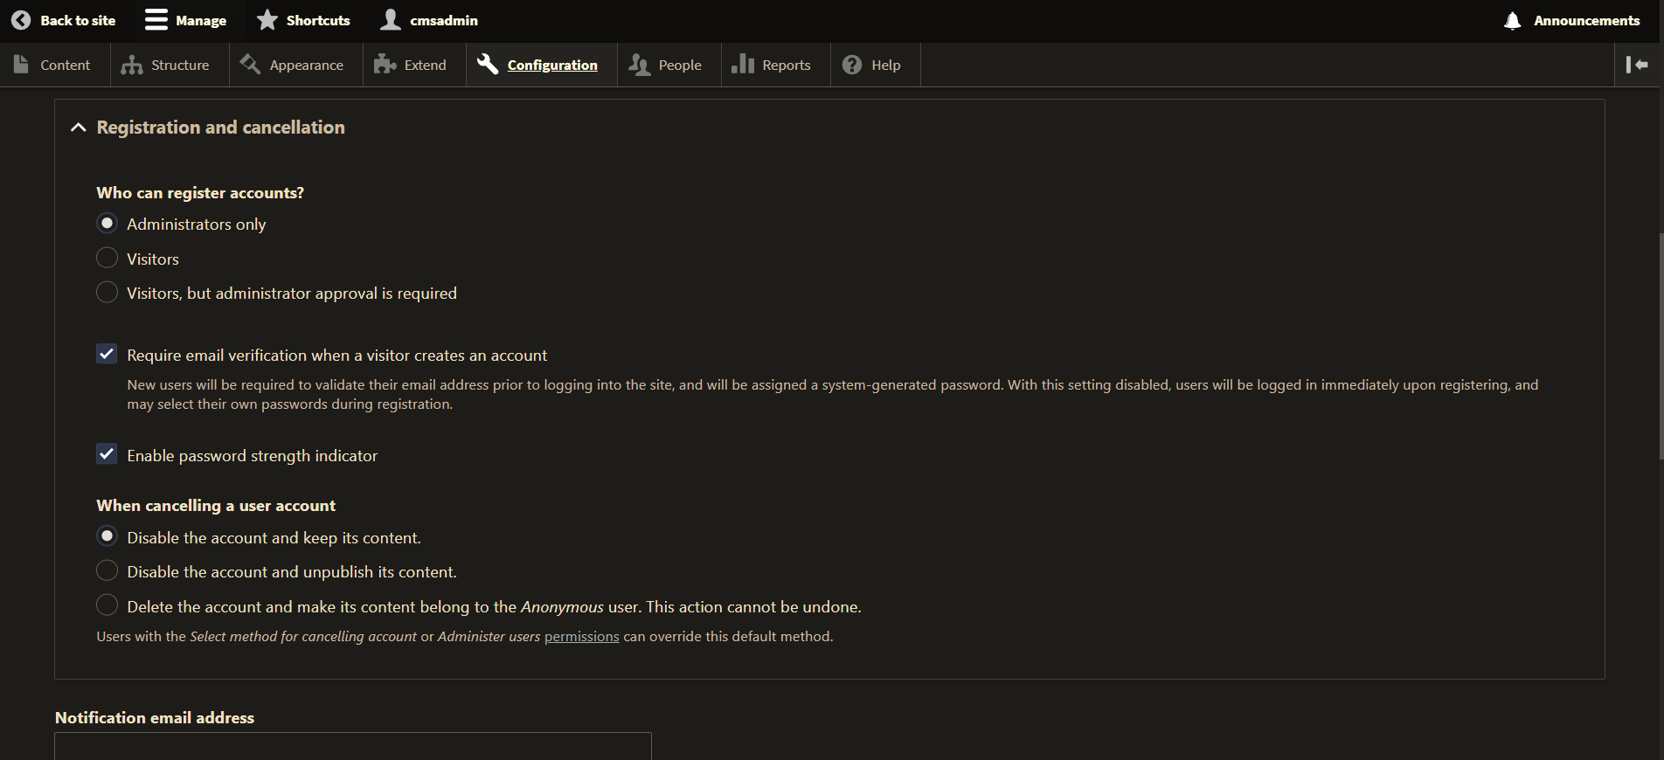

1. Proof of Media and Media Library module activation.   
   Backend ADMIN SCREEN CAPTURE of the Extend page  
   Admin toolbar > Extend with Media and Media Library visible and enabled[B.6]

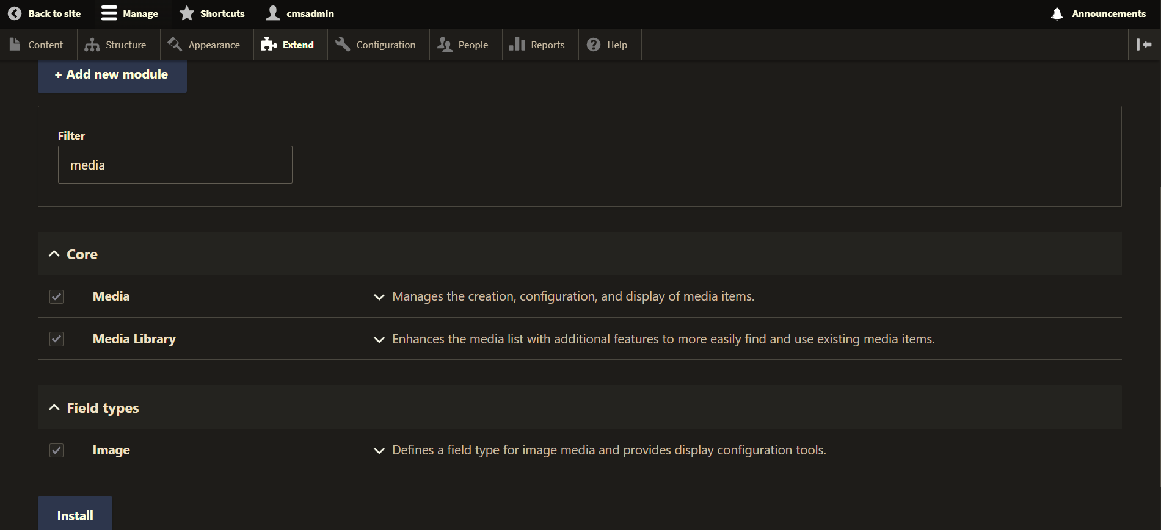

Go back to the instructions and continue with Part C.

Part C – Introduction to Drupal URL Aliases.

1. SCREEN CAPTURE – Backend list of URL Aliases   
   Admin toolbar > Configuration  
   Under “Search and metadata” select “> URL aliases”  
    Take a screen capture URL aliases pages list of the Aliases we added.[C.1]

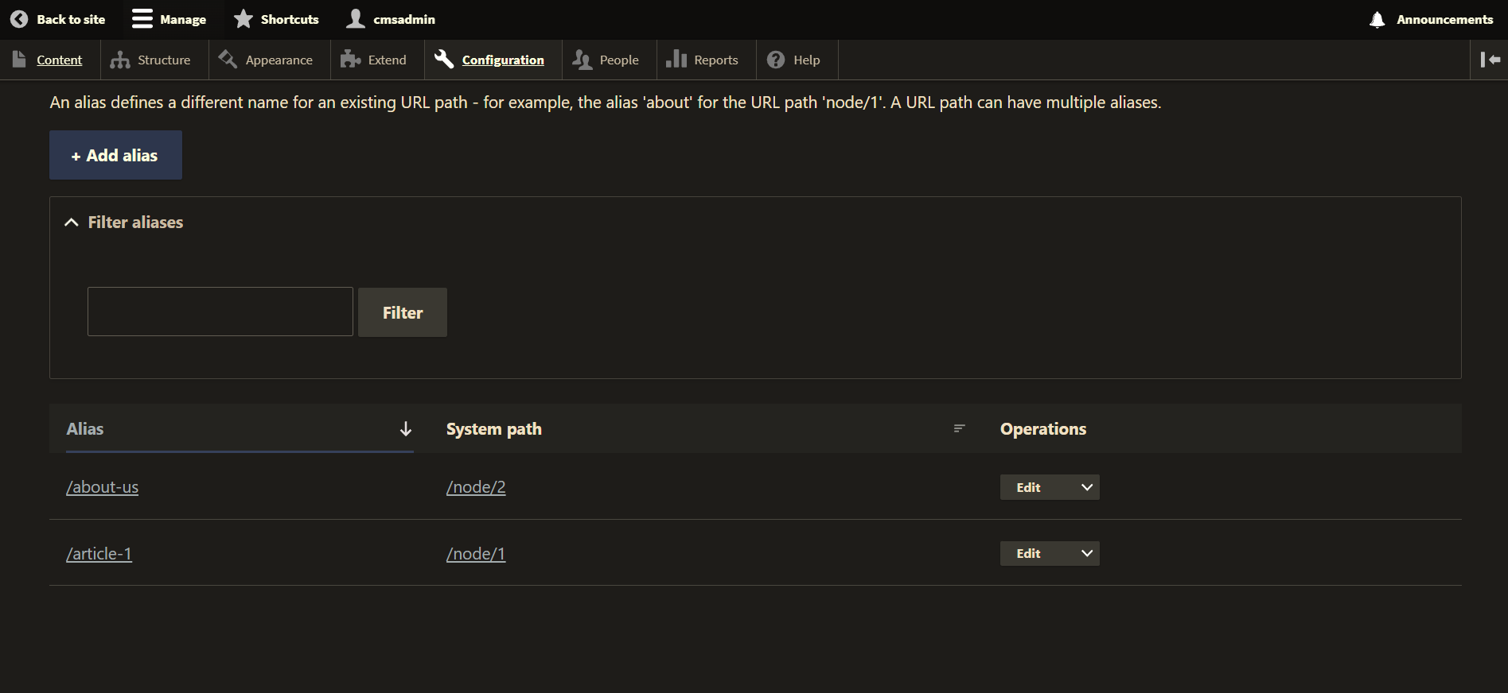

Go back to the instructions and continue with Part D.

Part D.1 – Installing modules with Composer Dependency Manager

**Note for Pantheon.io users:** You cannot work along with this Part. Watch the videos **to learn how to install modules using composer commands on a BASH Terminal**.

1. Were you able to successfully install the Drupal Address module using Composer?  
   [D.1.1]   
   Yes
2. FOR PARTIAL CREDIT: If you were unable to install the Address module, please list the issues encountered AND provide screen captures from the Terminal window?  
   [D.1.2]   
   [ISSUES HERE]  
   [TERMINAL SCREEN CAPTURE HERE]
3. If you were not able to successfully install the Drupal Address module using Composer, then install the Simple Address module using the GZIP file form the Simple Address project page?  
   [D.1.3]   
   [Did you install the Simple Address module instead?]  
   SCREEN CAPTURE – Backend list of Modules, showing the Simple Address module enabled under the Field Types section   
   [SCREEN CAPTURE HERE]

Part D.2 – Installing Simple Address module only on Pantheon:

**Note for cPanel (Namecheap) users:** You do not work along with part D.2. You already installed an Address module using Composer commands in the Part D.1

**Note for Pantheon.io users:** You can work along with this Part. Watch the videos **and work along as we install the Simple address module from the Drupal backend**.

1. Were you able to successfully install the Drupal Simple Address module using GZIP and FTP?  
   [D.2.1]   
   [Yes or No ANSWER HERE]  
   [If no, provide information and screen captures of the errors and issues]
2. If you able to successfully install the Drupal Simple Address module, take a screen capture of it listed in the Extend page  
   [D.2.2]   
   SCREEN CAPTURE – Backend list of Modules, showing the Simple Address module enabled under the Field Types section.

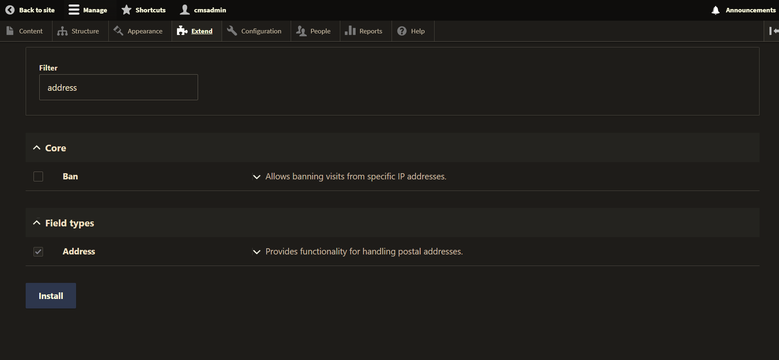

Go back to the instructions and continue with Part E.

Part E - Introduction to Drupal Taxonomy and Vocabulary

1. SCREEN CAPTURE – Backend list Taxonomy Vocabularies  
   Admin toolbar > Structure > Taxonomy  
    [E.1]

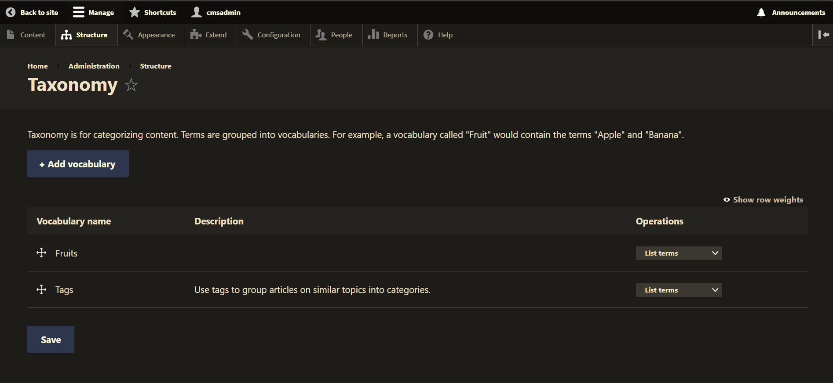

1. SCREEN CAPTURE – Backend list of the Fruit Vocabulary Terms   
   Admin toolbar > Structure > Taxonomy, then select “List terms” for Fruit and take a screen capture of the Terms.  
    [E.2]

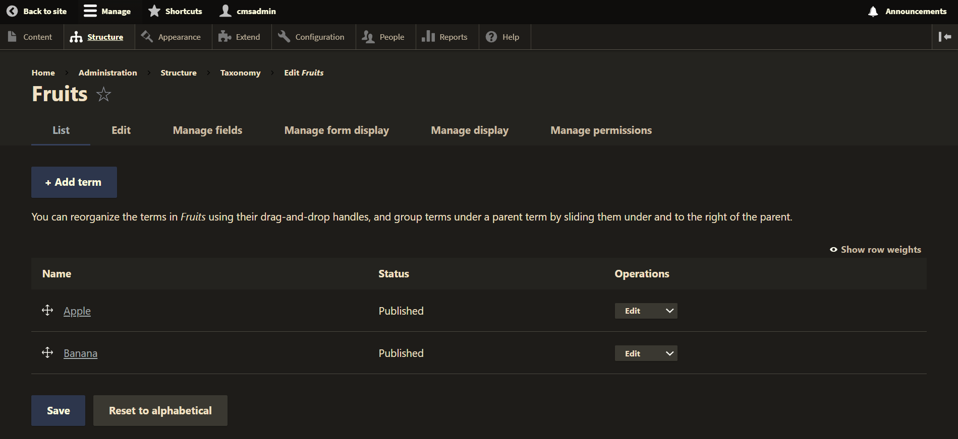

Go back to the instructions and continue with Part F.

Part F – Creating Custom Content Types

1. SCREEN CAPTURE – List of Content types   
   Admin toolbar > Structure > Content types  
    [F.1]

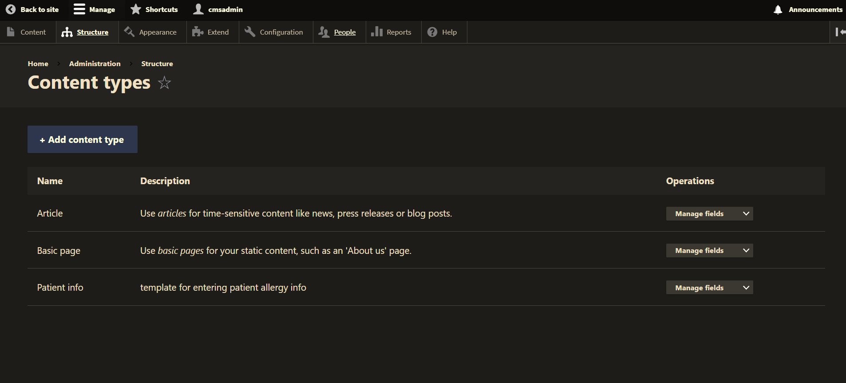

1. Access the Content type page [Admin toolbar > Structure > Content types] then select the Manage fields button for Patient info. Take a screen capture of the Manage fields page. The bread crumbs at the top of page should be [Administration > Structure > Content types > Patient info].  
    [F.2]

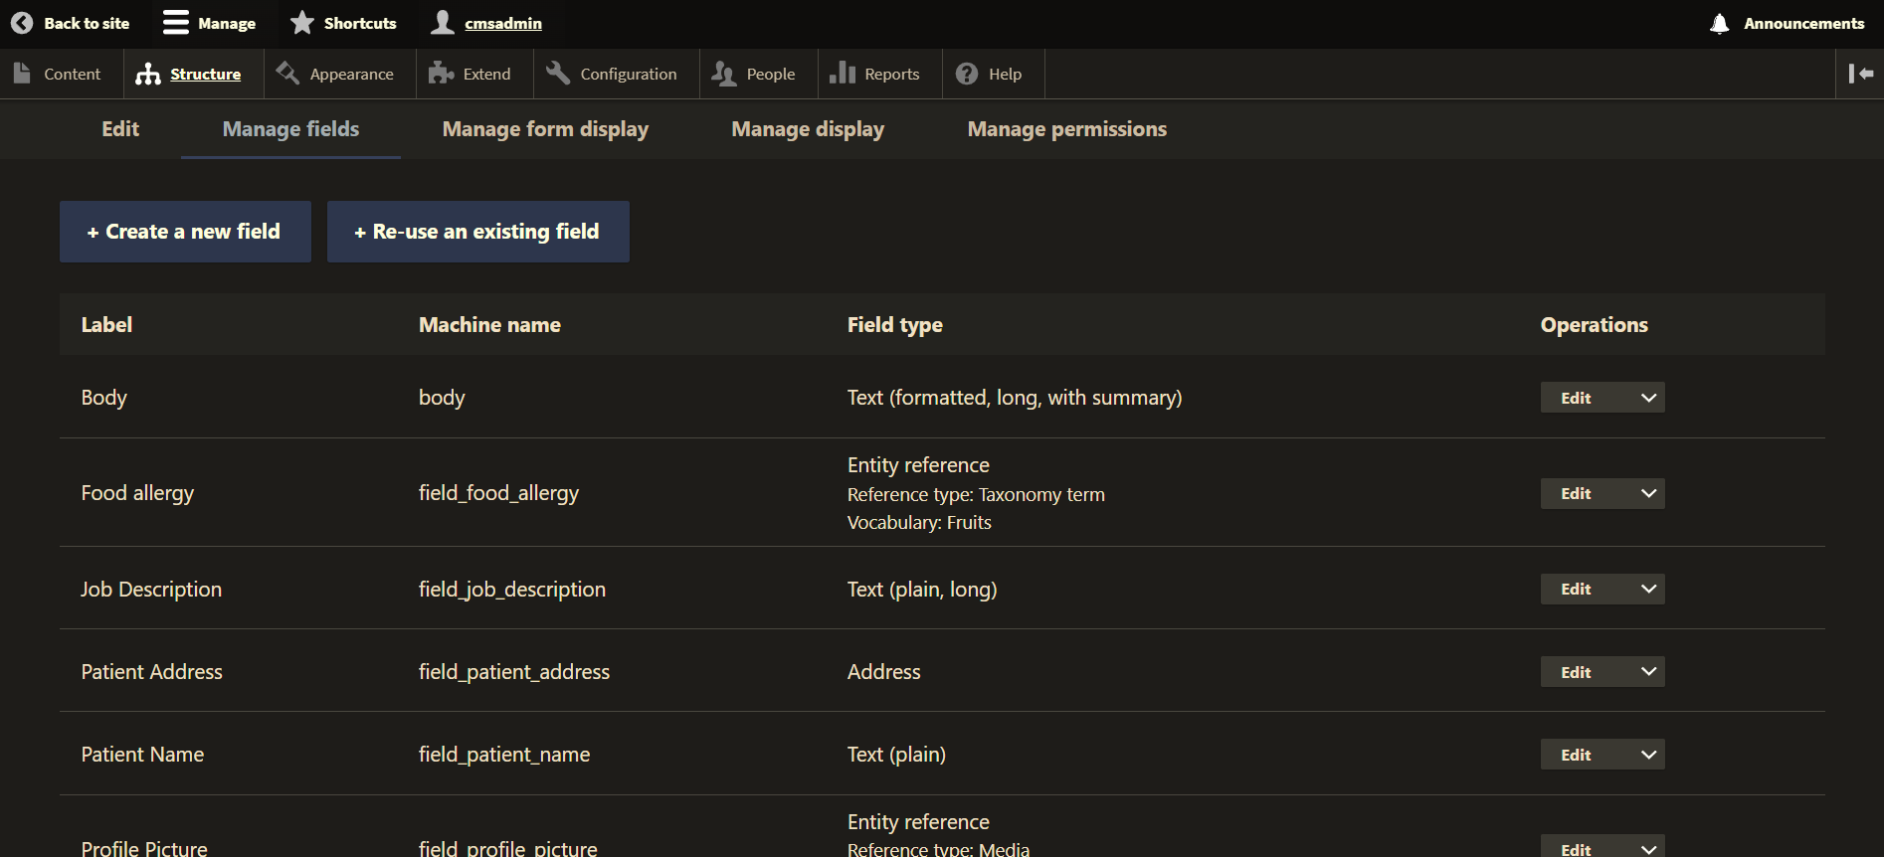

Go back to the instructions and continue with Part G.

Part G – Creating Custom Content Nodes (Records)

1. SCREEN CAPTURE – List of Content nodes  
   Admin toolbar > Content, filter by Patient info  
    [G.1]

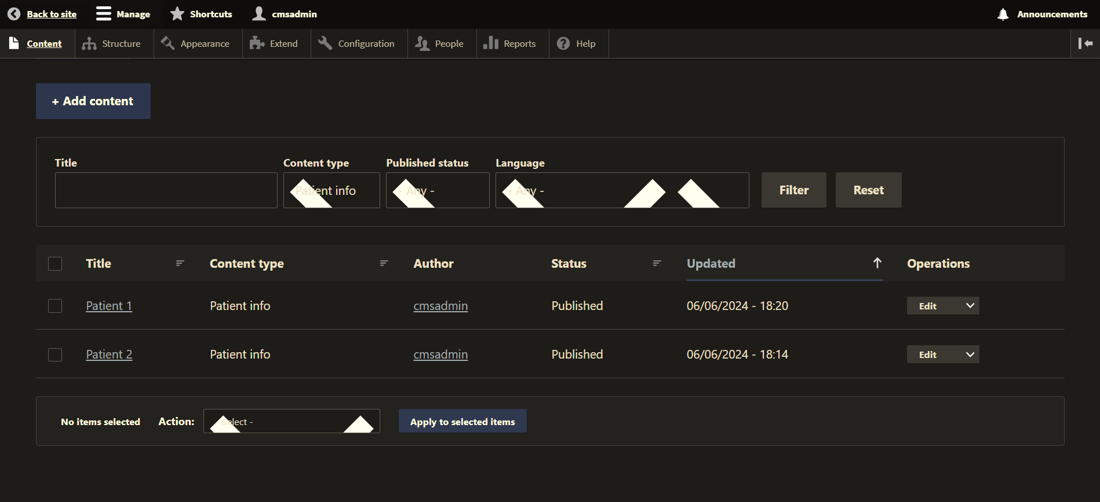

1. Edit 1 Patient info node record and take a screen capture of its Edit page. This may take more than one screen captures.  
    [G.2]

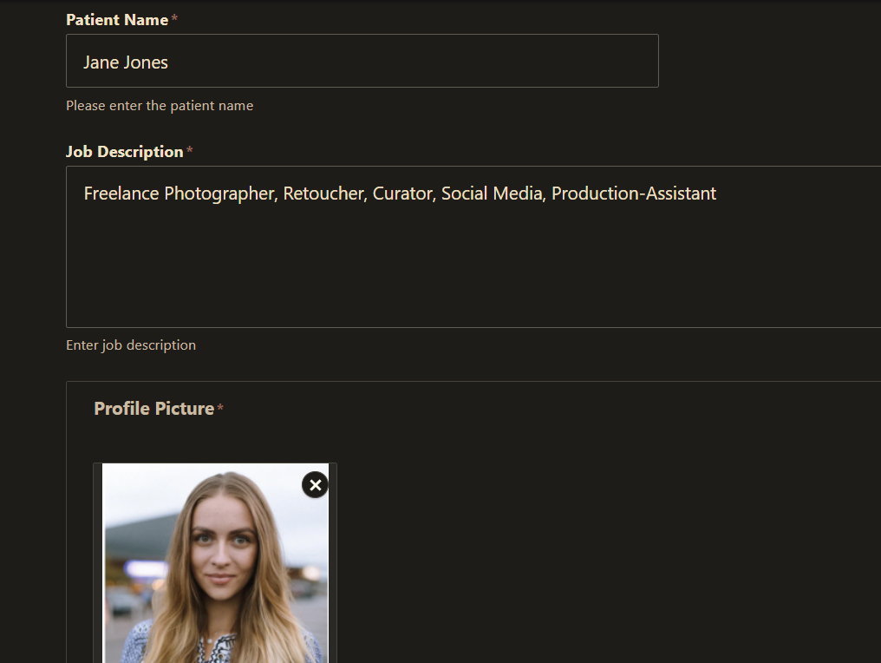

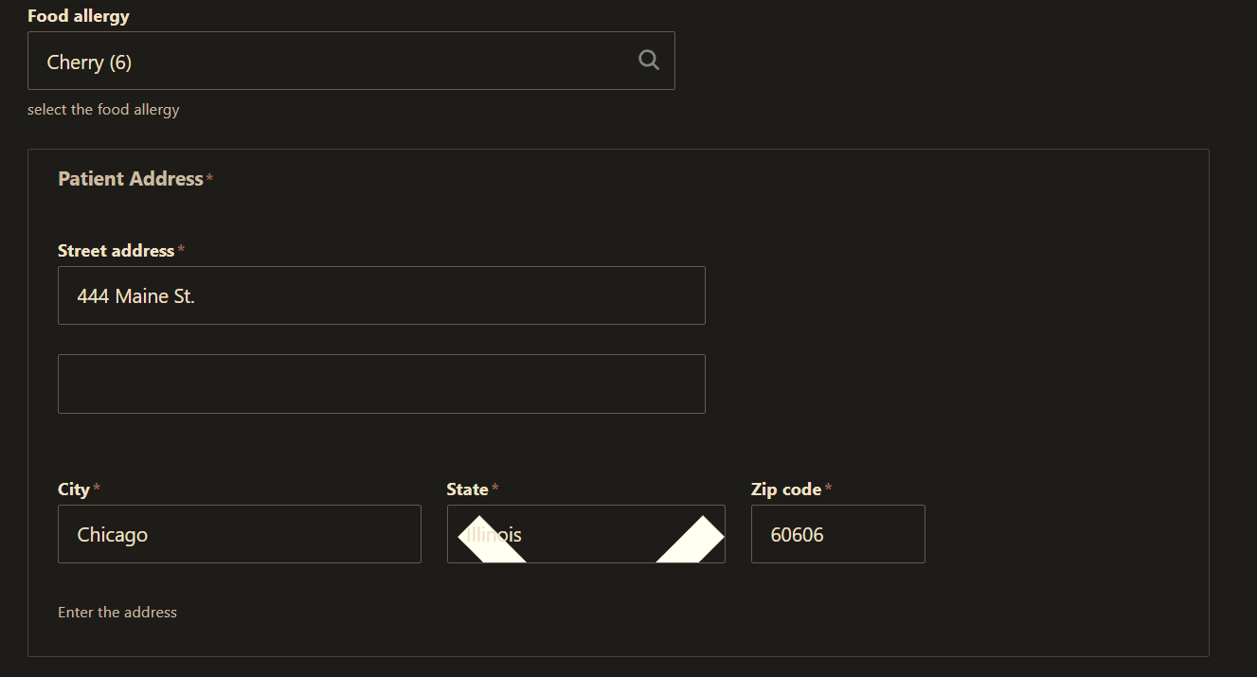

Go back to the instructions and continue with Part H.

Part H – Introduction to Drupal Views – Pages and Block Views

1. SCREEN CAPTURE – Backend list of Views   
   [Admin toolbar > Structure > Views] , with Patient records view, Second Patient View , and Patient Block visible  
    [H.1]

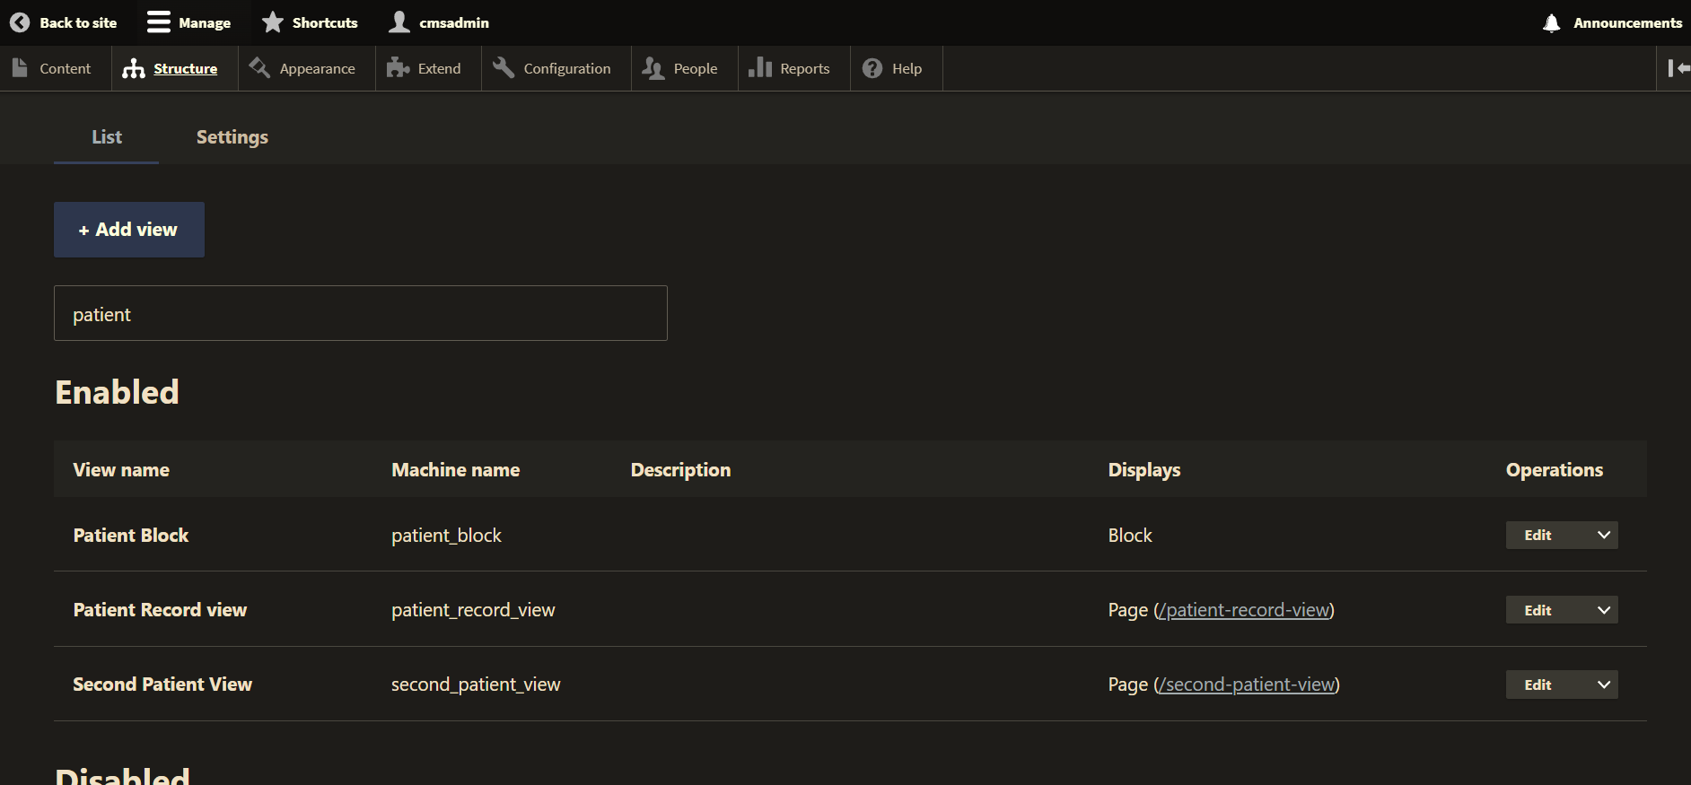

1. From the Structure > Views page, select the SCREEN CAPTURE – Backend list of Views   
   [Admin toolbar > Structure > Views] , select Edit button for Patient records view and take a screen capture of JUST the top 3 column block of the View Summary Page  
   [H.2]

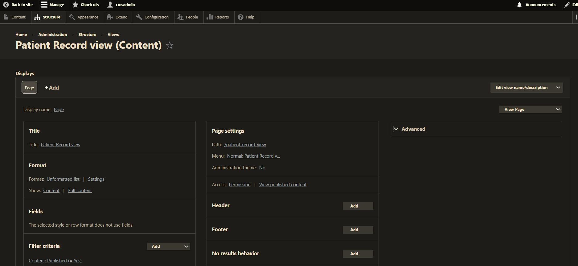

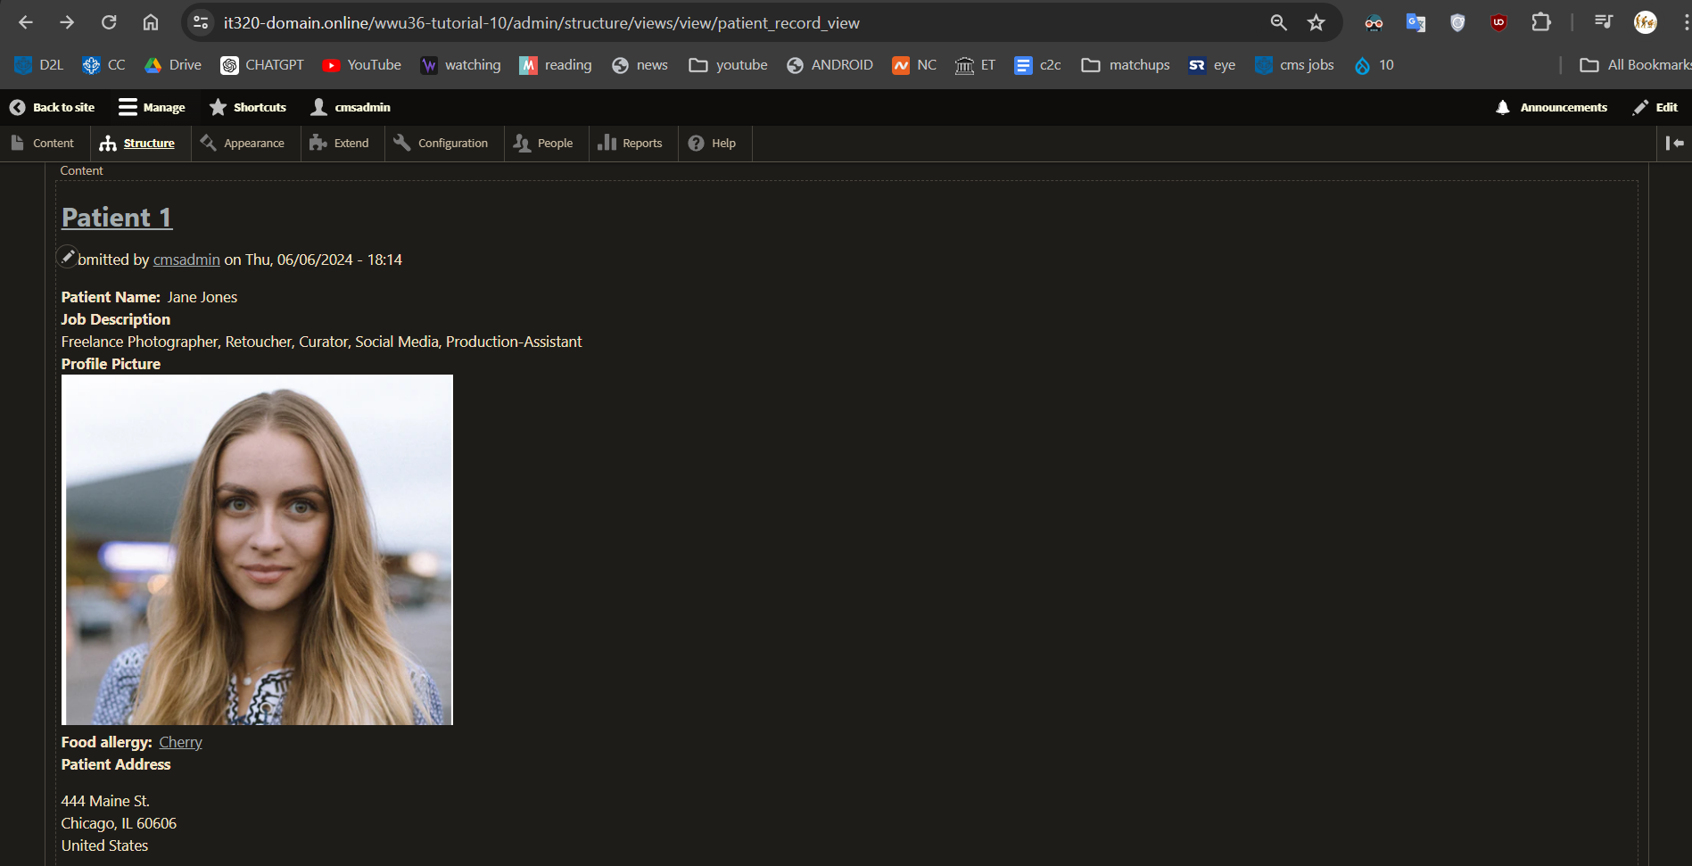

1. From the Structure > Views page, select the SCREEN CAPTURE – Backend list of Views   
   [Admin toolbar > Structure > Views] , select Edit button for Patient Block and take a screen capture of JUST the top 3 column block of the View Summary Page  
   [H.3]

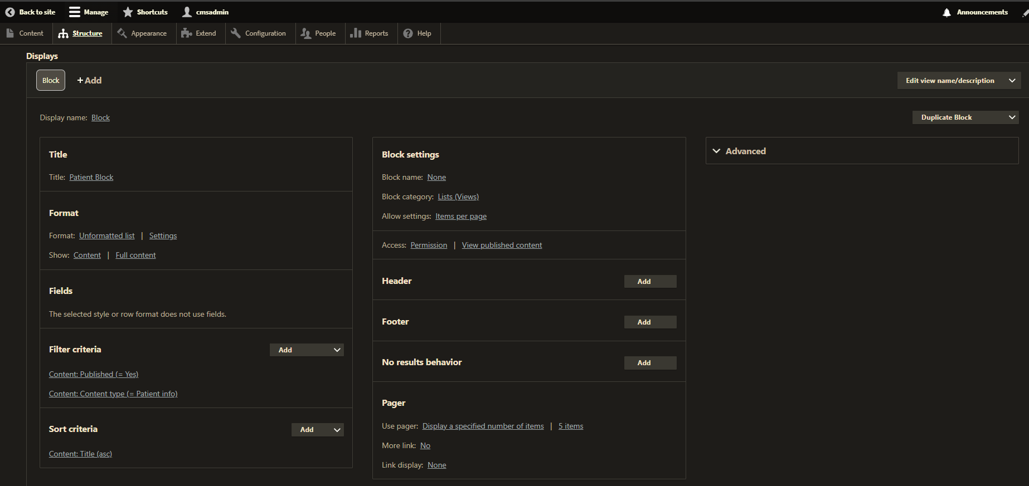

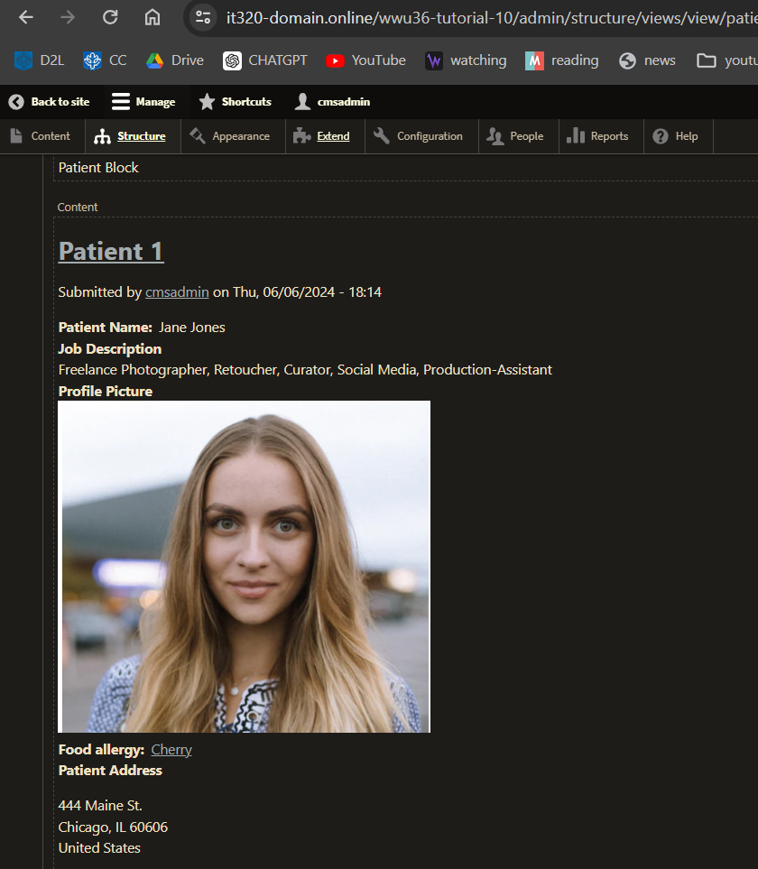

Go back to the instructions and continue with Part I.

Part I – Introduction to Drupal Custom Modules

1. What ASCII Editor did you use?  
   [I.1]   
   Visual Studio Code
2. Were you able to successfully configure your ASCII Editor?  
   [I.2]   
   Yes
3. Please provide proof of ASICC Editor configuration (10 Points)  
    [I.3]

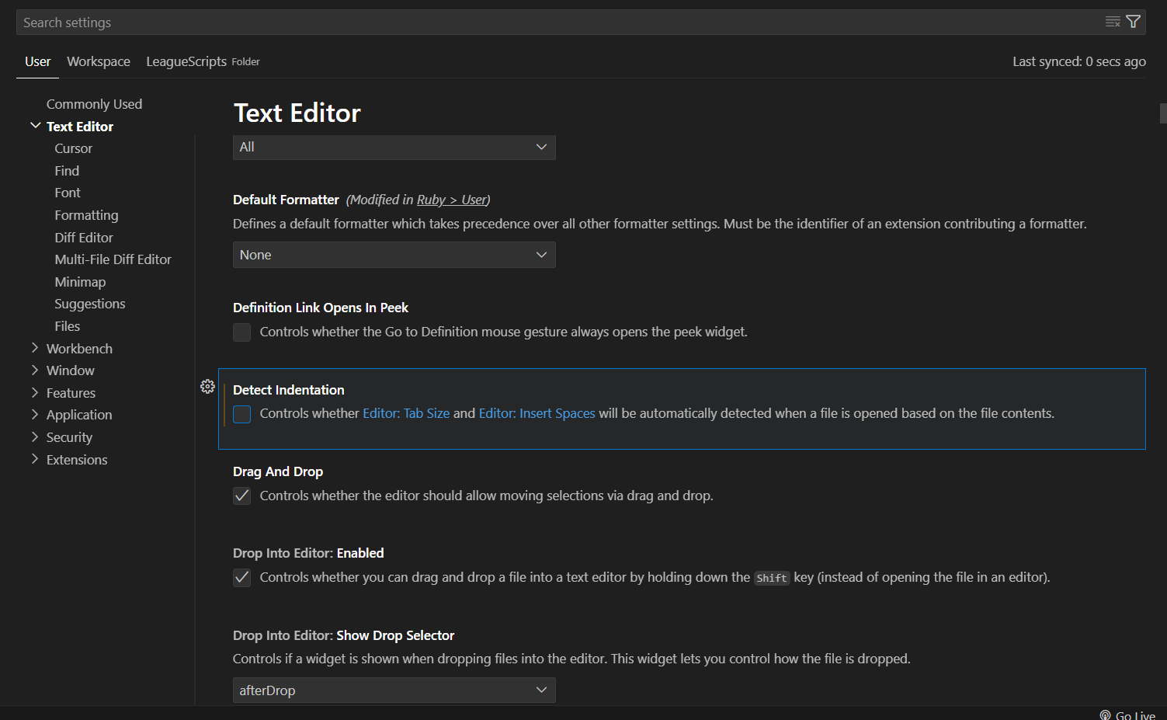

1. Were you able to successfully install the provided Drupal custom module?  
   [I.4]   
   Yes
2. FOR PARTIAL CREDIT - If you were unable to install the Drupal custom module, please list the issues encountered and any relevant screen captures. This includes captures of the **File System folder** (fully expanded) as well as **all custom module files** showing the entire file contents.   
   [I.5]   
   I was able to also add the module
3. SCREEN CAPTURE – Backend list of Modules, showing the custom module listed and enabled under the Custom panel   
   Admin toolbar > Extend , then scroll down to the Custom section  
   [I.6]

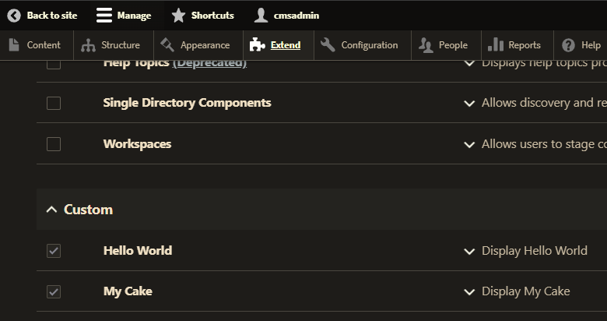

1. SCREEN CAPTURE – Frontend website screen capture of the website front page testing the custom module output display   
   [I.7]

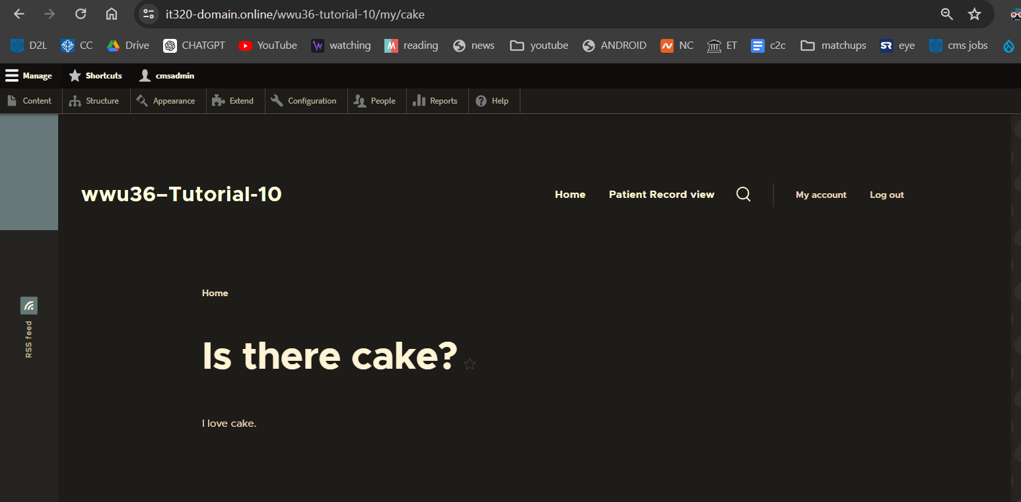

Go back to the instructions and continue with Part J.

Part J - Overview - Watch me last

There are no template screen captures or template questions on Part J

Return to the instructions to wrap up this tutorial.