**IT320 Assignment 02 Template – Version 8.0**Assignment 02 – WordPress CMS Website (Basic Pages)

Instructions for completing template:   
Replace [bracketed red text] with the requested information or screen capture.  
Replace bracketed red text with black text and then remove the brackets.  
Do not include full screen shot images, or full screen shots that are reduced in size. Use a snippet tool to capture parts of the screen and insert those images into the template.  
Do not remove tags from this template. Please answer all questions.  
Please do not alter the formatting or delete parts of this template.  
Assignment questions are not as detailed as activity questions.   
The assignment is where you demonstrate understanding of the material covered in IT 320 modules to date.

**Part A - Student Information**

1. **Student Name: Wesley Wu [A01]**
2. **Student Contact Information:** wwu36@depaul.edu **[A02]**
3. **What day and date did you start this assignment:** Tuesday, 4/9/24 **[A03]**

**Go back to the instructions and begin work on Part B.**

**Part B - Create 1 Shared Web Host WordPress CMS Website**

(1) Shared Web Host WordPress CMS Site Information:

Shared Web Host Name: Namecheap [B01]  
Shared Web URL: **it320-domain.online** [B02]  
Domain Name: wwu36-Assignment02 [B03]

Website Admin Username: cmsadmin [B04]  
Website Admin Password: CMSPassword9! [B05]  
Database Name: wp195 [B06]  
Table Prefix: wp2q_ [B07]  
WordPress CMS Frontend Website URL: https://it320-domain.online/mod2tutorial2/ [B08]

-OR-

(2) Pantheon – WordPress CMS Site Information:

**Assignment Website Site Name:** **[Site Name here] [B01]**

**WEBSITE Admin Username:** **[Admin Username here] [B02]**

**WEBSITE Admin Password:** **[Admin Password here] [B03]**

**Pantheon Frontend Website URL:** **[Frontend website URL here] [B04]**

**Go back to the instructions and begin work on Part C.  
  
Part C - Extend the WP Shared Web Host Site with Menus**

1. SCREEN CAPTURE of the **Media** Library Page **[Dashboard > Media > Library]** showing the images you added in Grid and List View  
    **[Grid SCREEN CAPTURE HERE] [C.1.1]**

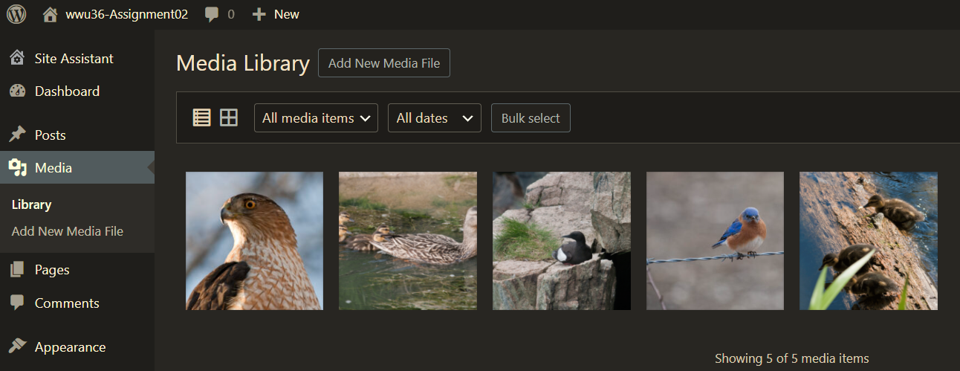

**[List SCREEN CAPTURE HERE] [C.1.2]**

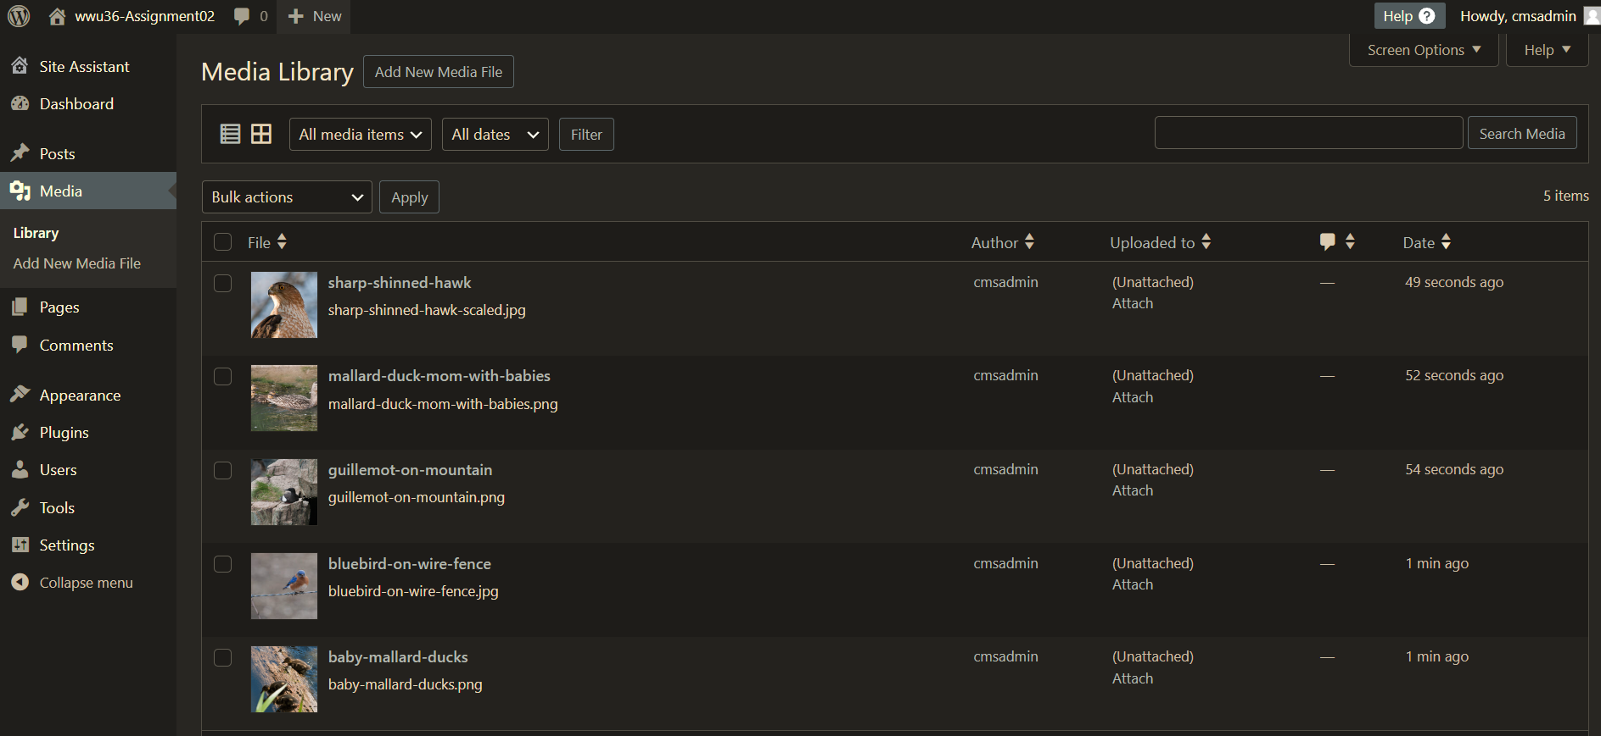

1. SCREEN CAPTURE of the **Menu** Page **[Dashboard > Appearance > Menu]** showing your Menu Name, and Menu Settings.  
   This may require multiple captures to show the check boxes at the bottom  
    **[SCREEN CAPTURE HERE] [C.2]**

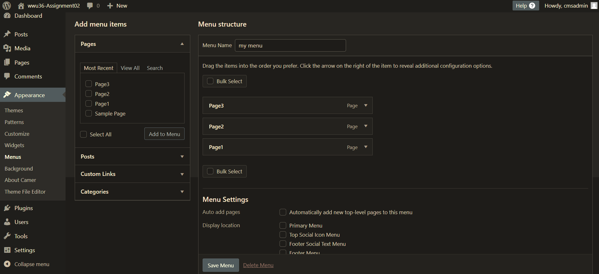

1. Did you add IPSUM or ChatGPT content to your Pages.   
   **[Answer HERE] [C.3]**

Yes

1. SCREEN CAPTURE of the Client Facing front end website, showing the test pages as menu items. Please make sure your screen capture shows the web browser address bar for full credit.   
   **[SCREEN CAPTURE HERE] [C.4]**

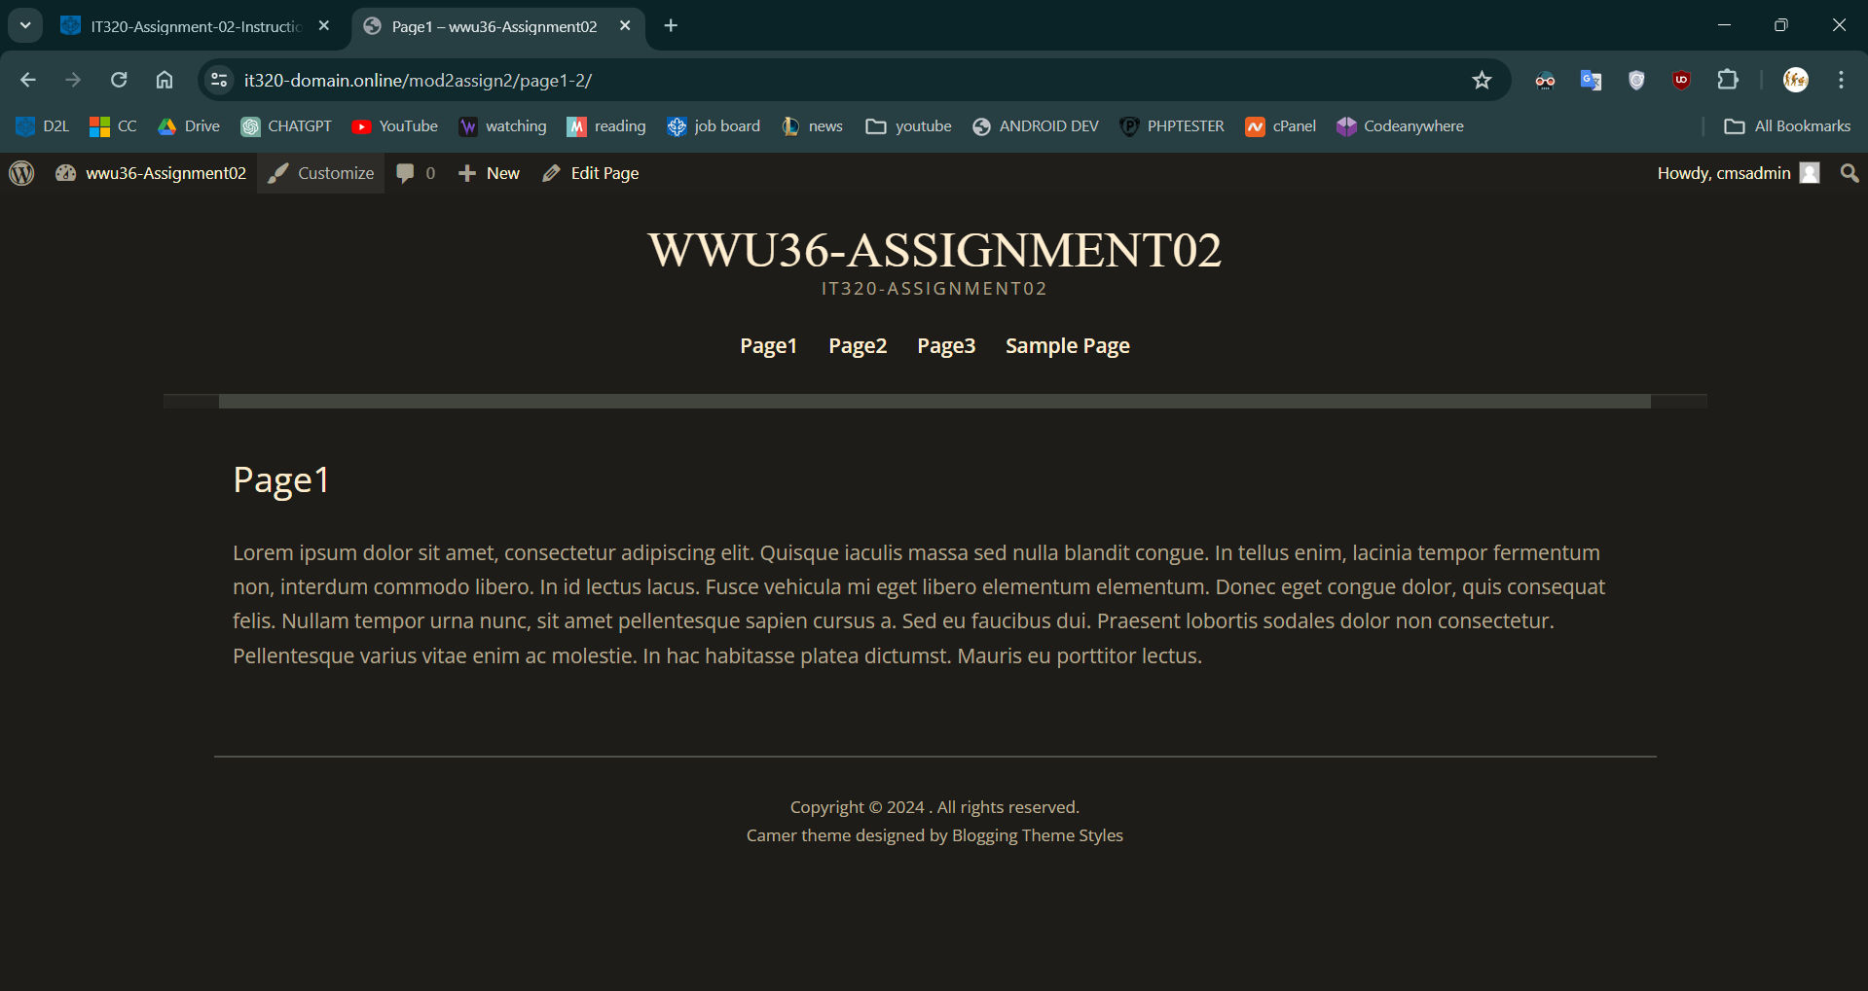

**Go back to the instructions and begin work on Part D.**

**Part D – Create a WordPress CMS Site on Codeanywhere: (REQUIRED)**

1. D.1 Codeanywhere CMS site credentials:Enter the following Codeanywhere web host account and WordPress site information **[D.1]**
   1. Site Title: [ wwu36-wp-assign02 ]
   2. Website Admin Username: [ admin ]
   3. Website Admin Password: [ CMSAdmin! ]
2. **Return to the instructions in part D.2 and continue working**

**D.2 - The screen captures for this part are from the Codeanywhere WordPress site you build and configured in Part E.**

1. **SCREEN CAPTURE of the Codeanywhere Info page. Please select and screen capture the entire web browser.  
   To display the Info page, right click on the left side Container, and select Info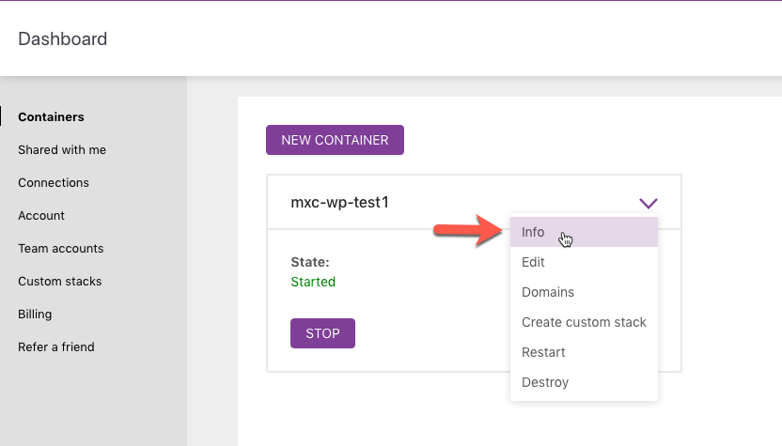 [SCREEN CAPTURE HERE] [D.2-01.1]**

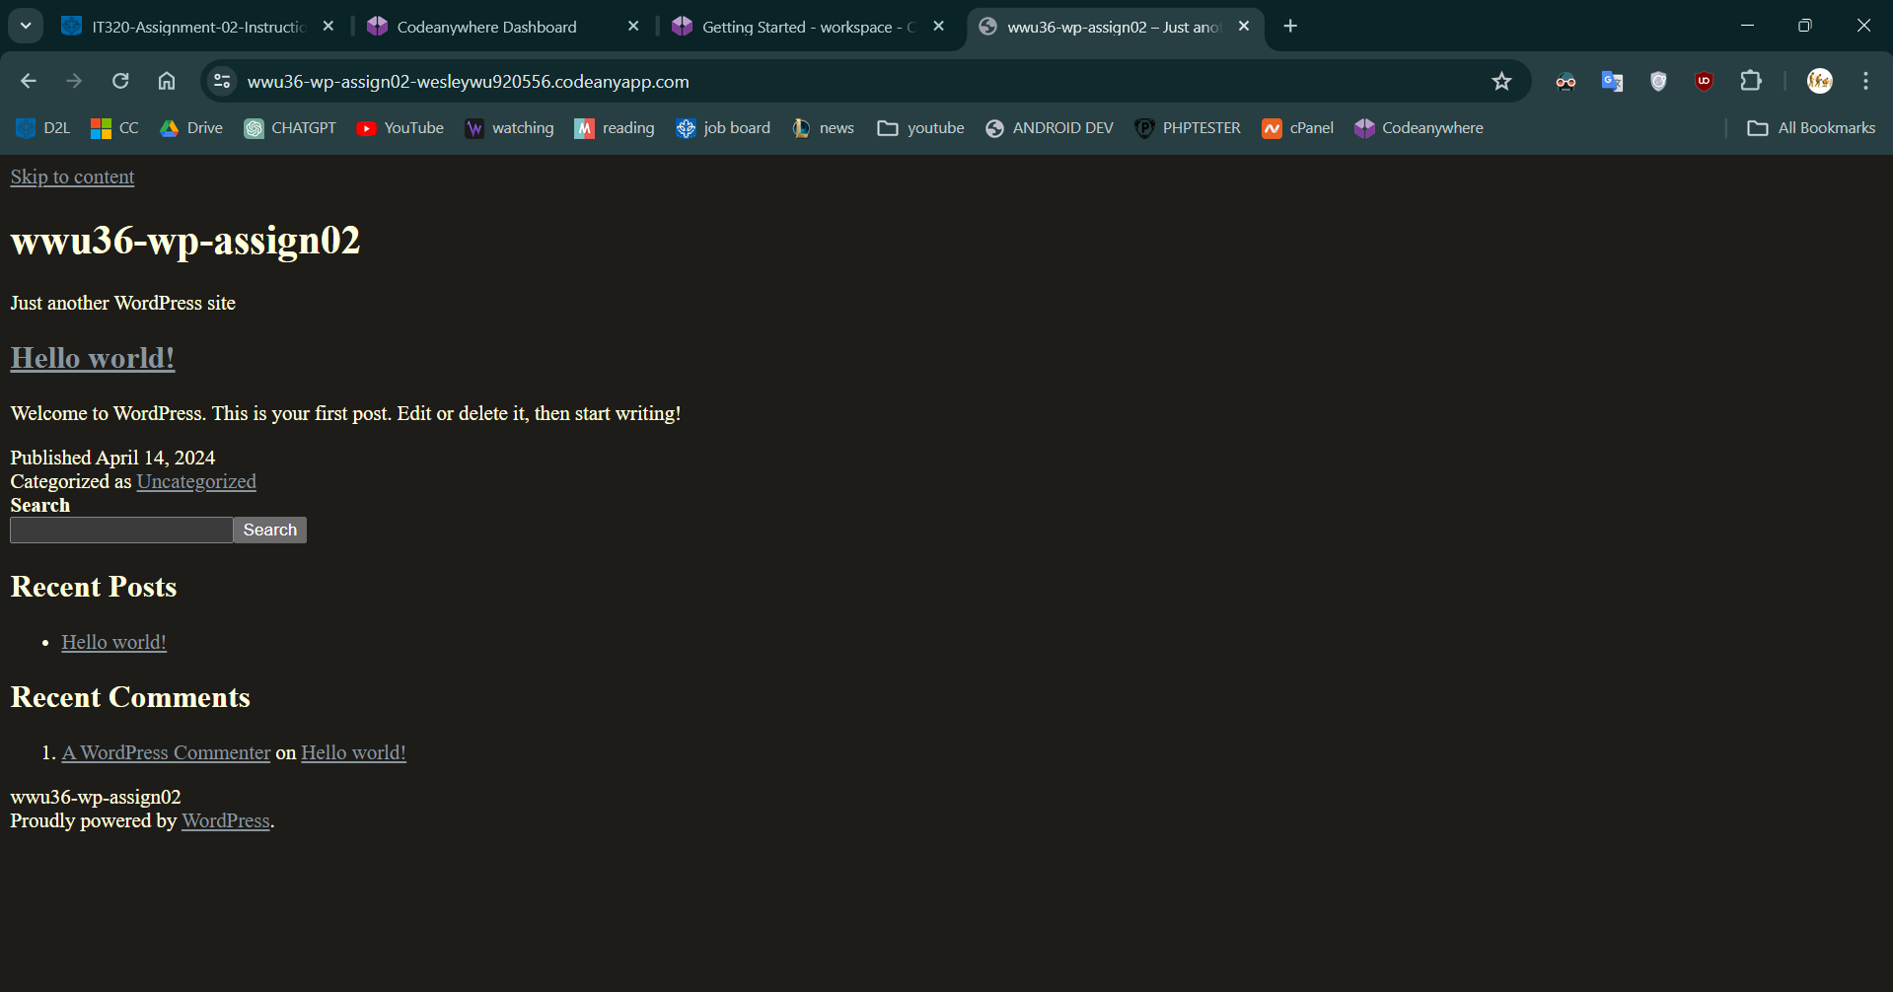

1. **SCREEN CAPTURE of the Codeanywhere WordPress Backend Admin site,   
   selecting Dashboard > Home   
   Please make sure the “At a Glance” section is visible to verify the WordPress version and active theme.   
   [SCREEN CAPTURE HERE] [D.2-01.2]**

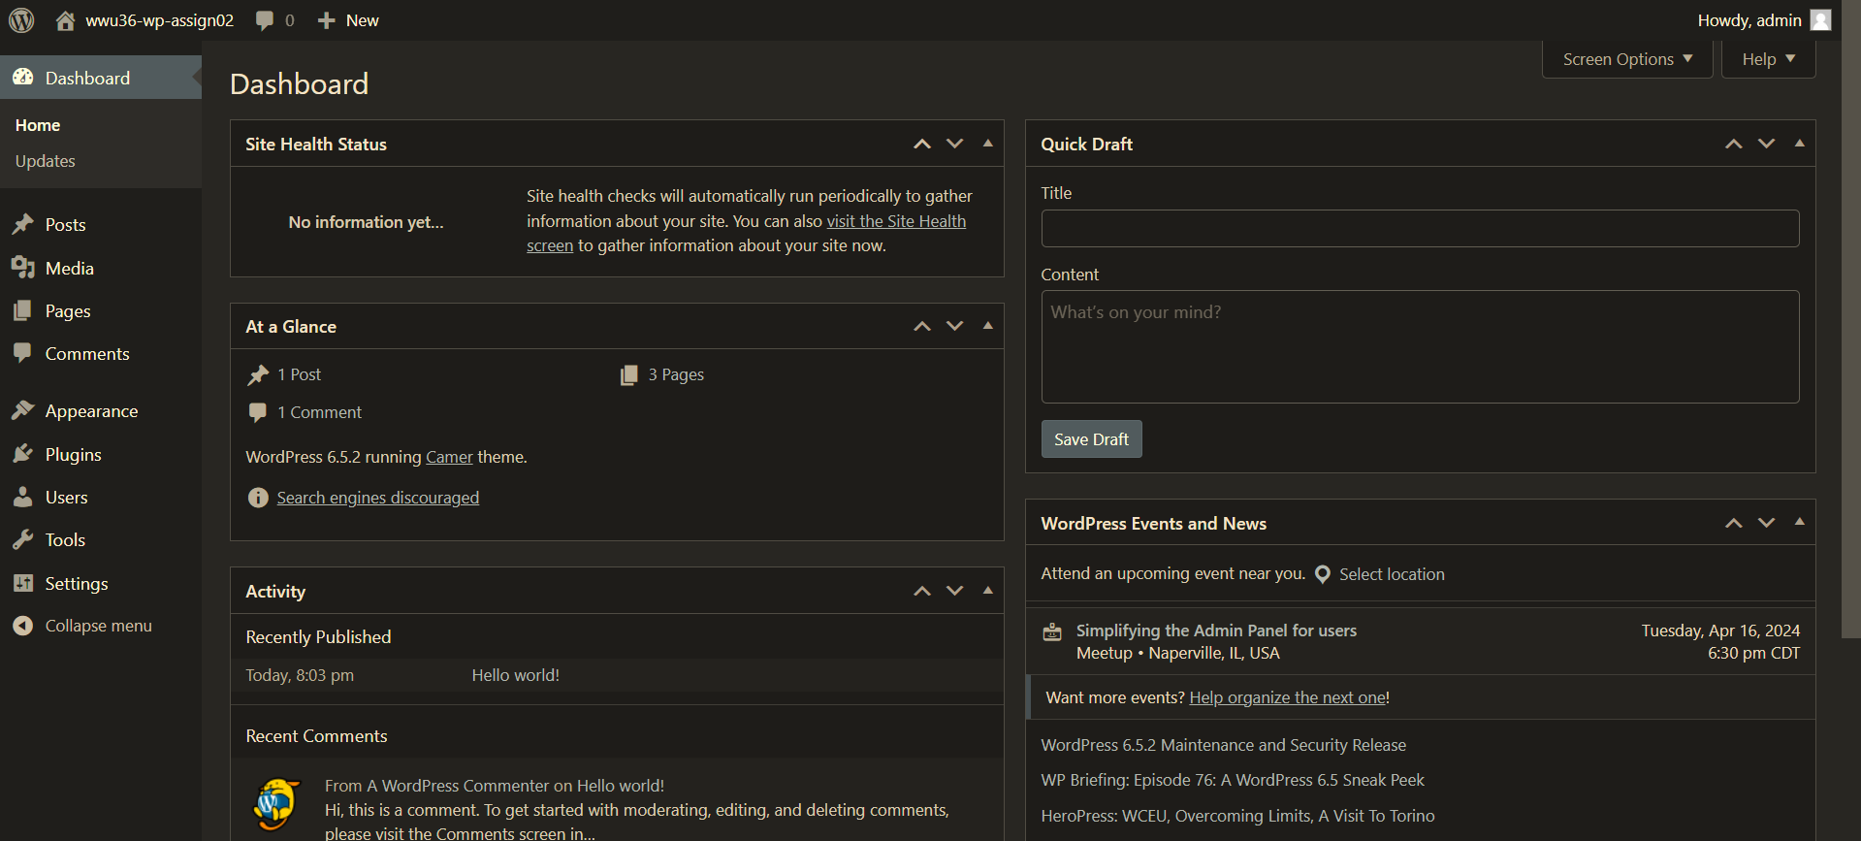

1. SCREEN CAPTURE of the **Media** Library Page **[Dashboard > Media > Library]** showing the images you added in Grid and List View  
    **[Grid SCREEN CAPTURE HERE] [D.2-02.1]**

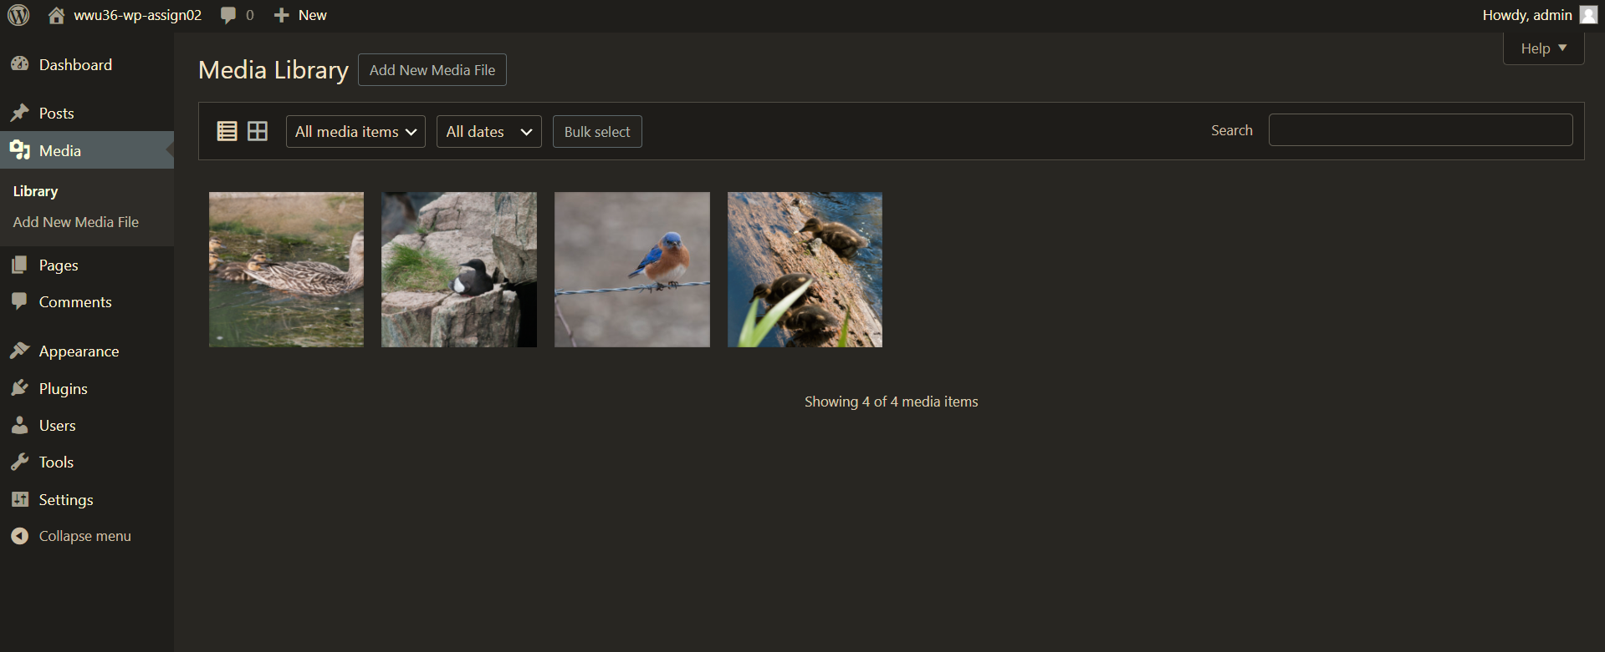

**[List SCREEN CAPTURE HERE] [D.2-02.2]**

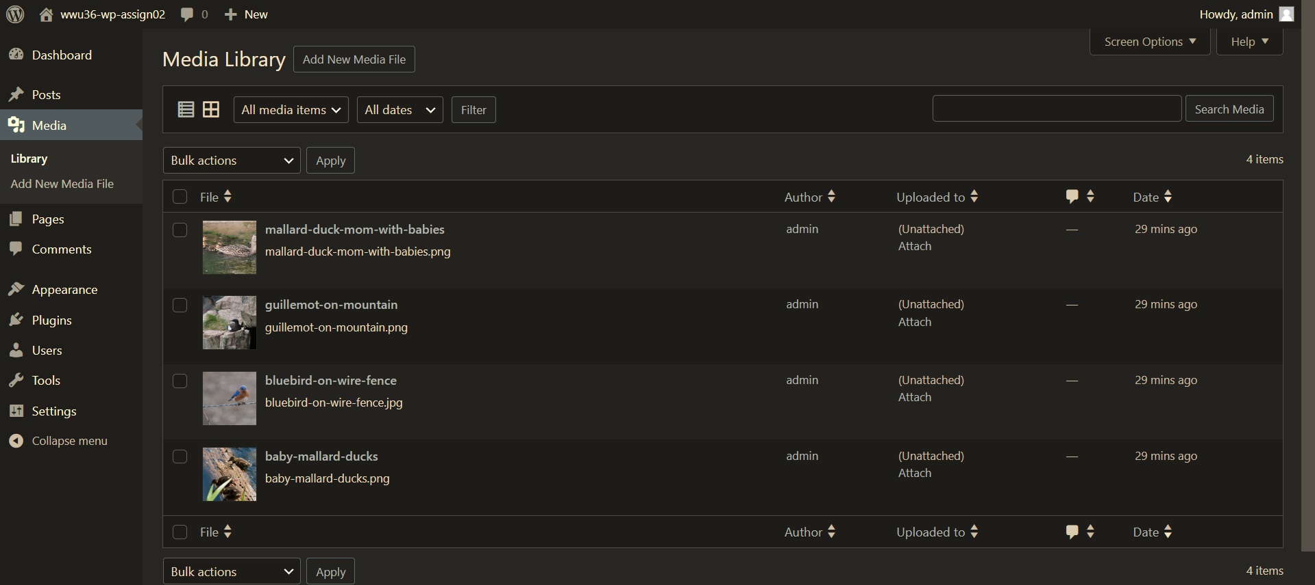

1. SCREEN CAPTURE of the **Menu** Page **[Dashboard > Appearance > Menu]** showing your Menu Name, and Menu Settings.  
   This may require multiple screen captures to show the check boxes at the bottom  
    **[SCREEN CAPTURE HERE] [D.2-03]**

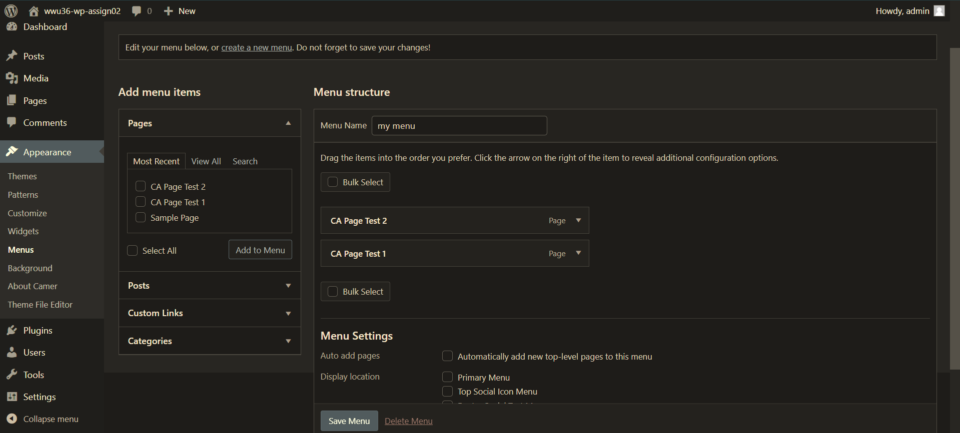

1. SCREEN CAPTURE of the Client Facing front end website, showing the test pages as menu items. Please make sure your screen capture shows the web browser address bar for full credit.   
   **[SCREEN CAPTURE HERE] [D.2-04]**

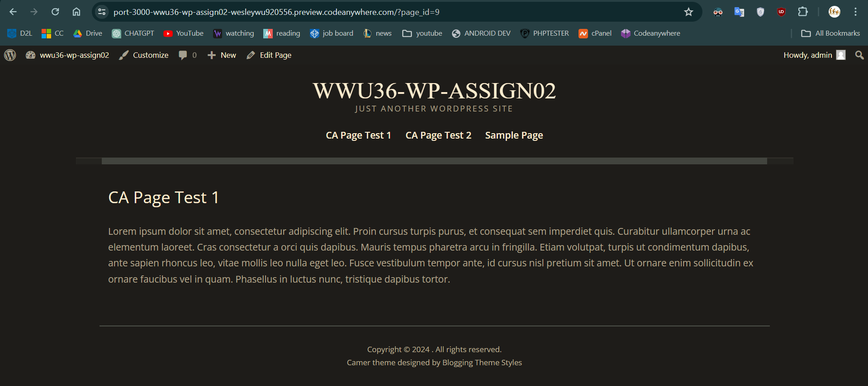

**Go back to the instructions and begin work on Part E.**

**Part E - PHP Exercises:**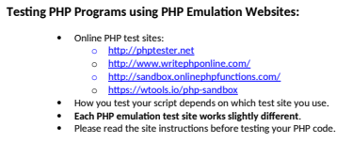

1. Demonstrate an understanding of how to code an echo statement by writing and executing a PHP program that echo the values of 3 variables named as you wish with values of an Integer, float (with a decimal point) and string. Execute your PHP code on a web PHP emulator (tester) and screen capture the code and output and paste it in the box below.

**Test your code using an online PHP test site and paste a screen shot of the tested code and results from the website emulator in the table cell below.**

|  |
| --- |
| Copy and paste the code block and record the results on the next row. A screen shot from the PHP test site will be the best way to not affect template format. Please try not to change the template numbering or format. **[E01]** |
| **Paste screen capture from PHP test website here ** |

1. Demonstrate an understanding of how to code PHP arithmetic operators by writing and executing a PHP program that echo the result of 5 lines of code, each one using one of 5 arithmetic operators, +, -, *, /, %. Use variables or constant values, named as you wish with values of integers, or floats (with a decimal point). Execute your PHP code on a web PHP emulator (tester) and screen capture the code and output and paste it in the box below.

**Test your code using an online PHP test site and paste a screen shot of the tested code and results from the website emulator in the table cell below.**

|  |
| --- |
| Copy and paste the code block and record the results on the next row. A screen shot from the PHP test site will be the best way to not affect template format. Please try not to change the template numbering or format. **[E02]** |
| **Paste screen capture from PHP test website here ** |

1. Demonstrate an understanding of how to code the PHP concatenation operator by writing and executing a PHP program that echo the result of 5 lines of code, each one using the concatenation operator to join string variables or constant value. Variables named as you wish with string values. Execute your PHP code on a web PHP emulator (tester) and screen capture the code and output and paste it in the box below.

**Test your code using an online PHP test site and paste a screen shot of the tested code and results from the website emulator in the table cell below.**

|  |
| --- |
| Copy and paste the code block and record the results on the next row. A screen shot from the PHP test site will be the best way to not affect template format. Please try not to change the template numbering or format. **[E04]** |
| **Paste screen capture from PHP test website here ** |

1. Demonstrate an understanding of how to code PHP HTML TABLE output.  
   Variables names and values as follows. Execute your PHP code on a web PHP emulator (tester) and screen capture the code and output and paste it in the box below.
2. Creates 5 variables, with values “**A**”, “**Fine**”, “**Time**”, “**To Learn”, PHP**”.
3. Write PHP code that displays each variable in a single HTML TABLE.   
   Please build the table using embedded HTML Table tags and **concatenation operators.**  
   Please display each word above in a row, making the HTML TABLE a 1 column 5 ROW HTML TABLE.

|  |
| --- |
| A |
| Fine |
| Time |
| To Learn |
| PHP |

**Test your code using an online PHP test site and paste a screen shot of the tested code and results from the website emulator in the table cell below.**

|  |
| --- |
| Copy and paste the code block and record the results on the next row. A screen shot from the PHP test site will be the best way to not affect template format. Please try not to change the template numbering or format. **[E05]** |
| **Paste screen capture from PHP test website here ** |

1. Demonstrate an understanding of how to code PHP HTML TABLE output.  
   Variables names and values as follows. as you wish with string values. Execute your PHP code on a web PHP emulator (tester) and screen capture the code and output and paste it in the box below.
2. Creates 6 variables, with values “**A**”, “**Fine**”, “**Time**”, “**To” , “Learn”, PHP**”.
3. Write PHP code that displays each variable in a single HTML TABLE.   
   Please display each word above in a row, making the HTML TABLE a 2 column 3 ROW HTML TABLE.  
   Please build the table using embedded HTML Table tags and **concatenation operators.**

|  |  |
| --- | --- |
| A | Fine |
| Time | To |
| Learn | PHP |

**Test your code using an online PHP test site and paste a screen shot of the tested code and results from the website emulator in the table cell below.**

|  |
| --- |
| Copy and paste the code block and record the results on the next row. A screen shot from the PHP test site will be the best way to not affect template format. Please try not to change the template numbering or format. **[E06]** |
| **Paste screen capture from PHP test website here ** |

**Part F – Questions:**

1. Based on the reading material and tutorial work list and describe in a few sentences 3 CMS core concepts covered on Modules 01 and 02?

|  |
| --- |
| CMS are extensible, can manage security by assigning roles, and have both a front end and backend. |

1. Based on the reading material and tutorial work, what does it mean to extend a CMS?

|  |
| --- |
| Extending a CMS means adding functionality through plugins or themes. For example, using a theme that provides menus. |

1. Based on reading material and tutorial work, put the following List the order of plugin best practices in order, with the most important best practice attribute first, and least important last: **Star reviews, # of installations, Last Updated, and Compatibility**

|  |
| --- |
| Answer here:   1. Most important: Compatibility 2. Second most important: Last updated 3. Third most important: # of installations 4. Forth most important (not that important): Star reviews |

1. Based on reading material and tutorial work, describe feature analysis when considering installing a plugin to extend a WordPress CMS?

|  |
| --- |
| When plugins cannot be differentiated by best practices, they should be compared by their features as needed by the site. |

1. Based on reading material and tutorial work, What are 3 differences between WordPress.com and WordPress.org?

|  |
| --- |
| Wordpress.com is a hosted service while .org requires you to do the hosting. .org allows full customization of the site, including themes and plugins. .org allows any form of monetization, while .com is limited to ads. |

**Part G – Wrap up:**

1. **Did you have any problem or issues completing this assignment?  
   This is not an optional question.   
   [Yes or No] [G01]**No

**If you answered yes to this question, please elaborate and be specific.  
If you had trouble with a specific question, please identify it by number and explain what you did not understand or had problems with.  
I can only improve this assignment with your help.**

**[List problems here] [G02] *Only if you answered yes to G01**

Submit this completed template to the correct D2L assignment dropbox.If you prefer not to navigate by hand to the D2L dropbox, take advantage of the dropbox link in the D2L this module’s section. This link will take you to the correct assignment dropbox location.