Tutorial 03 – Version 8.1 – 34 Items

Build WordPress CMS on Multiple Platforms and using Best Practices, extend with pages, posts, categories, tags, and plugins.

Students are required to have access to at least two Web Host accounts that they use to create and manage multiple CMS websites.   
Additionally, we will do a few PHP problems, to test your understanding of the PHP material we covered in class.   
If you have difficulties completing this assignment, please inform the instructor and consider working with DePaul tutors.

**Instructions for completing template:***Replace* **[bracketed red text]** *with the requested information and change the* ***red text to black text.*** *Do not include full screen shot images, or full screen shots that are reduced in size. Use a snippet tool to capture parts of the screen and insert those images into the template.  
Please answer all questions.* **Please do not alter template numbering.  
Each answer and screen capture are worth equal points.**

Part A.2 – Getting started Student Contact Information

1. Student Name: Wesley Wu [A.2.1]

2. Student Contact Information:   
wwu36@depaul.edu [A.2.2]   
3124792868 [A.2.3]

Go back to the tutorial instructions and begin working onPart B**.**

Part B – Create a WordPress sites on All Platforms

Part B.1 – Create a WordPress site on a shared web host

1. Enter the following shared web host WordPress site information **[B.1]**
   1. Shared Web Host Company Name: [B.1.1] Namecheap
   2. WordPress Website Info:
      1. Website Admin Username: [B.1.2] cmsadmin
      2. Website Admin Password: [B.1.3] CMSPassword9!
      3. Database Name: [B.1.4] wp922
      4. Table Prefix: [B.1.5] wpur_
   3. WordPress website Frontend URL: [B.1.6] https://it320-domain.online/tutorial03/
2. Go back to the tutorial instructions and begin working on Part B.3.

Part B.2 – Create a WordPress site on Pantheon (PaaS)

1. Enter the following shared web host WordPress site information [B.2]
   1. PaaS WordPress Front end site URL: [B.2.1] [ website URL here]
   2. PaaS WordPress site Admin Username:[B.2.2] [ website admin username here]
   3. PaaS WordPress site Admin Password: [B.2.3] [ website admin password here]
2. Go back to the tutorial instructions and begin working on Part B.3.

Part B.3 – Create a WordPress site on Codeanywhere

1. Enter the following Codeanywhere WordPress site information [B.3]
   1. Site Title: [B.3.1] [ site title here]
   2. WordPress Username: [B.3.2] [ username here]
   3. WordPress Password: [B.3.3] [ password here]
2. Go back to the tutorial instructions and begin working on Part C.

Part C – Verify and Configure WordPress sites on All Platforms

Part C.1 – Shared web host

1. Take screen captures of the backend administration WordPress site   
   Dashboard > Home, with both the “**Site Health Status**” and “**At a Glance**” panels visible   
   **[**C.1.1**]  
   [** Paste screen capture here**]**

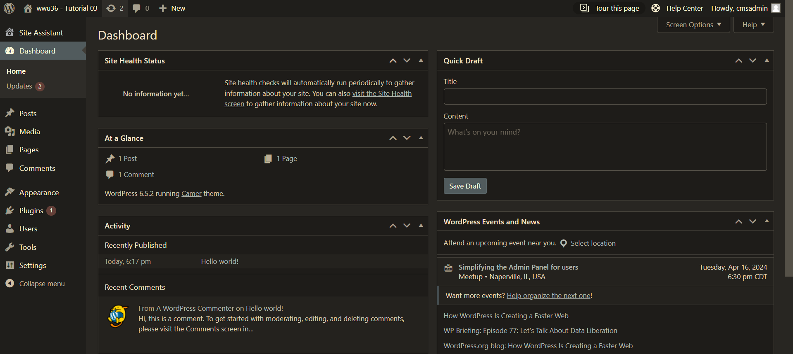

1. Take screen captures of the backend administration WordPress site   
   Dashboard > Plugins > Installed Plugins   
   **[**C.1.2**]  
   [** Paste screen capture here**]**

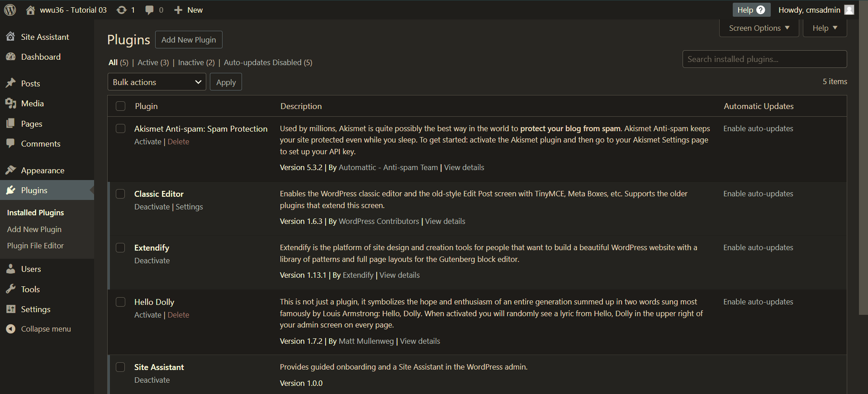

1. Take screen captures of the backend administration WordPress site   
   Dashboard > Appearance > Themes   
   **[**C.1.3**]  
   [** Paste screen capture here**]**

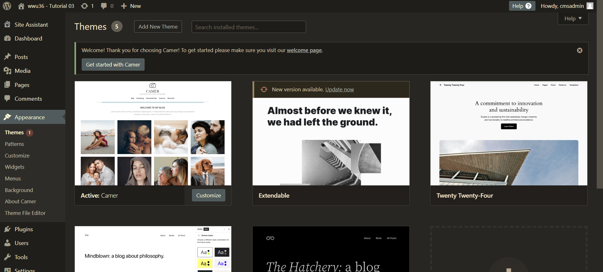

1. Take screen captures of the backend administration WordPress site   
   Dashboard > Appearance > Menus   
   **[**C.1.4**]  
   [** Paste screen capture here**]**

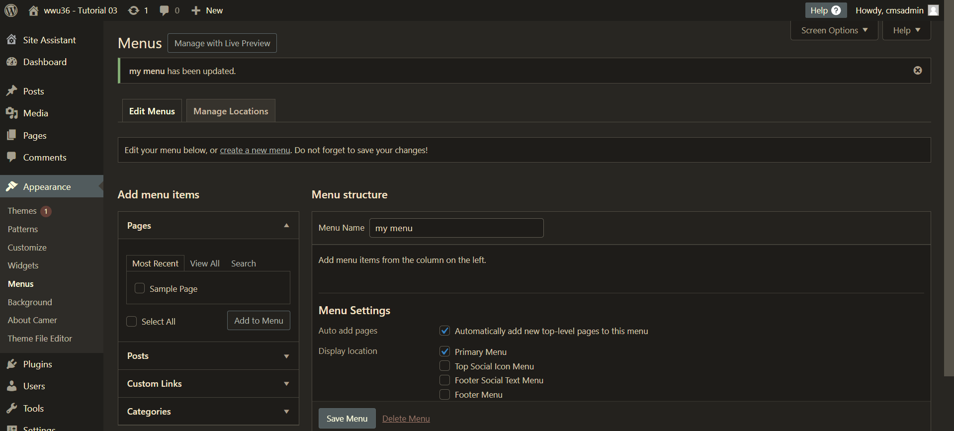

1. Take screen captures of the backend administration WordPress site   
   Dashboard showing that LiteSpeed is not on the dashboard  
   **[**C.1.5**]  
   [** Paste screen capture here**]**

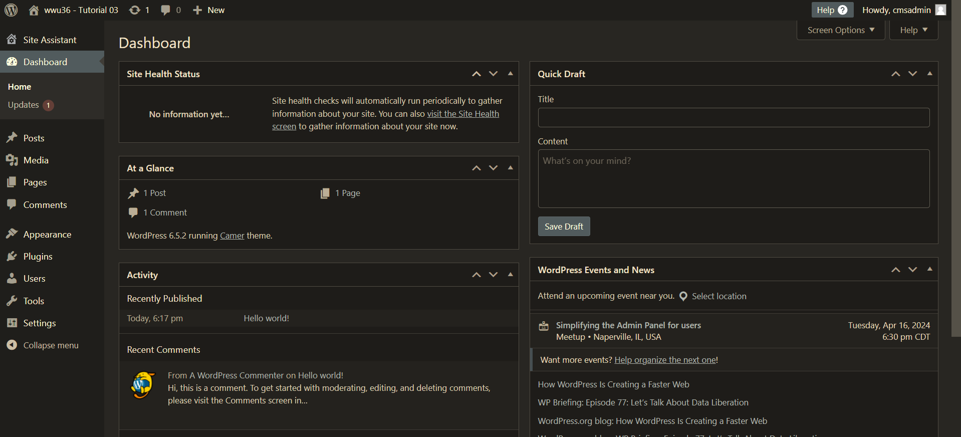

1. Go back to the tutorial instructions and begin working on Part C.3.

PartC.2 – Create a WordPress site on Pantheon (PaaS)

1. Take screen captures of the backend administration WordPress site   
   Dashboard > Home, with both the “**Site Health Status**” and “**At a Glance**” panels visible   
   **[**C.2.1**]  
   [** Paste screen capture here**]**
2. Take screen captures of the backend administration WordPress site   
   Dashboard > Plugins > Installed Plugins   
   **[**C.2.2**]  
   [** Paste screen capture here**]**
3. Take screen captures of the backend administration WordPress site   
   Dashboard > Appearance > Themes   
   **[**C.2.3**]  
   [** Paste screen capture here**]**
4. Take screen captures of the backend administration WordPress site   
   Dashboard > Appearance > Menus   
   **[**C.2.4**]  
   [** Paste screen capture here**]**
5. Go back to the tutorial instructions and begin working on Part C.3.

Part C.3 – Create a WordPress site on Codeanywhere

1. Take screen captures of the backend administration WordPress site   
   Dashboard > Home, with both the “**Site Health Status**” and “**At a Glance**” panels visible   
   **[**C.2.1**]  
   [** Paste screen capture here**]**

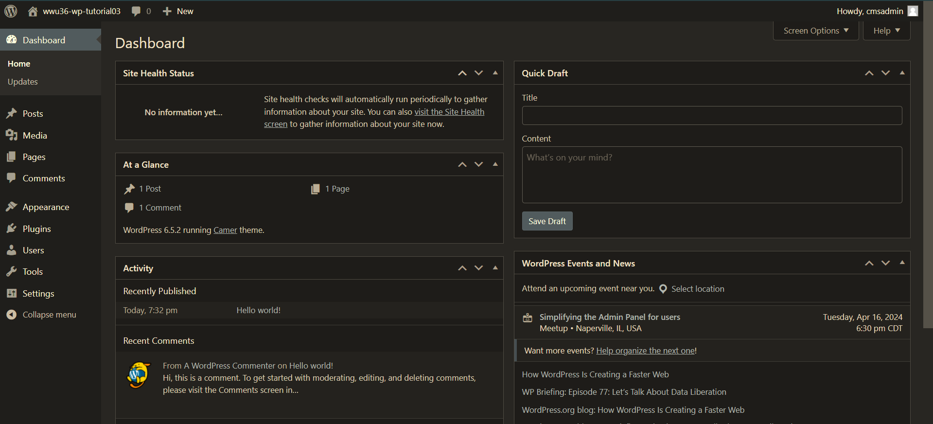

1. Take screen captures of the backend administration WordPress site   
   Dashboard > Media > Add New Media File **[**C.2.2**]  
   [** Paste screen capture here**]**

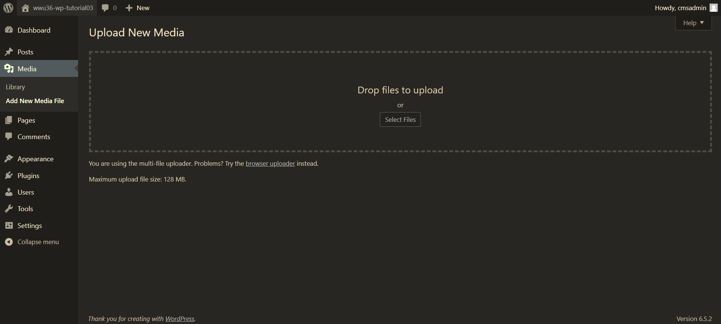

1. Take screen captures of the backend administration WordPress site   
   Dashboard > Plugins > Installed Plugins **[**C.2.3**]  
   [** Paste screen capture here**]**

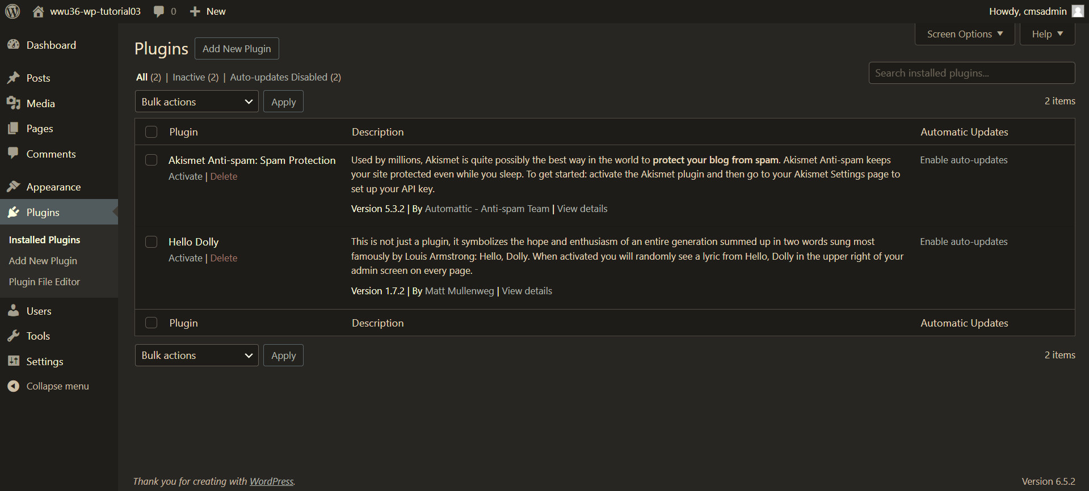

1. Take screen captures of the backend administration WordPress site   
   Dashboard > Appearance > Themes **[**C.2.4**]  
   [** Paste screen capture here**]**

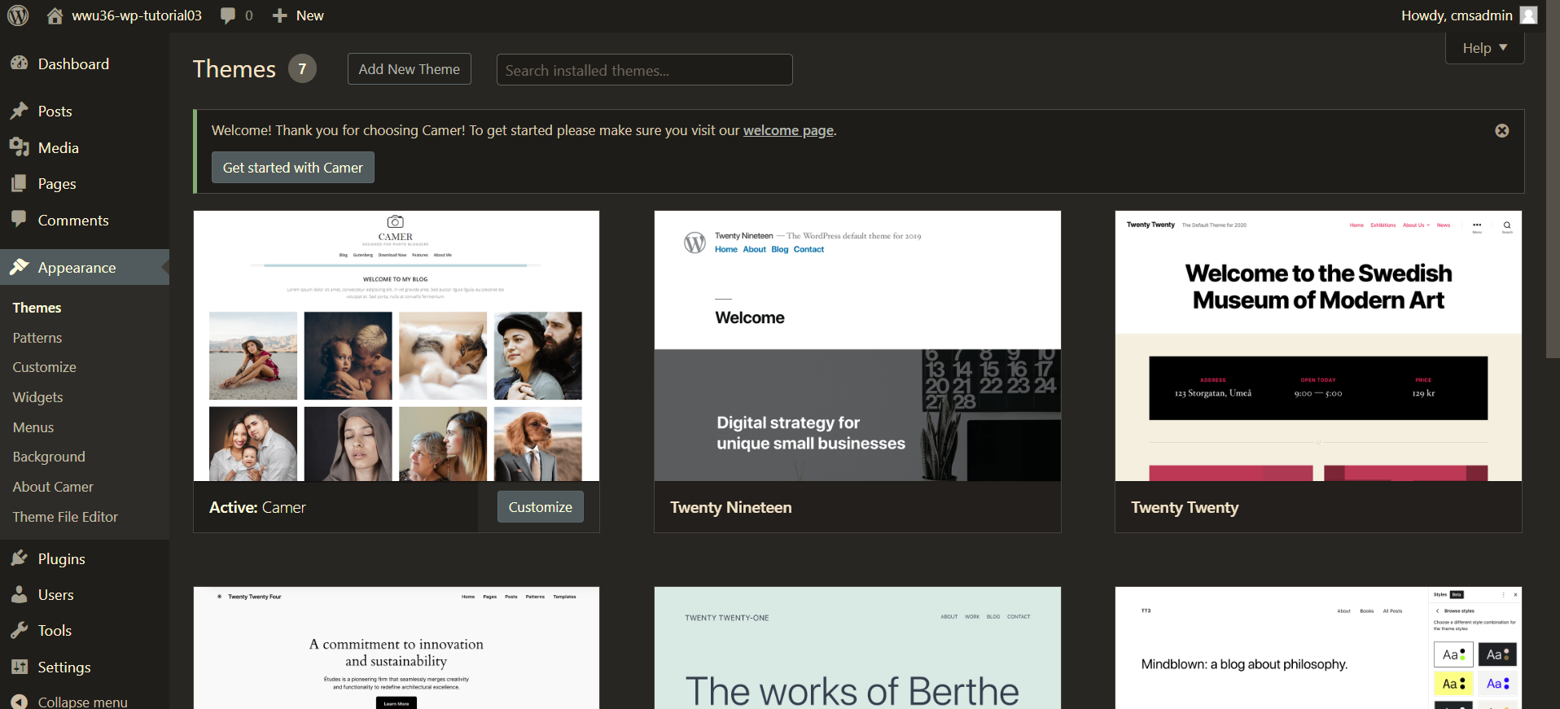

1. Take screen captures of the backend administration WordPress site   
   Dashboard > Appearance > Menus **[**C.2.5**]  
   [** Paste screen capture here**]**

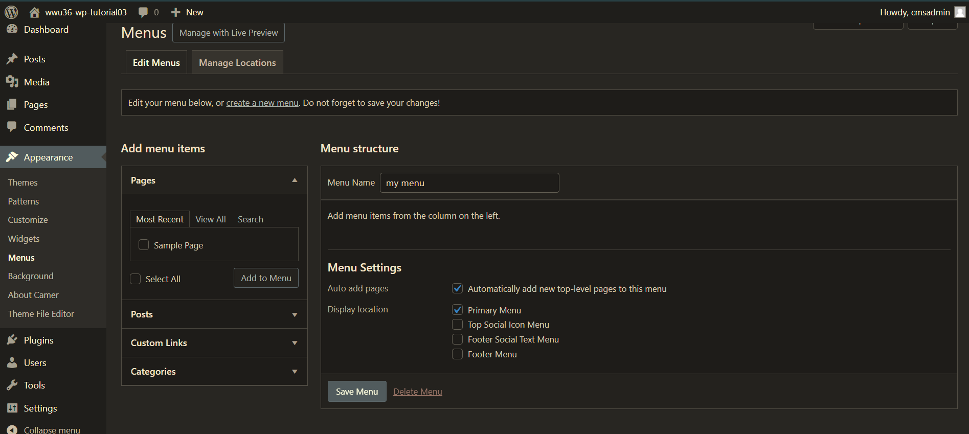

1. Go back to the tutorial instructions and begin working on Part D.

Part D – Creating Website Content with ChatGPT

1. No screen captures to Part D. Continue to Part E.
2. Go back to the tutorial instructions and begin working on Part F.

Part E – Prepare for creating content Pages and Posts

Please make sure all Part E screen capture include the web browser address bar. **[E]**

1. Take screen captures of the backend administration WordPress site Dashboard > Appearance > Media page – with the media library in **List** mode **[**E.1**]  
   [** Paste screen capture here**]**

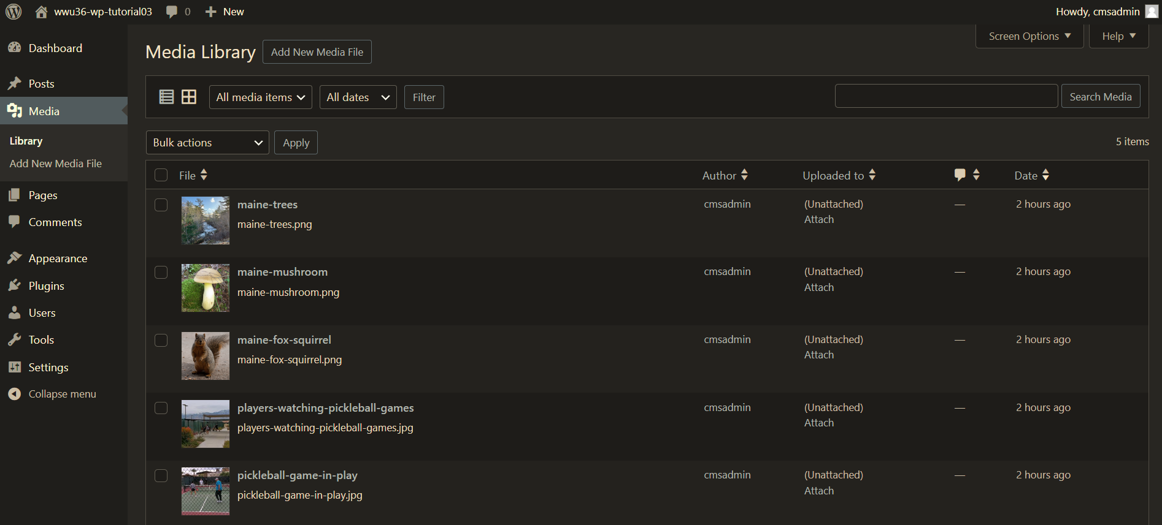

1. Take screen captures of the backend administration WordPress site Dashboard > Posts > Categories page – with the list of categories visible **[**E.2**]  
   [** Paste screen capture here**]**

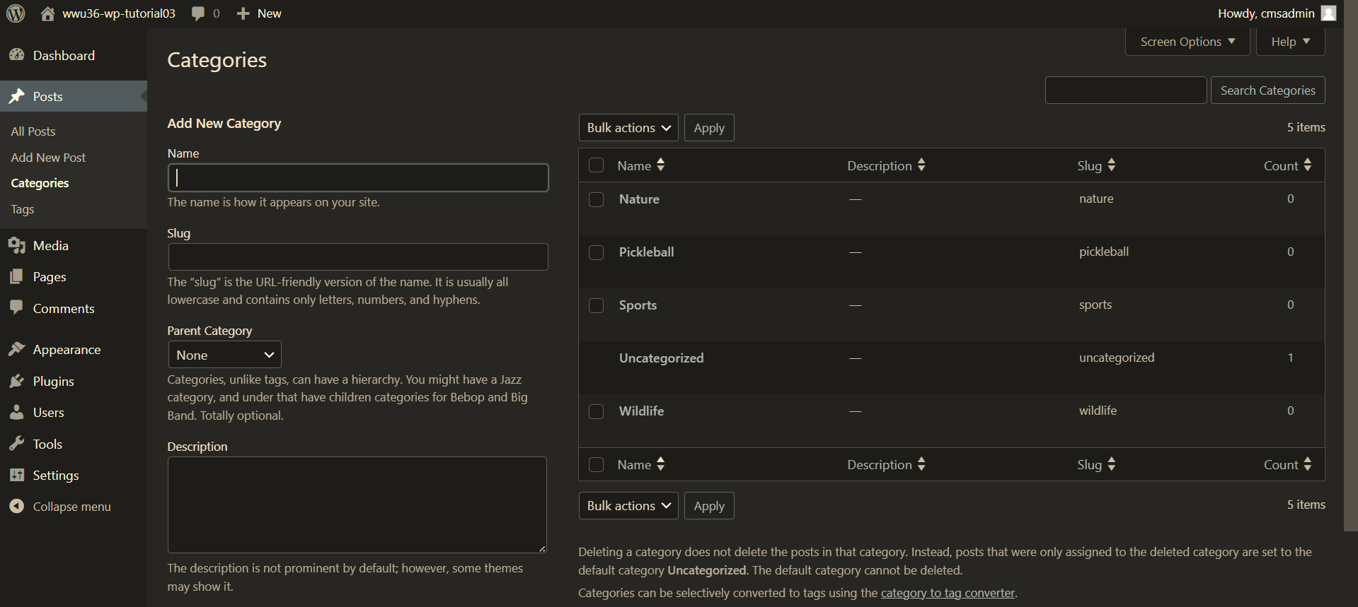

1. Take screen captures of the backend administration WordPress site Dashboard > Posts > Tags page – with the list of tags visible **[**E.3**]  
   [** Paste screen capture here**]**

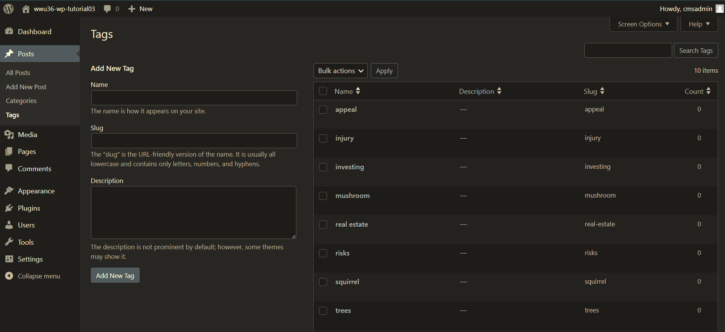

1. Go back to the instructions and continue atPart F**.**

Part F – Creating WordPress Pages

Please make sure all Part F screen capture include the web browser address bar. **[F]**

1. Take screen captures of the backend administration WordPress site Dashboard > Pages **[**F.1**]  
   [ Paste screen capture here]**

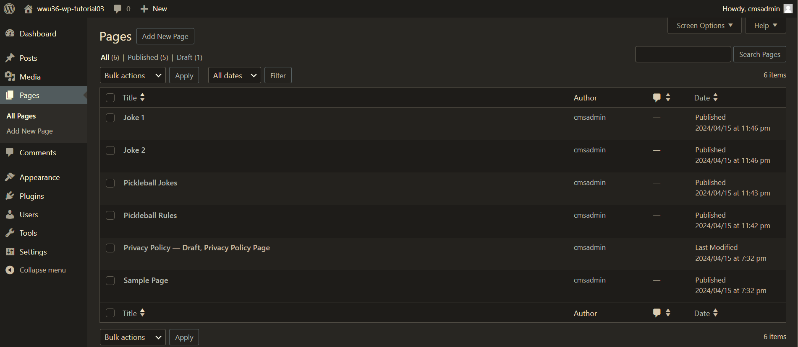

1. Take screen captures of the front-end client facing WordPress site showing the created menu items on the home page**[**F.2**]**

**[ Paste screen capture here]**

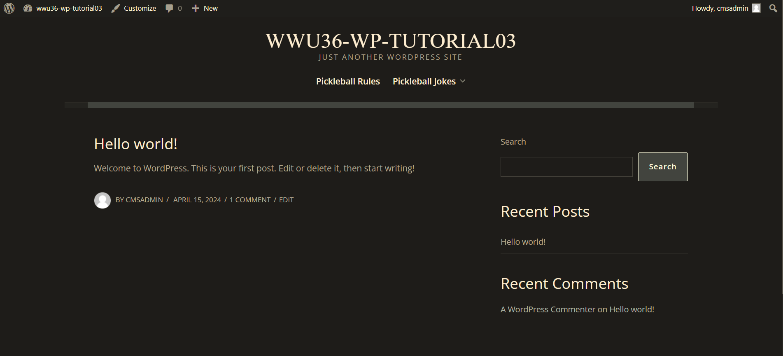

1. Go back to the instructions and continue at Part G**.**

Part G – Creating WordPress Posts

Please make sure all Part G screen capture include the web browser address bar. **[G]**

1. Take screen captures of the backend administration WordPress site Dashboard > Posts **[**G.1**]  
   [ Paste screen capture here]**

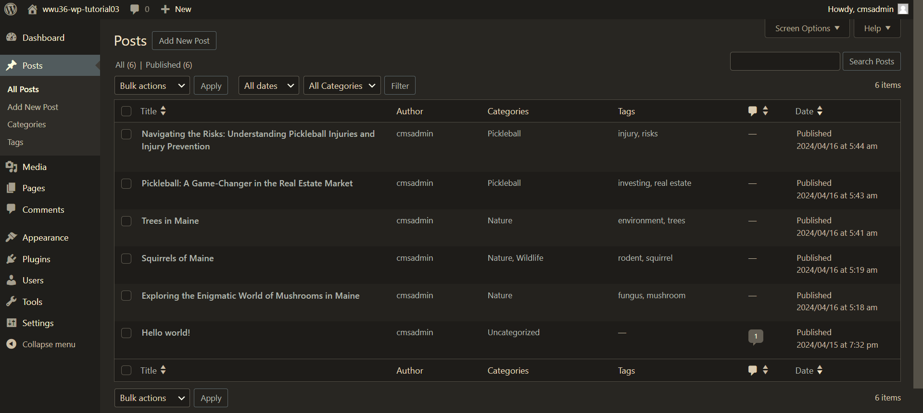

1. Take screen captures of the front-end client facing WordPress site showing the home page with at least 1 Post visible**[**G.2**]  
   [ Paste screen capture here]**

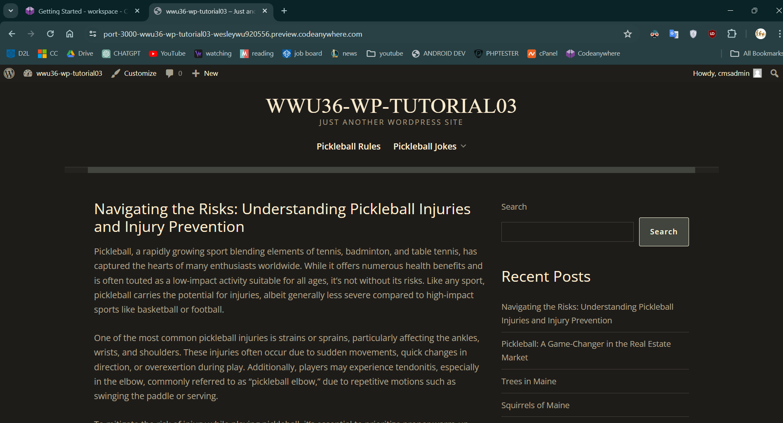

1. Go back to the instructions and continue at Part H**.**

Part H – Finding Best Fit Plugins by Example

Please make sure all Part H screen capture include the web browser address bar. **[H]**

1. Take screen captures of the backend administration WordPress site Dashboard > Plugins showing all plugins on this WordPress site. **[**H.1**]  
   [ Paste screen capture here]**

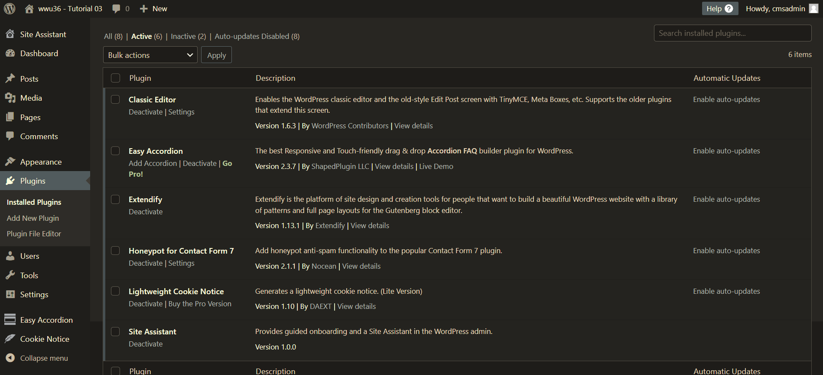

1. Go back to the instructions and continue at Part I**.**

Part I **– PHP**

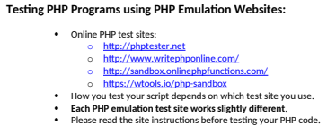

1. Write and test PHP code that does the following:
   1. Creates 2 variables $a and $b, with values 1 and 5
   2. Write an if statement that compares the two values using a less than comparison operator
   3. If $a is less than $b, echo “that the first variable is less than the second variable”
   4. **Test your code using an online PHP emulator and paste the code and results in the table cell below.  
      [I.1]**

|  |
| --- |
| Copy and paste a screen shot from the PHP test site will be the best way to not affect template format. Please try not to change the template numbering or format. |
| **Paste screen capture from PHP test website here ** |

1. Create an array variable named $mycats with the following cats names as strings “midnight”, “fritz”, “bill”, “amber”, “happy”. After creating the array, write code to iterate the array using a **foreach** statement and echo out each array item. Test your code in a PHP web emulator.  
   **[I.2]**

|  |
| --- |
| Copy and paste a screen shot from the PHP test site will be the best way to not affect template format. Please try not to change the template numbering or format. |
| **Paste screen capture from PHP test website here ** |

1. Create an associative array named $fruitarray with 3 total array items with key and values of 1 for Apple, 2 for Orange, 3 for Grape. After creating the array, write code to iterate the array using a **foreach** statement and echo out each array item. Test your code in a PHP web emulator.  
   **[I.3]**

|  |
| --- |
| Copy and paste the code block and record the results on the next row. A screen shot from the PHP test site will be the best way to not affect template format. Please try not to change the template numbering or format. |
| **Paste screen capture from PHP test website here ** |

**Go back to the instructions and work on Part J.**