ASSIGNMENT 04 Template – Version 8.1 **WordPress CMS Website**

**Instructions for completing template:**Replace **[bracketed red text]** with the requested information or screen capture.  
Replace **bracketed red text with black text**.  
Do not include full screen shot images, or full screen shots that are reduced in size. Use a snippet tool to capture parts of the screen and insert those images into the template.  
Do not remove tags (tag example [C.1]) from this template. Please fill out all items and answer all questions. Please do not alter template formatting or delete parts of this template.

Part A - Student Information:   
 **1. Student Name:** Wesley Wu

**2. Phone:** 3124792868

**3. DePaul Email:** wwu36@depaul.edu

Go back to the instructions and continue with Part B.Part B.1- Shared Web Host WP CMS Website Information:

Shared Web Host Name: Namecheap [B.1.1]  
Website Admin Username: [cmsadmin] [B.1.2]  
Website Admin Password: [CMSPassword9!] [B.1.3]  
Database Name: [wp862] [B.1.4]  
Table Prefix: [wphu_] [B.1.5]  
WordPress CMS Website URL: [https://it320-domain.online/mod4assign4] [B.1.6]

Go back to the instructions and continue with Part C.

-OR-  
Part B.2- Pantheon WP CMS Website Information:  
**Assignment Website Site Name:** **[**Site Name**]** [B.2.1] **Assignment Website Frontend URL:** **[**WEBSITE FRONTEND URL**]** [B.2.2] **Website Admin Username:** **[**ADMIN USERNAME**]** [B.2.3] **Website Admin Password:** **[**ADMIN PASSWORD**]** [B.2.4]

Go back to the instructions and continue with Part C.

**-OR-**

Part B.3 - Codeanywhere WP CMS Website Information:

Website Admin Username: [ username here][B.3.1]

Website Admin Password: [ password here] [B.3.2]

Go back to the instructions and continue with Part C.

**Part C - WordPress CMS + Website Extensions + Comments**

Before working part C, please watch the video “Assignment 04- WordPress Comments” that walks through enabling Comments on Pages and Posts, adding comments, and finally approving them.

1. Backend Screen capture of the dashboard > Themes   
   [C.1]

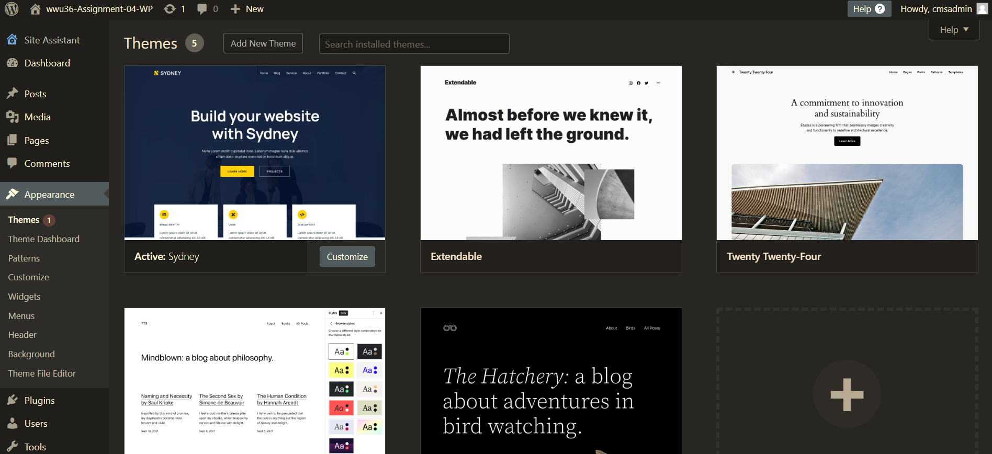

1. Backend Screen capture of the dashboard > Comments  
   [C.2]

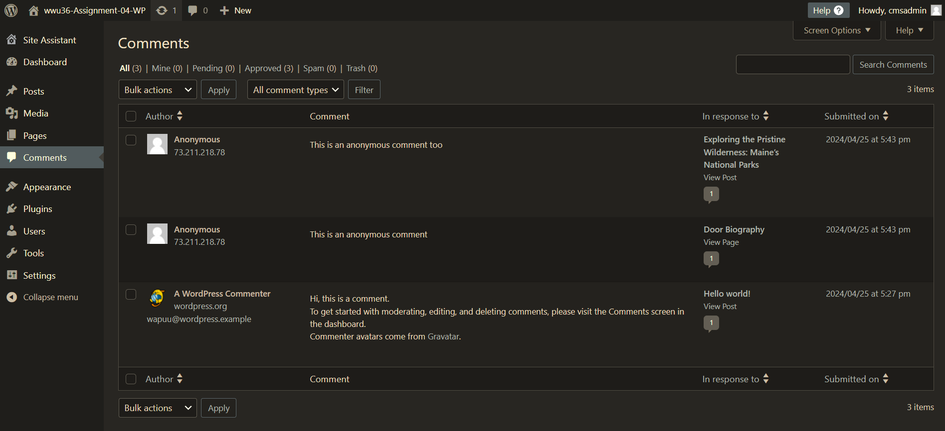

1. Backend Screen capture of the dashboard > Post > Categories   
   [C.3]

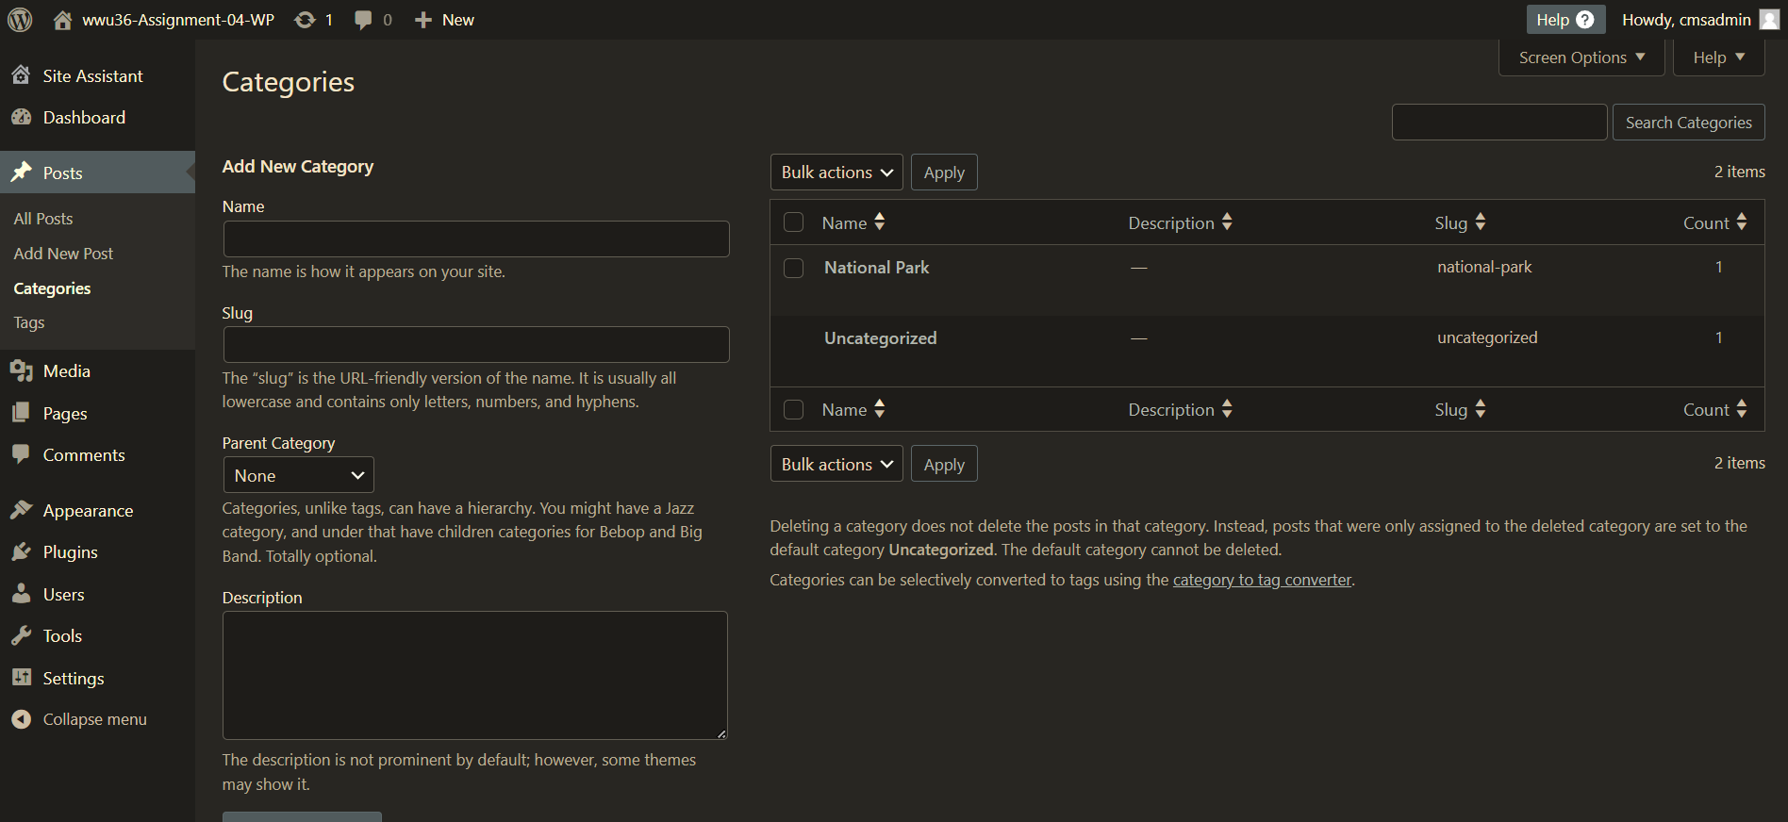

1. Backend Screen capture of the dashboard > Post > Tags   
   [C.4]

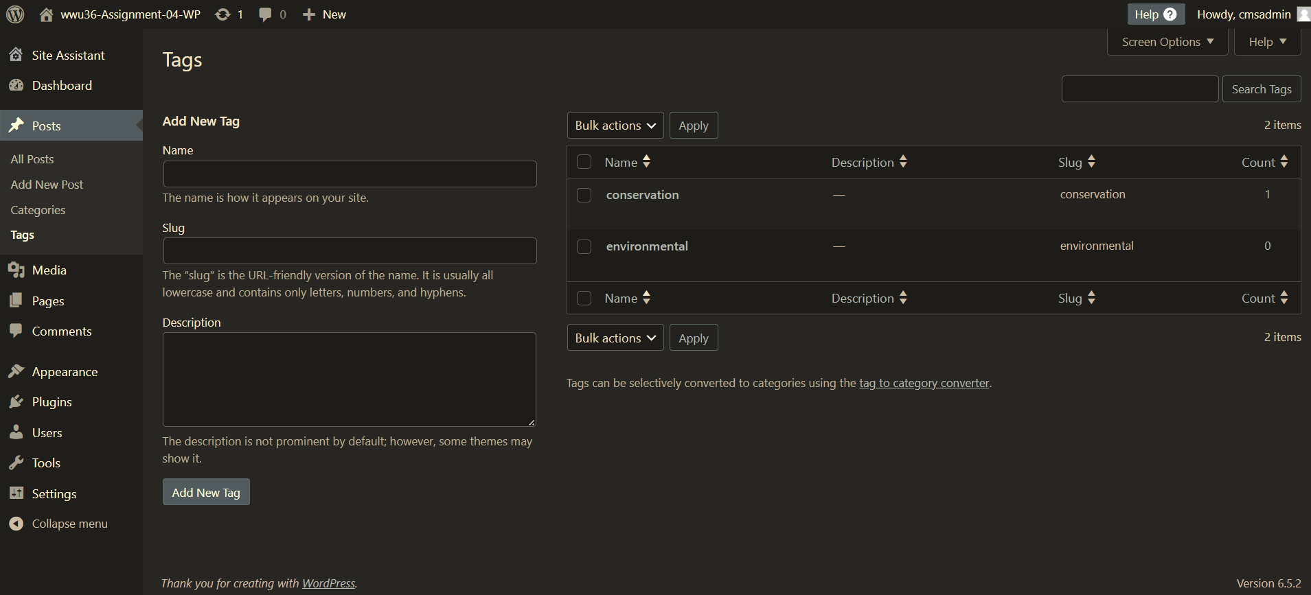

1. Backend Screen capture of the Quick Edit of the Door Biography Page   
   [C.5]

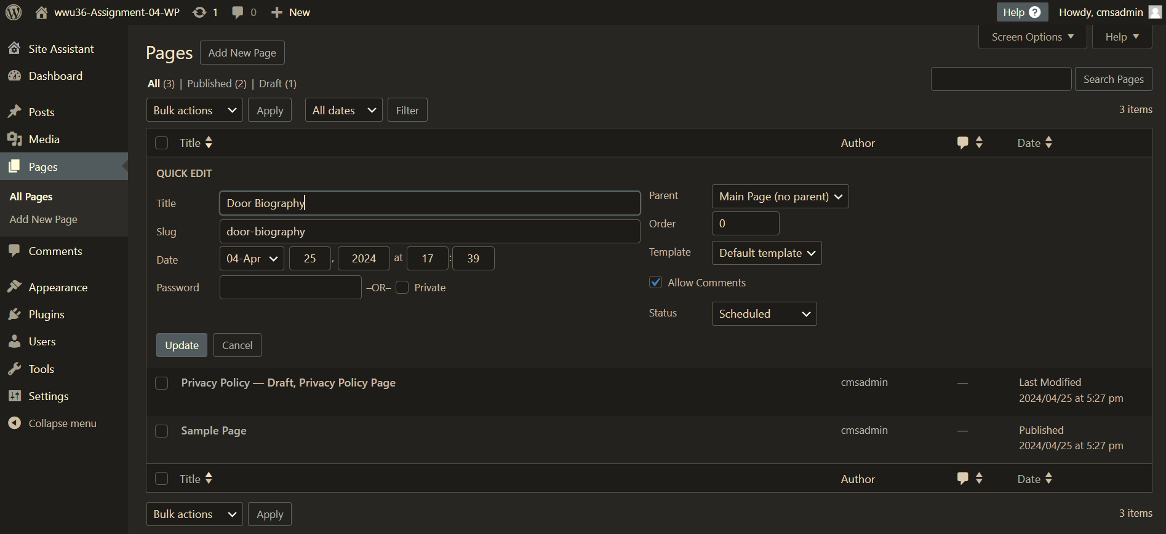

1. Backend Screen capture of the Quick Edit of the Maine’s National Park Post  
   [C.6]

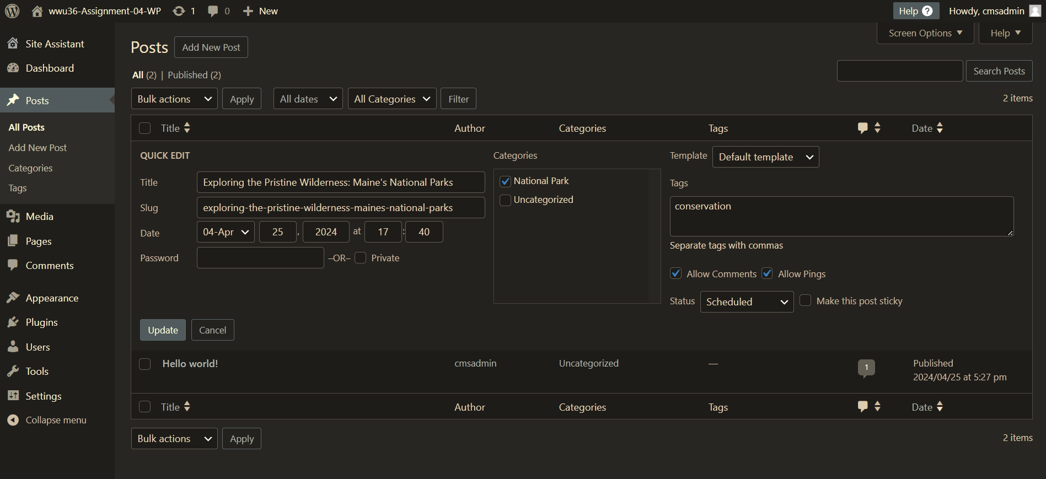

**Part D –** Custom Plugins

1. Backend Screen capture of the dashboard > Plugins, with 2 custom plugins visible  
   [D.1]

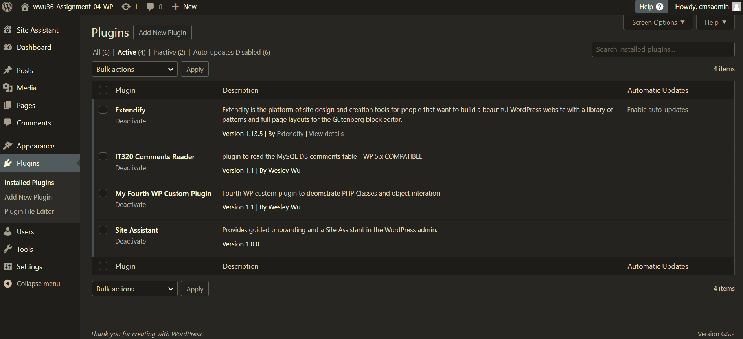

1. Front end Screen capture of “IT320 Comments Reader” Page showing object table displayed in an HTML table  
   [D.2]

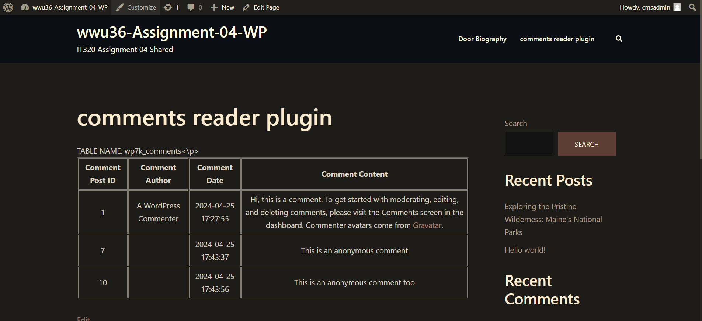

1. Front end Screen capture of “Class and object Example” Page showing comments database table content displayed in an HTML table  
   [D.3]

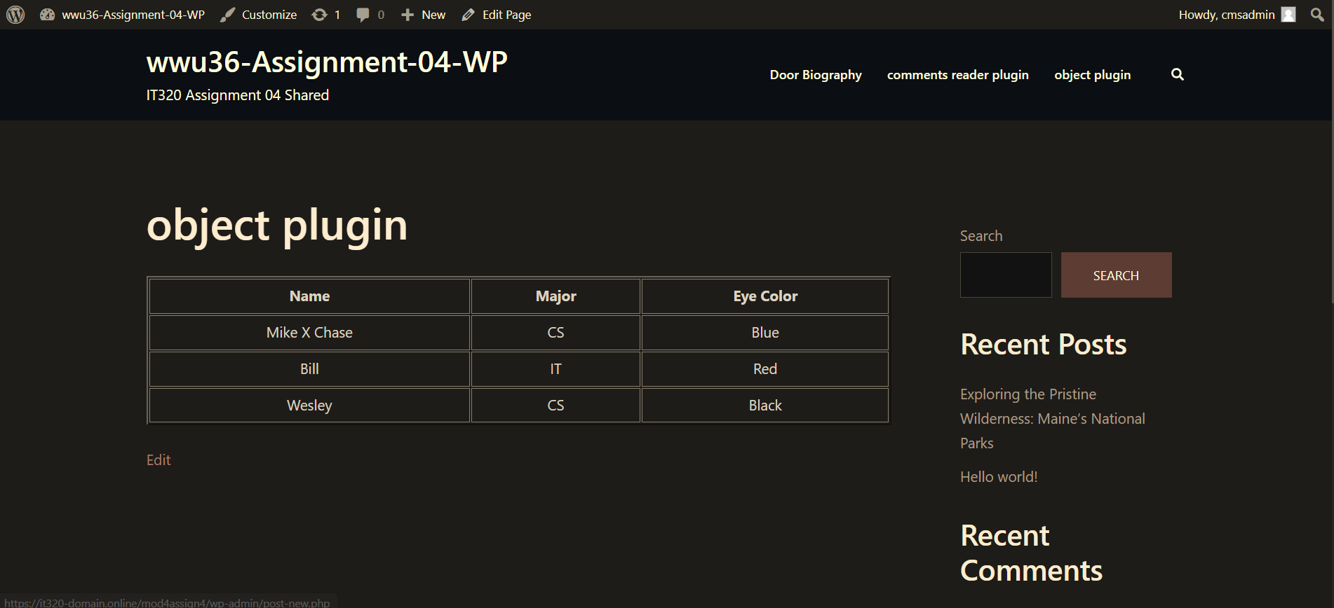

Go back to the instructions and begin work on **Part E.**

**Part E – Assignment Wrap up:**

1. **Did you have any problem or issues completing this assignment?**This is not an optional question. If you did not answer or provide screen captures for any items in the assignment, please put yes and explain what happened in E.2. **[**E.1**]   
   [**Please put your Yes or No Answer here**]**

No **If you answered yes to this question, please elaborate and be specific.  
If you had trouble with a specific question, please identify it by number and explain what you did not understand or had problems with, especially if you left parts empty.  
I can only improve this assignment with your help.**

1. **[**Elaborate your problems or issues here**]   
   [**E.2**]**Required If you answered Yes to **[**E.1**]** above or if you left one or more parts empty in the template.

Submit this completed template to the correct D2L assignment submission folder.If you prefer not to navigate by hand to the D2L submission folder, take advantage of the submission folder link in the D2L this module’s section. This link will take you to the correct assignment submission folder location.