Assignment 06 Template – Version 8.1

**Instructions for completing template:**Replace **[bracketed red text]** with the requested information or screen capture.  
Replace **bracketed red text with black text** and then remove the brackets.  
Do not include full screen shot images, or full screen shots that are reduced in size. Use a snippet tool to capture parts of the screen and insert those images into the template.  
Do not remove tags from this template. Please answer all questions.  
**Please do not alter the formatting or delete parts of this template.**  
Assignment questions are not as detailed as activity questions.   
The assignment is where you demonstrate understanding of the material.

**Part A - Student Information**

1. **Student Name: [A01]** Wesley Wu
2. **Student Contact Information: [A02]** wwu36@depaul.edu
3. **What day and date did you start this assignment: [A03]** Wednesday, 5/8/2024

**Go back to the instructions and begin work on part B.  
  
Part B - Create 1 Shared Web Host + cPanel WordPress CMS Website**

Part B.1– For WordPress site on a shared web host [B.1]

1. Enter the following shared web host WordPress site information
   1. Shared Web Host Company Name: Namecheap
   2. Website Admin Username: cmsadmin
   3. Website Admin Password: CMSPassword9!
   4. Database Name: wp858
   5. Table Prefix: wprw_
   6. WP website URL: <https://it320-domain.online/assign06>

Part B.2 – For WordPress site on Pantheon (PaaS) [B.2]

1. Enter the following shared web host WordPress site information   
   1. PaaS WordPress site Admin Username: [B.2.1] [ website admin username here ]
   2. PaaS WordPress site Admin Password: [B.2.2] [ website admin password here ]
   3. PaaS WordPress Front-end site URL: [B.2.3] [ Pantheon website URL here ]
2. Go back to the tutorial instructions and begin working on Part C.

Part B.3 – Create a WordPress site on Codeanywhere [B.3]

1. Enter the following Codeanywhere WordPress site information
   1. Site Title: [B.3.1] [ site title here]
   2. WordPress Username: [B.3.2] [ username here]
   3. WordPress Password: [B.3.3] [ password here]
2. Go back to the tutorial instructions and begin working on Part C.

**Part C - Extend the WP Site Content**

1. SCREEN CAPTURE of the backend WordPress **[Dashboard > Home]**With the web browser address bar and the Home “At a Glance” section visible. **[**C.1**]**

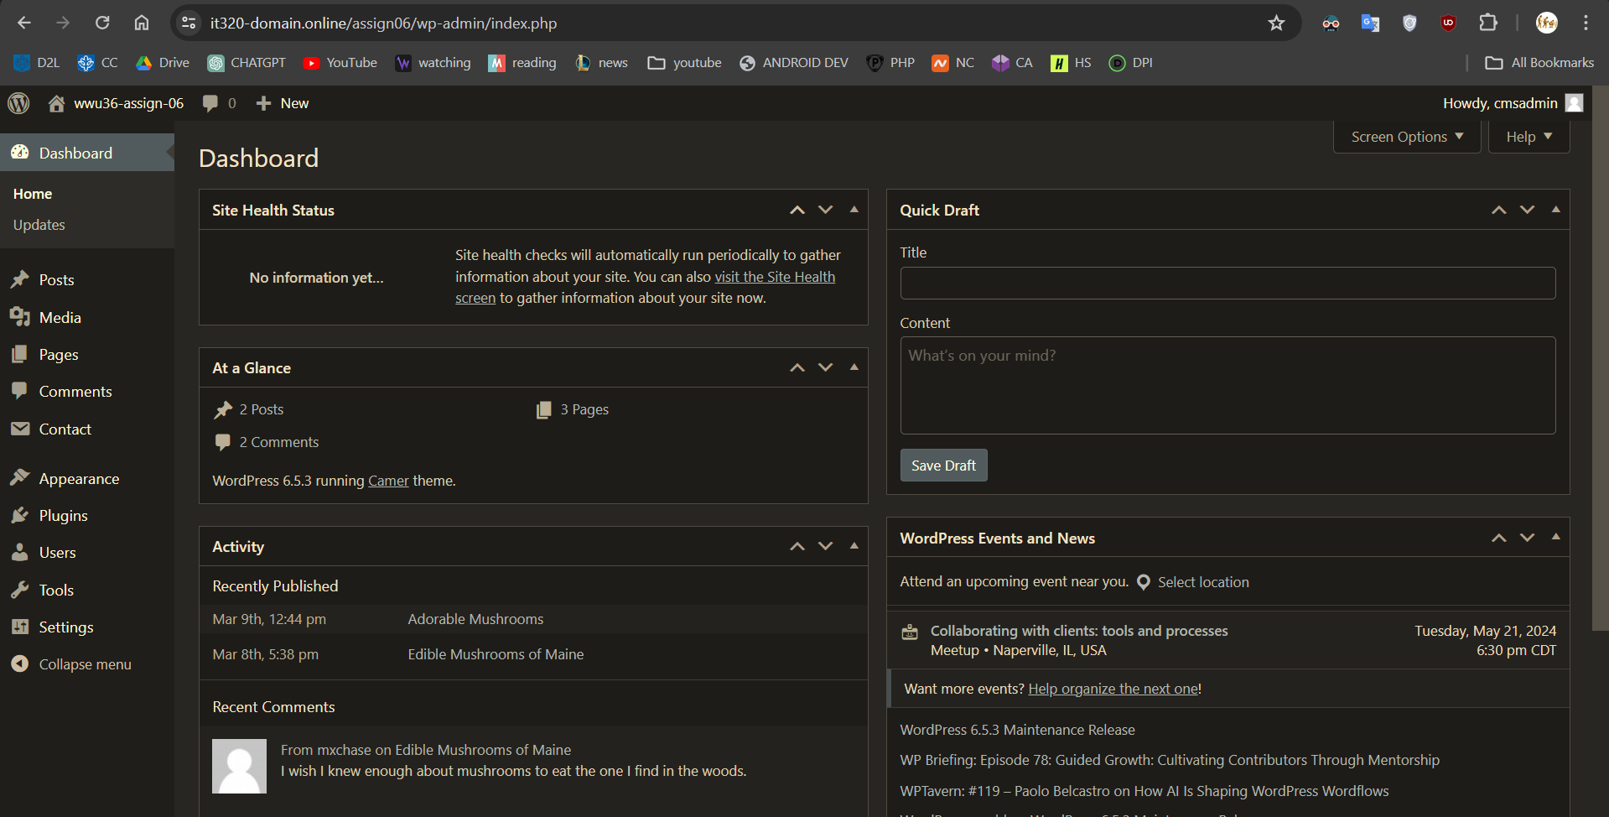

1. SCREEN CAPTURE of the backend WordPress **[Dashboard > Appearance] [**C.2**]**

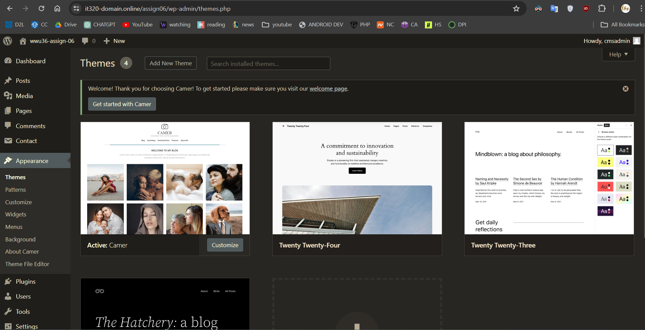

1. SCREEN CAPTURE of the backend WordPress **[Dashboard > Appearance > Menus] [**C.3**]**

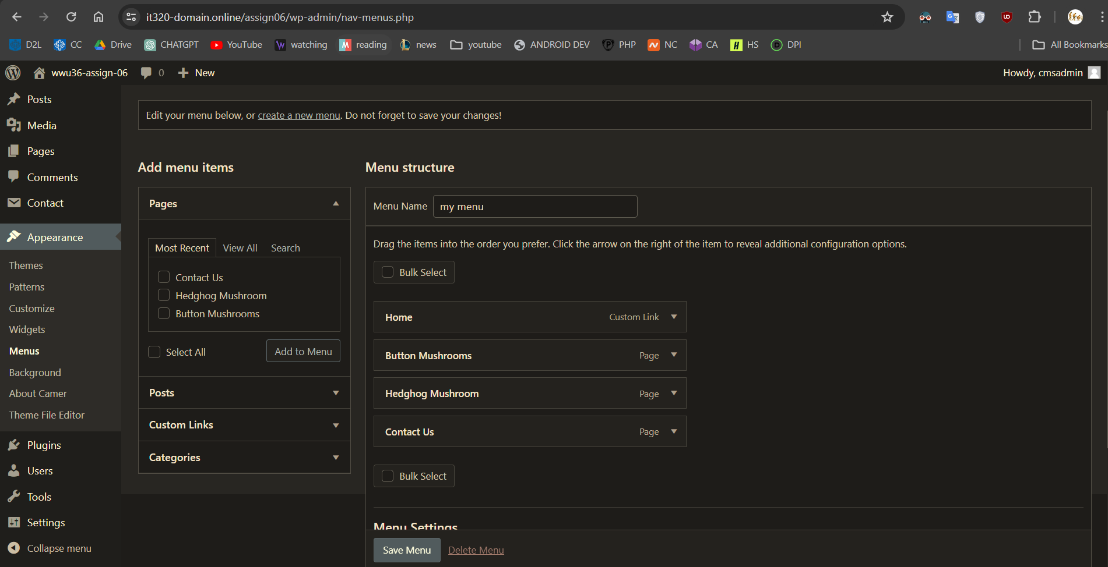

1. SCREEN CAPTURE of the backend WordPress **[Dashboard > Pages] [**C.4**]**

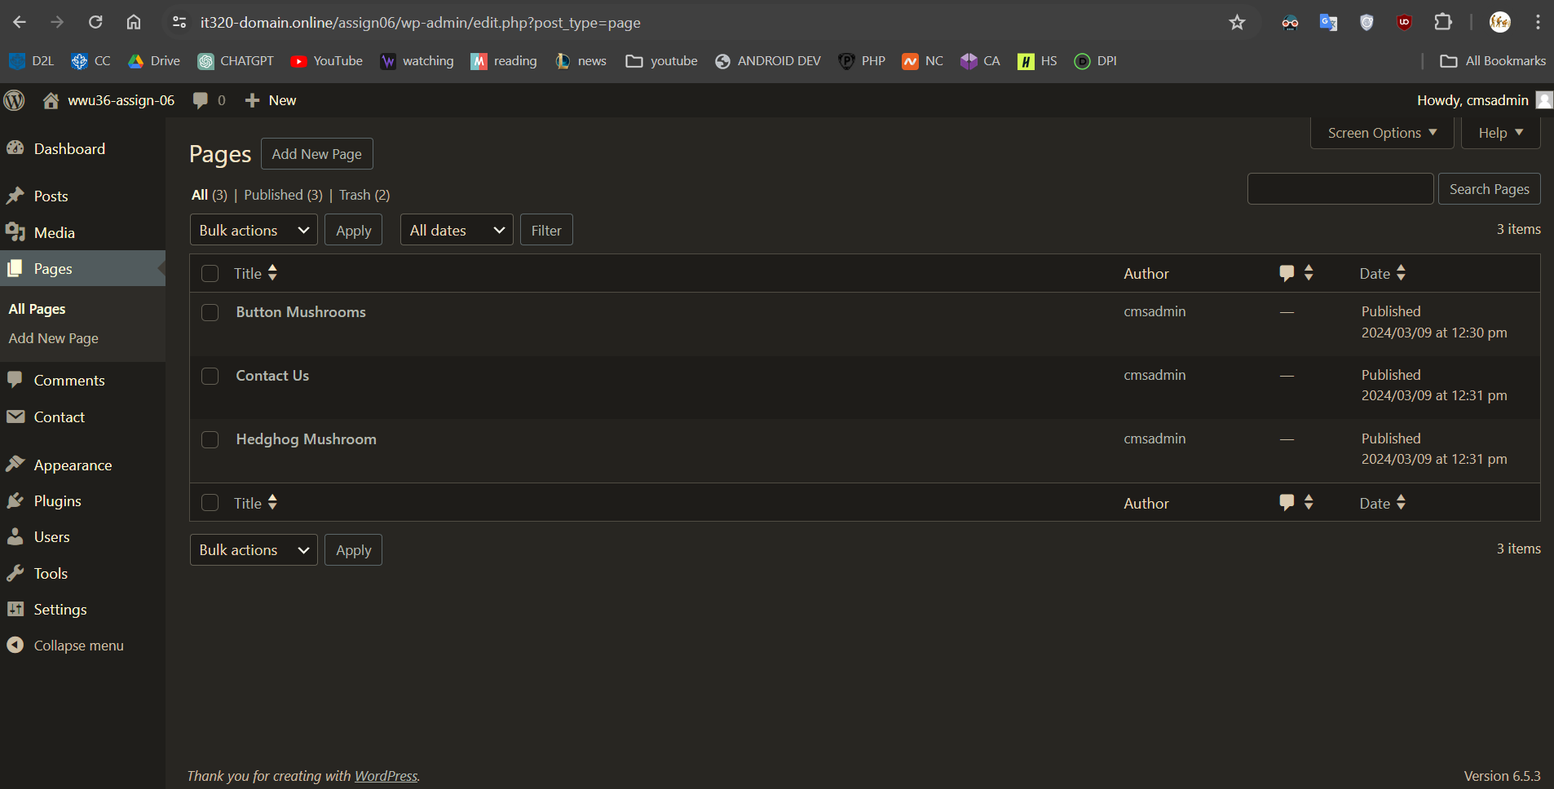

1. SCREEN CAPTURE of the backend WordPress **[Dashboard > Posts] [**C.5**]**

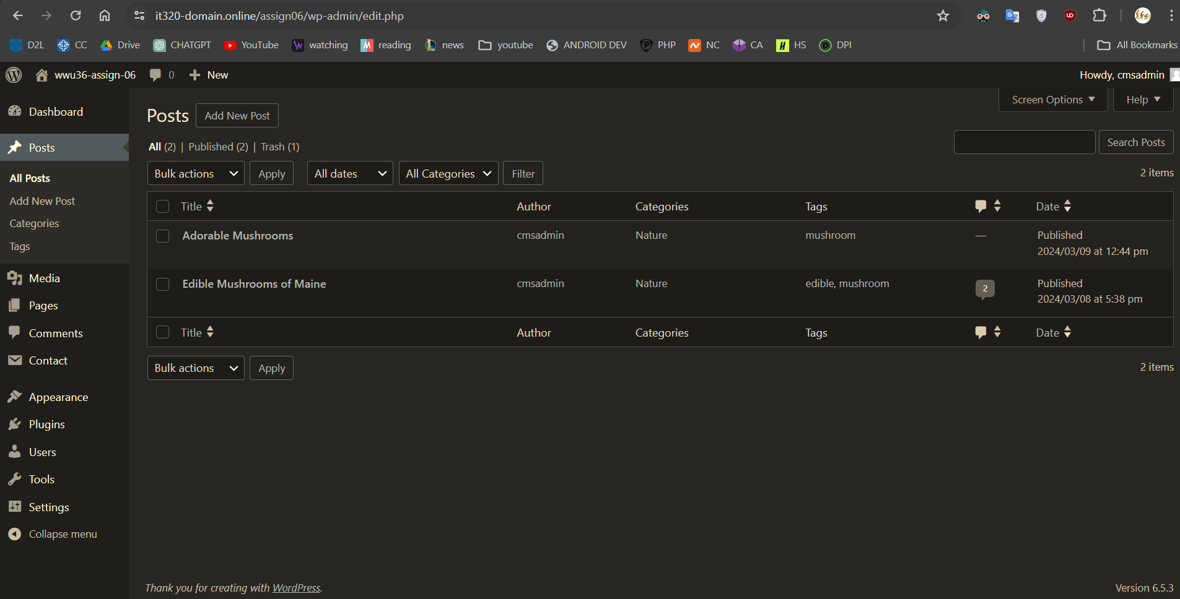

Go back to the instructions and begin work on Part D.

**Part D – Import Employee MySQL Table**

1. Take a SCREEN CAPTURE of the expanded WordPress database showing the tables with their prefixes with the adapter table visible **[**D01**]   
   Example:**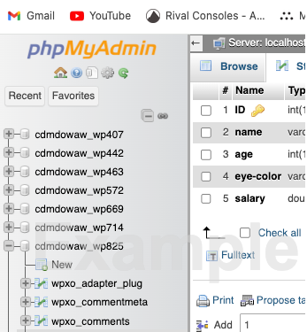

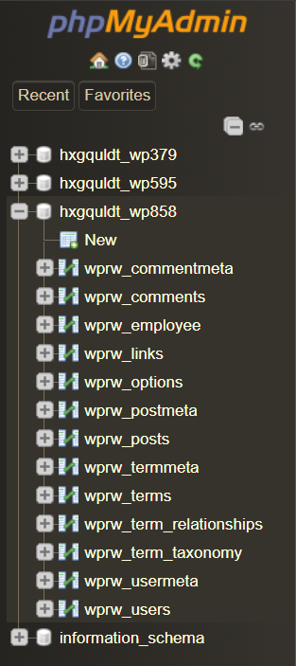

1. Select the Browse TAB and take a SCREEN CAPTURE of the **Employee table   
    [**D02**]**

1. 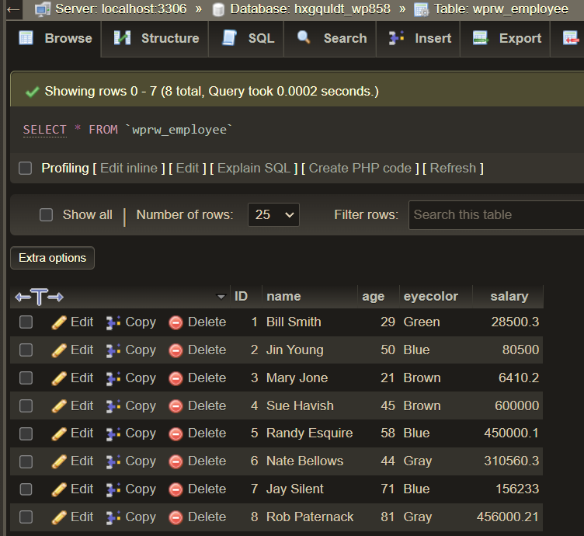Select the Structure TAB and take a SCREEN CAPTURE of the **Employee table   
    [**D03**]**

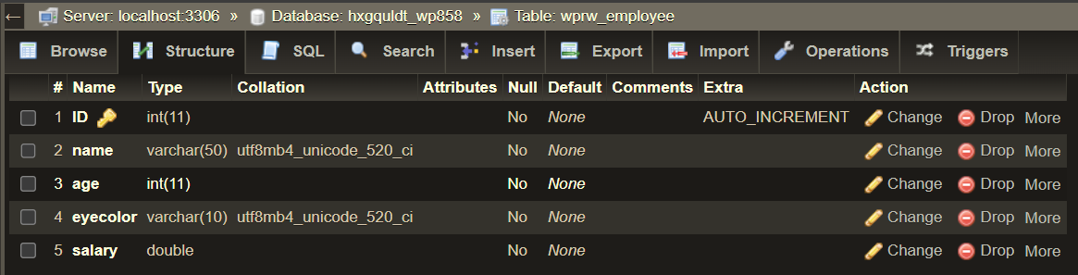

Go back to the instructions and begin work on Part E.

**Part E - Create and deploy a WordPress Custom Plugin**

**1. Take a** SCREEN CAPTURE of the **backend** **[Dashboard > Plugins] with ALL plugins including the employee plugin visible.  
Remember to verify that you have disabled any cache plugins.  
[**E.1**]**

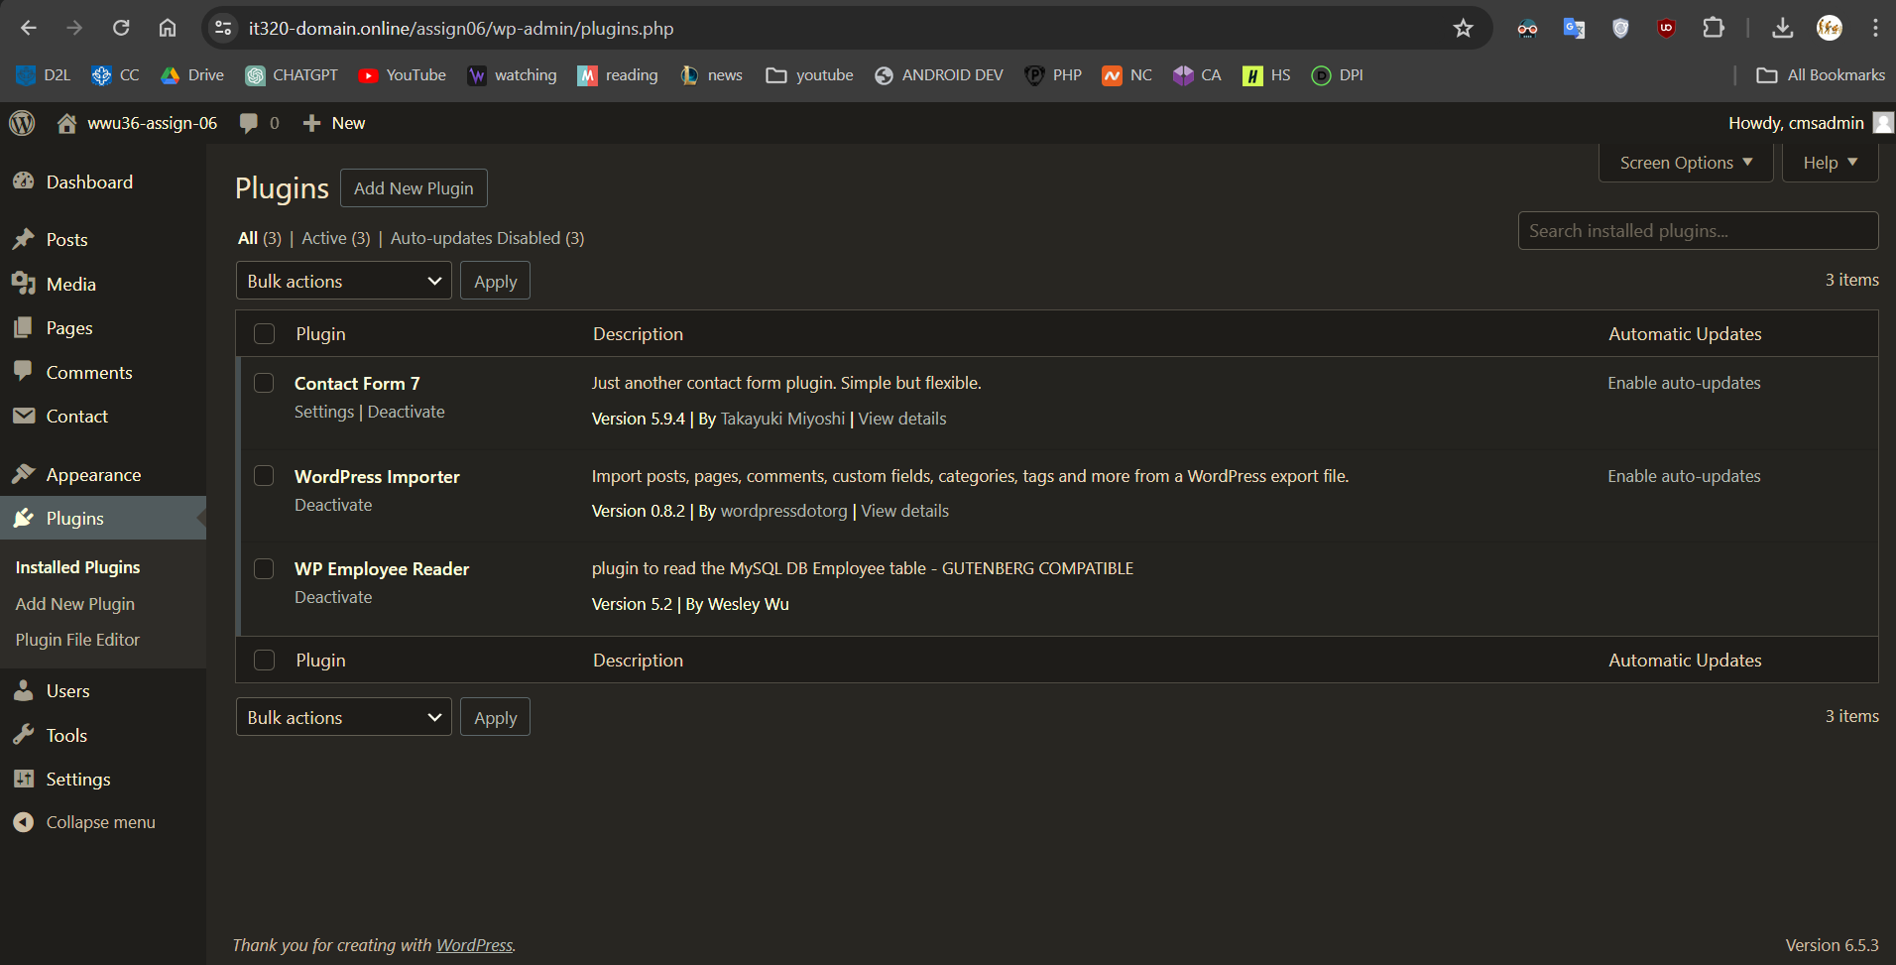

**2. Take a** SCREEN CAPTURE of the **backend** **[Dashboard > Themes > Menus]   
[**E.2**]**

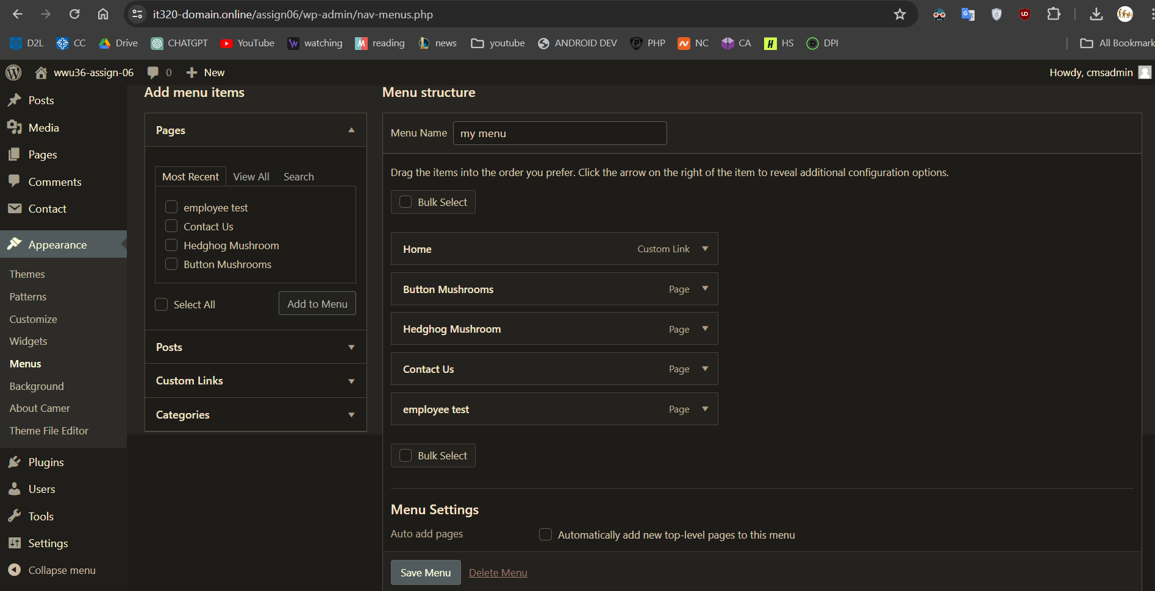

**3. Open the custom plugin code in an ASCII editor and take as many captures as you need to capture the entire PHP file contents.**For full credit you must capture and post the entire PHP plugin file contents. **Paste the** SCREEN CAPTURES of the **custom Plugin in the area below.  
[**E.3**]**

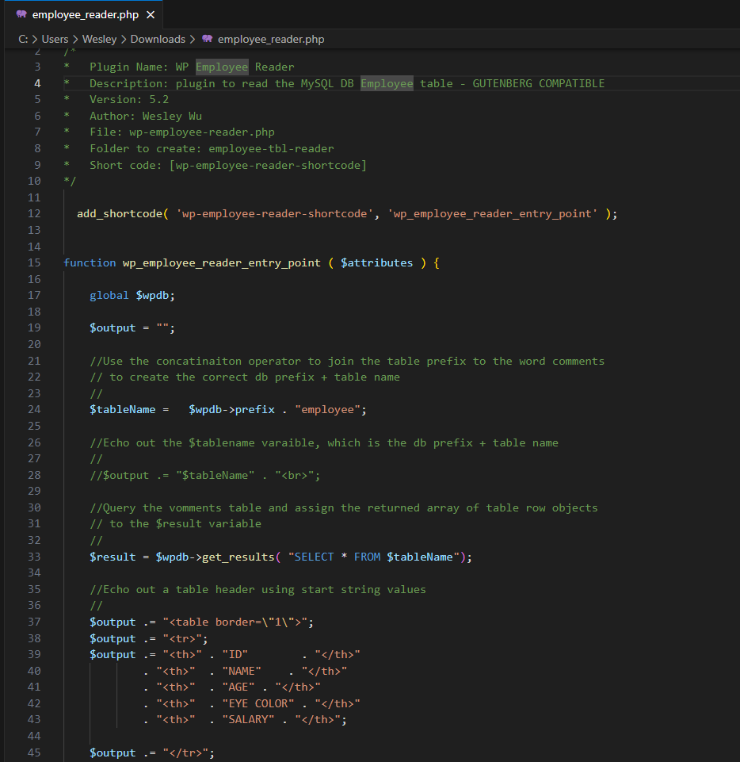

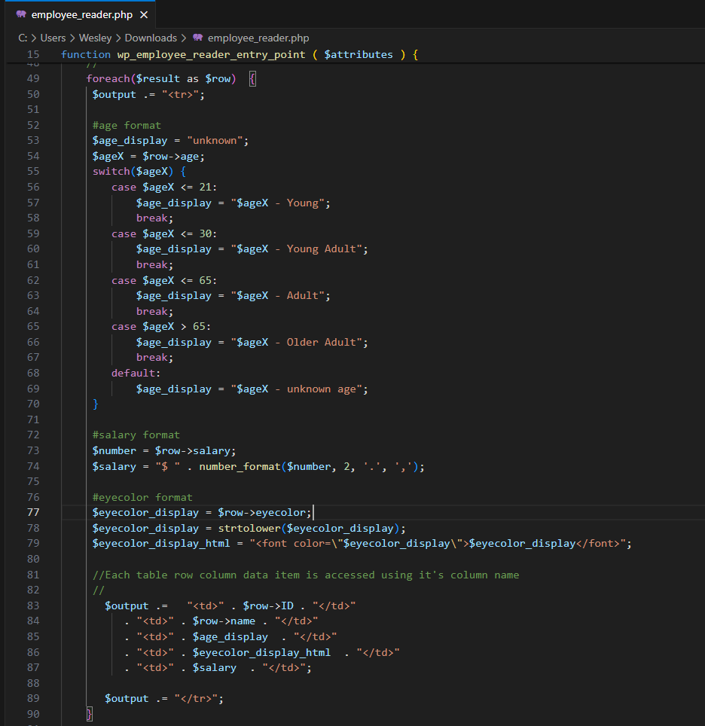**4. SCREEN CAPTURE of the frontend** of the website showing your working custom plugin selected from the menu **[**E.4**]**

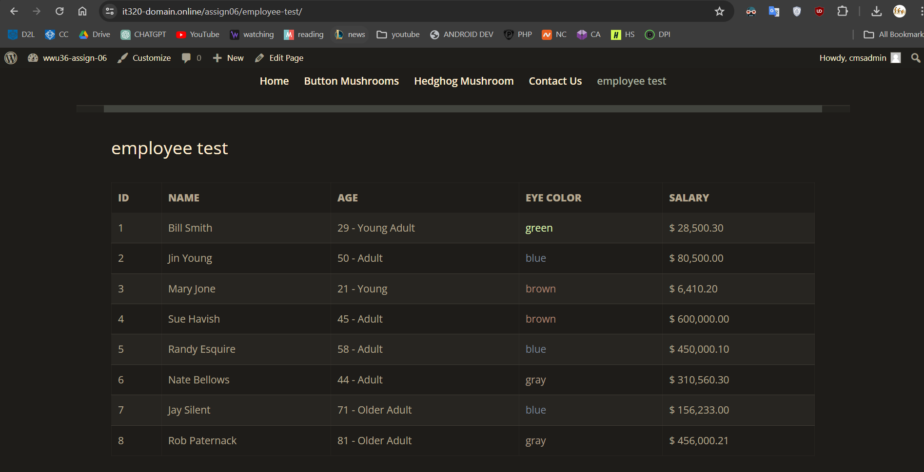

Go back to the instructions and begin work on Part F. **Part F – Advanced CMS Security – Salting Keys:**

1. What does it mean to salt keys and why does it improve CMS website security?   
   **[**F.1**]**

Salting keys means added random characters to the password before hashing. This makes the final, encrypted password more difficult to hack.

1. After reviewing the WordPress Salt Shaker plugin, write a few sentences about what this Salt Shaker plugin does to improve WordPress security.   
   **[**F.2**]**

The plugin not only adds a salt, but the salt also randomizes itself based on an interval the user chooses (daily/weekly/monthly) or manually.

1. Would you install this plugin on a current WordPress site and if so, why? Please be sure to mention how best practices worked into your decision   
   **[**F.3**]**

Yes. Although the reviews are low, there is a decent number of installations (10k+). It is also up-to-date and compatible with my version of WP.

Go back to the instructions and begin work on Part G.

**Part G – Assignment Wrap up:**

1. **Did you have any problem or issues completing this assignment?**If your custom plugin did not work, then you had a problem and attending office hours visit or connecting with the class tutor is a recommended.   
   This is not an optional question. **[**G.1**]** No
2. **If you answered yes to this question, please elaborate and be specific.  
   If you had trouble with a specific question, please identify it by number and explain what you did not understand or had problems with.  
   I can only improve this assignment with your help.**Only if you answered yes above.

**[**G.2**]   
[**List problems here**]**

Submit this completed template to the correct D2L assignment submission folder.If you prefer not to navigate by hand to the D2L submission folder, take advantage of the submission folder link in the D2L this module’s section. This link will take you to the correct assignment submission folder location.