**teaCHAIR**

An offline mobile application that provides instructors an easy way to assign and organize the seating arrangements of the students. Creating a seat plan manually can sometimes be both time consuming and frustrating for an instructor. teaChair was created and design to make it easier just by downloading different layouts (e.g. Laboratory, Lecture) and download the names of the students where you can drag the name of the students on each box, who are enrolled on that class. Through this application we can guarantee that the instructor will surely save time.

This application is a type of mobile development in which the application is built to run from a central server, from where it can be accessed by any mobile devices like Android and IOS Phones. It is very functional while offline especially when users may lose network connection while on the move. Also, retrieving resources from the server locally is more reliable because resources load faster.

teaChair application can adapt its content to mobile devices through a responsive design. The application maximizes the entire screen when loading it up. The application resize itself so that it is in correct size whatever the screen size or orientation (from portrait to landscape, or vice versa) of the device.

Web technologies such as HTML5, jQuery, jQuery-ui, canvas, sortable, Materialize and others are used to develop the application. The underlying technologies are JavaScript, HTML and CSS.

jQuery

* jQuery is a fast, small, and feature-rich JavaScript library. It makes things like HTML document traversal and manipulation, event handling, animation, and Ajax much simpler with an easy-to-use API that works across a multitude of browsers. With a combination of versatility and extensibility, jQuery has changed the way that millions of people write JavaScript.

jQuery-ui

* jQuery UI is a curated set of user interface interactions, effects, widgets, and themes built on top of the jQuery JavaScript Library. Whether you're building highly interactive web applications or you just need to add a date picker to a form control, jQuery UI is the perfect choice.

HTML5 canvas

* **element** can be used to draw graphics via scripting in [JavaScript](https://developer.mozilla.org/en-US/docs/Web/JavaScript). For example, it can be used to draw graphs, make photo compositions, create animations, or even do real-time video processing or rendering**.**

HTML5 sortable

* Lightweight standalone library for creating sortable lists and grids using native HTML5 drag and drop API.

Materialize

* Created and designed by Google, Material Design is a design language that combines the classic principles of successful design along with innovation and technology. Google's goal is to develop a system of design that allows for a unified user experience across all their products on any platform.

**Screenshots**

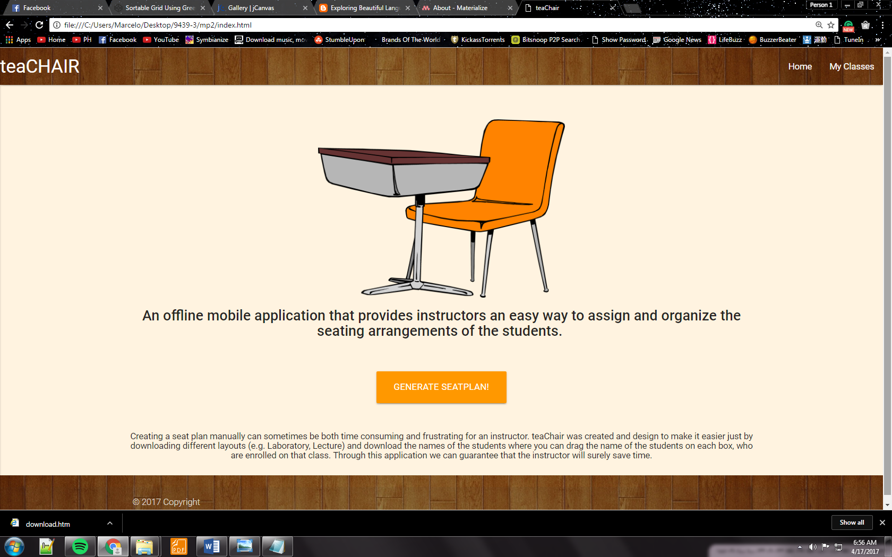

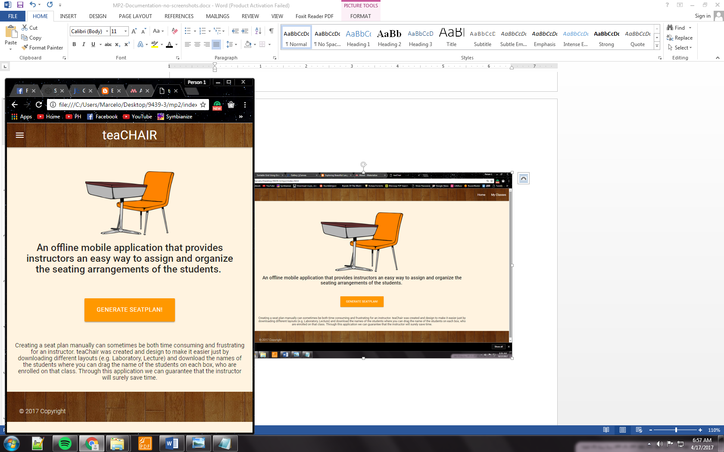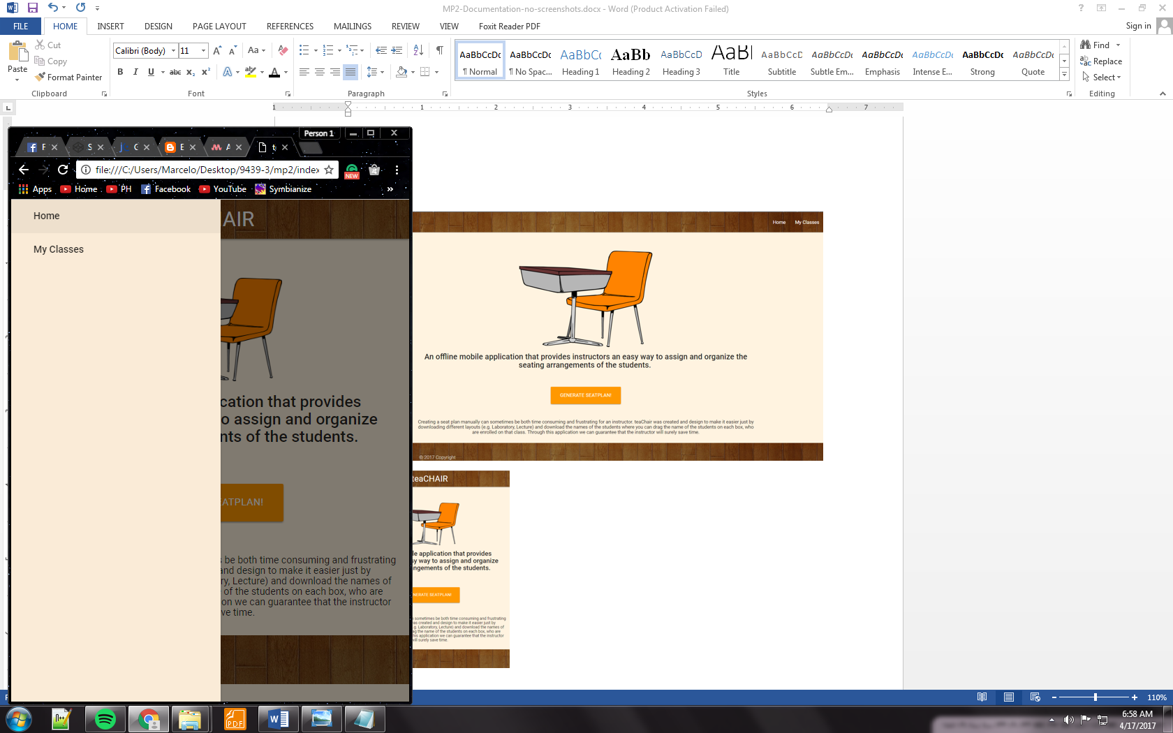

The main user interface is generally the instructor’s navigating interface and also serves as a landing interface to attract instructors. This interface is facilitated with a “Generate Seat plan” button. An overview of the application is also included in the main user interface.

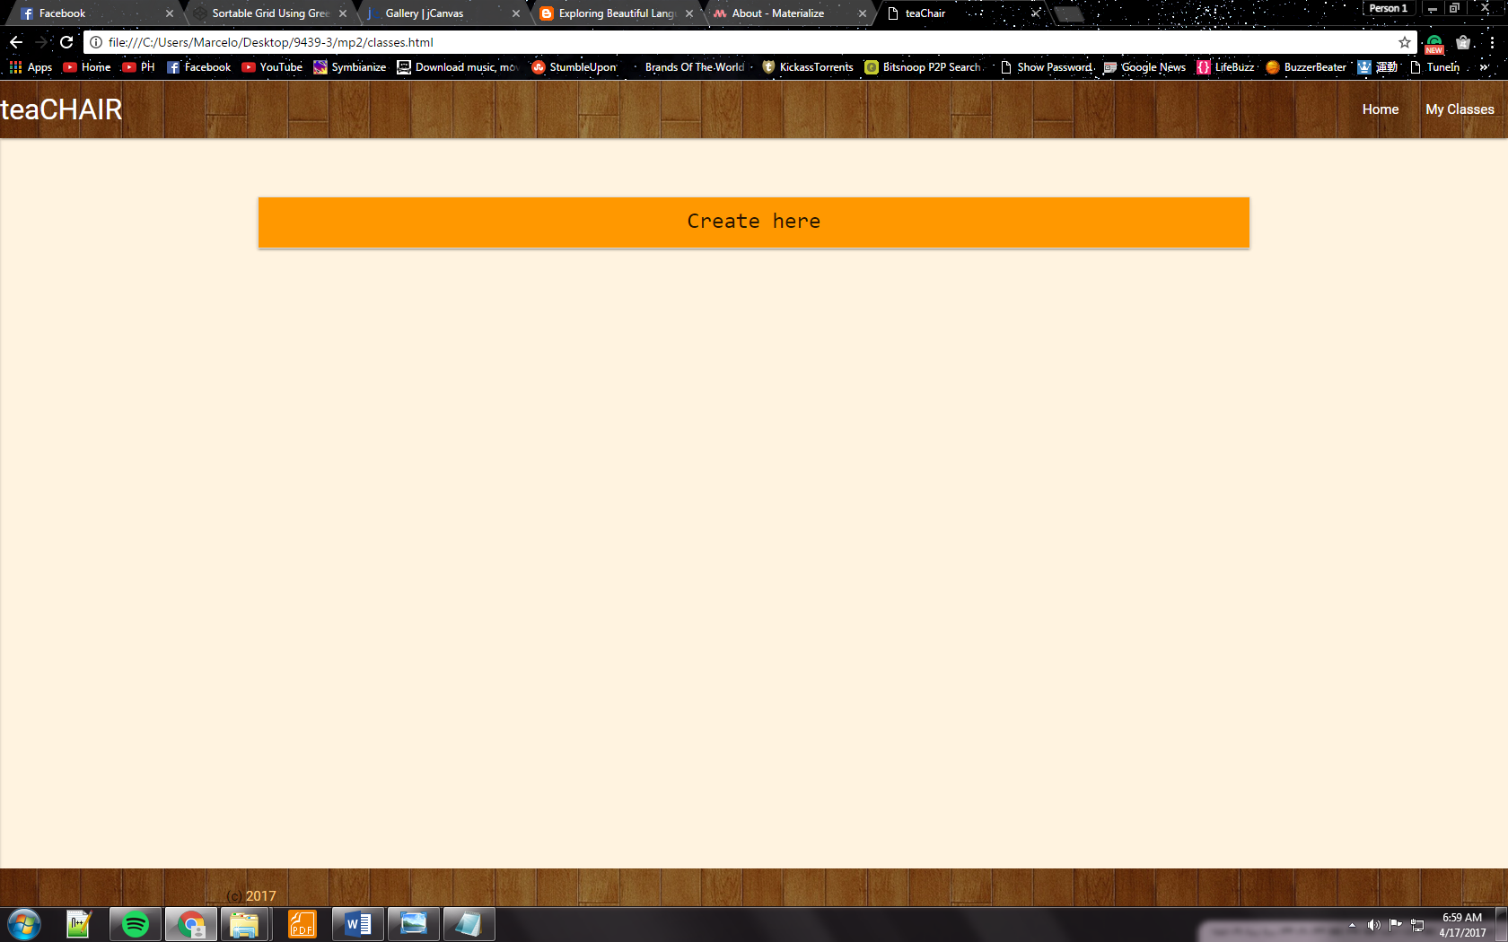

This interface is facilitated with the chosen layout and has an “Upload File” button.

After the generating the students’ seat plan, it can be downloaded or saved as an image.