**Tyrone G. Toldo BSCS 1B Documentation of GUI Project**

**Title of the code**: Quiz App

**Description**: The Quiz App is a fun and interactive application that tests users' knowledge on various subjects through a series of multiple-choice questions. It keeps track of users' progress by score and provides answer if the users answer is incorrect, making it an effective learning tool.

**Benefits of the code**: It is a great learning tool for people of all ages. This quiz application is easy to use and customize. It's a fun way to learn about different topics, with randomly selected questions and feedback on answers. The code is easy to change and expand, and it uses standard libraries in Python.

**Objective**: The objective of this quiz application is to create a fun and easy-to-use quiz that tests users' knowledge on various topics. The overall goal is to provide a great learning tool for users of all ages.

**Purpose:** The purpose of the code is to create a simple quiz application that tests users' knowledge on different topics. The application provides feedback on user answers and updates the user's score. The questions and answers are stored in a dictionary within the code, and the user interface is customized with various options. The overall goal is to make learning fun and interactive.

**Significance of the code**: The significance of this quiz application code lies in its ability to provide a fun and interactive way to test one's knowledge on various topics. The application utilizes tkinter widgets and style options to create a customizable and visually appealing user interface, and randomly selects questions from a dictionary to keep the quiz interesting. The ability to provide feedback on user answers and update the user's score encourages users to continue trying to improve their score, providing a sense of accomplishment. The ease of modifying and expanding the quiz content makes the application flexible and adaptable to different learning needs.

**Features of this code:**

1. **User-friendly**: The application is easy to use and navigate.
2. **Customizable**: The style and content of the application can be easily modified.
3. **Random question selection**: The next question is randomly selected from a dictionary.
4. **Feedback and scoring:** The application provides feedback on user answers and updates their score.
5. **Utilizes standard libraries**: The application uses standard Python libraries.
6. **Fun and interactive:** The application is a fun and interactive way to learn about different topics.

**Code:**

import tkinter as tk

from tkinter import messagebox

import random

class QuizApp:

def __init__(self, master):

self.master = master

self.master.title("Quiz Game")

self.master.geometry("500x800")

self.master.configure(bg="#d9e6f2")

self.question_style = {"font": ("Arial", 10), "wraplength": 350, "bg": "#d9e6f2"}

self.entry_style = {"font": ("Arial", 10)}

self.button_style = {"font": ("Arial", 10), "bg": "#3399ff", "fg": "white"}

self.score_style = {"font": ("Arial", 10), "bg": "#d9e6f2"}

self.questions = {

"What is the capital of France?": "Paris",

"Who wrote 'Romeo and Juliet'?": "William Shakespeare",

"What is the chemical symbol for water?": "H2O",

"Which planet is known as the Red Planet?": "Mars",

"Who painted the Mona Lisa?": "Leonardo da Vinci"

}

self.question_var = tk.StringVar()

self.answer_var = tk.StringVar()

self.score = 0

self.question_label = tk.Label(master, textvariable=self.question_var, **self.question_style)

self.question_label.pack(pady=20)

self.next_question()

self.answer_entry = tk.Entry(master, textvariable=self.answer_var, **self.entry_style)

self.answer_entry.pack(pady=10)

self.submit_button = tk.Button(master, text="Submit", command=self.check_answer, **self.button_style)

self.submit_button.pack(pady=10)

self.score_label = tk.Label(master, text=f"Score: {self.score}", **self.score_style)

self.score_label.pack()

def next_question(self):

question = random.choice(list(self.questions.keys()))

self.question_var.set(question)

def check_answer(self):

question = self.question_var.get()

answer = self.answer_var.get()

correct_answer = self.questions.get(question)

if answer.lower() == correct_answer.lower():

messagebox.showinfo("Correct!", "You got it right!")

self.score += 1

else:

messagebox.showinfo("Incorrect!", f"Sorry, the correct answer is: {correct_answer}")

self.score_label.config(text=f"Score: {self.score}")

self.next_question()

root = tk.Tk()

app = QuizApp(root)

root.mainloop()

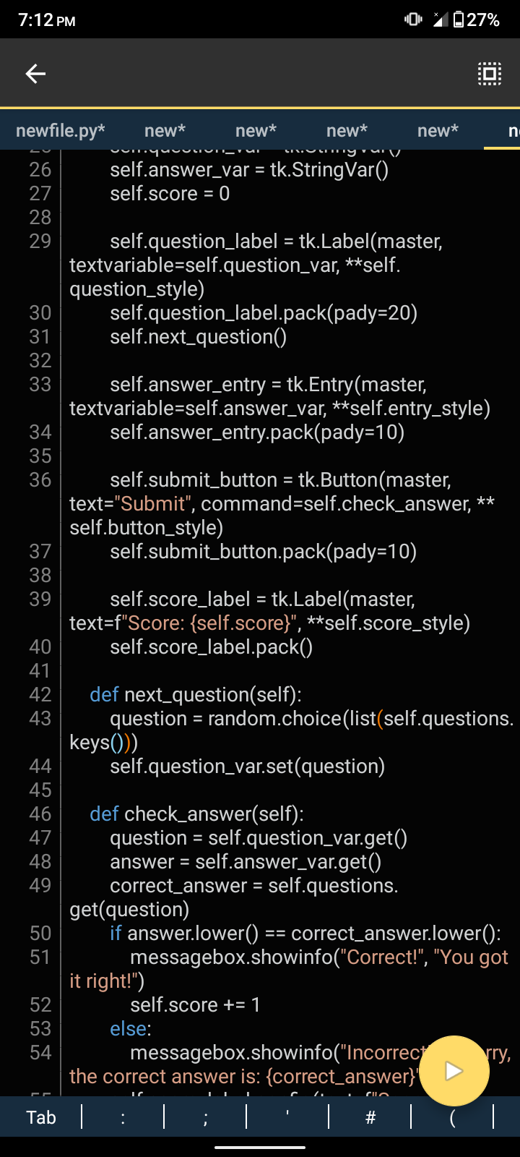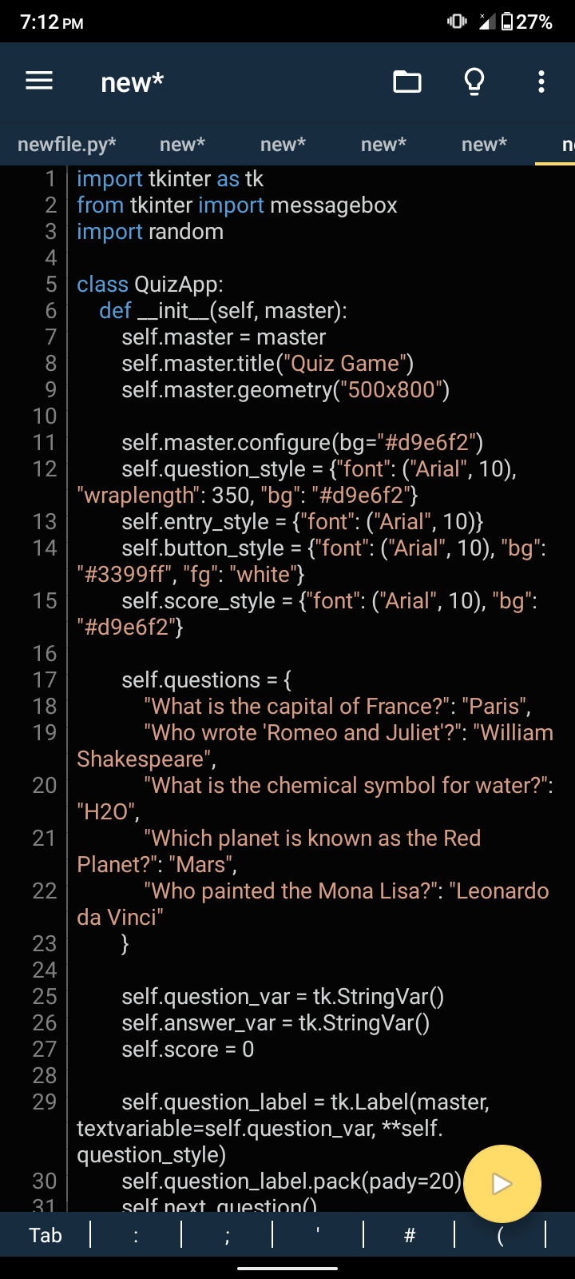**Screenshots:**

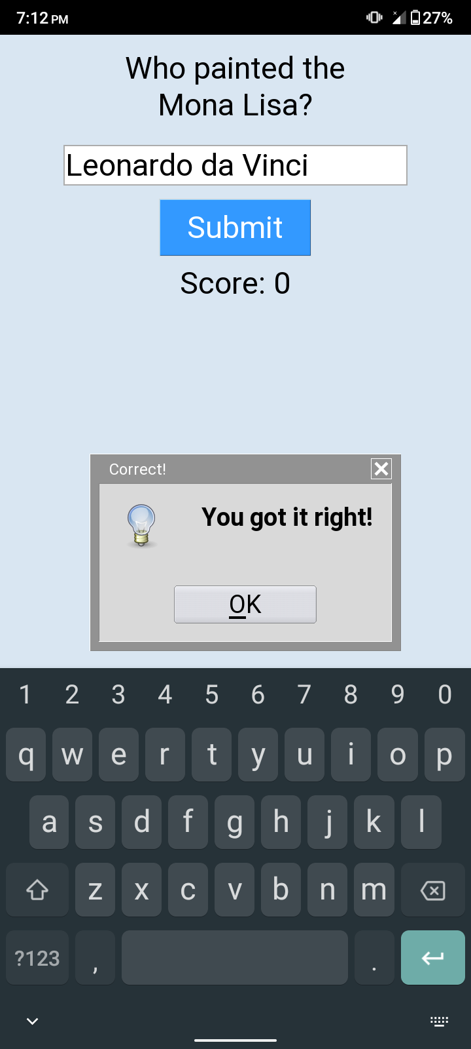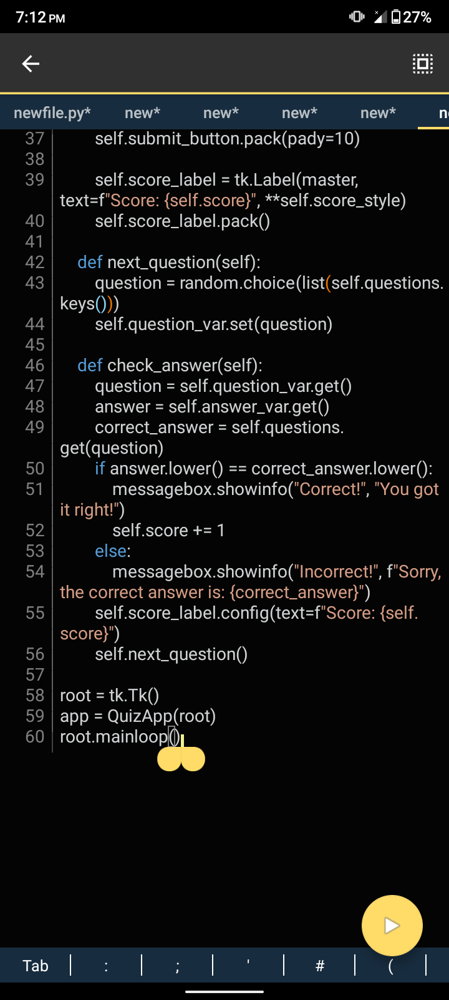

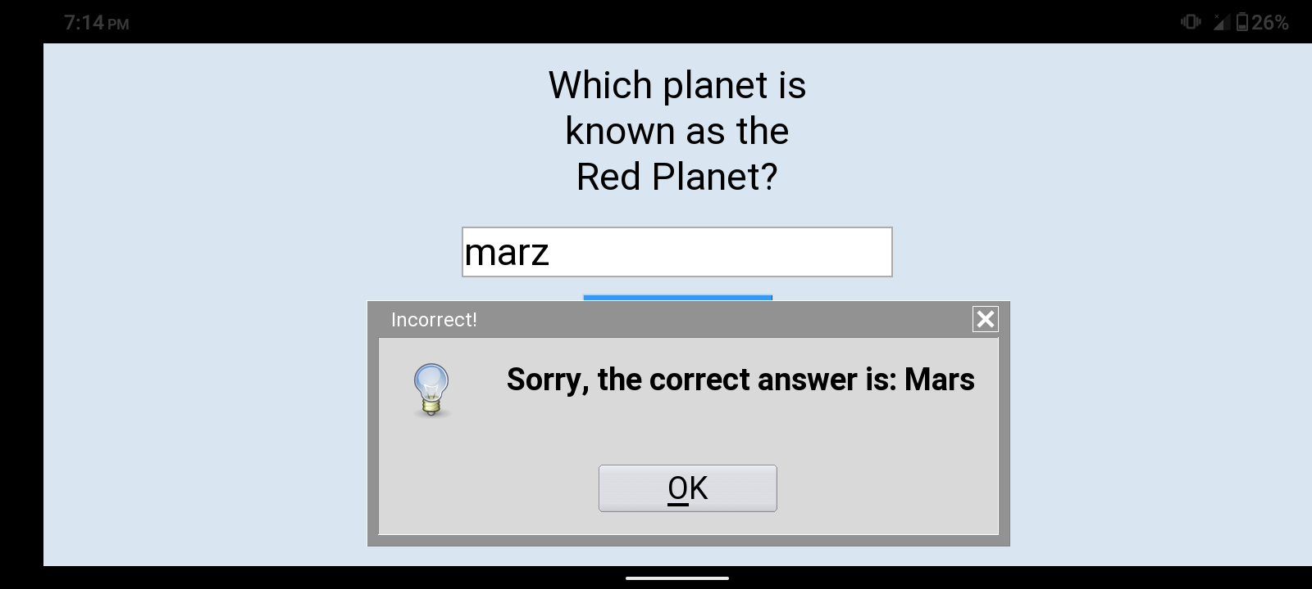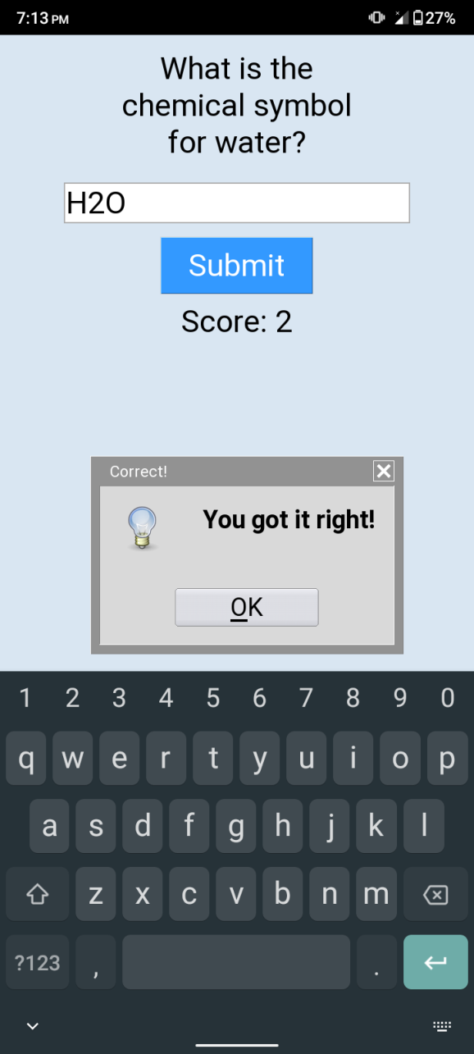 **CURRICULUM VITAE**

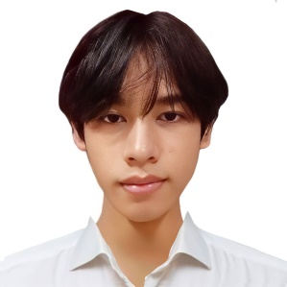

**PERSONAL INFORMATION**

Name: Tyrone G. Toldo

Contact Number: 09859653647

Email Address: [ttoldo@ssct.edu.ph](mailto:ttoldo@ssct.edu.ph)

Place of Birth: Dapa Surigao Del Norte

Address: Brgy 1 Dapa Surigao Del Norte

Age: 19

Nationality: Filipino

Religion: Roman Catholic

Civil Status: Single

Father’s Name: Roberto N. Toldo

Mother’s Name: Leah G. Toldo

**EDUCATIONAL BACKGROUND:**

Elementary: Don Enrique Navarro Memorial School

Junior High: Dapa National High School

Senior High: Siargao Island Institute of Technology