Mark Justine Apit

BSCS-SS

Homework 1 – SYSADD 1

Installing Git 2.13.0 64 bit

Step 1: Download the installer and run it.

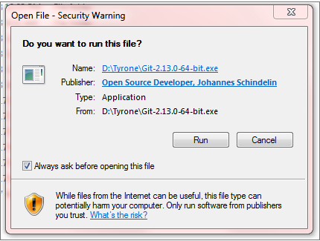

Step 2: Click Next when you are ready to continue with Setup

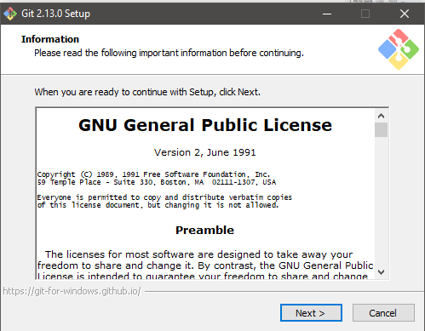

Step 3: Select where you want to install Git. To continue, click Next.

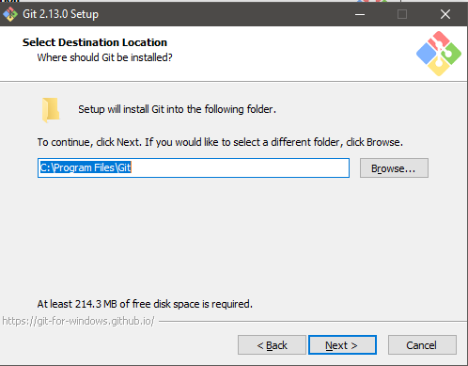

Step 4: Select the components that you want to install and Click Next when you are ready to continue.

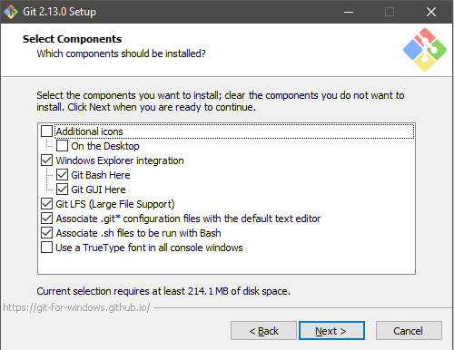

Step 5: To continue, click Next. If you would like to select a different folder, click Browse.

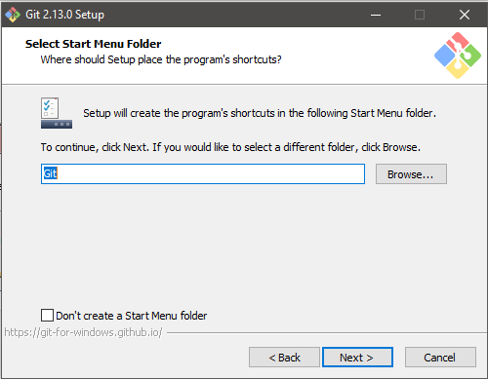

Step 6: Select your PATH environment, then click Next.

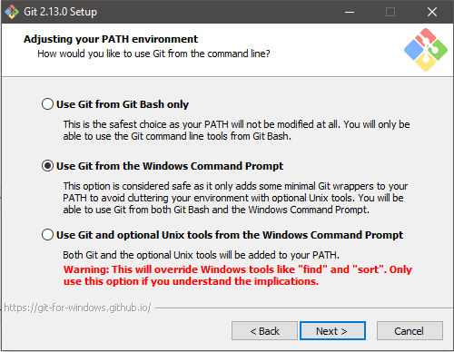

Step 7: Select which SSL/TLS library would you like Git to use for HTTPS connections, then click Next.

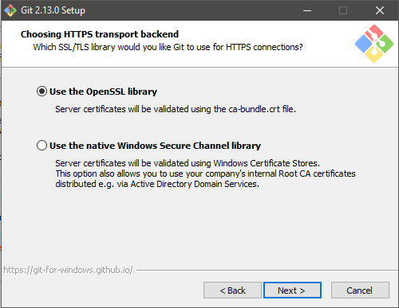

Step 8: Select how you want your Git treat line endings in text files, then click Next.

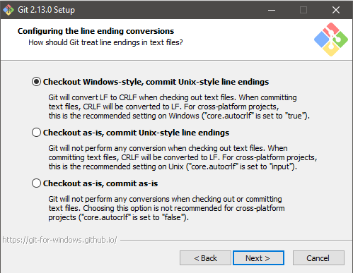

Step 9: Select which terminal emulator you want to use with your Git Bash, then click Next.

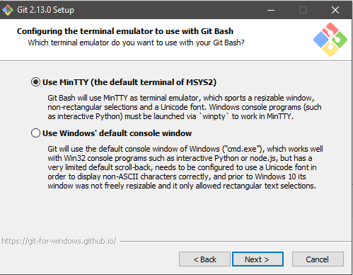

Step 10: Select which features you like to enable, then click Install.

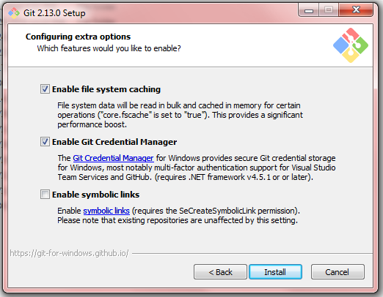

Step 11: Wait while Setup installs git on your computer.

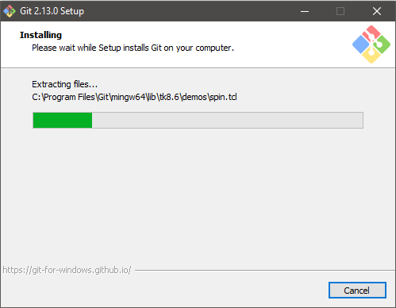

Step 12: Click Finish.

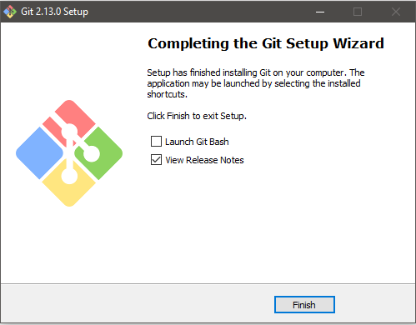

Installing TortoiseSVN-1.9.2.24708 64 bit

Step 1: Download the installer and run it.

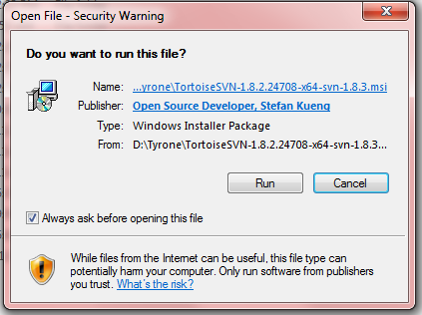

Step 2. Click Next when you are ready to continue with Setup.

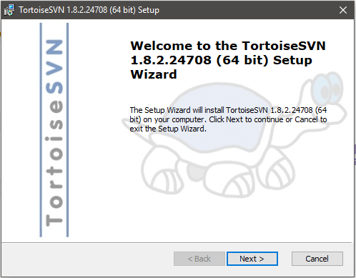

Step 3: Select “I accept the terms in the License Agreement”, then click Next.

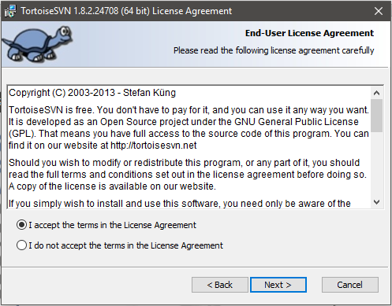

Step 4: Pick an install location and which features you want, then click Next.

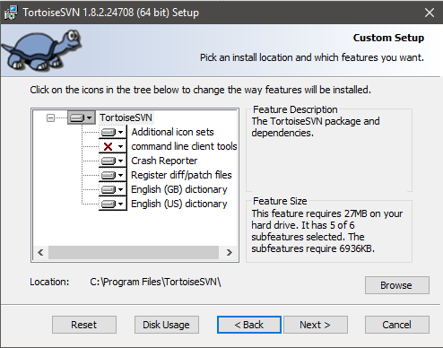

Step 5: Click Install to begin the installation.

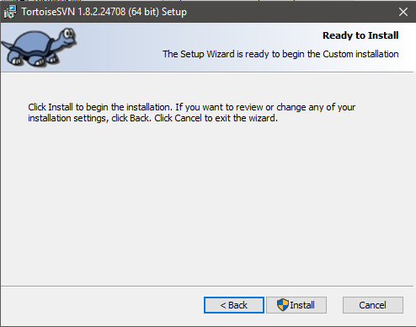

Step 6: Wait while the Setup Wizard installs TortoiseSVN 1.8.2.24708 64 bit

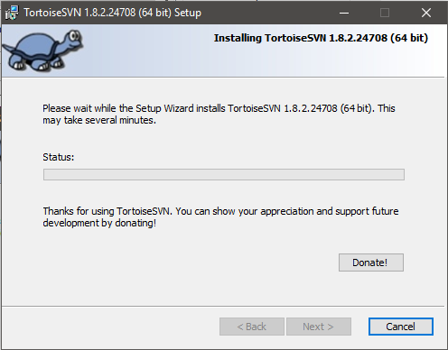

Step 7: Click the Finish button to exit the Setup Wizard.

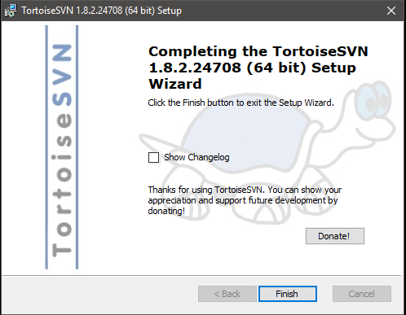

Adding/Commit a new file on GitHub.

Step 1: Find your repository on GitHub then click “Clone or download”.

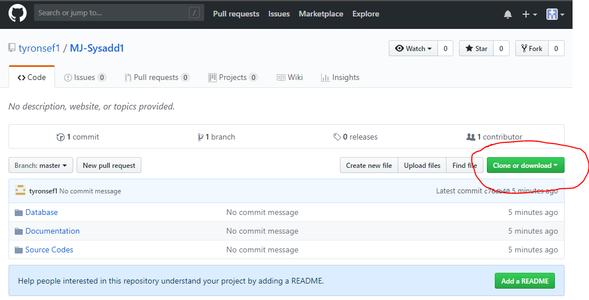

Step 2: Copy the link of that repository.

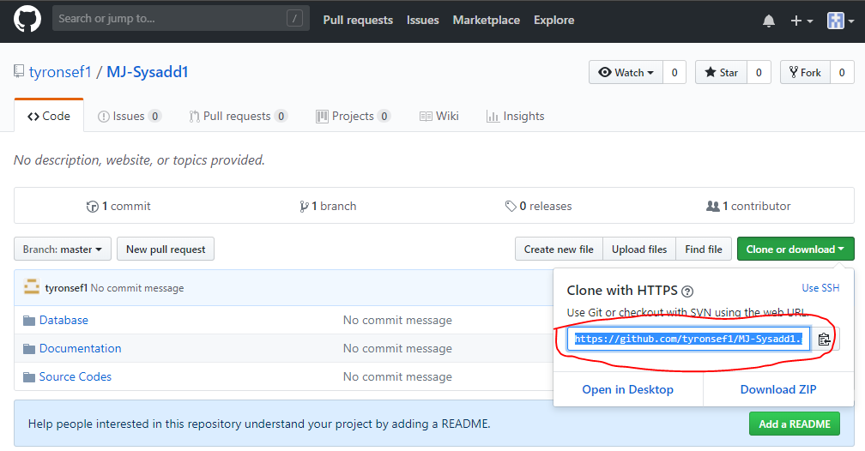

Step 3: Choose the location where you want the repository to be saved in and right click on an empty area, then click SVN Checkout.

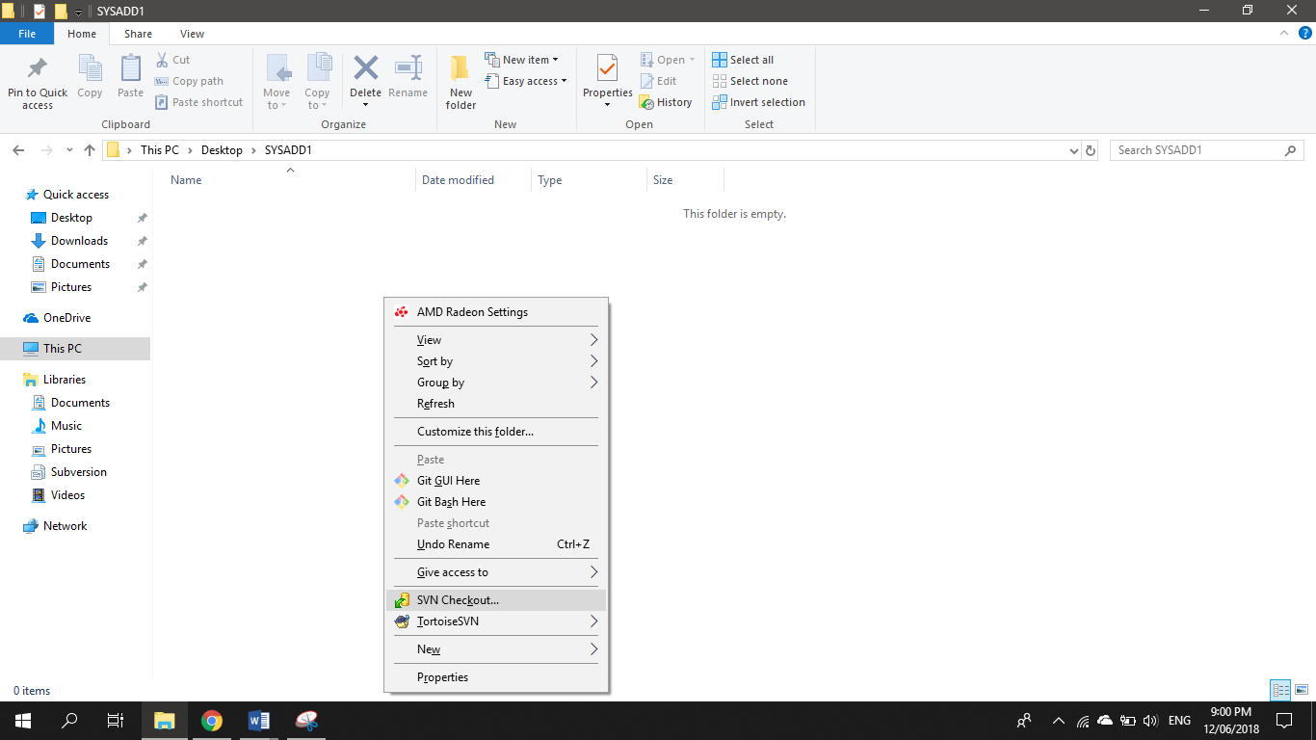

Step 4: Paste the link of the repository that you copied in step 2, then click OK.

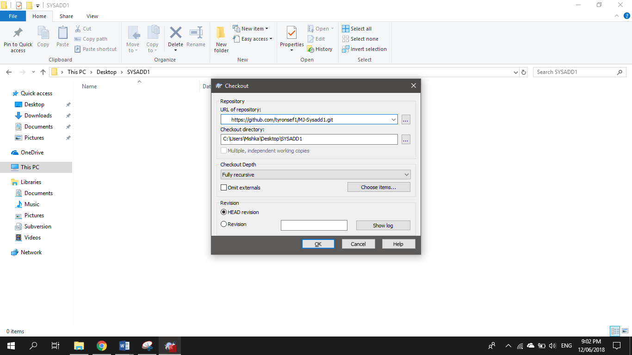

Step 5: Wait for a while.

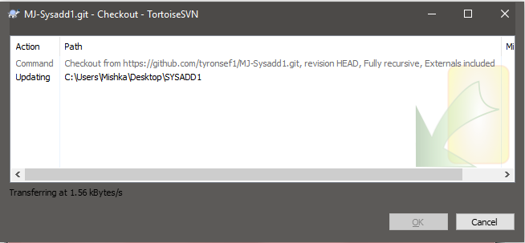

Step 6: Click OK once it’s finished.

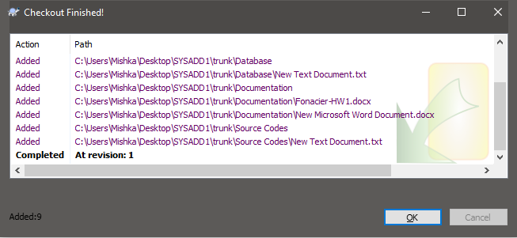

Step 7: Open the trunk folder.

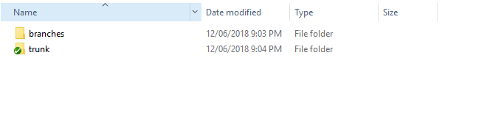

Step 8: Open the Documentation folder.

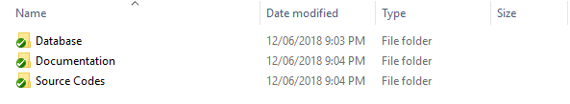

Step 9: Add the new file.

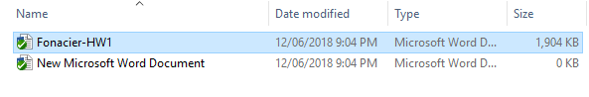

Step 10: Right click on an empty area, then click SVN Commit.

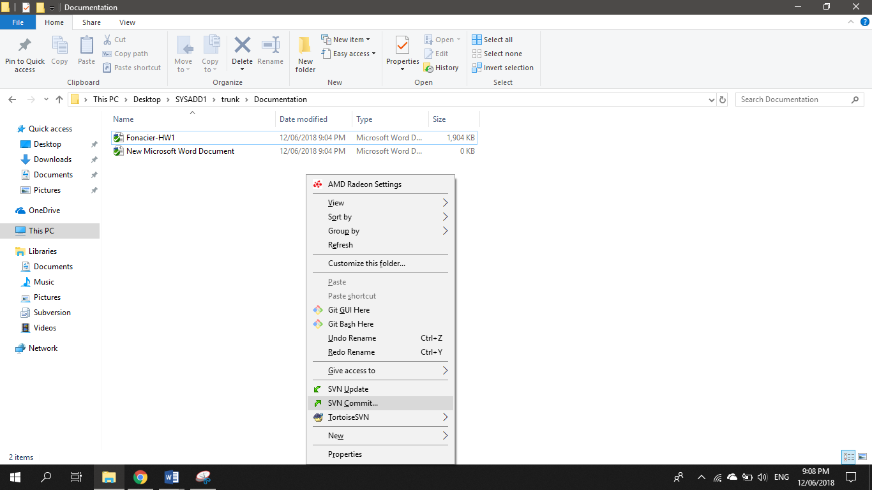

Step 11: Add a message, then click OK.

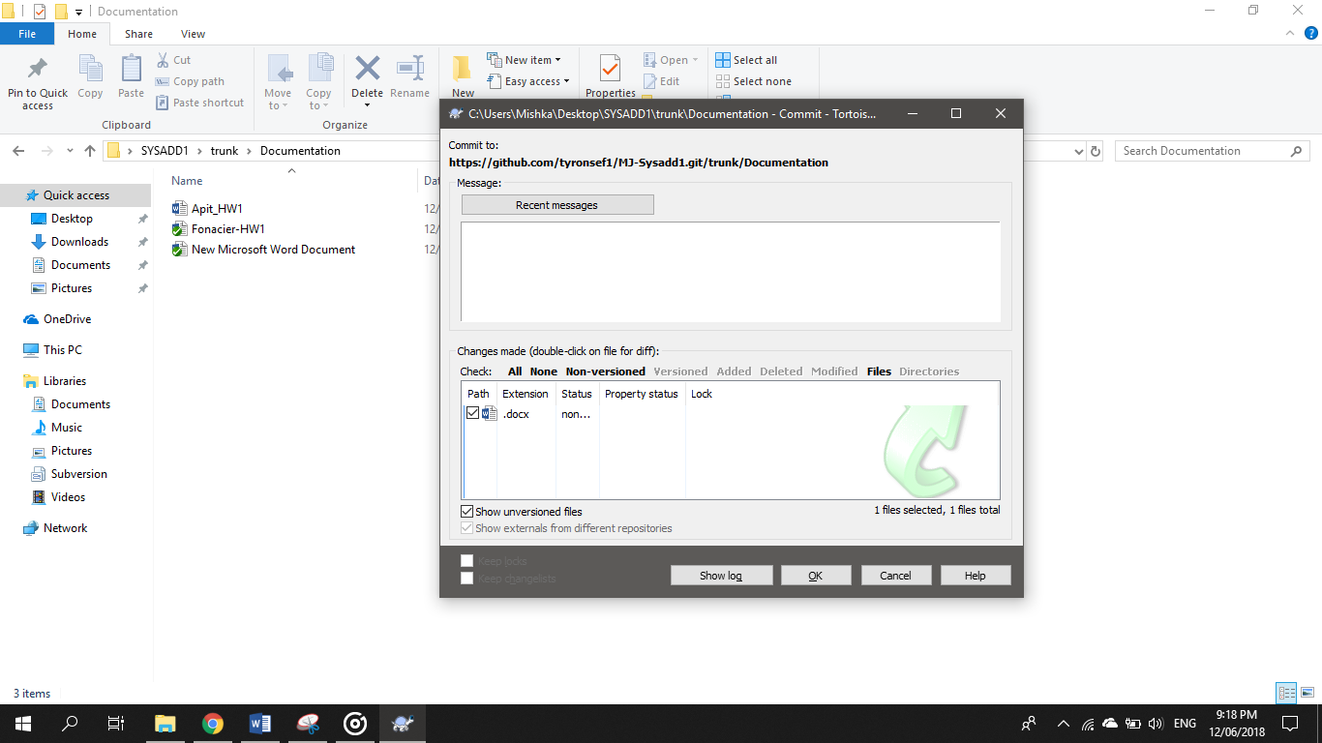

Step 13: Click OK once it’s finished.

