SSIS-to-ADF Migration Accelerator
Executive solution walkthrough
Automate predictable conversion, focus AI on uncertain logic, and use reconciliation as the proof of migration.
Prepared 29 October 2026

Executive walkthrough
Purpose: Help a customer move SSIS packages to Azure Data Factory with a repeatable process, explicit human decisions, and evidence that the new pipelines preserve the intended behavior.
Core proposition: Automate what is predictable. Use AI only where interpretation is required. Treat reconciliation—not generated code—as the proof of migration.

1. What the customer experiences
The customer points the solution to a folder, repository, or supported SQL Server source containing SSIS packages. One command creates the initial inventory, assessment, ADF assets, and review queue.
ssis-adf migrate --source <ssis-source> --workspace work/<migration-name>
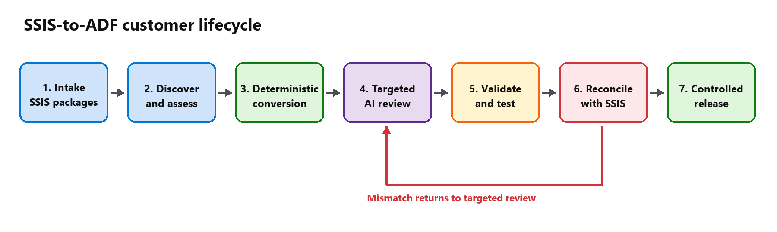
The customer does not receive a black-box conversion result. They receive the generated assets, the assumptions, the unresolved items, and the evidence required to approve each package.

2. What the customer provides
Input | Purpose
SSIS projects and .dtsx packages | Source logic to inventory and convert
SQL Agent or schedule metadata, when available | Preserve orchestration and timing
Connection and environment mappings | Replace on-premises endpoints with Azure targets
Representative test data or a controlled business-date window | Run SSIS and ADF against equivalent inputs
Business owners and acceptance criteria | Approve intentional differences and production readiness

Credentials are not embedded in reports or generated assets. Secret references should be mapped to Azure Key Vault or the customer’s approved secret-management standard.

3. End-to-end customer journey
Stage | What happens | Primary owner | Customer output
1. Intake | Create a migration workspace and capture the source package set | Customer + CLI | Versioned source scope
2. Discover | Parse packages, tasks, data flows, variables, connections, schedules, and dependencies | Deterministic engine | Estate inventory
3. Assess | Score complexity, classify conversion paths, identify unsupported or uncertain behavior, and group dependent packages | Engine + migration lead | Assessment and wave plan
4. Convert | Generate ADF pipelines, linked services, datasets, data flows, triggers, parameters, and code stubs for known patterns | Deterministic engine | ADF baseline
5. Resolve | Review only the explicit gaps: scripts, ambiguous SQL, error paths, lookup behavior, ordering, precision, or architecture choices | Copilot + engineer | Reviewed changes and decision log
6. Validate | Check artifact structure, references, expressions, dependencies, policies, and unresolved findings | Engine | Build-readiness result
7. Test and reconcile | Run SSIS and ADF on equivalent inputs; compare counts, totals, keys, hashes, rejects, and control-flow outcomes | Customer + engine + Copilot | Reconciliation evidence
8. Release | Promote approved assets, run in parallel, activate triggers, and retire the SSIS workload | Customer platform team | Release pack and cutover approval

Packages move through the process in dependency-aware waves. A package cannot advance because the generated code “looks right”; it advances only when the required gate evidence exists.

4. How work is divided
Deterministic Python engine | GitHub Copilot | Customer team
Parses SSIS and creates a canonical model | Explains unfamiliar or ambiguous logic | Defines target architecture and operating constraints
Applies versioned conversion rules | Proposes the smallest safe remediation | Reviews and approves decisions
Generates repeatable ADF assets | Drafts code for scripts or unsupported patterns | Provides environments, identities, and test data
Creates the review queue | Diagnoses failed tests and reconciliation mismatches | Executes business acceptance and cutover
Enforces workflow gates | Produces concise technical explanations | Owns production approval
Records evidence and status | Does not declare equivalence or approve production | Signs off on accepted outcomes

This division limits AI usage and keeps production decisions with accountable people.

5. Trust model
Gate | Decision | Minimum evidence
G1 — Assessment | Is the migration approach understood and owned? | Inventory, risks, dependencies, owners, target pattern
G2 — Build | Is the ADF implementation structurally complete? | Clean validation, resolved findings, reviewed dependencies
G3 — Test | Does the pipeline execute in development? | Successful runs, expected error-path behavior, run IDs
G4 — Reconciliation | Does it preserve required business behavior? | Counts, totals, key differences, row hashes, accepted tolerances
G5 — Cutover | Is it safe to make ADF the production system of record? | Clean parallel runs, monitoring, rollback plan, approval

Reconciliation is the decisive control
Typical comparisons include:
- row counts for successful, rejected, inserted, updated, and deleted records;
- control totals by business dimension;
- key-set differences in both directions;
- deterministic hashes over material columns;
- null, precision, rounding, and watermark checks;
- branch, error-path, and reject-path outcomes;
- runtime and service-level comparisons where required.
A mismatch creates a new review item and returns the package to remediation. It is not converted into a warning or silently accepted.

6. What the customer receives
Deliverable | Contents | Business value
Estate inventory | Packages, jobs, dependencies, connections, components, and schedules | Establishes scope and migration waves
Assessment report | Complexity, risks, supported patterns, assumptions, and decisions | Makes effort and risk visible before build
ADF implementation | Pipelines, linked services, datasets, data flows, parameters, triggers, and supporting code | Provides deployable source-controlled assets
AI review queue | Only logic that requires interpretation or design judgment | Focuses engineering time and AI cost
Decision log | Approved mappings, exceptions, owners, and rationale | Creates traceability and auditability
Validation and test evidence | Static checks, deployment results, and execution history | Demonstrates technical readiness
Reconciliation pack | Comparison rules, results, differences, tolerances, and sign-off | Demonstrates behavioral equivalence
Release pack | Deployment log, cutover checklist, rollback plan, and approvals | Supports controlled production transition

All assets remain in the customer’s repository and Azure environment.

7. Deployment and operating model
The solution is CLI-first. It can be run by a migration engineer directly or invoked by Copilot in agent mode. MCP is optional and is not required for the core workflow.
Customer workstation or build agent
├─ SSIS source packages
├─ ssis-adf CLI and deterministic rules
├─ Migration workspace and evidence
└─ GitHub Copilot for targeted review
│
▼
Customer Azure subscription
├─ Azure Data Factory
├─ Azure Key Vault
├─ Data stores and integration runtime
└─ Monitoring and CI/CD
Recommended controls:
- run the engine inside the customer’s controlled environment;
- keep customer packages and generated workspaces outside the public repository;
- store secrets in Key Vault;
- deploy triggers in a stopped state;
- require reviewed pull requests for generated and AI-assisted changes;
- preserve source, rule-set, decision, test, and reconciliation versions.

8. Current capability and intended product experience
The repository is a working accelerator, not yet a fully managed enterprise migration platform.
Capability | Available now | Target customer experience
Local package discovery and parsing | Yes | Add complete SSISDB, environment, and job discovery
Inventory, complexity, gaps, and dependency analysis | Yes | Add estate dashboards and automated wave optimization
Deterministic ADF generation | Yes, with documented coverage limits | Expand versioned conversion rules and connectors
Focused AI review queue | Yes | Add reusable remediation playbooks and approved rule promotion
Workflow state and readiness gates | Yes | Add richer approvals, resumability, and portfolio reporting
Static artifact validation | Yes, with known limitations | Add full reference, schema, expression, and policy validation
Development deployment | Yes | Add production-grade CI/CD templates and environment promotion
Reconciliation workflow | Evidence recording and sample implementations | Add reusable execution adapters and generated reports
Customer portal and managed service | No | Optional future interface; CLI remains the source of truth

No output should be represented as production-ready until its package-specific review, testing, and reconciliation are complete.

9. Example outcome
For the included customer transaction-risk sample, the solution:
- finds and parses the SSIS package;
- generates an ADF baseline without using AI;
- identifies three review items: lookup no-match routing, conditional-split ordering, and aggregate grouping;
- blocks build approval until those items are resolved;
- validates the generated assets;
- compares SSIS and ADF outputs across counts, amounts, keys, and hashes;
- records the evidence required for release.
The same operating model applies to a broader estate, with packages grouped into migration waves.

10. Executive takeaway
This solution is designed to be a customer-owned migration control plane, not a one-click code converter. Its value is the combination of:
- repeatable deterministic conversion;
- targeted use of AI for the work that requires judgment;
- transparent assumptions and decisions;
- reconciliation-led proof;
- customer ownership of code, evidence, and operating knowledge.
The practical next step is a controlled proof of value using a representative package set: one simple package, one transformation-heavy package, and one package with scripts or complex error handling.

