# Scenario 2.0: Borrow Item Limit bug 2

## Scenario Description

This scenario tests that the item limit of 2 items is correctly enforced when a user with 0 current loans attempts to borrow more than 2 items in a single session.

Tests that if a patron already has 2 items borrowed, they cannot return and add more in a later session.

## Version Control

|  |  |  |  |
| --- | --- | --- | --- |
| Version # | Date | Author | Description |
| 0.1 | 15/10/2022 | Ty Saunders | Initial Draft |
| 1.0 | 15/10/2022 | Ty Saunders | Initial Version |

## Test Scripts

The following scripts will cover this scenario:

2.1 Attempt to borrow items above the limit – Replicate bug

2.2 Attempt to borrow items above the limit in a later visit

## Use Case

* Customer with 0 current loans tries to borrow more than 2 items.
* Customer who has exceeded loan limit returns at a later time to borrow more items.

## Test Components / Requirements

Need a customer with 0 loans for script 1.

Need a customer who has borrowed multiple items in 1 session until the loan limit is enforced for script 2.

Bug reproduced if:

Customer is able to exceed the borrowing limit of 2 items.

## Script 2.1: Attempt to borrow items above the limit

### Script Description

* Customer with 0 current loans tries to borrow more than 2 items.

### Testing Objective

This test script covers the following specific testing requirements:

When customer with 0 loans tries to borrow more than 2 items they are denied.

### Setup

A patron with 0 outstanding loans.

***Test Data***

|  |  |
| --- | --- |
| Patron | PatronId: 1;  First Name: John;  Last Name: Smith;  Email: dotcom;  Phone: 1234 |
| Item Id | Type: Book;  Title: Yes;  Author: No;  CallNo: 1 |
| Item Id | Type: Book;  Title: Why;  Author: Because;  CallNo: 2 |
| Item Id | Type: Book;  Title: Above;  Author: Below;  CallNo: 3 |

### Teardown

* Return all items borrowed.

### Script Steps

| **Step #** | **Test Action** | **Expected Results** | **Pass/ Fail** | |
| --- | --- | --- | --- | --- |
| 1 | Type B press enter | Borrow Item UI opens | P | P |
| 2 | Type Patron number 1 press enter: | Scan item menu opens | P | P |
| 3 | Type item number 1 press enter | Item is added to borrow list | P | P |
| 4 | Type item number 2 press enter | Loan limit reaches should be displayed after 2 items. If it is not displayed, the code is buggy. | F |  |

## Script 1.2: Attempt to return later to borrow an item after exceeding limit

### Script Description

* Customer who who saw ‘loan limit reached’ in the GUI returns at a later time to borrow more items.

## Script 2.2: Attempt to return later to borrow an item after exceeding limit

### Script Description

* Customer who who saw ‘loan limit reached’ in the GUI returns at a later time to borrow more items.

### Testing Requirements

This test script covers the following specific testing requirements:

When customer who saw ‘loan limit reached’ tries to borrow more items later they are denied.

### Setup

A patron starting with zero loans, borrows multiple items in a single borrowing session until they see ‘loan limit reached’.

Start with a patron with 0 loans

Borrow items until loan limit is reached is displayed on the GUI, then commit the loans.

***Test Data***

|  |  |
| --- | --- |
| Patron | PatronId: 1;  First Name: John;  Last Name: Smith;  Email: dotcom;  Phone: 1234 |
| Book | Type: Book;  Title: Outside;  Author: Inside;  CallNo: 4 |

### Teardown

* Return all items borrowed.

### Script Steps

| **Step #** | **Test Action** | **Expected Results** | **Pass/ Fail** | |
| --- | --- | --- | --- | --- |
| 1 | Type B press enter | Borrow Item UI opens | P | P |
| 2 | Type Patron number 1 press enter: | Patron is denied from borrowing. If patron is not denied then bug is reproduced: | P | P |

***Run results:***

***Run 1 results - Script 1***

***FAILED.***

**Step 1:**

Borrow item1

**Step 2**:

Borrow item 2, if code is working correctly, item limit reached will be displayed.

Actual result:

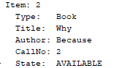

**Step 3:**

Keep borrowing until item limit reached:

Result – 3 items borrowed:

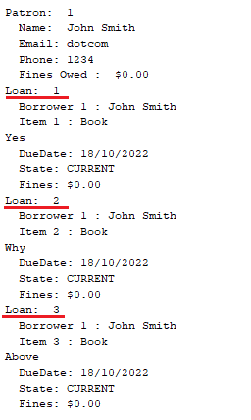

***Run 1 results – Script 2:***

***FAILED.***

**Step 1:**

Starting with a patron who has exceeded borrow item limit, attempt to borrow an item in a new visit.

Result – An extra item was borrowed bringing the total to 4 items

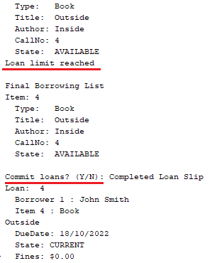

***Run 2 results - Script 1***

***Run 2 results - Script 2***

### Test Execution

|  |  |  |  |  |
| --- | --- | --- | --- | --- |
| Date/Time | Tester | Test ID | Test Phase | Status |
| 15/10/2022 | Ty Saunders | Ty | System Cycle 1 | Failed |
|  |  |  |  |  |