Linda Zall

The Environmental Spy

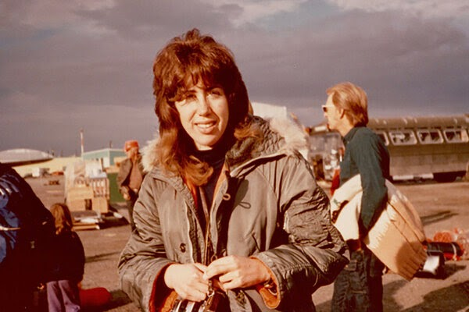

Tyler Schmalenbach
BIOSC-170-9085
Prof. Levy
January 28, 2022

Linda Zall – The Environmental Spy

