Experiment name: _______________

Participant ID: ______ Date (YYYY-MM-DD):

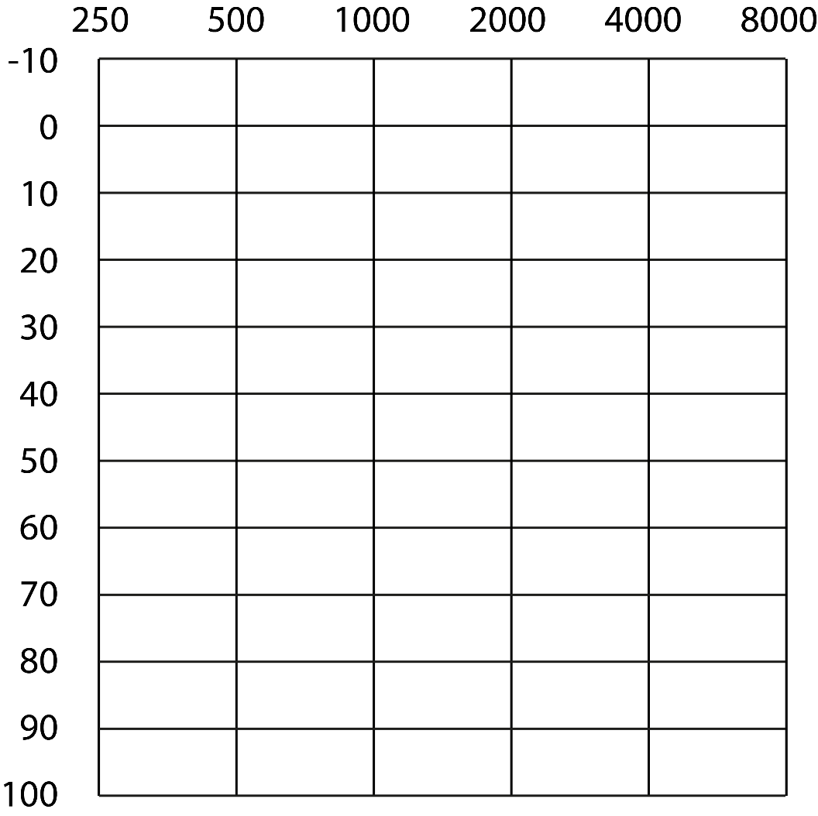

O – left ear X – right ear