InfoComm 2017
Sennheiser presents “Sennheiser for Business” portfolio at InfoComm 2017

Orlando, FL, June 5, 2017 – At InfoComm 2017 (June 14-16, Orlando, Florida), Sennheiser will showcase its comprehensive range of dedicated business products. For the first time at a US event of this kind, the audio specialist will be presenting the new TeamConnect Wireless Tray-M Set, a more compact configuration of the innovative wireless conferencing solution for up to 12 participants, as well as the SpeechLine Boundary 114-S DW microphone – a new wireless addition to the SpeechLine family. Sennheiser will also present two themed areas allowing visitors to explore its range of solutions for Education and for Houses of Worship.

“We are excited to offer the opportunity for US customers to learn more about our growing ‘Sennheiser for Business’ offering. This comprehensive 360° portfolio for the corporate market includes innovative solutions for personal communication, meeting & conferencing, presentation and visitor information,” said Andy Niemann, Director Business Communication. “Across all four of these areas there are huge transformations occurring as digital technologies transform the nature of the workplace, of collaboration and customer engagement. High quality audio is therefore becoming a vital asset to organizations of every size and in every industry. Sennheiser is excited to be presenting a strong portfolio of solutions to meet and exceed these rapidly evolving customer demands.”

TeamConnect Wireless Tray-M Set - Turn any room into a meeting venue

This year, Sennheiser has expanded its TeamConnect Wireless portable wireless conference system with the TeamConnect Wireless Tray-M Set. This more compact configuration - with two rather than four satellites – is a perfect solution for dedicated meeting rooms and conferences for up to 12 participants. Boasting award-winning design, TeamConnect Wireless provides excellent sound for online meetings. The system delivers multiple connectivity options with any smartphone, laptop or PC via Bluetooth, USB, or 3.5mm jack - brilliant flexibility to cater for a broad range of Unified Communications demands.

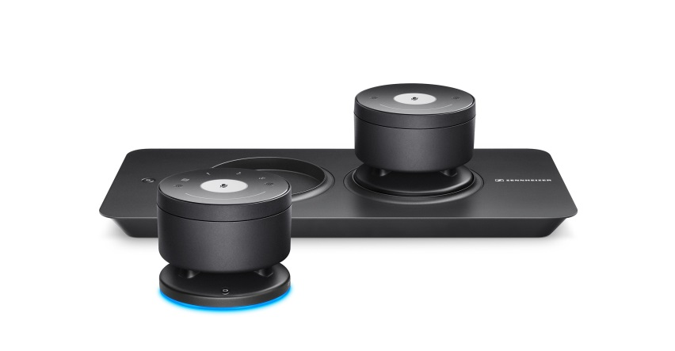 | The new and compact TeamConnect Wireless Tray-M Set comes with two satellites – serving as perfect solution for dedicated meeting rooms and conferences for up to 12 participants.

SpeechLine Boundary 114-S DW - The experience of simplicity with the freedom of wireless

Dedicated to speech, Sennheiser’s SpeechLine Boundary 114-S DW extends the capability of the TeamConnect conferencing system with a wireless solution. Easily adapted to any conference, it optimizes speech-intelligibility so that conference participants don’t need to speak directly into or even sit close to the microphone. As well as charging via USB, the SL Boundary 114-S DW offers the simplicity of wireless charging and is compatible with Sennheiser’s CHG 2W, an inductive charging solution that can charge two mobile devices simultaneously. The new microphone delivers a winning combination of performance, flexibility and intuitive fuss-free set-up and operation, with detailed monitoring and control made possible with Sennheiser’s comprehensive Control Cockpit software suite.

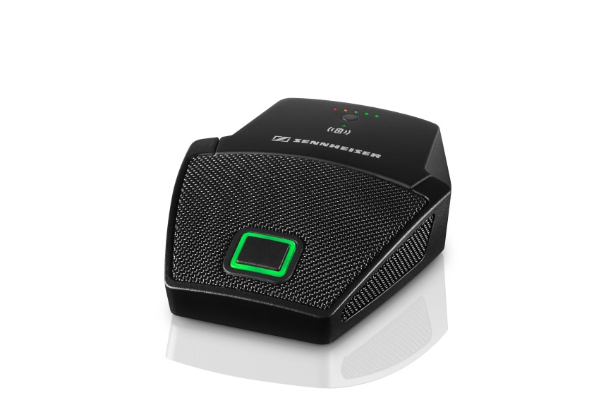 | The SpeechLine Boundary 114-S DW wireless microphone is the newest extension for the TeamConnect conferencing system.

Visit the Sennheiser Booth at InfoComm

Sennheiser’s booth at InfoComm (Audio Pavilion – booth 4947) will include a “Sennheiser for Education” showcase, which will feature products from the MobileConnect and speech-dedicated SpeechLine DW range. There will also be a Sennheiser for “House of Worship” showcase, allowing visitors to learn about solutions that help to meet the diverse needs of such institutions. These range from the newly launched Digital 6000, a high-end digital wireless solution ideal for mega-churches, to easy to use wireless options such as the XS Wireless 2 that’s well suited to small and mid-sized churches. This area will also present wired solutions for music including the evolution 600/800 series as well as solutions for in ear monitoring (2000 IEM series).

About Sennheiser
Audio specialist Sennheiser is one of the world's leading manufacturers of headphones, microphones and wireless transmission systems. Based in Wedemark near Hanover, Germany, Sennheiser operates its own production facilities in Germany, Ireland and the USA and is active in more than 50 countries. With 19 sales subsidiaries and long-established trading partners, the company supplies innovative products and cutting-edge audio solutions that are optimally tailored to its customers' needs. Sennheiser is a family owned company that was founded in 1945 and which today has 2,750 employees around the world that share a passion for audio technology. Since 2013, Sennheiser has been managed by Daniel Sennheiser and Dr. Andreas Sennheiser, the third generation of the family to run the company. In 2015, the Sennheiser Group had sales totaling €682 million. www.sennheiser.com
Local Contact Global Contact

Jeff Touzeau Esther Röttger
jeff@hummingbirdmedia.com esther.roettger@sennheiser.com
T: +1 (914) 602-2913 T: +49 (0) 5130 600 1023
M: +49 (0) 162 292 1922

