Sennheiser bids farewell to gerhard tammen on his retirement after 15 successful years working with the audio SPECIALIST

Wedemark, June 2, 2017 – On June 1st, Sennheiser bid farewell to Gerhard Tammen, Vice President Global Retail Channel, after fifteen years at the company. Gerhard Tammen took over the management of the audio specialist’s global distribution of consumer products at the beginning of 2015. In this role he worked alongside Guido Karbautzki, who will henceforth occupy the role alone. Prior to that, Gerhard Tammen was Managing Director of the German sales subsidiary, Sennheiser Vertrieb and Service GmbH & Co. KG (SVS).

“With his outstanding personality, Gerhard Tammen decisively influenced the German distribution company SVS and later Sennheiser’s Global Retail Channel. We are very grateful for his very successful and ever-reliable contribution," said Daniel Sennheiser, co-CEO of Sennheiser. "With his impressive energy and motivation, Gerhard has led many sales projects over recent years and has thereby contributed to the strengthening of our company," adds Dr. Andreas Sennheiser, co-CEO of Sennheiser.

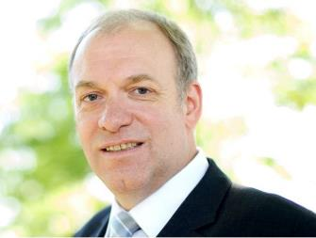
Sennheiser bids farewell to Gerhard Tammen after working together for many years.

Together with Hans-Joachim Weymer and Ties-Christian Gerdes, Gerhard Tammen successfully managed Sennheiser’s German sales subsidiary, SVS, from 2002 to 2012. Prior to that, he – as a managing shareholder of Diekhöner – was part of the successful merger of Sennheiser Vertriebs GmbH, Gerdes Elektronik GmbH and Walter Diekhöner KG. Mid-2012, Gerhard Tammen joined the Sennheiser headquarters as Vice President EMEA of the Global Sales Division, until he became the Vice President Global Retail Channel together with Guido Karbautzki in January 2015.

"We have consciously established the management of the Global Retail Channel as a two-person team to ensure a smooth transition. I am therefore very grateful to be able to hand over my tasks completely to Guido Karbautzki. In recent years, we have not only grown together as business partners but have also become close friends," said Gerhard Tammen.

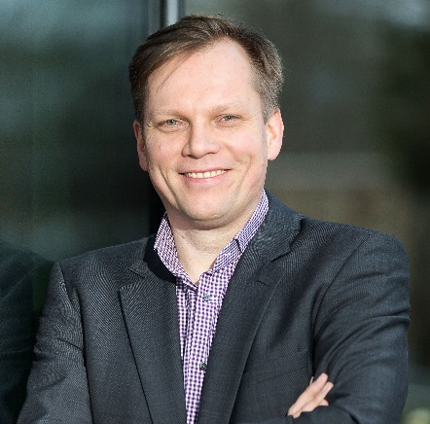
Guido Karbautzki took over the position as Vice President Global Retail Channel together with Gerhard Tammen at the beginning of 2015. On Tammen's retirement on June 1st, he will execute this role alone.

Guido Karbautzki has been working for Sennheiser since 2007 and started as Head of Sales and Marketing Communications for the Danish joint venture, Sennheiser Communications A/S in Ballerup. Five years later, he joined Sennheiser electronic GmbH & Co. KG in Wedemark, where he was responsible for the cooperation with Sennheiser’s sales partners as well as key account management as Director Country Partner Sales.

After 15 years at Sennheiser, Gerhard Tammen is now saying goodbye to Sennheiser and the CE industry: "At Sennheiser, I experienced exciting times with many great but also challenging projects. I will remember my time with the company in the best possible way."

About Sennheiser
Audio specialist Sennheiser is one of the world's leading manufacturers of headphones, microphones and wireless transmission systems. Based in Wedemark near Hanover, Germany, Sennheiser operates its own production facilities in Germany, Ireland and the USA and is active in more than 50 countries. With 19 sales subsidiaries and long-established trading partners, the company supplies innovative products and cutting-edge audio solutions that are optimally tailored to its customers' needs. Sennheiser is a family owned company that was founded in 1945 and which today has 2,750 employees around the world that share a passion for audio technology. Since 2013, Sennheiser has been managed by Daniel Sennheiser and
Dr. Andreas Sennheiser, the third generation of the family to run the company. In 2015, the Sennheiser Group had sales totalling €682 million. www.sennheiser.com

Global Contact
Sennheiser electronic GmbH & Co. KG
Mareike Oer
Head of Global Public Relations
T +49 (0)5130 600-1719
mareike.oer @sennheiser.com

