Annual Report 2016: SENNHEISER sees REDUCED turnover but INCREASED Profitability

Wedemark, 21stJune 2017 – In the fiscal year 2016, the Sennheiser Group generated a turnover of €658.4 million. This corresponds to a decline of 3.8 percent, primarily due to placing greater focus on the core business. During the reporting year, the audio specialist exited the aviation segment and also ended relationships with third-party brands in the Professional Systems Division. In addition, the termination of governmental subsidies in Japan affected the turnover. The Group's profit before taxes rose by 15.2 percent to €34.9 million compared to the same period in the previous year. Research and development were further strengthened: Sennheiser invested €54.5 million, which is a total of 16 percent more than in 2015.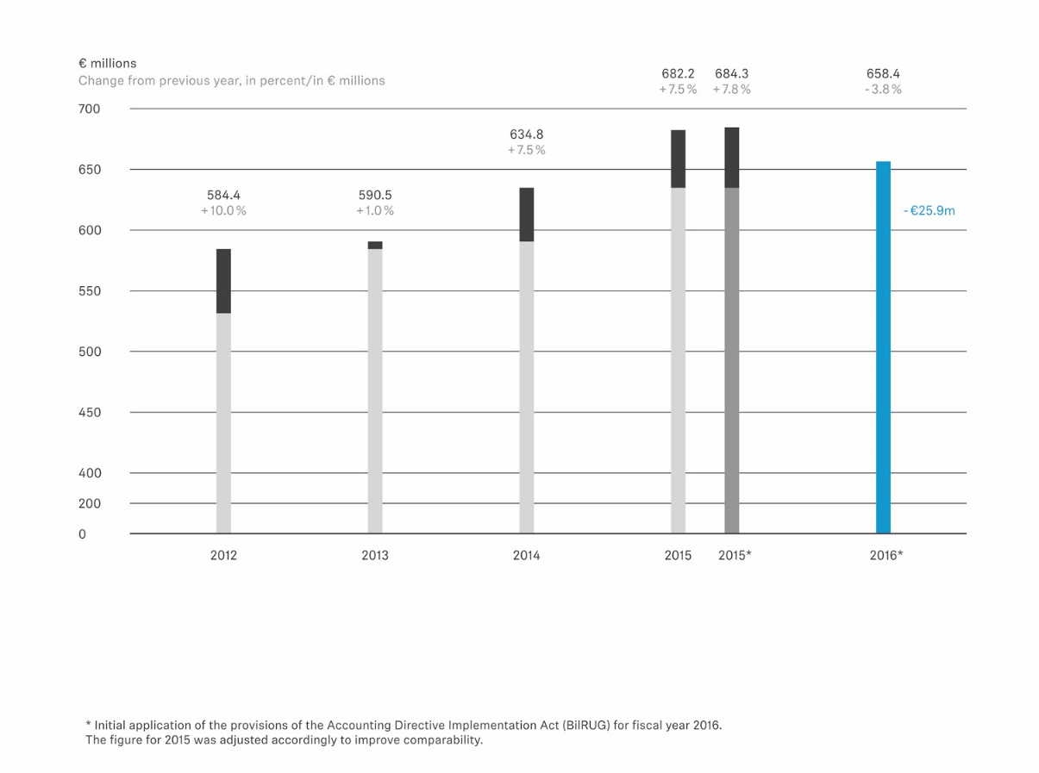
"Coming from a very strong year in 2015, we were unable to build on the previous turnover growth in the reporting year. This was mainly due to placing strategic focus on core business in our Professional Systems Division," explains Dr. Andreas Sennheiser, Co-CEO of Sennheiser. "At the same time, in 2016 we did a lot of groundwork to ensure our future success by delivering even greater innovation and value to our customers," adds Co-CEO Daniel Sennheiser. “As a family-owned company, we focus on the long term and pursue a clear goal: shaping the future of audio.”

Despite the decrease in turnover, the Sennheiser Group was able to significantly increase its profitability. In fiscal year 2016, profit before taxes increased by €4.6 million to €34.9 million, which was mainly due to reduction in material, personnel and other operating expenses.

EMEA region grows, APAC region declines

€358.2 million of the total sales of the Sennheiser Group were accounted for by the EMEA region, which showed a slight turnover growth of 0.3 percent compared to the previous year. In the Americas region, the group achieved €168.8 million, 6.1 percent less than in 2015.

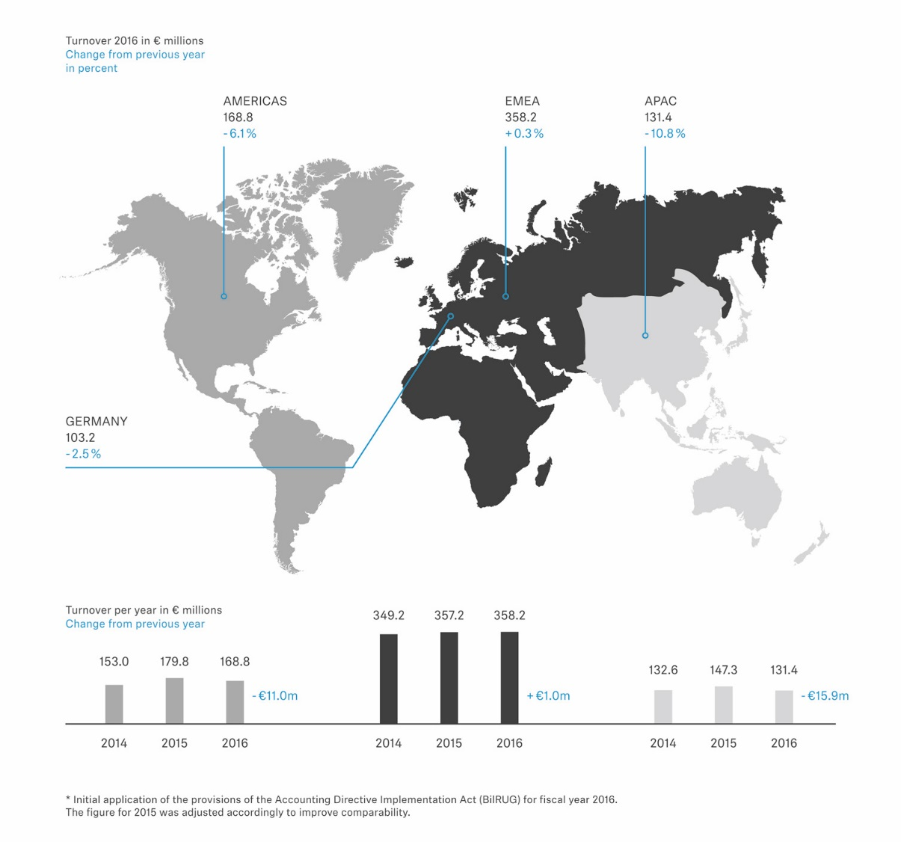

In the APAC region, Sennheiser realized €131.4 million, a decrease of 10.8 percent compared to the previous year. The decline in turnover is in particular due to the phasing-out of a special situation: As planned, the Japanese government stopped subsidizing wireless microphone systems at the end of the first quarter. These subsidies had a positive effect on turnover especially in reporting year 2015.

Professional Systems Division turnover dipped, Consumer Electronics Division continues to grow

The turnover of the Professional Systems Division amounted to €316.3 million, a decrease of €31.7 million or 9.1 percent compared to the previous year. This can mainly be attributed to the withdrawal from the aviation business, the separation of selected third-party brands and the end of the governmental subsidies in Japan. In contrast, the Consumer Electronic Division continued its growth, generating turnover of €342.1 million. Compared to the previous year, growth was slightly more modest, at €5.8 million and 1.7 percent, respectively.

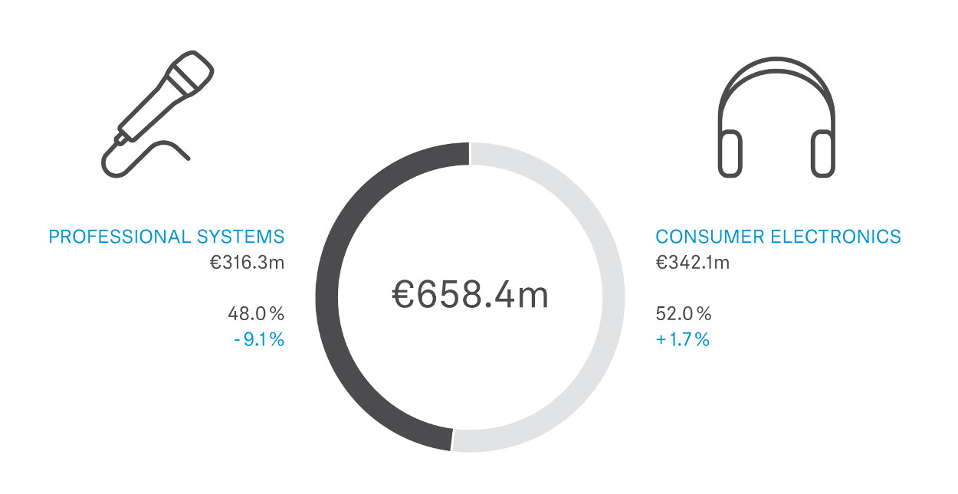

"Last year, we set up our product portfolio in both divisions to be well prepared for the future: For example, wired solutions will hardly be in demand a few years from now – a continuous development that we are reflecting in our products," says Dr. Andreas Sennheiser.

During fiscal year 2016, the Professional Systems Division launched wireless solutions such as the SpeechLine Digital Wireless microphone series, the TeamConnect Wireless conference system and the EK 6042 two-channel camera receiver for professional video coverage. In addition, Sennheiser presented a new digital wireless microphone system – Digital 6000, which entered the market in early 2017.

"In the Consumer Electronics Division, we put an emphasis on expanding our wireless headphone portfolio," says Daniel Sennheiser. "With the PXC 550 Wireless we have been able to once again demonstrate our leadership claim in the area of noise cancelling travel headsets."

The number of Sennheiser employees worldwide is rising
On an annual average, the Sennheiser Group had 2,725 employees – an increase of 1.8 percent compared to the previous year. At the end of the year 2016, Sennheiser employed approximately 2,830 people worldwide. The share of the employees working in Germany (51 percent) and abroad (49 percent) was more or less equal. The number of trainees remained on a high level of 69.

New innovations thanks to strengthened research and development
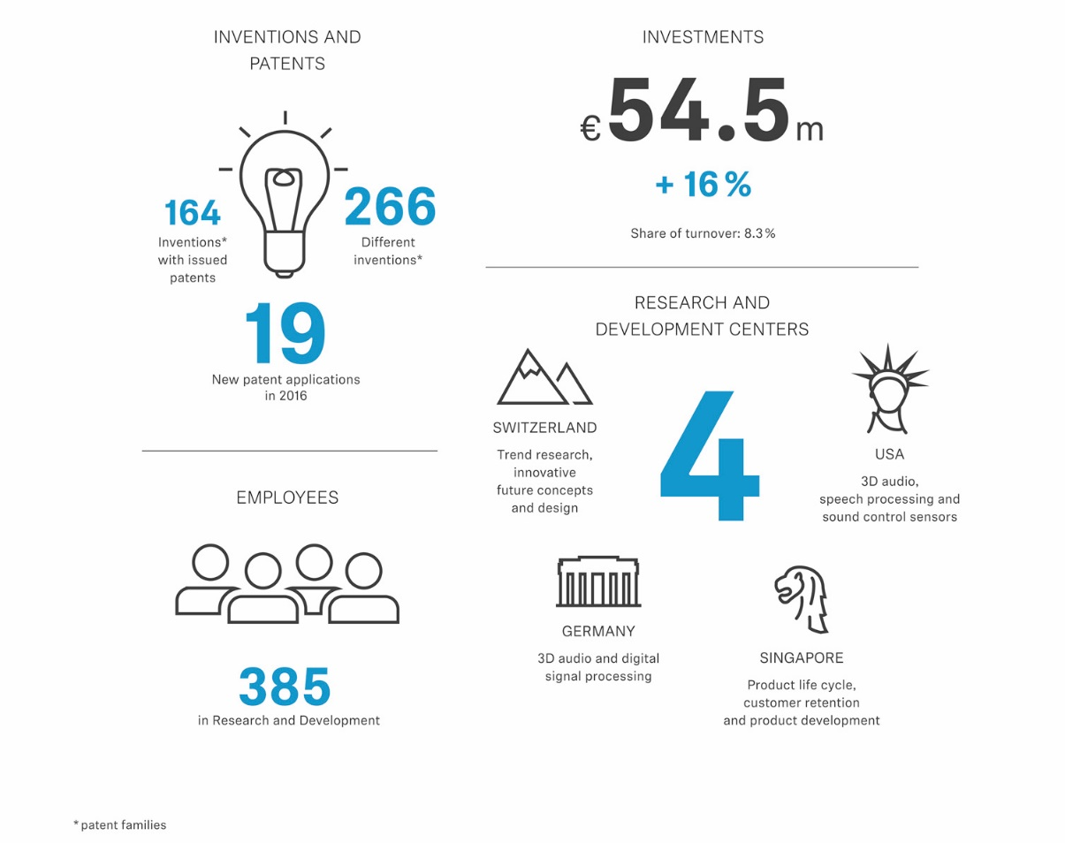The Sennheiser Group once again increased its investment in research and development activities by 16 percent to €54.5 million compared to the previous year. Research and development expenses thus amounted to 8.3 percent of turnover. In total, 385 employees worked in four research and development centers.

"The strategic lighthouse project of our research and development work is AMBEO. 3D audio formats will be a significant driver for innovation in the field of audio in the future – whether it's recording, processing or reproduction. AMBEO is a framework for us to develop various hardware and software products as well as workflows," explains Daniel Sennheiser. "We have already introduced some products under the AMBEO trademark. With the AMBEO SMART HEADSET, which will enter the market soon, 3D audio will now also become available to end consumers," adds Dr. Andreas Sennheiser. "It’s all about creating audio experiences that are so realistic that the listener cannot determine the difference between reality and reproduction anymore."

About Sennheiser
Sennheiser is shaping the future of audio – a vision built on more than 70 years of innovation culture, which is deeply rooted within the family-owned company. Founded in 1945, Sennheiser is one of the world’s leading manufacturers of headphones, microphones and wireless transmission systems. With 20 sales subsidiaries and long-established trading partners, the company is active in more than 50 countries and operates its own production facilities in Germany, Ireland and the USA. Sennheiser has around 2,800 employees around the world that share a passion for audio excellence. Since 2013, Sennheiser has been managed by Daniel Sennheiser and Dr. Andreas Sennheiser, the third generation of the family to run the company. In 2016, the Sennheiser Group had sales totaling €658.4 million. www.sennheiser.com

Global Press Contact
Sennheiser electronic GmbH & Co. KG
Mareike Oer
Head of Global Public Relations
T +49 (0)5130 600-1719
mareike.oer@sennheiser.com

