Sennheiser DIGITAL 9000 Series provides Ed Sheeran with transparent sound for his DIVIDE Tour

Wedemark, June 22, 2017 – Ed Sheeran has always enjoyed huge popularity, but with ÷ (Divide) having dominated the international album charts since its release and the accompanying ÷ Tour selling out the instant dates were announced, it has never been higher. The tour began in Europe in Italy’s Turin in March, travelling to Switzerland, Germany, Sweden, Denmark, the Netherlands, Belgium, France and Spain before heading to the arenas of the UK and Ireland. It has worked its way round South America, Central America and Mexico in May and June, then back to the UK before heading over to the US. Ed is once again using Sennheiser’s flagship Digital 9000 Series microphone system and 2000 series wireless monitors, supplied by production company Major Tom.

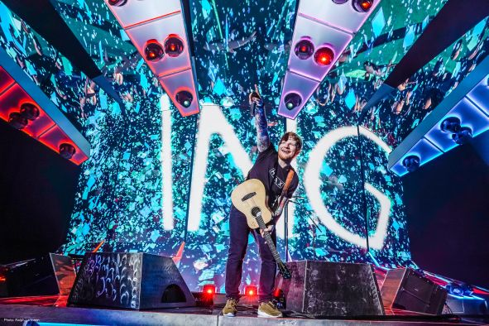 | Ed Sheeran performing with his Digital 9000 wireless microphone system during the ÷ Tour  (Photo credit: Ralph Larmann/larmann.com)

Chris Marsh, Ed’s Production Manager, as well as front-of-house and monitor engineer, has been with the singer for six years and has an intimate understanding of what he wants and needs. Ed has been using Sennheiser microphones from the very start and switched to Digital 9000 during his 2014 US tour for his vocal, loop vocal and guitar.

“We had Ed’s guitar on a cable and DI for four years, because I simply couldn’t find a wireless system that gave us the sound that we needed to deliver his performance,” Chris explains. “On first listening to the 9000 system, we discovered it was the most transparent sounding system we had ever heard. We were only meant to be checking it out on a soundcheck, but Ed and I both agreed we had to use it that night, and we have ever since.”

Four mic channels are dedicated to Ed’s acoustic guitars, one channel for electric guitar and three channels for vocals – main, spare and loop vocal.

Ed Sheeran playing the 02 Arena in London  (Photo credit: Ralph Larmann/larmann.com) | 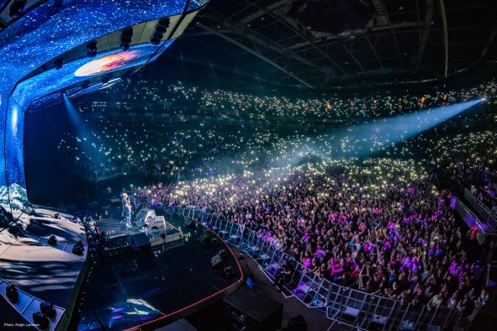

“For the loop vocal I use an MMD 945 super-cardioid capsule,” says Chris. “As this vocal gets looped and repeated throughout the songs I can’t risk there being too much background noise, so the tight pickup of the 945 is perfect.

“Ed’s main vocal is a cardioid MD 9235 dynamic capsule which captures a lot of detail. Importantly, it copes very well with being handled heavily and cupped a lot, which is Ed’s style. I use the Sennheiser 2050 wireless in ear monitors as they are rock solid, which is all that really matters to Ed.”

“Sennheiser has a long-standing relationship with both Chris and Ed,” says Jack Drury, Artist Relations Manager for Sennheiser. “We’re delighted that Digital 9000 has proved to be the perfect choice for him, both in its performance and its robustness for his demanding tours.”

“Sennheiser has been very supportive of us,” Chris concludes. “There have been times where we could not ship our rig, or were flying in to perform one-offs and they have always helped me source the equipment I need and been on hand for technical support 24/7.”

About Sennheiser
Sennheiser is shaping the future of audio – a vision built on more than 70 years of innovation culture, which is deeply rooted within the family-owned company. Founded in 1945, Sennheiser is one of the world’s leading manufacturers of headphones, microphones and wireless transmission systems. With 20 sales subsidiaries and long-established trading partners, the company is active in more than 50 countries and operates its own production facilities in Germany, Ireland and the USA. Sennheiser has around 2,800 employees around the world that share a passion for audio excellence. Since 2013, Sennheiser has been managed by Daniel Sennheiser and Dr. Andreas Sennheiser, the third generation of the family to run the company. In 2016, the Sennheiser Group had sales totaling €658.4 million. www.sennheiser.com

Local Contact Global Contact

Sarah James Stephanie Schmidt
sarah@gasolinemedia.com stephanie.schmidt@sennheiser.com
+44 (0)1372 471472 +49 (5130) 600 – 1275

