Sennheiser and Neumann Microphones and Wireless Technology Power the UNusual Sounds of Blue Man Group

Las Vegas, Nevada, June 27, 2017 – Since it first graced the stage of the Astor Place Theatre in New York City twenty-five years ago, Blue Man Group has riveted audiences with a completely original combination of colorful visuals, compelling percussion-based music, and interactive theater. With shows around the United States in cities like Chicago and Las Vegas, as well as internationally via a show in Berlin and a World Tour slated to begin again soon, Marcus Ross, resident audio supervisor and sound designer for Blue Man Productions, is committed to ensuring a seamless audio experience for each and every audience member. He achieves this with Sennheiser and Neumann microphones and Sennheiser wireless systems.

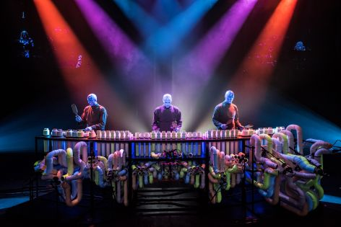 | Blue Man Group performances are remarkable in part for their use of unconventional instrumentation, featuring an array of percussive sound-makers made from materials including PVC.  (Photo credit: Lindsey Best, courtesy Blue Man Group)

Blue Man Group performances are remarkable in part for their use of unconventional instrumentation, featuring an array of percussive sound-makers made from materials including PVC. Ross has a simple philosophy regarding microphone selection for the myriad instruments: “I always like a mic that’s as transparent as possible so I can hear the instrument I’m miking,” he says. “And that’s something I get from Sennheiser and Neumann.”

Capturing the Unconventional
Capturing the range of tones produced by Blue Man Group’s numerous PVC instruments is no simple task, but Ross easily transfers their unique sonic qualities to the audience with a dozen Neumann KM 184 mics. “Neumann and Sennheiser give me the clearest representation of the instruments that I’m miking, and that’s one of the reasons why the KM 184 is perfect for capturing the sound of the specialized instruments that are part of our productions.”

Ross reaches for the Sennheiser e 602-II on several of the large drums that feature in the performance, owing to its low-end extension, and even combining it with the e 904 for some of the largest drums in the production.

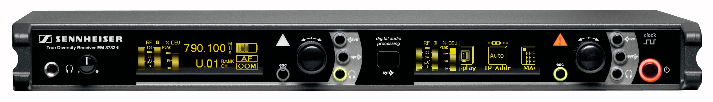 | The Blue Man Group production team relies on sixteen channels of Sennheiser EM 3732-II receivers to capture their use of unconventional instrumentation.

World-Class Precision
For the World Tour, which kicks off again on August 7th in Tel Aviv, Israel, Ross elected to skip a conventional stereo overhead mic pair for the drum kit in favor of a close miking of the kit’s cymbals and hi-hats. This approach provides additional control that Ross finds helpful. “We use the Neumann KM A body with the KK 145 capsule for the hi-hats because of the natural low-end roll-off, which gives us exactly the frequencies we need from them,” he says.

“For the other cymbals it’s the KM A body again but with KK 120 figure-8 capsules. We place these right under the bell of the cymbals, so the isolation is great and we can easily adjust the level of each cymbal individually in the mix without bringing up ambient noise. This setup gives us a lot of control that really helps us both on the in-ear monitor side and on the front-of-house mix side.”

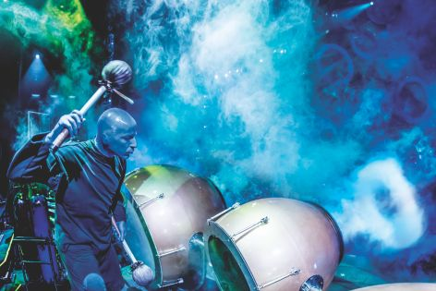 | The Sennheiser e 602-II microphone is routinely used on several of the large drums that feature in Blue Man Group. This is often used in combination with the Sennheiser e 904 for some of the largest drums in the production.  (Photo courtesy Blue Man Group)

Sennheiser and Neumann mics are also also heavily employed on the kit’s drums. “We use the e 901 and e 902 combination on the kick drum, which works great,” Ross says. He then turns to e 904 mics for all of the kit’s toms. A Neumann KM 184 is selected for the bottom of the snare drum.

A Liberating Experience
Sennheiser wireless transmitters and receivers help free Blue Man Group’s performers to move about the stage during the show and deliver their unique combination of musical performance and theatrics. Ross employs compact SKP 3000 transmitters to convert any mic of his choosing into a wireless mic. “With the SKP 3000 we’re able to provide phantom power that makes it very versatile,” he says. “And some of the other features on the transmitter are very handy, such as the great sensitivity control and pads. There was no other manufacturer that was going to give us the amount of options that we have with that system.”

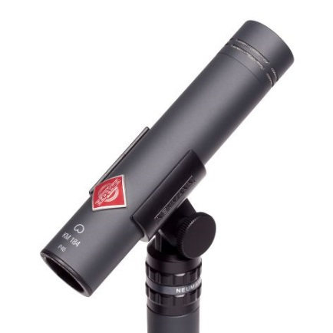 | The inimitable Neumann KM 184 small-diaphragm condenser microphone is used to capture Blue Man Group's famous PVC-based instruments.

Ross uses sixteen channels of EM 3732-II receivers reinforced further by four EM 500 G3 receivers to provide twenty channels of wireless capacity for the show. “There’s one sequence during a song called Bug where we’ve got 18 channels going at a time, so it’s pretty demanding from an RF perspective,” Ross explains.

The Sennheiser Wireless Systems Manager software allows Ross to further expand his wireless system’s capabilities by enabling him to reprogram all the receivers on the fly simply by loading a preset. “WSM allows us to have more transmitters than receiver channels, which is important because it enables us to have a transmitter for each instrument and avoid having to move the transmitters from instrument to instrument during the show,” he says. “We just load our next preset at the right point during the show, the receivers tune into the next set of frequencies, and we’re getting the correct signal from the correct instrument.”

Each night, during its performances around the world, Blue Man Group uses a combination of both conventional and unconventional instruments.  (Photo courtesy Blue Man Group) | 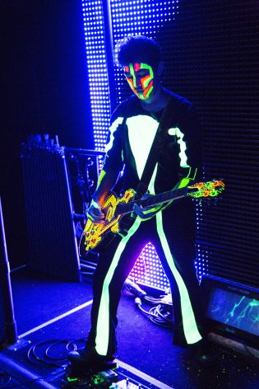

This comes in handy for some of the notable instruments that appear only during a certain segment of the performance, such as the iconic ‘drumbone,’ a fan-favorite tuned percussion instrument that has been part of the show since its earliest days. “We have two mics and transmitters hidden inside it,” he says. “It’s pretty covert.”

Sennheiser wireless monitors round out the system, with EK 2000 bodypack receivers worn on a harness under the clothes of the performers. “They’re compact and reliable, and they have a handy kill switch built in in case they want to cut off the signal to their ears for any reason.” Sennheiser’s staff has also helped Ross and his team deliver the wireless they need efficiently. “Sennheiser has really taken away a lot of the challenges in what could otherwise be a challenging RF environment.”

A Higher Standard
While the high-performance standards of Sennheiser and Neumann gear help them stand out, it may be the service that keeps Ross coming back. “Sennheiser support has been great no matter where we are in the world,” he says. “They’re never more than an email away.” It is a valuable thing for Ross, who is responsible for so many shows running concurrently at different locals, each relying heavily on Sennheiser and Neumann products.

“My most important goal is repeatability. I want to ensure that the show sounds just as good night after night, from every seat in the house, with different Blue Men or different musicians, or in the case of the touring production in all different theaters. Sennheiser products not only perform very well sonically, they are built to last and are actively supported by the manufacturer. Sennheiser stands by their products and that’s why I stand by Sennheiser.”

About Sennheiser and Neumann
Sennheiser is shaping the future of audio – a vision built on more than 70 years of innovation culture, which is deeply rooted within the family-owned company. Founded in 1945, Sennheiser is one of the world’s leading manufacturers of headphones, microphones and wireless transmission systems. With 20 sales subsidiaries and long-established trading partners, the company is active in more than 50 countries and operates its own production facilities in Germany, Ireland and the USA. Sennheiser has around 2,800 employees around the world that share a passion for audio excellence. Since 2013, Sennheiser has been managed by Daniel Sennheiser and Dr. Andreas Sennheiser, the third generation of the family to run the company. As part of the Sennheiser Group, Georg Neumann GmbH, known as “Neumann.Berlin”, is the world’s leading manufacturer of studio microphones. Founded in 1928, the company has been recognized with numerous international awards for its technological innovations. Since 2010, Neumann.Berlin has expanded their expertise in electro-acoustic transducer design to include the studio monitor market. In 2016, the Sennheiser Group had sales totaling €658.4 million.
www.sennheiser.com | www.neumann.com

Local Contact Global Contact

Jeff Touzeau Stephanie Schmidt
jeff@hummingbirdmedia.com stephanie.schmidt@sennheiser.com
+1 (914) 602-2913 +49 (5130) 600 – 1275

Andreas Sablotny
andreas.sablotny@neumann.com
+49 (30) 417 724 – 19

