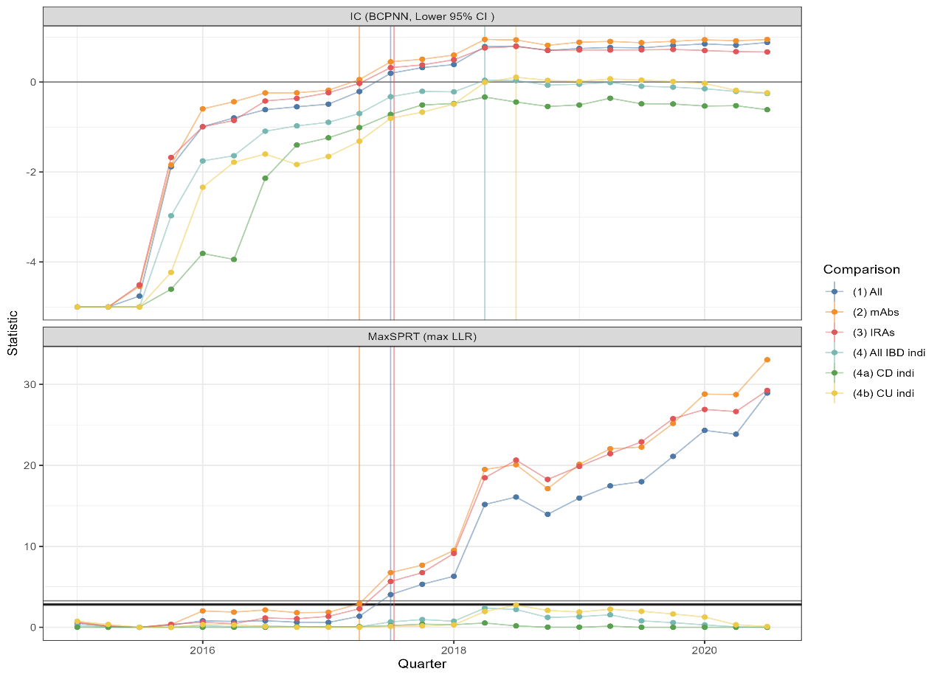**1(a) End of period snapshot vedol/panc signal detection 1(b) over time signal detection for vedol/panc**

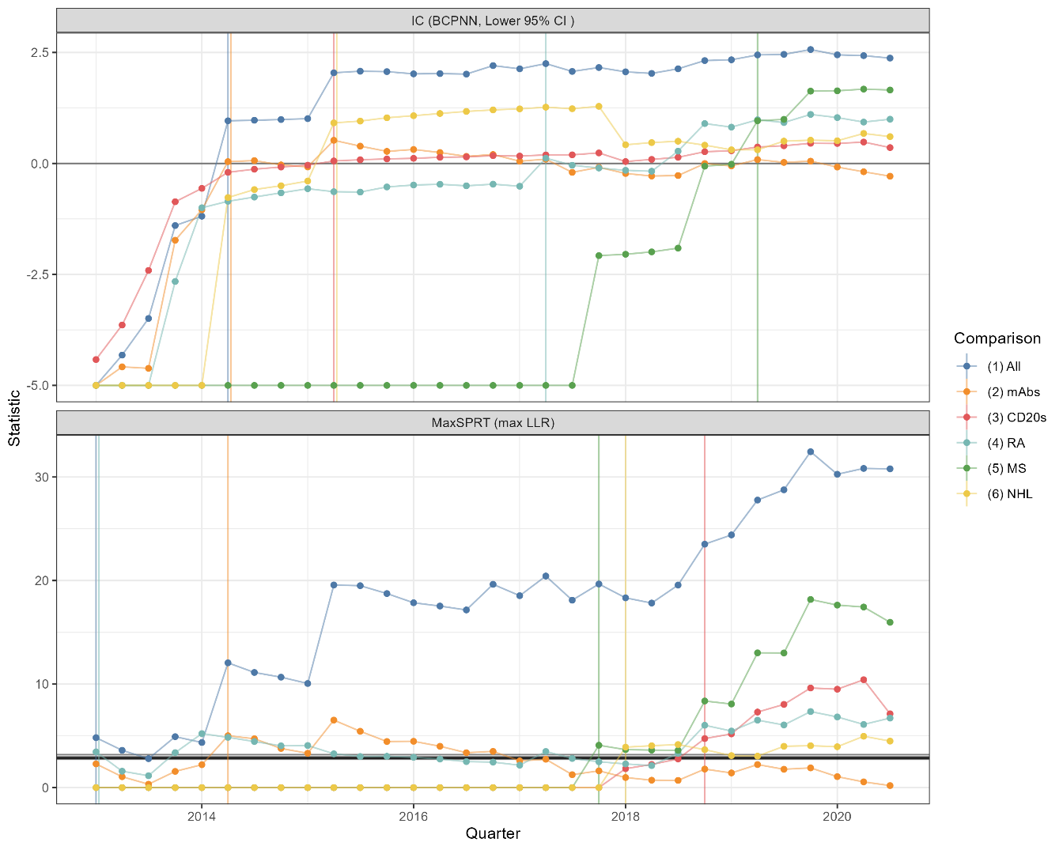**2(a) End of period snapshot ritux/PG signal detection 2(b) over time signal detection for ritux/PG**