fishmechr

# library(fishmechr)  
devtools::load_all()  
#> ℹ Loading fishmechr

library(tidyverse)  
library(patchwork)

# Using the Hilbert transform to estimate swimming kinematics

One convenient and relatively robust way to estimate body wavelength, wave speed, and bending frequency involves the use of the Hilbert transform , a procedure that uses the Fourier transform to estimate a periodic signal that is 90deg shifted relative to another. In essence, given a cosine signal, the Hilbert transform returns the sine with the same amplitude and frequency. The utility of this operation is that it lets us estimate the ``analytic signal’’, a complex-valued signal where the magnitude of the complex number is the amplitude of the wave and the phase angle of the complex number is the phase of the signal.

If a fish swims using a traveling wave of curvature defined at a position along the body as

where is the wave amplitude, is the wave length, is the oscillation frequency, and is time.

We can then take the Hilbert transform to estimate the analytic signal for curvature

where is the imaginary number. (Note that the hilbert function in R and Python returns the full analytic signal, not just the imaginary component as written above). For a complex number , the magnitude is denoted by and the phase angle is denoted by .

One can also estimate the analytic signal for the lateral excursion of the body , where is the lateral position of a point on the body, relative to the overall axis of the body. We suggest using the singular value decomposition to estimate the central body axis and then using a low-pass filter with a cutoff frequency lower than the tail beat frequency to remove the tail beat oscillation. See numerical details below.

The analytic signal thus provides an estimate of the phase can be estimated as a continuous function of both time and position along the body. Other techniques for estimating phase require identifying particular features in the signal (such as peaks or zero crossings) and therefore do not estimate phase as a continuous signal. The estimated phase is thus

For a traveling wave, this phase, as estimated here, is equal to the argument of the cosine function from the traveling wave equation above, .

Therefore, we can use the estimated phase to compute the frequency and wavelength by taking derivatives in time or space, respectively,

The body wave speed is the product of the two:

## Numerical considerations

The Hilbert transform only works well for this analysis with signals that are centered around zero and consist of many relatively smooth tailbeats. This is why we suggest using the curvature , rather than something like lateral position or the coordinate of the body. To use the Hilbert transform on a lateral position, it is important to subtract a baseline value or use a high pass filter to ensure that the signal is centered around zero.

Similarly, if the signal is noisy, the phase will not increase steadily and the derivatives used to estimate and will not be meaningful. It is best to filter the input signal using a bandpass or low pass filter so that the oscillations are smooth.

In most programming languages, one should use a function atan2 to estimate phase (not atan), because it gives an angle that ranges around the full circle (rather than 0 to 180 degrees). However, the output of atan2 will jump (usually from to ) as or increase. To estimate frequency or wavelength, before performing the derivatives, one should estimate a smoothly increasing phase using a function unwrap, which searches for jumps and removes them.

## Arc length

Most kinematic variables are best specified in terms of arc length , the distance along the body from the head to a particular point :

Using arc length is better than something like the coordinate for two reasons. First, often a fish does not swim precisely along the axis, which means that the points would need to be rotated. Second, many fish swim with relatively large amplitude motions, which means that the distance along the curve is larger than the distance along the swimming direction, particularly near the tail where amplitudes are higher.

## Estimating curvature

The 2D curvature of the midline in the horizontal plane is often a useful variable to compute. It can be thought of in two different ways. First, it is the inverse of the radius of curvature: the radius of a circle drawn through three successive points. The smaller the radius of curvature, the sharper the body bend, and the larger the value of . This estimate for curvature is defined by the following equation

Second, it is the spatial derivative of the angle of each segment. If a segment at arc length has an angle to the horizontal axis, then the curvature is

The angle for segment is .

Although both formulas are mathematically equivalent, they have slightly different properties depending on the measurement error on the and positions.

## Estimating lateral excursion

One can also estimate the body phase, and then the wavelength and wave speed, based on the excursion of the body relative to a primary axis. We suggest using the singular value decomposition (SVD) to estimate the primary axis, then using a low-pass filter to remove any oscillations at the tail beat frequency or higher. If you have a matrix of and coordinates of points along the body at a specific time,

where the subscript indicates the size of the matrix ( points along the body by 2).

First, center each axis by subtracting the location of the center of mass or the mean of each column, to produce a matrix , centered around 0. Then the singular value decomposition allows you to write the matrix in the form

The matrix then represents the principal axes of the body in that frame. The matrix can be estimated at each time point, to produce a time-varying matrix .

Assuming the amplitude is relatively small, the first column of represents a unit vector pointing along the primary axis of the body (which we call and the second column is a unit vector normal to the primary axis.

We suggest using a low pass filter with a cutoff frequency below the tail beat frequency to smooth the components of the vector, making sure to normalize it after smoothing. See implementation details below.

# Example analysis of a lamprey data set

The data set lampreydata is included in the fishmechr package. Most swimming kinematics data sets should have a similar structure: * A time or frame column. It’s often good to keep both in the data set. (Here, these are in t and frame) * A column that identifies the point on the body. This could be a factor variable, with names of each body part (like returned by Sleap or DeepLabCut), as long as there is a clear order from head to tail. Or it could be a numeric variable, with points numbered from 1 to , where 1 is the snout and is the tail. (here this is in point). * x and y coordinates of the point. Currently, these algorithms are only designed to work on 2D movements in the horizontal plane. (here these are in mxmm and mymm, indicating “midline” x and y points in mm)

head(lampreydata)  
#> # A tibble: 6 × 17  
#> # Groups: point [6]  
#> t frame point mxmm mymm smm curve_ang curve_xy ph_c ph_e a b  
#> <dbl> <int> <int> <dbl> <dbl> <dbl> <dbl> <dbl> <dbl> <dbl> <dbl> <dbl>  
#> 1 0.02 1 1 NA NA 0 NA NA NA NA NA NA  
#> 2 0.02 1 2 NA NA NA NA NA NA NA NA NA  
#> 3 0.02 1 3 NA NA NA NA NA NA NA NA NA  
#> 4 0.02 1 4 NA NA NA NA NA NA NA NA NA  
#> 5 0.02 1 5 NA NA NA NA NA NA NA NA NA  
#> 6 0.02 1 6 NA NA NA NA NA NA NA NA NA  
#> # ℹ 5 more variables: swimaxis_x <dbl>, swimaxis_y <dbl>, mxmm_ctr <dbl>,  
#> # mymm_ctr <dbl>, cycle <dbl>

This plot shows the midlines in two frames.

lampreydata |>   
 filter(frame %in% c(10, 20)) |>   
 mutate(frame = factor(frame)) |>   
 ggplot(aes(x = mxmm, mymm, color = frame, group = frame)) +  
 geom_path() +  
 coord_fixed()

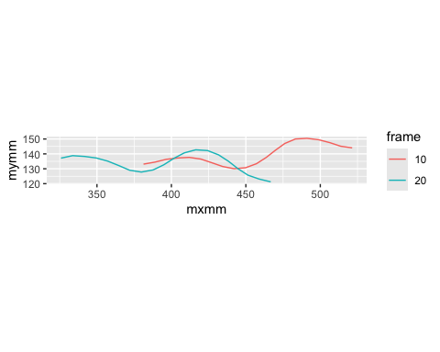

## Compute curvature

This computes the curvature by the two different methods.

lampreydata <-  
 lampreydata |>   
 group_by(frame) |>   
 mutate(smm = arclength(mxmm, mymm),  
 curve_ang = curvature(smm, mxmm, mymm),  
 curve_xy = curvature(smm, mxmm, mymm, method="xy"))

Compare the results. Here they aren’t very different, although the “xy” method gives very slightly higher peaks.

lampreydata |>   
 filter(frame %in% c(10, 20)) |>   
 mutate(frame = factor(frame)) |>   
 ggplot(aes(x = smm, color = frame, group = frame)) +  
 geom_path(aes(y = curve_ang), linetype='solid') +  
 geom_path(aes(y = curve_xy), linetype='dashed')  
#> Warning: Removed 4 rows containing missing values or values outside the scale range  
#> (`geom_path()`).  
#> Removed 4 rows containing missing values or values outside the scale range  
#> (`geom_path()`).

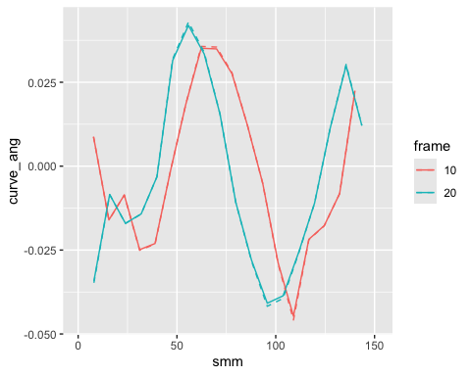 Plot curvature as a function of time for two different points along the body. For the Hilbert analysis to work well, these should be close to sinusoidal and centered around 0.

lampreydata |>   
 filter(point %in% c(10, 18)) |>  
 mutate(point = factor(point)) |>   
 ggplot(aes(x = t, y = curve_ang, color = point)) +  
 geom_path()  
#> Warning: Removed 4 rows containing missing values or values outside the scale range  
#> (`geom_path()`).

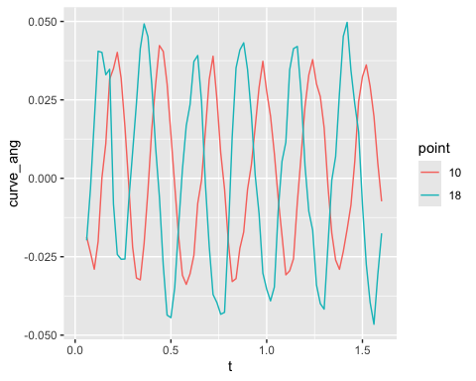

## Get excursion

This extracts the central swimming axis.

swimaxis <-  
 lampreydata |>  
 group_by(t) |>  
 summarize(swimaxis = get_primary_swimming_axis(mxmm,mymm)) |>   
 unnest(swimaxis)  
  
swimaxis  
#> # A tibble: 80 × 5  
#> t swimaxis_x swimaxis_y swimaxis_xctr swimaxis_yctr  
#> <dbl> <dbl> <dbl> <dbl> <dbl>  
#> 1 0.02 NA NA NA NA   
#> 2 0.04 NA NA NA NA   
#> 3 0.06 0.989 0.150 487. 147.  
#> 4 0.08 0.990 0.143 482. 146.  
#> 5 0.1 0.991 0.136 477. 145.  
#> 6 0.12 0.991 0.130 473. 143.  
#> 7 0.14 0.993 0.121 467. 142.  
#> 8 0.16 0.993 0.118 463. 141.  
#> 9 0.18 0.993 0.116 458. 140.  
#> 10 0.2 0.993 0.117 452. 139.  
#> # ℹ 70 more rows

lampreydata <- lampreydata |>   
 get_primary_swimming_axis_df(t,point, mxmm,mymm)  
#> Warning in get_primary_swimming_axis_df(lampreydata, t, point, mxmm, mymm): Data frame  
#> has columns that are assigned in 'get_primary_swimming_axis_df'. Overwriting

lampreydata |>   
 filter(frame %in% c(10, 20, 30)) |>   
 ggplot(aes(x = mxmm, y = mymm, color = frame)) +  
 geom_path(aes(group = frame)) +  
 geom_point(aes(x = mxmm_ctr, y = mymm_ctr), color='red') +  
 geom_segment(data = ~ filter(.x, point == 20),   
 aes(x = mxmm_ctr, y = mymm_ctr,   
 xend = mxmm_ctr - 50*swimaxis_x,   
 yend = mymm_ctr - 50*swimaxis_y)) +  
 facet_grid(frame ~ .) +  
 coord_fixed()

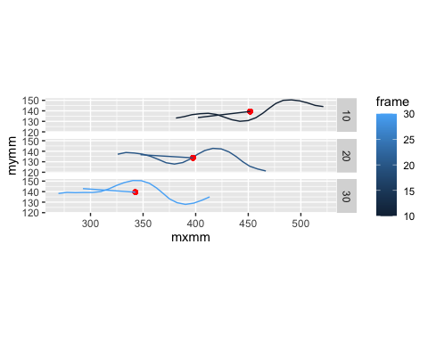

Similar to curvature, we can compute phases based on the lateral excursions (b). As above, they need to be mostly sinusoidal and centered around zero.

lampreydata |>   
 filter(point %in% c(10, 18)) |>  
 mutate(point = factor(point)) |>   
 ggplot(aes(x = t, y = b, color = point)) +  
 geom_path()  
#> Warning: Removed 4 rows containing missing values or values outside the scale range  
#> (`geom_path()`).

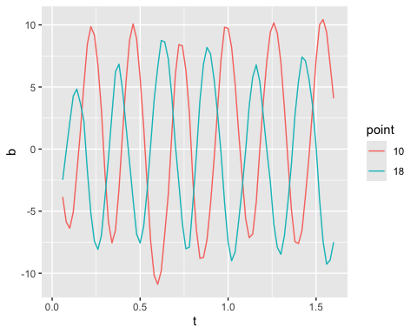

## Phase

Now we compute the phase of each body point as it oscillates over time, looking at either the curvature curve_ang or the excursion b.

lampreydata <-  
 lampreydata |>   
 group_by(point) |>   
 mutate(ph_c = hilbert_phase(curve_ang),  
 ph_e = hilbert_phase(b))  
#> Warning: There were 42 warnings in `mutate()`.  
#> The first warning was:  
#> ℹ In argument: `ph_c = hilbert_phase(curve_ang)`.  
#> ℹ In group 2: `point = 2`.  
#> Caused by warning in `hilbert_phase()`:  
#> ! Phase seems to go backwards a lot, which may indicate an overly noisy signal  
#> ℹ Run `dplyr::last_dplyr_warnings()` to see the 41 remaining warnings.

hilbert_phase does a few checks on the results and gives warnings if it finds things that might cause problems. * It checks to make sure that most of the input data is not NA. It does not give a warning if all of the input data is NA, only if at least some of the data is not NA. * It checks that the input signal seems to oscillate around 0. * It looks whether the phase mostly advances over time. If we have cases when the phase seems to run backwards, that’s often a good indication that the data isn’t smoothed enough. In the case above, the warning is for point 2, which is close to the head, where curvature tends to be quite low, so we can ignore the warning.

Compare the two phase estimates. We expect the slopes to be the same, but there could be an offset of in places. Here solid lines are phase based on curvature and dashed are phase based on excursion.

lampreydata |>   
 ungroup() |>   
 filter(point %in% c(3, 8, 15, 18)) |>   
 mutate(point = factor(point)) |>   
 pivot_longer(cols = c(ph_c, ph_e), names_to = "method", values_to = "phase") |>   
 ggplot(aes(x = t, y = phase, color = point, linetype = method)) +  
 geom_path() +   
 facet_wrap(~point)  
#> Warning: Removed 16 rows containing missing values or values outside the scale range  
#> (`geom_path()`).

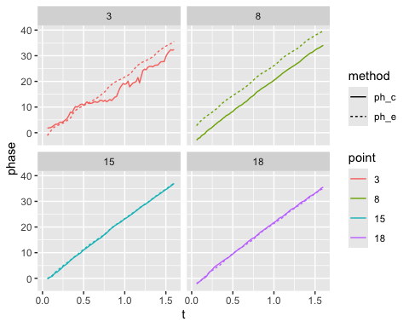 Note that the curvature based phase (solid line) tends to fluctuate a lot for point 3, which is near the head where curvature is small.

## Frequency

As described above, the time derivative of the phase is the frequency. Here, we can compute a frequency at each point along the body, although they ought to be the same.

lampreydata |>   
 group_by(point) |>   
 mutate(freq_c = get_frequency(t, ph_c, method='deriv'),  
 freq_e = get_frequency(t, ph_e, method='deriv')) |>   
 pivot_longer(cols = c(freq_c, freq_e), names_to = "method", values_to = "freq") |>   
 filter(point %in% c(3, 15, 18)) |>   
 mutate(point = factor(point)) |>   
 ggplot(aes(x = t, y = freq, color = point, shape = method)) +  
 scale_shape_manual(values = c(1, 17)) +  
 geom_point() +  
 facet_wrap(~point)  
#> Warning: There were 4 warnings in `mutate()`.  
#> The first warning was:  
#> ℹ In argument: `freq_c = get_frequency(t, ph_c, method = "deriv")`.  
#> ℹ In group 2: `point = 2`.  
#> Caused by warning in `get_frequency()`:  
#> ! Phase seems to go backwards a lot, which may indicate an overly noisy signal  
#> ℹ Run `dplyr::last_dplyr_warnings()` to see the 3 remaining warnings.  
#> Warning: Removed 18 rows containing missing values or values outside the scale range  
#> (`geom_point()`).

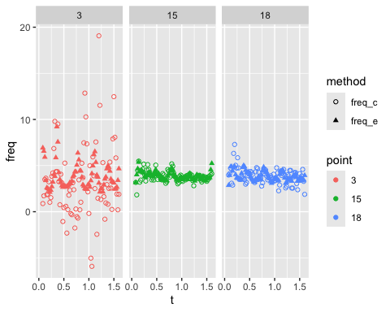 # Body wavelength

Body wavelength, as described above, is the derivative of the phase of each point along the body with respect to arc length. Phase typically decreases along the body, which indicates a backward traveling wave.

lampreydata |>   
 filter(frame %in% c(60, 80)) |>   
 group_by(frame) |>   
 mutate(phbody = ph_e) |>  
 ggplot(aes(x = smm, y = phbody, color = frame)) +  
 geom_path(aes(group = frame))

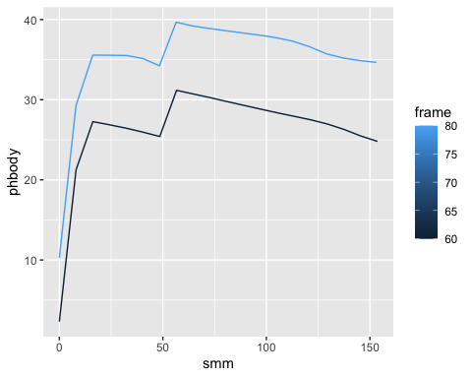 The apparent discontinuity at = 50mm is not real. It just reflects the fact that phase goes from to and then wraps around back to 0. We get rid of that by using the unwrap function, applied across the spatial dimension (equivalently, using group_by with time or frame number).

This is the phase across the body with the discontinuities removed.

lampreydata |>   
 filter(frame %in% c(60, 80)) |>   
 group_by(frame) |>   
 mutate(phbody = gsignal::unwrap(ph_e)) |>  
 ggplot(aes(x = smm, y = phbody, color = frame)) +  
 geom_path(aes(group = frame))

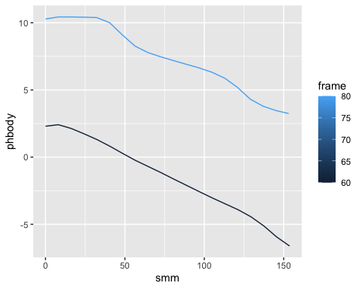

## Methods of estimating wavelength

There are several ways to estimate body wavelength based on the body phase, which have different advantages and disadvantages. The function get_wavelength can run each of them.

1. At each point along the body, you can estimate the derivative of the phase with respect to arc length. This gives the most comprehensive results, and, in particular, makes it fairly simple to consider whether wavelength varies along the body, but is also very sensitive to noise.
2. You can fit a line to all of the data along the body and take the slope of that line. This method is the least sensitive to noise, but only gives a single value along the entire body.
3. You can look for the distance along the body in which the phase changes by a full or a half cycle. If you look for the phase at the tail and then step backward along the body until you find a point that’s either a full or half cycle before the tail, then that distance represents a full or half wave, respectively. get_wavelength makes this process more accurate by using a simple linear interpolation to find the distance that represents exactly 1 or 0.5 waves.

The phase tends to be poorly estimated for body points that are more anterior. get_wavelength allows you to specify a formula to ignore certain locations for the estimate.

Here is an example for a single frame. We’re ignoring points that are less than 30mm from the head.

w <-  
 lampreydata |>   
 filter(frame %in% c(50)) |>   
 group_by(frame) |>   
 mutate(ph2 = gsignal::unwrap(ph_e),  
 wavelen_deriv = get_wavelength(smm, ph2, method="deriv",  
 ignore_s = \(s) s < 30),  
 wavelen_slope = get_wavelength(smm, ph2, method="slope",  
 ignore_s = \(s) s < 30),  
 wavelen_cycle = get_wavelength(smm, ph2, method="cycle",  
 ignore_s = \(s) s < 30),  
 wavelen_halfcycle = get_wavelength(smm, ph2, method="halfcycle",  
 ignore_s = \(s) s < 30))  
w |>   
 pivot_longer(cols = contains("wavelen"), names_to = "method", values_to = "wavelen") |>   
 ggplot(aes(x = smm, y = wavelen, color = method, shape = method)) +  
 geom_point()  
#> Warning: Removed 41 rows containing missing values or values outside the scale range  
#> (`geom_point()`).

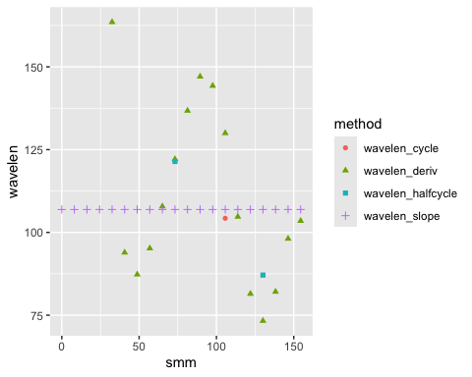 Here, you can see that all of the methods give similar results, but there are different numbers of values and different resolution along the body. We suggest the “halfcycle” option as a good, relatively robust compromise.

lampreydata |>   
 group_by(frame) |>   
 mutate(phbody_e = gsignal::unwrap(ph_e),  
 phbody_c = gsignal::unwrap(ph_c),  
 wavelen_exc = get_wavelength(smm, phbody_e, method="halfcycle",  
 ignore_s = \(s) s < 30),  
 wavelen_curve = get_wavelength(smm, phbody_c, method="halfcycle",  
 ignore_s = \(s) s < 30)) |>   
 pivot_longer(cols = contains("wavelen"), names_to = "method", values_to = "wavelen") |>   
 ggplot(aes(x = t)) +  
 geom_point(aes(y = wavelen, color = smm, shape=method)) +  
 scale_shape_manual(values = c(15, 4))  
#> Warning: Removed 2870 rows containing missing values or values outside the scale range  
#> (`geom_point()`).

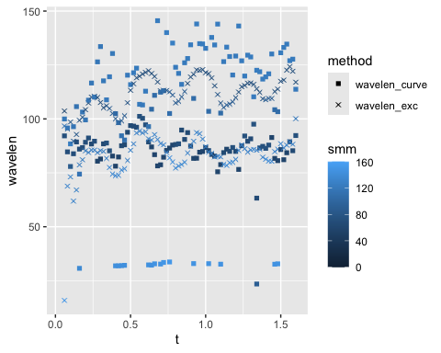 Here we see that wavelength estimated based on curvature is slightly noisier than curvature based on excursion, and that both fluctuate over time.

lampreydata |>   
 group_by(frame) |>   
 mutate(phbody_e = gsignal::unwrap(ph_e),  
 phbody_c = gsignal::unwrap(ph_c),  
 wavelen_exc = get_wavelength(smm, phbody_e, method="halfcycle",  
 ignore_s = \(s) s < 30),  
 wavelen_curve = get_wavelength(smm, phbody_c, method="halfcycle",  
 ignore_s = \(s) s < 30)) |>   
 pivot_longer(cols = contains("wavelen"), names_to = "method", values_to = "wavelen") |>   
 ggplot(aes(x = smm)) +  
 geom_point(aes(y = wavelen, color = smm, shape=method)) +  
 scale_shape_manual(values = c(15, 4)) +  
 facet_wrap(~method)  
#> Warning: Removed 2870 rows containing missing values or values outside the scale range  
#> (`geom_point()`).

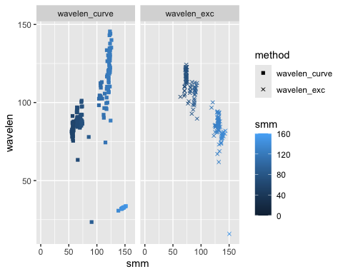 This plot shows wavelength as a function of body position and estimation method. The curvature-based wavelengths seem to increase along the body (aside from some erroneous very low values very close to the tail), while the excursion-based wavelengths tend to decrease moving toward the tail.

# Amplitude

To estimate amplitude, it’s helpful to set up an overall cycle number for the whole body. We define this based on the excursion of the tail point. get_body_cycle_numbers also excludes partial cycles.

lampreydata <-  
 lampreydata |>   
 get_body_cycle_numbers(t, ph_e, point, 20) |>   
 arrange(t, point)  
#> Warning in check_if_overwrite_columns(df, c("cycle"), overwrite): Data frame has  
#> columns that are assigned in 'get_body_cycle_numbers'. Overwriting

lampreydata  
#> # A tibble: 1,600 × 17  
#> # Groups: point [20]  
#> t frame point mxmm mymm smm curve_ang curve_xy ph_c ph_e a b  
#> <dbl> <int> <int> <dbl> <dbl> <dbl> <dbl> <dbl> <dbl> <dbl> <dbl> <dbl>  
#> 1 0.02 1 1 NA NA 0 NA NA NA NA NA NA  
#> 2 0.02 1 2 NA NA NA NA NA NA NA NA NA  
#> 3 0.02 1 3 NA NA NA NA NA NA NA NA NA  
#> 4 0.02 1 4 NA NA NA NA NA NA NA NA NA  
#> 5 0.02 1 5 NA NA NA NA NA NA NA NA NA  
#> 6 0.02 1 6 NA NA NA NA NA NA NA NA NA  
#> 7 0.02 1 7 NA NA NA NA NA NA NA NA NA  
#> 8 0.02 1 8 NA NA NA NA NA NA NA NA NA  
#> 9 0.02 1 9 NA NA NA NA NA NA NA NA NA  
#> 10 0.02 1 10 NA NA NA NA NA NA NA NA NA  
#> # ℹ 1,590 more rows  
#> # ℹ 5 more variables: swimaxis_x <dbl>, swimaxis_y <dbl>, mxmm_ctr <dbl>,  
#> # mymm_ctr <dbl>, cycle <dbl>

Now, we can use group_by on cycles to find cycle-by-cycle values. Here, we look for the range of the excursion variable b. Half of that range is the amplitude, which we can define at each point on the body, and over the four cycles that are present in this trial.

lampreydata |>   
 group_by(point, cycle) |>   
 summarize(amp = (max(b) - min(b)) / 2,  
 smm = mean(smm)) |>   
 ggplot(aes(x = smm, y = amp, color = cycle)) +  
 geom_path(aes(group = cycle))  
#> `summarise()` has grouped output by 'point'. You can override using the `.groups`  
#> argument.  
#> Warning: Removed 20 rows containing missing values or values outside the scale range  
#> (`geom_path()`).

