Technical Documentation (TD)
Importing partner data from Central Statistical Office (CSO)
Table of contents
========= Business Requirements Document (BRD) Phase (by Lacan) 3
Team roles 3
Purpose 3
Document Conventions 3
Project Scope 3
References 4
Product Perspective 5
Product Features 5
Must have 6
Should have 6
Nice to have 6
NOT have 6
User Classes and Characteristics 6
Operating Environment 6
Simplified Developmental Requirements 6
Design and Implementation Standards 7
TD requirements (tools to include in TD phase) 7
LT Acceptance Team for TD 8
========= Rough Order of Magnitude (ROM) Phase (by Developer) 8
Rough Order of Magnitude 8
Length estimation 9
Price estimation 12
Cost Break Down 12
Other Developer's remarks 12
Similar projects 12
Future usage 13
SubContracting 13
ROM Costs Approval (Lacan Part) 13
Infrastructure Provision: 13
Users 13
Branches 14
========= Technical Documentation (TD) Phase (by Developer & Lacan) 14
Module Diagram 14
Module Description 14
Process Diagram 15
System Features (Functionality) 15
Field Specification & Validations 18
Additional developmental requirements (Development) 18
Documentation 20
Interface requirements (Usability) 20
Unit tests 21
Security 21
Performance 21
Communication plan (QC) 21
Appendicies 21
========= Project Plan (PP) Phase (by Developer) 21
Project plan 21
Current release plan 21
Taget Delivery Date: 27th May 2014 (Already Delivered) 22
Final costs calculation 22
Requested users allowance: 22
========= Lacan approvals 22
Acceptance Period: 22
Changes in infrastructure requirements: 22
Infrastructure provided: 23
Lacan approvals: 23

Please note that TD has been divided intro 5 phases:
- Phase 1 – Business Requirements Document (BRD) which is generaly prepared by the LT PM and sent by him to the Developer in order to receive Rough Order of Magnitude (ROM)
- Phase 2 – BRD is extended with the Developer's notes and information gathered during ROM preparation
- Phase 3 – Rough Order Magnitude that specifies rough estimation prepared by the Developer at the basis of Phases 1&2
- Phase 4 – Technical Documentation (TD) which extends SRS with information according to standards, procedures and decisions made within the contracting process. TD is used to contract the Developer with a certain project.
- Phase 5 – Project Plan – Developer's estimates and comittments
Later in the documentation we use the names of the phases. Numbers of the phases are stated here for ordering reasons.
Revision history:
Name | Date | Reason for change | Version
Tomasz Kostrzewa | 04.02.2014 | Creating document – Phase 1 | 0.01
Abul Hassan | 18.02.2014 | ROM Estimates | 0.02
Abul Hassan | 03.03.2014 | ROM with revised pricing | 0.03
Abul Hassan | 22.03.2014 | TD updated as per TD phase | 0.04
Marta Ćwiertnia | 25.04.2014 | LT PM change | 0.05
Abul Hassan | 07.05.2014 | Changes made with more diagrams added as per request | 0.06
Abul Hassan | 30.05.2014 | Release Plan updated with QC | 1.0

RFC (Lacan internal use only):
ftp://fileserver/department/wsparcie/ogolne/RFC/RFC_Ksiegowosc/RFC_Ksiegowosc.odt

========= Business Requirements Document (BRD) Phase (by Lacan)

Team roles
Role | Name | E-mail | Phone no.
LT PM | Marta Ćwiertnia | Marta.cwiertnia@lacan.com.pl | +48 698 698 469
S PM | Abul Hassan | abulhassan@aspirantlabs.com | +919840864990
LT AC | Maciej Brylewicz | maciej.brylewicz@lacan.com.pl | +48 608 484 569
S AC | Abul Hassan | abulhassan@aspirantlabs.com | +919840864990

Purpose
The aim of this document is to describe scope of integration with Central Statistical Office's (CSO) database of partners. This module should provide the Customer easy way to enter new contractors into OpenERP. The integration should be carried only one-way (CSO → OpenERP)

Document Conventions
NIP Number stands for VAT Number in ERP (field „vat” in res.partner object).
REGON Number is the number given by CSO – it isn't commonly used in invoices – it may be used but it's not obligatory.

Project Scope
The module should allow matching NIP number given by partner while creating an invoice for them or adding a partner to company's database, with the whole partner's data (such as business name – field „name” in res.partner object and headquarter's address – street, street2, zip and city fields in res.partner.address object) from Polish Central Statistical Office. While entering data to an invoice or company's database, salesman or accountant fills in just NIP number (field „vat” in res.partner object). Then, the module connects with Central Statistical Office's database and collects all relevant information. After that operation, the module fills up remaining fields automatically. The salesman or accountant accepts them if they're correct. If not, they may change data. It is important that module collects only the data for existing businesses – predicting a situation in which someone had run business, has closed it and then opened any other business using the same NIP Number.

References
The Central Statistical Office allows gaining enerpreneurs' data using their website at: http://www.stat.gov.pl/regon/
There are 2 options: searching on REGON or NIP number. Choosing NIP option is shown below:
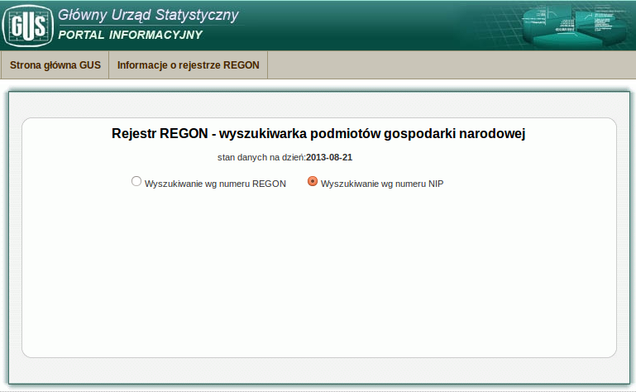
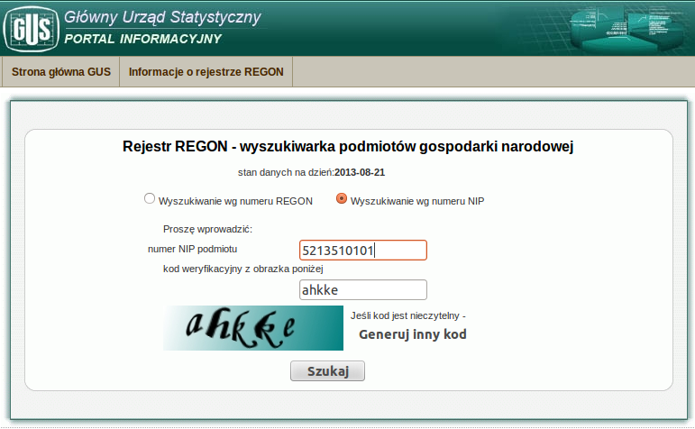

Product Perspective
The module is a supplement for module that allows generating invoices (smb_account) and for the module that allows adding partners to company's database (base). Now all data must be filled in manually in both modules and requires from the person that does this to know partner's business name and headquarter's address. The module requires change in the interface – it fills in the fields that are nowadays filled in manually but there's need to add button that begins the process of importing the data after filling in NIP Number and pressing that button.

Product Features
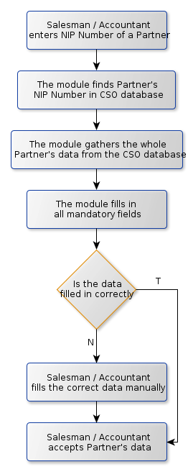
Process Graph

Must have
- collecting relevant data based on NIP number from CSO's database
- matching NIP number of a partner with their data gathered by CSO
- button that begins the process of importing the data after filling in NIP Number and pressing that button
- filling in the form using data gathered – after filling in NIP number manually, filling in the other mandatory fields automatically
- ROM needs to containg description of technology that will be used to handle capthcha form CSO wersite (module names/system interction diagram etc.)

Should have
- checking Central Statistical Office's database while creating an invoice for the partner every time – to avoid the situation that a partner changed their company without informing us. If the data has changed, then there should be a pop-up notification about this. Configuration option should allow to turn this feature on and off.

Nice to have

NOT have
- Updating Central Statistical Office's database

User Classes and Characteristics
The module will be used especially by salesmen ad sometimes by accountants or other people that have contact with company's partners.

Operating Environment
System should require only internet access. Lack of internet access or lack of connection to CSO should be reported to user and should block only features provided by module.

Simplified Developmental Requirements
1 modules:
New module: lacan_account_gus with required features
2. API: CSO has no API.
See http://forum.4programmers.net/Webmastering/211502-dane_z_gus_-_nip (polish language – needs translation)
Module has to emulate human user and display captcha for end user (as a wizard) and send result back to CSO

Design and Implementation Standards

Scope | Level | Remarks
Functionality | F1
Development | DV2
Documentation | D1
Usability | US2
Unit Tests | UT1
Security | S2
Performance | P1
PM QC | QCF1
Tech QC | QCD1

TD requirements (tools to include in TD phase)

Tool name | Required | Not Required | Remarks
Module Diagram | X
Module Descriptions |  | X
Process Diagram |  | X | With function names
Database structure diagram | X |  | With function names
Process with models diagram | X |  | with method names
System interaction diagram | X

LT Acceptance Team for TD

Role | Acceptance needed (YES/NO)
LT PM | YES
LT AC | YES
LT TECH
others

Wydział: DEW_ZPROD
Projekt: <uzupełnia Technolog>

========= Rough Order of Magnitude (ROM) Phase (by Developer)

Rough Order of Magnitude
<NOTE: All following information MUST be given that we can evaluate your ROM>

Solution Overview
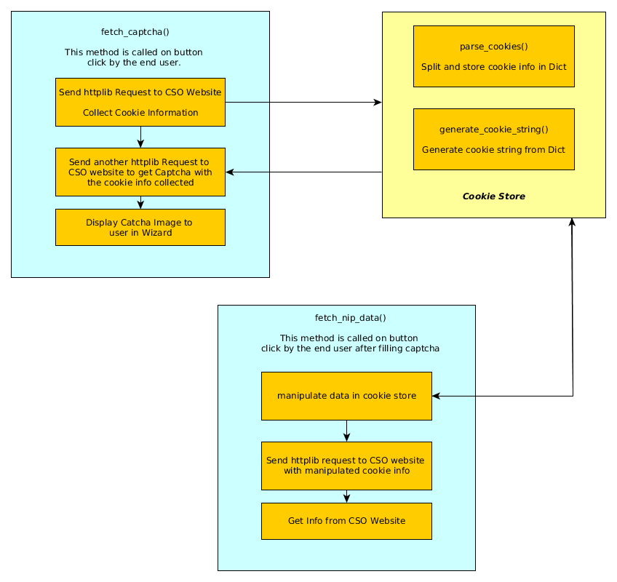

Length estimation
TD Acceptance Estimation : 0 Days
As per BRD, functionality standard F1, and there won't be any requirement for TD. Please confirm this.

Maximum working days to deliver: 5 Weeks (25 Man Days) from ROM Approval

Details of the estimation:
Development Task Break-Up & Assumption

Activity | Task | Man days | Assumptions
Dev | Module Creation, Change existing views to create Button to initiate wizard | 0.5 | NIP is not mandatory. If not given, the existing funtionality will work
Dev | Open a Wizard when the button is clicked. Functionality to create a session in CSO & send the session information to show the captcha image inside the wizard | 0.5
Dev | Send Captcha Information & session information to CSO site and get the results | 2.5 | Longer development time due to Header Manipulation risks & data scraping risks.
Dev | Parse the results & import it in openerp to fill Customer Form in Name, Address etc filed as editable fields. While saving customer data , save the NIP number also | 2 | If structure of the cso website page changes or if the input parameters or cookie parameters change, then our code may malfunction
Dev | If no proper response is obtained from the CSO database or if the number is wrong, then alert message is shown to user. The Wrong NIP number is cleared. | 1 | This case would apply for Lack of internet access or lack of connection to CSO. Appropriate error messages will be shown. Will cover any other HTTP errors & Connection Timeouts.
Dev | Whenever Invoice is being created, during partner selection, Check NIP validation with CSO server. If there is an error, throw an alert message with the changed data from the CSO. | 2 | In Invoice generation, we assume that the verification will happen during partner selection.  No additional buttons in this page. Captcha will be shown after partner selection.  If NIP is empty for the Partner, then this validation process is ignored.  Data from CSO is not updated automatically if there is a mismatch.
 | Create configuration in Sales configuration page to enable/disable alert | 0.5
Dev | Create Default Privilege Levels to view this module for only Accounts and Sales Department | 1

Total Project Estimation WorkSheet with all Phases included

Sr.No | Phase | Tasks |  | Effort in Days |  |  |  | Phase Wise Effort | Phase Wise Effort %
Sr.No | Phase | Tasks | Responsible | Best Case | Most Likely | Worst Case | Mean Effort | Phase Wise Effort | Phase Wise Effort %
1 | Requirements |  |  |  |  |  |  | 2 | 6.02%
 |  | Requirements Gathering | BA/ Business | 0.0 | 0.0 | 0.0 | 0.0
 |  | Develop SRD/ FSD | BA | 0.0 | 0.0 | 0.0 | 0.0
 |  | Requirement analysis | Dev / QA | 0.5 | 0.5 | 0.5 | 0.5
 |  | Test Planning | QA/PM/BA | 0.5 | 0.5 | 0.5 | 0.5
 |  | Prepare Baseline estimates | BA/ Dev | 0.5 | 0.5 | 0.5 | 0.5
2 | Design |  |  |  |  |  |  | 4 | 17.73%
 |  | Define system architecture | System Architect | 0.5 | 1.0 | 1.0 | 0.9
 |  | Prepare Integration test plan | Dev | 0.5 | 0.5 | 0.5 | 0.5
 |  | Prepare Technical Specifications | Dev Lead | 1.0 | 1.5 | 2.0 | 1.5
 |  | Test Design | QA | 1.0 | 1.5 | 2.0 | 1.5
 |  | Prepare unit test plan | Dev | 0.0 | 0.0 | 0.0 | 0.0
3 | Build |  |  |  |  |  |  | 12 | 47.49%
 |  | Software Coding | Dev | 10.0 | 10.0 | 12.0 | 10.3
 |  | Code Review, Compliance & Unit Testing activities | Dev | 1.0 | 1.5 | 2.0 | 1.5
4 | Test Execution |  |  |  |  |  |  | 5 | 20.07%
 |  | Integration Testing | Dev | 0.0 | 0.0 | 0.0 | 0.0
 |  | Prepare Test Environment | Dev | 0.0 | 0.0 | 0.0 | 0.0
 |  | Test Execution | QA, Dev | 5.0 | 5.0 | 5.0 | 5.0
5 | UAT & Closure |  |  |  |  |  |  | 2 | 8.70%
 |  | Acceptance Test Review, Support & Closure | Business, QA, Dev | 2.0 | 2.0 | 3.0 | 2.2
 |  |  |  |  |  | Total | 25 | 25 | 100.00%

Price estimation
ROM Costs Estimate: EUR 2024.6

Cost Break Down
# | Role | Phase 1 | Phase 2 | Phase 3 | Phase 4 | Phase 5 | Total Effort (Days) | Billable/ hour | Total Cost(EUR)
 | Duration | 2 | 3 | 10 | 5 | 3
1 | PM | 0.00 | 0.10 | 0.20 | 0.10 | 0.10 | 3.10 | 10.00 | 248
2 | BA | 0.00 | 0.00 | 0.00 | 0.10 | 0.10 | 0.80 | 10.00 | 64
3 | Dev | 0.50 | 0.60 | 1.00 | 0.60 | 0.30 | 16.70 | 10.00 | 1336
4 | QA | 0.50 | 0.60 | 0.00 | 0.20 | 0.30 | 4.70 | 10.00 | 376
 | Man Days Calculation | 2 | 3.9 | 12 | 5 | 2.4 | 25.30 |  | 2024

Other Developer's remarks

Other Assumptions
Module will be developed for LT version and only GTK Client
Fields / Labels / Documentation / Comments / File Name / Module Name / Alerts / Error Messages will be in English. Translation to Polish or other languages are out of scope of this estimation.

Similar projects
- We have been working on similar project ? YES/NO
YES
- Shortly describe the project if yes.
Worked in Data Scraping for Airline Reservation results, Offers/Deals, Scores etc by mimicing user input. But not in OpenERP.
- If yes please append any documentation if possible
Worked in multiple similar projects as mentioned above. Documentations are confidential as NDA signed with clients.

Future usage
- We would like to use the code we will produce in this project in the future?/
No
- Shortly describe the scope of usage if yes.
- Give the licensing type you would like to use if yes.
- Are you willing to participate in the project costs? (especially important if you want to make the code AGPL licensed)
No
- If above answer is yes, please describe how much are you going to participate in the projects costs?

SubContracting
- Are you planning subcontracting on this project?
No
- Shortly describe the scope and potential subcontractor if yes.

ROM Costs Approval (Lacan Part)
System Architect:
Approval: Yes/No
Licensing Type: As per Agreement, following Developer's Standard, non AGPL if not stated otherwise in the Developer's Standard.

Infrastructure Provision:

Users
<ONLY names of the users that have been granted access to the Infrastructure>

Branches
<links to the SVN branches granted to the Infrastructure>

========= Technical Documentation (TD) Phase (by Developer & Lacan)
<In TD Phase specify only these parts required in part Design and Implementation Standards of BRD. Please refer to the generic standard provided and explain differences from the generic standard.>

Module Diagram

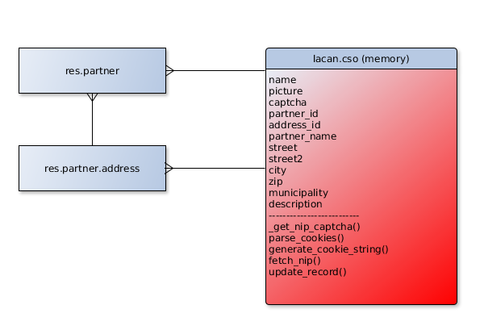

Module Description
Module Name | Module Description
lacan_cso | - Adds a button in the partner form  - Fetches partner address information when button is clicked in partner address form from CSO website  - Updates address everytime from the database if partner name is correct.  - Can be accessed while generating invoice and while creating partner.

Process Diagram
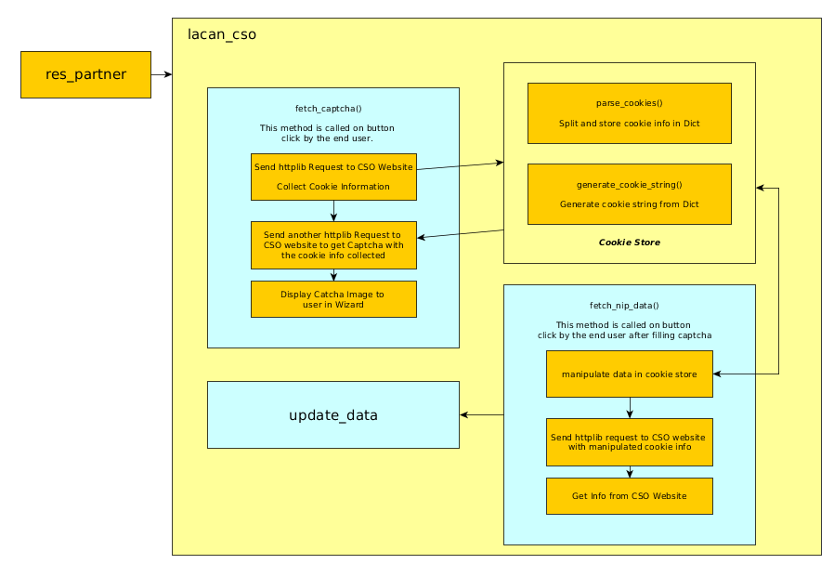

System Features (Functionality)
The entire functionality of this module is to update information obtained from the CSO website.
When creating / modifying a partner (Partner form view), a button "Fetch data from CSO" as shown in a1.47_lacan_account_gus_picture_1 will be available. This button is available in the address form. This button can be accessed also from the "Partner Form" from within the Invoice.
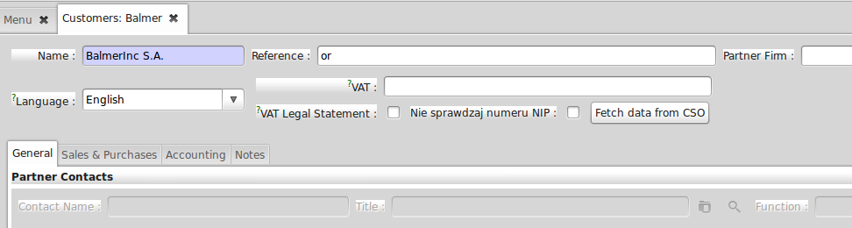
a1.47_lacan_account_gus_picture_1

The mockup a1.47_lacan_account_gus_picture_1 also shows the "VAT" field to enter the "NIP" number in the database against the partner.

The following mockup a1.47_lacan_account_gus_picture_2 shows a wizard which shows the captcha image from the CSO website. The user has the option to edit the "Vat" number before sending the request to CSO website.
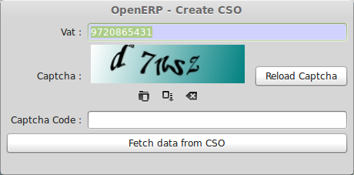
a1.47_lacan_account_gus_picture_2
If the captcha entered is correct, then the user is shown the next screen as shown in a1.47_lacan_account_gus_picture_3. Else the user is shown an error saying the captcha is wrong. User also has the option to Reload the captcha incase if the displayed Captcha is difficult.
If there is no company with given VAT/ PEASEL number then error massage is presented after clicking „Fetch data fro CSO”.user can change VAT/PESEL number afterwarrds.

The following mockup a1.47_lacan_account_gus_picture_3 shows a confirmation to the user with the information obtained from CSO. The description box shows if the partner name does not match. Else, the box will be empty.
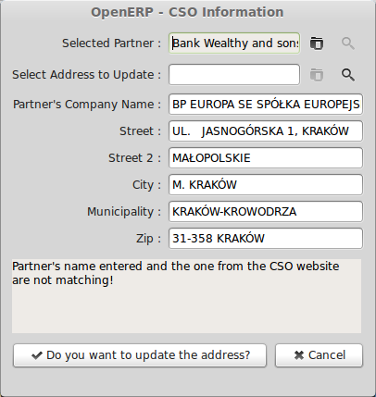
a1.47_lacan_account_gus_picture_3
User can select an existing address to update or can create a new address.
Field municipality is not stored
User then can either choose to update the address with the information present in the screen. User has the option to edit the information before it is stored. Else, the user can press cancel.
System will suggest existing address based on simplified rules (zip and City) and present it as default.

Note: There is a requirement in the BRD to have this checking of information from CSO to be enabled by a configuration. But, since this entire action takes place only based on user action, we believe it won't be required. Please suggest if you would like to change.

Field Specification & Validations

VAT/PESEL number inserted manually in wizard will be validated in the same way as field in partner form

Additional developmental requirements (Development)
Process model Diagram

Database Structure with Methods
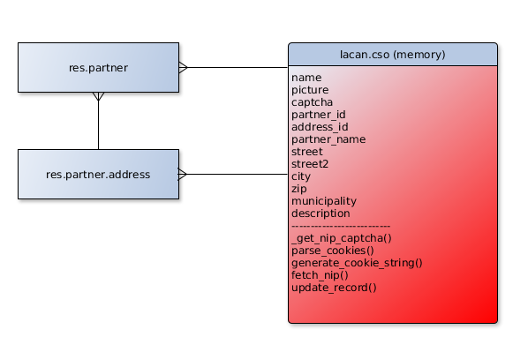
Process Model Diagram
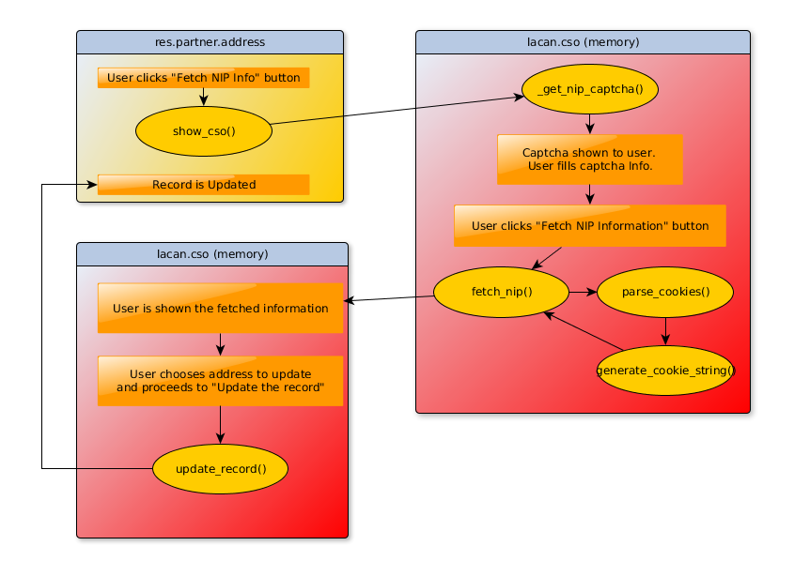
System Interaction Diagram
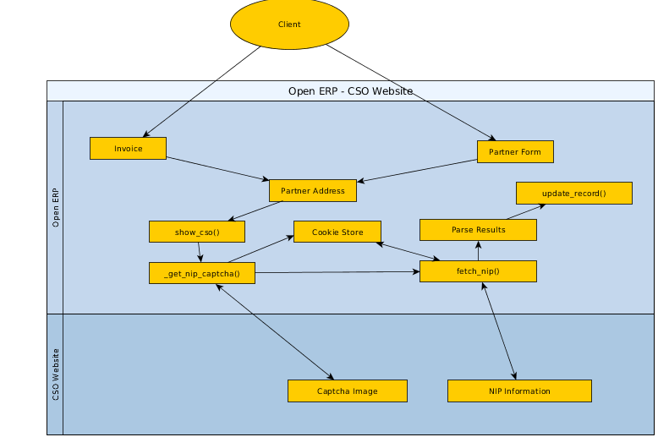

Documentation
Documentation standards required is D1. Module description will be present in the __openerp.py file and a release note will be sent.

Interface requirements (Usability)
Below are the comprehensive list of User Interfaces in this project. Listed here for reference with the picture names as mentioned in the document.
# | Screen | Image
1 | Partner form | a1.47_lacan_account_gus_picture_1
2 | Captcha from CSO shown in Wizard | a1.47_lacan_account_gus_picture_2
3 | Confirmation dialog | a1.47_lacan_account_gus_picture_3

Unit tests
UT1 – No unit tests required

Security
No additional model's present and therefore no additional user groups added.

Performance
<If applicable descrpition of performance requirements (i.e. Number of data to be processed, algoithms optimization, etc.)>

Communication plan (QC)
<If applicable describe specific communication plan for the project>

Appendicies

========= Project Plan (PP) Phase (by Developer)

Project plan

Current release plan
Module already completed as as per TD and released for QC as of 27th May 2014.

ID | Name | Duration | Start | Finish
1 | Development Completion & Release Notes | 1 days | 27/05/2014 | 27/05/2014
2 | Stage 1 QC – Round 1 | ?? | ?? | ??
3 | Stage 1 QC – Round 1 – Rework | 1 days | ?? | ??
4 | Stage 1 QC – Round 2 | ?? | ?? | ??
5 | Stage 1 QC – Round 2 – Rework | 1 days | ?? | ??
6 | Stage 2 QC – Round 1 | ?? | ?? | ??
7 | Stage 2 QC – Round 1 – Rework | 1 days | ?? | ??
8 | Stage 2 QC – Round 2 | ?? | ?? | ??
9 | Stage 2 QC – Round 2 – Rework | 1 days | ?? | ??
10 | Stage 3 QC – Round 1 | ?? | ?? | ??
11 | Stage 3 QC – Round 1 – Rework | 1 days | ?? | ??
12 | Stage 3 QC – Round 2 | ?? | ?? | ??
13 | Stage 3 QC – Round 2 – Rework | 1 days | ?? | ??
14 | Stage 4 QC – Round 1 | ?? | ?? | ??
15 | Stage 4 QC – Round 1 – Rework | 1 days | ?? | ??
16 | Stage 5 QC – Round 1 | ?? | ?? | ??
17 | Stage 5 QC – Round 1 – Rework | 1 days | ?? | ??
18 | Stage 5 QC – Round 2 | ?? | ?? | ??
19 | Stage 5 QC – Round 2 – Rework | 1 days | ?? | ??

Taget Delivery Date: 27th May 2014 (Already Delivered)

Final costs calculation
Final cost for the project : EUR 1250

Requested users allowance:
<Please give the Name and the Surname of the team members for the actual Project>

========= Lacan approvals

Acceptance Period:
<Please present the number of days after the delivery that Lacan would use to Quality Test the Software>

Changes in infrastructure requirements:
<Please write down all branches that the Developer has to have access to. This information will be used by SVN manager to grant appropriate access rights>

Infrastructure provided:
<Please write down all branches that the Developer has to have access to. This information will be used by SVN manager to grant appropriate access rights>

Lacan approvals:

