Census Data Analysis

Tytus Planck and Kyle Rossman
Data Mining
Homework 1 – September 12, 2017

Section 1 – Exploring the Data

For this homework, we were provided with census data that had a range of different data types. This posed an interesting problem as our team began process and analyzing the data provided. We’ve developed a small chart that helps show and interpret each one of the attributes found in our rows of data.

Section 2 – Our Python Program

Our Python program is rather simple and chooses to try to minimize the complexity of the data provided for this homework. We focused on three different proximity measurements then combined them at the end to get on final measurement of similarity between each one of the data rows.

The first measurement we used was a Simple Measurement Coefficient (SMC). This combined all the attributes that were in string form and provided several different options as values in each data row. Examples include education, work class, and native country. We simply checked whether the strings matched then added one to the match count of our SMC. Then taking the match over the total number of attributes and subtracting it from one gave us a number between one and zero. The lower the number the more similar the two rows of data are to one another.

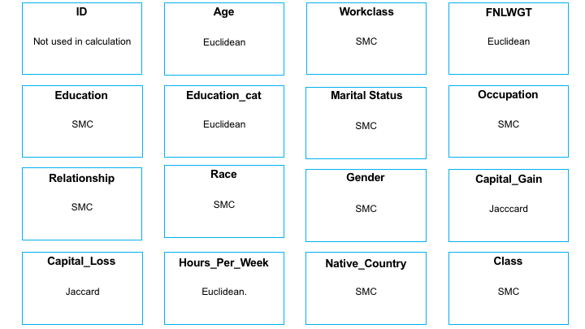

Section 3 – Results Analysis

test

