ISAT381

# Assignment 2

# Factors, Frequency Tables, Marginal Frequencies, and Relative Frequencies

# (55 Points)

**Problems:**

**PART A. (30 points) Creating Frequency, Marginal Frequiency, and Relative Frequency Tables**

1. (10 points) You are to create a **crosstab** that stores the annual sales data shown as below:

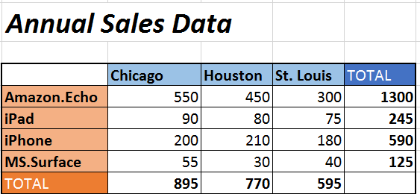

You need to following steps to create such a crosstab:

* 1. First create **a 'product' factor**
  2. Then create **a 'city' factor**
  3. Create a **crosstab**, named '**sales**', to combine the two factors you just created. The result should look as below:

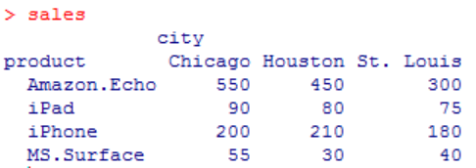

**product** <- factor(c(rep("Amazon.Echo", 1300), rep("IPad", 245), rep("IPhone", 590), rep("MS.Surface", 125)))

**City** <- factor(c(rep("Chicago", 550), rep("Houston", 450), rep("St. Louis", 300), rep("Chicago", 90), rep("Houston", 80), rep("St. Louis", 75), rep("Chicago", 200), rep("Houston", 210), rep("St. Louis", 180), rep("Chicago", 55), rep("Houston", 30), rep("St. Louis", 40)))

**sales** <- table(Product, city)

2. (10 points) Calculate **marginal frequencies** using the **margin.table()** function. Your answer should include the following results:

**2.1 marginal frequencies for the entire table (the total number of all 4 products being sold in all cities)**



> mt.sales <- margin.table(sales)

> mt.sales

[1] 2260

**2.2 marginal frequencies for ROW** (total number sold for each product)

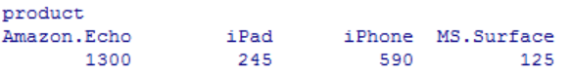

mt.product <- margin.table(sales, 1)

**2.3 marginal frequencies for COLUMN** (total number sold in each city)

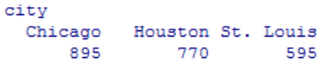

mt.city <- margin.table(sales, 2)

3. (10 points) Calculate **relative frequencies** using the **prop.table()** function. Your answer should include

**3.1 relative frequencies for the entire table**

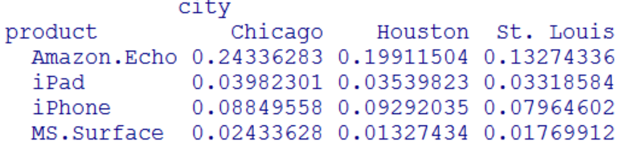

pt.sales <- prop.table(sales)

**3.2 relative frequencies for ROW**

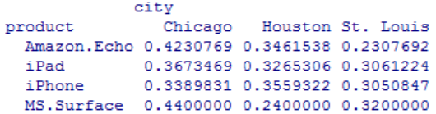

pt.product <- prop.table(sales, 1)

**3.3 relative frequencies for COLUMN**

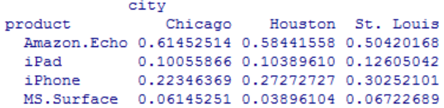

pt.city <- prop.table(sales, 2)

**PART B. (25 points) Queries - Use the indexing method to figure out the following information (the desired outcome is highlighted in yellow):**

1. In total, how many units of products were sold (including all products sold in all cities)?

> margin.table(sales)

[1] 2260

1. How many Echo, iPad, iPhone, Surface were sold in all three cities?

> margin.table(sales, 1)

product

Amazon.Echo iPad iPhone MS.Surface

1300 245 590 125

1. How many products (including all three products) sold in Chicago, Houston, and St. Louis?

city

Chicago Houston St. Louis

895 770 595

> margin.table(sales, 2)

City

Chicago Houston St. Louis

895 770 595

1. How many products (including all three products) sold in Houston?

Houston

770

> mt.city[2]

Houston

770

1. Figure out the percentages of Echo sold in Chicago, Houston, and St. Louis, respectively?

Chicago Houston St. Louis

0.4230769 0.3461538 0.2307692

> pt.product[1,]

Chicago Houston St. Louis

0.4230769 0.3461538 0.2307692

1. Figure out the percentages of Amazon.Echo and MS.Surface sold in Chicago, Houston, and St. Louis, respectively?

city

product Chicago Houston St. Louis

Amazon.Echo 0.4230769 0.3461538 0.2307692

MS.Surface 0.4400000 0.2400000 0.3200000

product[c(1, 4),]

city

product Chicago Houston St. Louis

Amazon.Echo 0.4230769 0.3461538 0.2307692

MS.Surface 0.4400000 0.2400000 0.3200000

1. What are the percentages of Echo, iPad, iPhone, and Surface sold in Houston?

Amazon.Echo iPad iPhone MS.Surface

0.58441558 0.10389610 0.27272727 0.03896104

> pt.city[,2]

Amazon.Echo IPad IPhone MS.Surface

0.58441558 0.10389610 0.27272727 0.03896104

1. What are the percentages of Echo, iPad, iPhone, and Surface sold in Houston and St. Louis?

city

product Houston St. Louis

Amazon.Echo 0.58441558 0.50420168

iPad 0.10389610 0.12605042

iPhone 0.27272727 0.30252101

MS.Surface 0.03896104 0.06722689

city[, c(2, 3)]

city

product Houston St. Louis

Amazon.Echo 0.58441558 0.50420168

IPad 0.10389610 0.12605042

IPhone 0.27272727 0.30252101

MS.Surface 0.03896104 0.06722689