Game Design Document

Fill up the following document

1. Write the title of your project.

Reach to house

1. What is the goal of the game?

To reach the house

1. Write a brief story of your game.

There is a boy/girl who went to the party and now they are late

So they are coming by a car and ontheroad there are many obstacle

And only three times you can get fuel and they have to reach to the house.

1. Which are the playing characters of this game?

* Playing characters are the ones who respond to the user based on the input from the user.
* Cars, monkeys, dinos, wizards, etc., are the playing characters in the game.

|  |  |  |
| --- | --- | --- |
| Number | Character Name | What can this character do? |
| 1 | Cars | Player |

1. Which are the Non-Playing Characters of this game?

* Non-Playing characters are the ones that don't have an action or behavior when the user interacts with the game.
* Hurdles, stones, bananas, coins, etc., are non-playing characters in the game.

|  |  |  |
| --- | --- | --- |
| Number | Character Name | What can this character do? |
| 1 | Cones | Obstacle |
| 2 | Tyers | Obstacle |
| 3 | Fuel | Lifeline |
| 4 | House | Goal |
| 5 |  |  |
| 6 |  |  |
| 7 |  |  |
| 8 |  |  |

Draw your imagination of this game. What does this game look like?

* Draw the game either on your computer or on paper.
* Add images of the game scenes to show each of the playing and non-playing characters at least once. 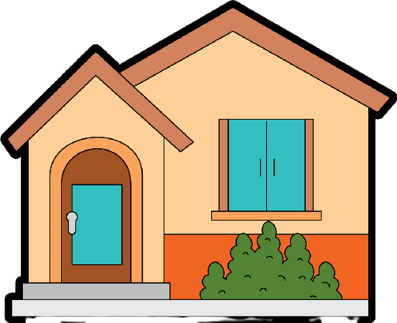

How do you plan to make your game engaging?

This thing I have discussed with my teacher.