**package** bao;

**import** java.util.Scanner;

**public** **class** Ceshi {

//作业1-加密解密

//主方法

**public** **static** **void** main(String[] args) {

**char** in,key;

**int** scr,out;

Scanner sc = **new** Scanner(System.***in***);

System.***out***.print("请输入你要加密的字符：");

in = sc.nextLine().toCharArray()[0];

System.***out***.print("请输入加密使用的密钥字符：");

key = sc.nextLine().toCharArray()[0];

scr = in^key;

System.***out***.println("加密结果为："+scr);

System.***out***.print("请输入密钥来解密：");

key = sc.nextLine().toCharArray()[0];

out = scr^key;

System.***out***.print("解密后的字符为："+(**char**)out);

}

}

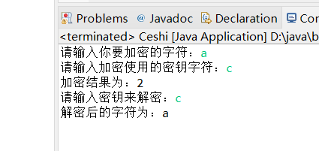

**package** bao;

**import** java.util.Scanner;

**public** **class** Ceshi {

//作业2-整数各位数字相加

//主方法

**public** **static** **void** main(String[] args) {

**int** a,ge,shi,bai,he;

Scanner sc = **new** Scanner(System.***in***);

System.***out***.print("请输入要操作的值：");

a = sc.nextInt();

**if**(a<0||a>1000)

{

System.***out***.println("超出范围！");

}

**else**

{

ge = a%10;

shi = a/10%10;

bai = a/100;

he = ge +shi + bai;

**if**(a == 1000) he = 1;

System.***out***.print("各位数之和为"+he);

}

}

}

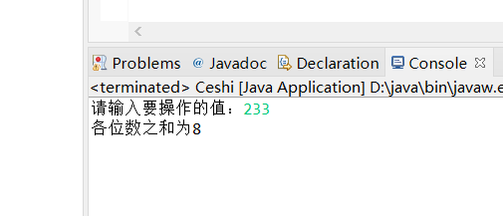

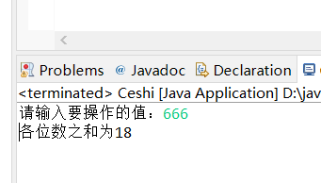

**package** bao;

**import** java.util.Scanner;

**public** **class** Ceshi {

//作业3-用公式算数

//主方法

**public** **static** **void** main(String[] args) {

**double** a,b,c,d;

Scanner sc = **new** Scanner(System.***in***);

System.***out***.println("请输入abc的值");

System.***out***.print("请输入a的值：");

a = sc.nextDouble();

System.***out***.print("请输入b的值：");

b = sc.nextDouble();

System.***out***.print("请输入c的值：");

c = sc.nextDouble();

d = ((-1)*b+Math.*sqrt*(b*b-4*a*c))/(2*a);

System.***out***.print("结果是："+d);

}

}

