1.字符串基本操作
package bao;

import java.util.Scanner;

public class StringTest {

public static void main(String[] args) {
String a;
Scanner in = new Scanner(System.in);
System.out.print("请输入一个字符串：");
a = in.nextLine();
System.out.print("字符串长度是："+a.length()+",第一个字符是："+a.toCharArray()[0]+",最后个字符是："+a.toCharArray()[a.length()-1]+",转换成大写是："+a.toUpperCase());
}
}
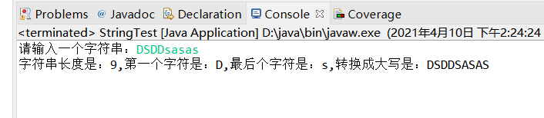

- 十进制转换成二进制字符串
package bao;

public class BinaryTest {

public static void main(String[] args) {
System.out.println(toBinary(10));
}

public static String toBinary(int value) {
String a = new String();
while(value != 0) {
if(value%2 == 1) {
value--;
a = "1" + a;
value = value/2;
}else {
a = "0" + a;
value = value/2;
}
}
return a;
}
}
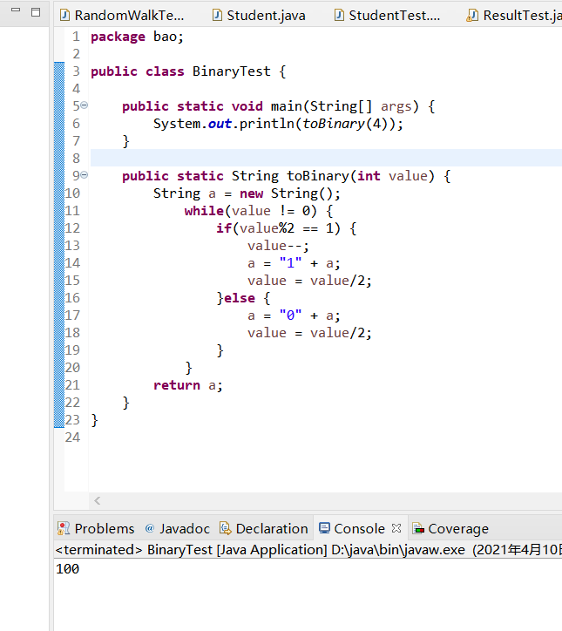
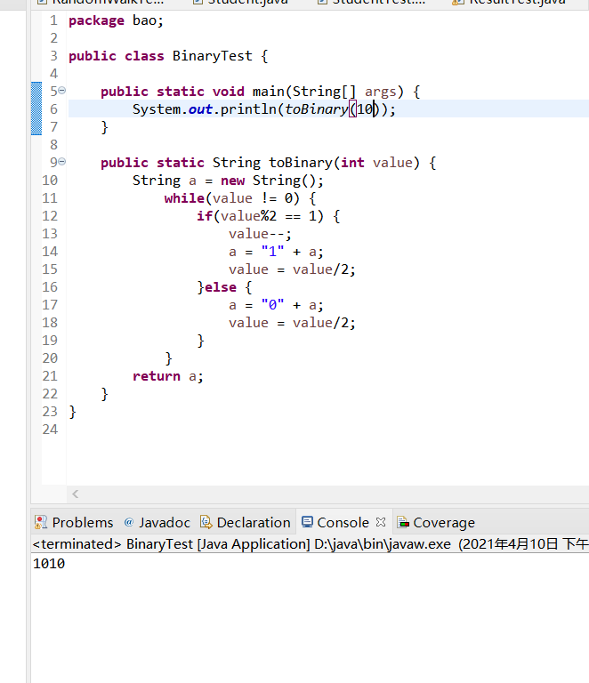
- 格式化输出字符串
package bao;

import java.util.Scanner;

public class CircleTest {

public static void main(String[] args) {
Scanner a = new Scanner(System.in);
System.out.printf("半径：");
double b = a.nextDouble();
System.out.printf("面积是：%.2f",b*b*Math.PI);
}

}
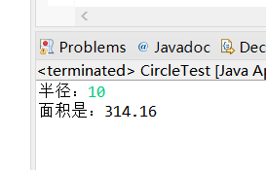

- 字符变后五个进行加密
package bao;
import java.util.Scanner;
public class CodeTest {

public static void main(String[] args) {
String b = new String();
Scanner a = new Scanner(System.in);
System.out.print("输入明文：");
b = a.nextLine();
System.out.println(b);
b = jiaMi(b);
System.out.println(b);
b = jieMi(b);
System.out.println(b);
}

public static String jiaMi(String az) {
String chu = new String("");
for(char wa:az.toCharArray()) {
if((wa >= 'A'&&wa <= 'U')||(wa >= 'a'&&wa <= 'u')) {
chu = chu + (char)(wa+5);
}
if((wa >= 'V'&&wa <= 'Z')||(wa >= 'v'&&wa <= 'z')) {
chu = chu + (char)(wa+5-26);
}
}
return chu;
}

public static String jieMi(String az) {
String chu = new String("");
for(char wa:az.toCharArray()) {
if((wa >= 'F'&&wa <= 'Z')||(wa >= 'f'&&wa <= 'z')) {
chu = chu + (char)(wa-5);
}
if((wa >= 'A'&&wa <= 'E')||(wa >= 'a'&&wa <= 'e')) {
chu = chu + (char)(wa-5+26);
}
}
return chu;
}
}
