Supplementary materials

Table of contents
Supplemental Methods 2
Family Socioeconomic Status Questionnaire 2
Detailed Task Descriptions 2
Hierarchical DDM Analysis 3
Support Vector Machine Classification 4
Supplemental Tables 6
Supplementary Table S1. Inclusion and exclusion criteria for study participants 6
Supplementary Table S2. Split-half reliability of inhibitory control tasks 8
Supplementary Table S3. Hierarchical drift-diffusion model specifications 9
Supplementary Table S4. Confirmatory factor analysis model fit and measurement invariance tests 10
Supplementary Table S5. Convergence diagnostics for hierarchical drift-diffusion model parameters 11
Supplementary Table S6. Hierarchical drift-diffusion model comparison 12
Supplemental Figures 13
Supplemental Figure S1. Confirmatory factor analysis of inhibitory control measures 13
Supplemental Figure S2. Markov chain Monte Carlo diagnostics for the Stroop task 14
Supplemental Figure S3. Markov chain Monte Carlo diagnostics for the Go/No-Go task 15
Supplemental Figure S4. Posterior predictive checks for model adequacy 16
Supplemental Figure S5. Mediation analyses examining HDDM parameters as mediators of group differences in behavioral performance 17
Supplemental Figure S6. Extrapyramidal symptoms in the patients group 18
Supplemental References 19

Supplemental Methods

Family Socioeconomic Status Questionnaire
Family socioeconomic status (SES) was assessed using a comprehensive questionnaire that encompassed four dimensions: material wealth, parental education, parental occupation, and household income. Material wealth was measured using the Family Affluence Scale (Boyce et al., 2006), a four-item instrument assessing car and computer ownership, private bedroom availability, and family holiday frequency. Scores ranged from 0 to 9, with higher values indicating greater material wealth. Parental education was scored on a six-point scale ranging from primary school or below (1) to master's or doctoral degree (6). Both maternal and paternal education levels were assessed and summed, yielding a combined score ranging from 2 to 12. Parental occupation was classified using an eight-level hierarchy: (1) temporary workers or unemployed; (2) manual workers or self-employed; (3) production or transportation equipment operators; (4) agricultural, forestry, animal husbandry, fisheries, or water conservancy personnel; (5) business or service industry personnel; (6) civil servants or company employees; (7) professional technicians (e.g., teachers, physicians); and (8) government, public institution, or company management positions. Both maternal and paternal occupational levels were assessed and summed, yielding a combined score ranging from 2 to 16. Monthly household income was categorized into nine levels (Chinese yuan, ¥): (1) < 300; (2) 300–500; (3) 501–700; (4) 701–1,000; (5) 1,001–2,000; (6) 2,001–4,000; (7) 4,001–6,000; (8) 6,001–10,000; and (9) > 10,000. The four dimensional scores were summed to generate a total SES score ranging from 5 to 46, with higher scores indicating higher family socioeconomic status (Zhao et al., 2022).

Detailed Task Descriptions
Stroop Task. Stimuli consisted of two high-frequency Chinese color words ("红" [red] and "绿" [green]) and a neutral stimulus ("####"), presented in either red or green font at the center of the screen. The task included three conditions: congruent (word meaning matched font color), incongruent (word meaning conflicted with font color), and neutral (non-word symbols). The experiment comprised one practice block (18 trials) and three test blocks (36 trials each, 12 per condition), yielding 108 test trials in total. Conditions were presented in pseudorandom order, ensuring that the same condition did not appear consecutively more than three times.
Go/No-Go Task. Simple letter stimuli ("X" and "Y") were used to minimize semantic processing confounds. The test phase consisted of four blocks (100 trials each; Go:No-Go ratio = 75%:25%), yielding 400 trials in total. The assignment of stimuli to Go and No-Go conditions was counterbalanced across blocks.

Hierarchical DDM Analysis
Data coding. For the Stroop task, model input data included participant ID, trial number, group, response type (0 = "F" key for red; 1 = "J" key for green), and reaction time in seconds. For the Go/No-Go task, correct responses on Go trials were coded as 1, and successful inhibitions on No-Go trials were coded as 0. Following HDDM documentation recommendations (Letkiewicz et al., 2024; Yang & van Vugt, 2025), reaction times for successful inhibitions were coded as 999, and reaction times for commission errors were coded as −999.
Bayesian inference decision rules. Following the decision framework of Kruschke and Liddell (2018), a region of practical equivalence (ROPE) was defined for each parameter. Statistical inference was based on the relationship between the 95% highest density interval (HDI) and the ROPE. If the 95% HDI fell completely outside the ROPE, the practical equivalence hypothesis was rejected, indicating a meaningful group difference. If the 95% HDI fell completely inside the ROPE, the practical equivalence hypothesis was accepted, indicating no practically meaningful difference. If the 95% HDI partially overlapped with the ROPE, the Bayesian probability P(ROPE | D) was calculated as the proportion of the 95% HDI falling within the ROPE, thereby quantifying the posterior probability of practical equivalence.
Bayes factor interpretation. Bayes factors were interpreted following established guidelines (Dienes, 2016). Evidence was classified as follows: weak when 1 < BF₁₀ < 3 for the alternative hypothesis or 1/3 < BF₁₀ < 1 for the null hypothesis; moderate when 3 < BF₁₀ < 10 for the alternative hypothesis or 1/10 < BF₁₀ < 1/3 for the null hypothesis; and strong when BF₁₀ > 10 for the alternative hypothesis or BF₁₀ < 1/10 for the null hypothesis. To distinguish Bayesian posterior probabilities from frequentist p-values, we denoted frequentist values as p and Bayesian posterior probabilities as P(θ | D). The interpretation of P(θ | D) followed these criteria (Kruschke & Liddell, 2018; Szul et al., 2020): When P(θ | D) = 1, the ROPE was completely contained within the 95% HDI, leading to acceptance of the null hypothesis (i.e., parameters were equivalent across conditions). When P(θ | D) = 0, the ROPE fell completely outside the 95% HDI, leading to rejection of the null hypothesis (i.e., parameters differed across conditions). When 0 < P(θ | D) < 1, partial overlap existed between the ROPE and the 95% HDI, with P(θ | D) representing the proportion of the 95% HDI falling within the ROPE and thus indicating the probability of practical parameter equivalence.

Support Vector Machine Classification
The support vector machine (SVM) classifier was implemented in Python (version 3.10.11) using the scikit-learn package (version 1.3.0; Pedregosa et al., 2011).
Data preprocessing. Missing values, which constituted less than 5% of the total dataset, were imputed after examination of missingness patterns. Outlier detection was performed using the local outlier factor (LOF) algorithm with k = 10 nearest neighbors, removing observations with significant density deviations from their local neighborhoods.
Validation framework. A nested cross-validation procedure was employed to ensure robust performance estimates. In each iteration, the preprocessed data were split into an 80% discovery set and a 20% hold-out test set using stratified sampling to maintain balanced outcome representation. Within the discovery set, nested cross-validation was implemented to avoid circular reasoning and overfitting. The inner loop (k = 5 folds, repeated 3 times) was used for hyperparameter optimization using Optuna (version 3.5.0; Akiba et al., 2019), with parameters selected based on the area under the curve (AUC) achieved in the validation sets, while the outer loop provided unbiased model validation. The optimal hyperparameters identified through the nested cross-validation procedure were used to train the final model on the entire discovery sample, which was then evaluated on the independent hold-out test set (Wu et al., 2023).

Supplemental Tables

Supplementary Table S1. Inclusion and exclusion criteria for study participants
Criteria | Schizophrenia | Major depressive disorder |  | Healthy controls
Inclusion
Age | - 18–65 years
Diagnosis | - Diagnosed with schizophrenia according to ICD-10 criteria (F20.0–F20.9) by two independent psychiatrists; diagnosis verified using SCID | - Diagnosed with major depressive disorder according to ICD-10 criteria (F32–F33) by two independent psychiatrists; diagnosis verified using SCID |  | - No current or lifetime history of mental disorders, confirmed using MINI; no first-degree relatives with psychiatric disorders
Clinical stability | - Stable symptoms and medication regimen for ≥6 weeks | - Current depressive episode; stable medication regimen for ≥2 weeks prior to enrollment |  | - N/A
Cognitive and communicative ability | - Able to understand and complete experimental tasks, and provide written informed consent
Exclusion
Severe physical illness | - Severe or unstable cardiovascular disease, epilepsy, active malignancy, or other major medical conditions affecting cognitive function
Visual impairment | - Corrected visual acuity < 0.8 or color blindness
Concomitant medications | - Regular use of high-dose benzodiazepines , anticholinergics, or other medications with significant cognitive effects
Extrapyramidal symptoms | - Clinically significant extrapyramidal symptoms (Simpson-Angus Scale score >3) affecting motor performance (Figure S6) |  | - N/A
Electroconvulsive therapy | - ECT treatment within the past 6 months |  | - N/A
Brain injury | - History of organic brain injury (e.g., traumatic brain injury with loss of consciousness >5 minutes, stroke, encephalitis)
Substance use | - Alcohol or substance use disorder within the past 12 months
Research participation | - Participation in other interventional studies within the past 3 months
Note. ECT = electroconvulsive therapy; ICD-10 = International Classification of Diseases, 10th Revision; MINI = Mini-International Neuropsychiatric Interview; N/A = not applicable; SCID = Structured Clinical Interview for DSM Disorders.

Supplementary Table S2. Split-half reliability of inhibitory control tasks
Task | Full Sample (N = 259) | SCZ (n = 87) | MDD (n = 86) | HC (n = 86)
Stroop task | 0.782 | 0.694 | 0.738 | 0.815
Go/No-Go task | 0.768 | 0.672 | 0.721 | 0.796
Note. Split-half reliability coefficients were calculated using Spearman–Brown corrected correlations between odd and even trials. HC = healthy controls; MDD = major depressive disorder; SCZ = schizophrenia.

Supplementary Table S3. Hierarchical drift-diffusion model specifications
Model | Description | Model Design (Python Code)
Baseline Model
M0 | Baseline model without group dependency | hddm.HDDM(data, include=['a', 'v', 't', 'z', 'sv', 'sz', 'st'])
Group-Dependent Models
M1 | Hierarchical model with parameters varying by group | hddm.HDDM(data, include=['a', 'v', 't', 'z', 'sv', 'st', 'sz'], depends_on={'a': ['Group'], 'v': ['Group'], 't': ['Group'], 'z': ['Group']})
Regression Models: Reference Group: Healthy Control (code 3)
M2v | Group effect on drift rate (v) | hddm.HDDMRegressor(data, "v ~ 1 + C(Group, Treatment('HC'))", ...)
M2a | Group effect on boundary separation (a) | hddm.HDDMRegressor(data, "a ~ 1 + C(Group, Treatment('HC'))", ...)
M2t | Group effect on non-decision time (t) | hddm.HDDMRegressor(data, "t ~ 1 + C(Group, Treatment('HC'))", ...)
M2z | Group effect on starting point bias (z) | hddm.HDDMRegressor(data, "z ~ 1 + C(Group, Treatment('HC'))", ...)
Note. All models were implemented using the HDDM package (version 0.9.8) in Python. The hierarchical Bayesian framework allows simultaneous estimation of individual-level and group-level parameters. Healthy controls served as the reference group in the regression models.
Model parameters: a = boundary separation (response caution); v = drift rate (evidence accumulation rate); t = non-decision time (encoding and motor execution); z = starting point bias; sv = inter-trial variability in drift rate; sz = inter-trial variability in starting point; st = inter-trial variability in non-decision time.
HC = healthy controls; HDDM = hierarchical drift-diffusion model; MDD = major depressive disorder; SCZ = schizophrenia.

Supplementary Table S4. Confirmatory factor analysis model fit and measurement invariance tests
Model | χ² | df | CFI | TLI | RMSEA [90% CI] | SRMR | Comparison | ΔCFI | ΔRMSEA
CFA
Full sample (N = 259) | 48.36 | 19 | 0.968 | 0.956 | 0.048 [0.028, 0.068] | 0.042 | — | — | —
SCZ (n = 87) | 32.46 | 19 | 0.964 | 0.952 | 0.052 [0.026, 0.076] | 0.046 | — | — | —
MDD (n = 86) | 29.85 | 19 | 0.972 | 0.962 | 0.046 [0.018, 0.072] | 0.044 | — | — | —
HC (n = 86) | 26.53 | 19 | 0.978 | 0.968 | 0.042 [0.000, 0.068] | 0.038 | — | — | —
Multiple-group CFA
M1: Configural | 88.84 | 57 | 0.962 | 0.952 | 0.054 [0.038, 0.069] | 0.056 | — | — | —
M2: Metric (weak) | 96.28 | 61 | 0.956 | 0.948 | 0.056 [0.040, 0.071] | 0.062 | M2 vs. M1 | 0.006 | 0.002
M3: Partial scalar (strong) | 104.86 | 65 | 0.950 | 0.944 | 0.058 [0.043, 0.073] | 0.066 | M3 vs. M2 | 0.012 | 0.002
M4: Covariances constrained | 117.32 | 67 | 0.941 | 0.936 | 0.062 [0.048, 0.076] | 0.072 | M4 vs. M3 | 0.009 | 0.004
Note. The two-factor model specified interference inhibition (indicated by Stroop interference effect) and response inhibition (indicated by No-Go accuracy and d′) as correlated latent factors. M1 = configural invariance (equal factor structure); M2 = metric invariance (equal factor loadings); M3 = partial scalar invariance (partially equal intercepts); M4 = M3 with factor covariances constrained to be equal across groups. Recommended cutoffs for invariance: |ΔCFI| < 0.010 and ΔRMSEA < 0.015.
Factor correlations: HC, r = 0.62; MDD, r = 0.48; SCZ, r = 0.38. Fisher's z tests: SCZ vs. HC, z = 2.48, p = 0.013; MDD vs. HC, z = 1.86, p = 0.063. Constraining correlations to be equal across groups significantly worsened model fit (Δχ² = 12.46, p = 0.002).
CFA = confirmatory factor analysis; CFI = comparative fit index; CI = confidence interval; df = degrees of freedom; HC = healthy controls; MDD = major depressive disorder; RMSEA = root mean square error of approximation; SCZ = schizophrenia; SRMR = standardized root mean square residual; TLI = Tucker–Lewis index.

Supplementary Table S5. Convergence diagnostics for hierarchical drift-diffusion model parameters
Parameter | SCZ (N = 87) |  | MDD (N = 86) |  | HC (N = 86)
 | MCSE (M ± SD) | R̂ | MCSE (M ± SD) | R̂ | MCSE (M ± SD) | R̂ | Converged
Stroop task
a | 0.0002 ± 0.0001 | 1.002 | 0.0001 ± 0.0001 | 1.001 | 0.0001 ± 0.0001 | 1.000 | ✓
v | 0.0005 ± 0.0002 | 1.003 | 0.0004 ± 0.0002 | 1.002 | 0.0003 ± 0.0001 | 1.001 | ✓
t | 0.0002 ± 0.0001 | 1.004 | 0.0001 ± 0.0001 | 1.002 | 0.0001 ± 0.0001 | 1.001 | ✓
z | 0.0003 ± 0.0002 | 1.002 | 0.0002 ± 0.0001 | 1.003 | 0.0002 ± 0.0001 | 1.001 | ✓
Go/No-Go task
a | 0.0002 ± 0.0001 | 1.002 | 0.0002 ± 0.0001 | 1.001 | 0.0001 ± 0.0001 | 1.001 | ✓
v | 0.0004 ± 0.0002 | 1.003 | 0.0003 ± 0.0002 | 1.002 | 0.0002 ± 0.0001 | 1.001 | ✓
t | 0.0002 ± 0.0001 | 1.003 | 0.0001 ± 0.0001 | 1.002 | 0.0001 ± 0.0001 | 1.000 | ✓
z | 0.0003 ± 0.0001 | 1.004 | 0.0002 ± 0.0001 | 1.002 | 0.0002 ± 0.0001 | 1.001 | ✓
Note. MCSE values are presented as mean (SD). Convergence criterion: R̂ < 1.01. All parameters achieved satisfactory convergence across groups and tasks.
a = boundary separation; t = non-decision time; v = drift rate; z = starting point bias; HC = healthy controls; MCSE = Monte Carlo standard error; MDD = major depressive disorder; R̂ = Gelman–Rubin statistic; SCZ = schizophrenia.

Supplementary Table S6. Hierarchical drift-diffusion model comparison
Model | Model specification | DIC | ΔDIC*
Stroop Task
m2v | v ~ 1 + C(Group, Treatment('HC')) | 4138.24 | 0
m2t | t ~ 1 + C(Group, Treatment('HC')) | 4165.58 | 27.34
m2a | a ~ 1 + C(Group, Treatment('HC')) | 4178.92 | 40.68
m1 | Group ~ 'a', 'v', 't', 'z' | 4312.46 | 174.22
m0 | include= ['a', 'v', 't', 'z', 'sv', 'sz', 'st'] | 4468.35 | 330.11
m2z | z ~ 1 + C(Group, Treatment('HC')) | 4472.18 | 333.94
Go/No-Go Task
m2v | v ~ 1 + C(Group, Treatment('HC')) | 3486.72 | 0
m2t | t ~ 1 + C(Group, Treatment('HC')) | 3524.36 | 37.64
m2a | a ~ 1 + C(Group, Treatment('HC')) | 3558.64 | 71.92
m1 | Group ~ 'a', 'v', 't', 'z' | 3612.48 | 125.76
m2z | z ~ 1 + C(Group, Treatment('HC')) | 3678.52 | 191.80
m0 | include= ['a', 'v', 't', 'z', 'sv', 'sz', 'st'] | 3892.64 | 405.92
Note. DIC = deviance information criterion. *ΔDIC values are calculated relative to the best-fitting model for each task (Stroop: m2v; Go/No-Go: m2v).
Lower DIC indicates better model fit; ΔDIC > 10 indicates substantially poorer fit. Model m0 = baseline model without group dependency; m1 = hierarchical model with all main parameters varying by group; m2 series = regression models testing specific parameter effects.
a = boundary separation; t = non-decision time; v = drift rate; z = starting point bias.

Supplemental Figures

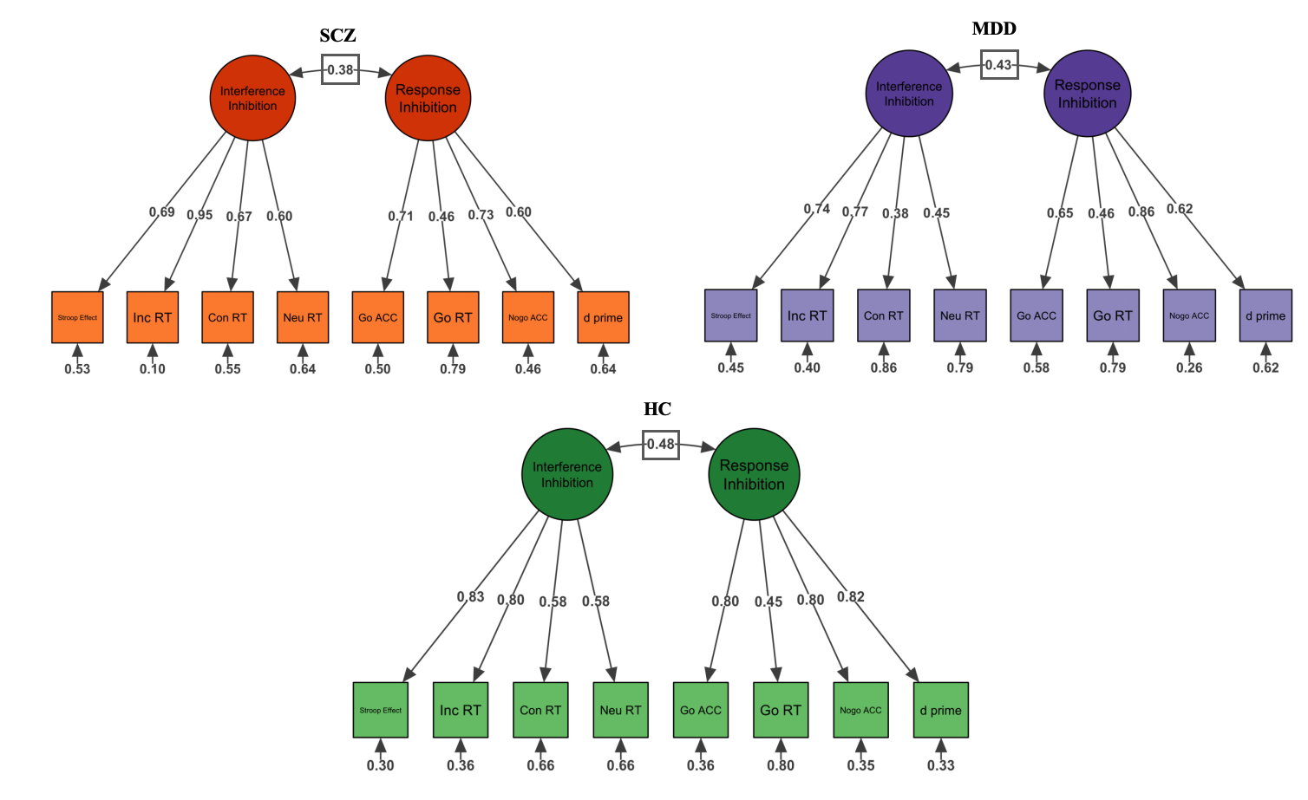
Supplemental Figure S1. Confirmatory factor analysis of inhibitory control measures
Note. Confirmatory factor analysis supporting a two-factor model of inhibitory control, with interference inhibition and response inhibition as separable yet correlated constructs. Standardized factor loadings are displayed on the paths; inter-factor correlations are shown for each group.

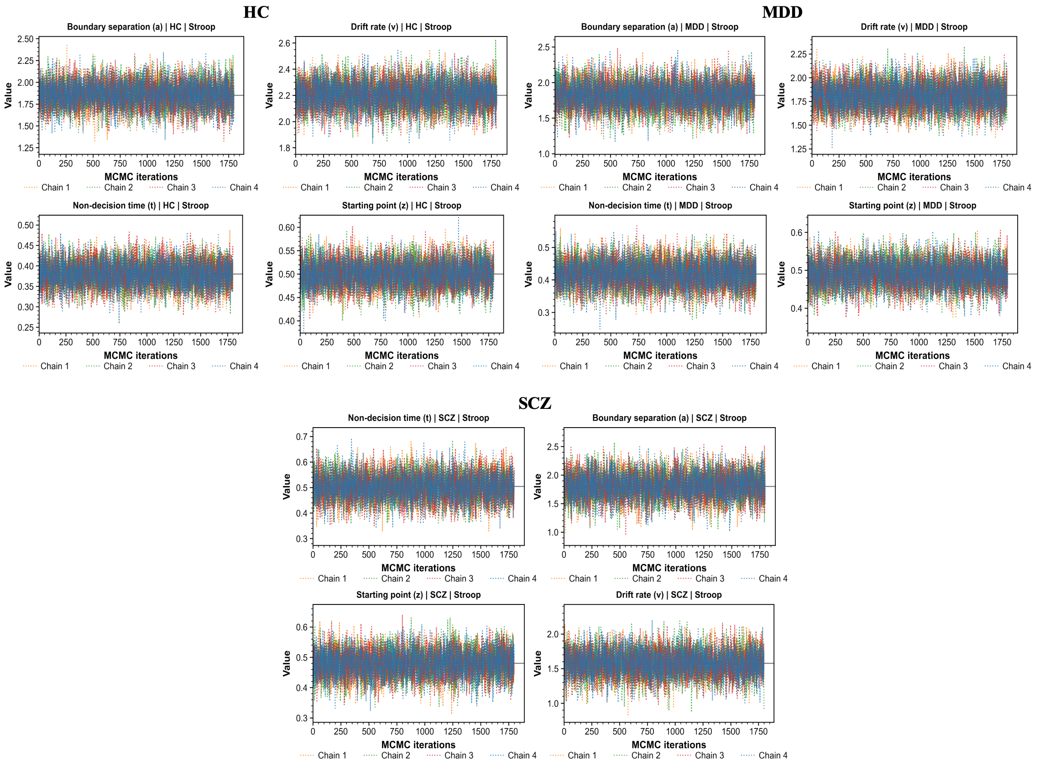
Supplemental Figure S2. Markov chain Monte Carlo diagnostics for the Stroop task
Note. Trace plots and posterior distributions of hierarchical drift-diffusion model (HDDM) parameters for the Stroop task.

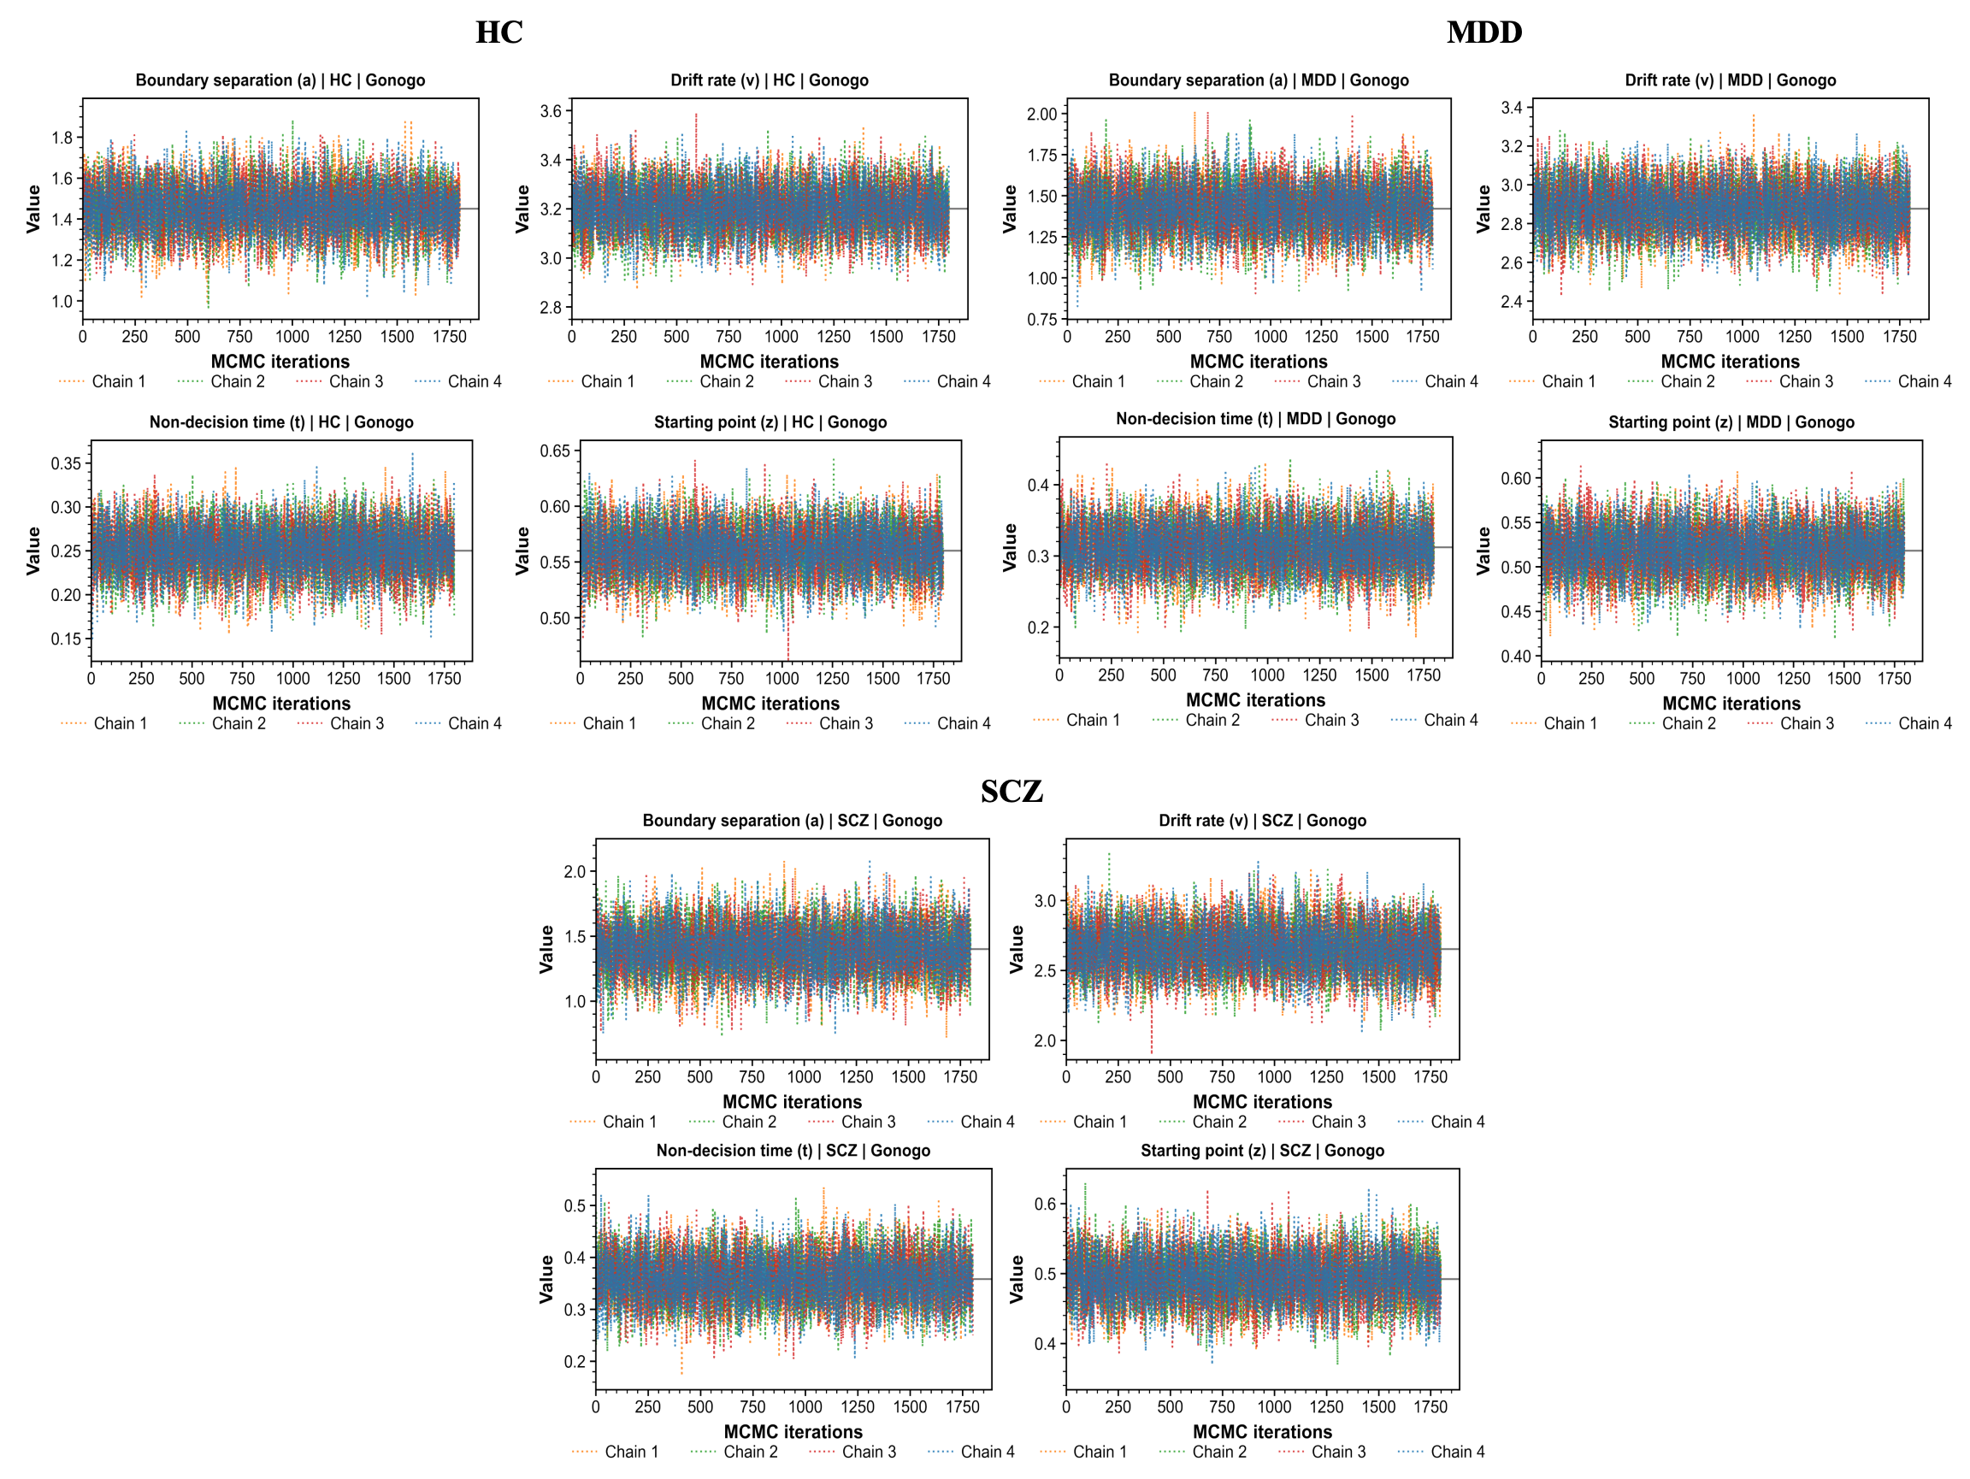
Supplemental Figure S3. Markov chain Monte Carlo diagnostics for the Go/No-Go task
Note. Trace plots and posterior distributions of hierarchical drift diffusion model (HDDM) parameters for the Go/No-Go task.

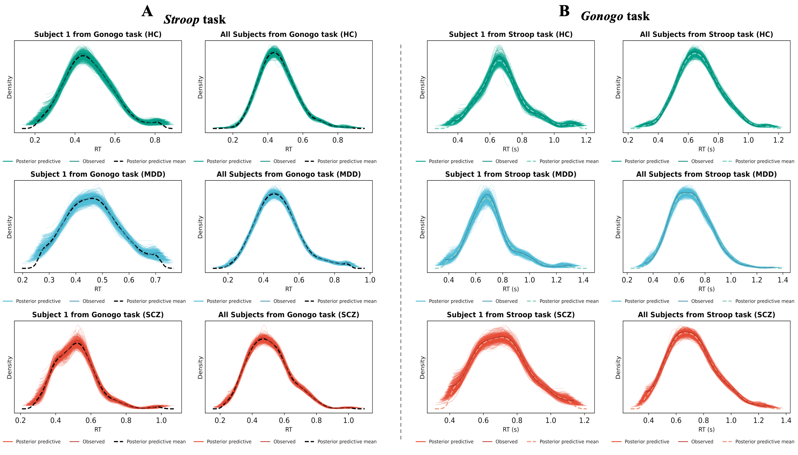
Supplemental Figure S4. Posterior predictive checks for model adequacy
Note. Posterior predictive checks assessing model fit for the (A) Stroop task and (B) Go/No-Go task. Observed reaction time distributions (histograms) are overlaid with simulated distributions from the fitted hierarchical drift-diffusion model (lines).
HC = healthy controls; MDD = major depressive disorder; SCZ = schizophrenia.

Supplemental Figure S5. Mediation analyses examining HDDM parameters as mediators of group differences in behavioral performance
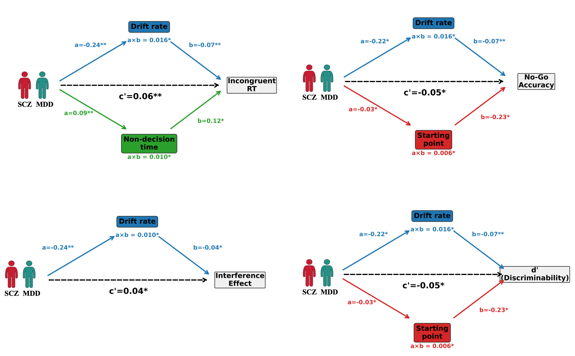
Note. Path diagrams illustrating the mediating role of hierarchical drift diffusion model (HDDM) parameters in the relationship between group status and behavioral performance.
MDD = major depressive disorder; SCZ = schizophrenia.*p < 0.05, **p < 0.01, ***p < 0.001.

Supplemental Figure S6. Extrapyramidal symptoms in the patients group
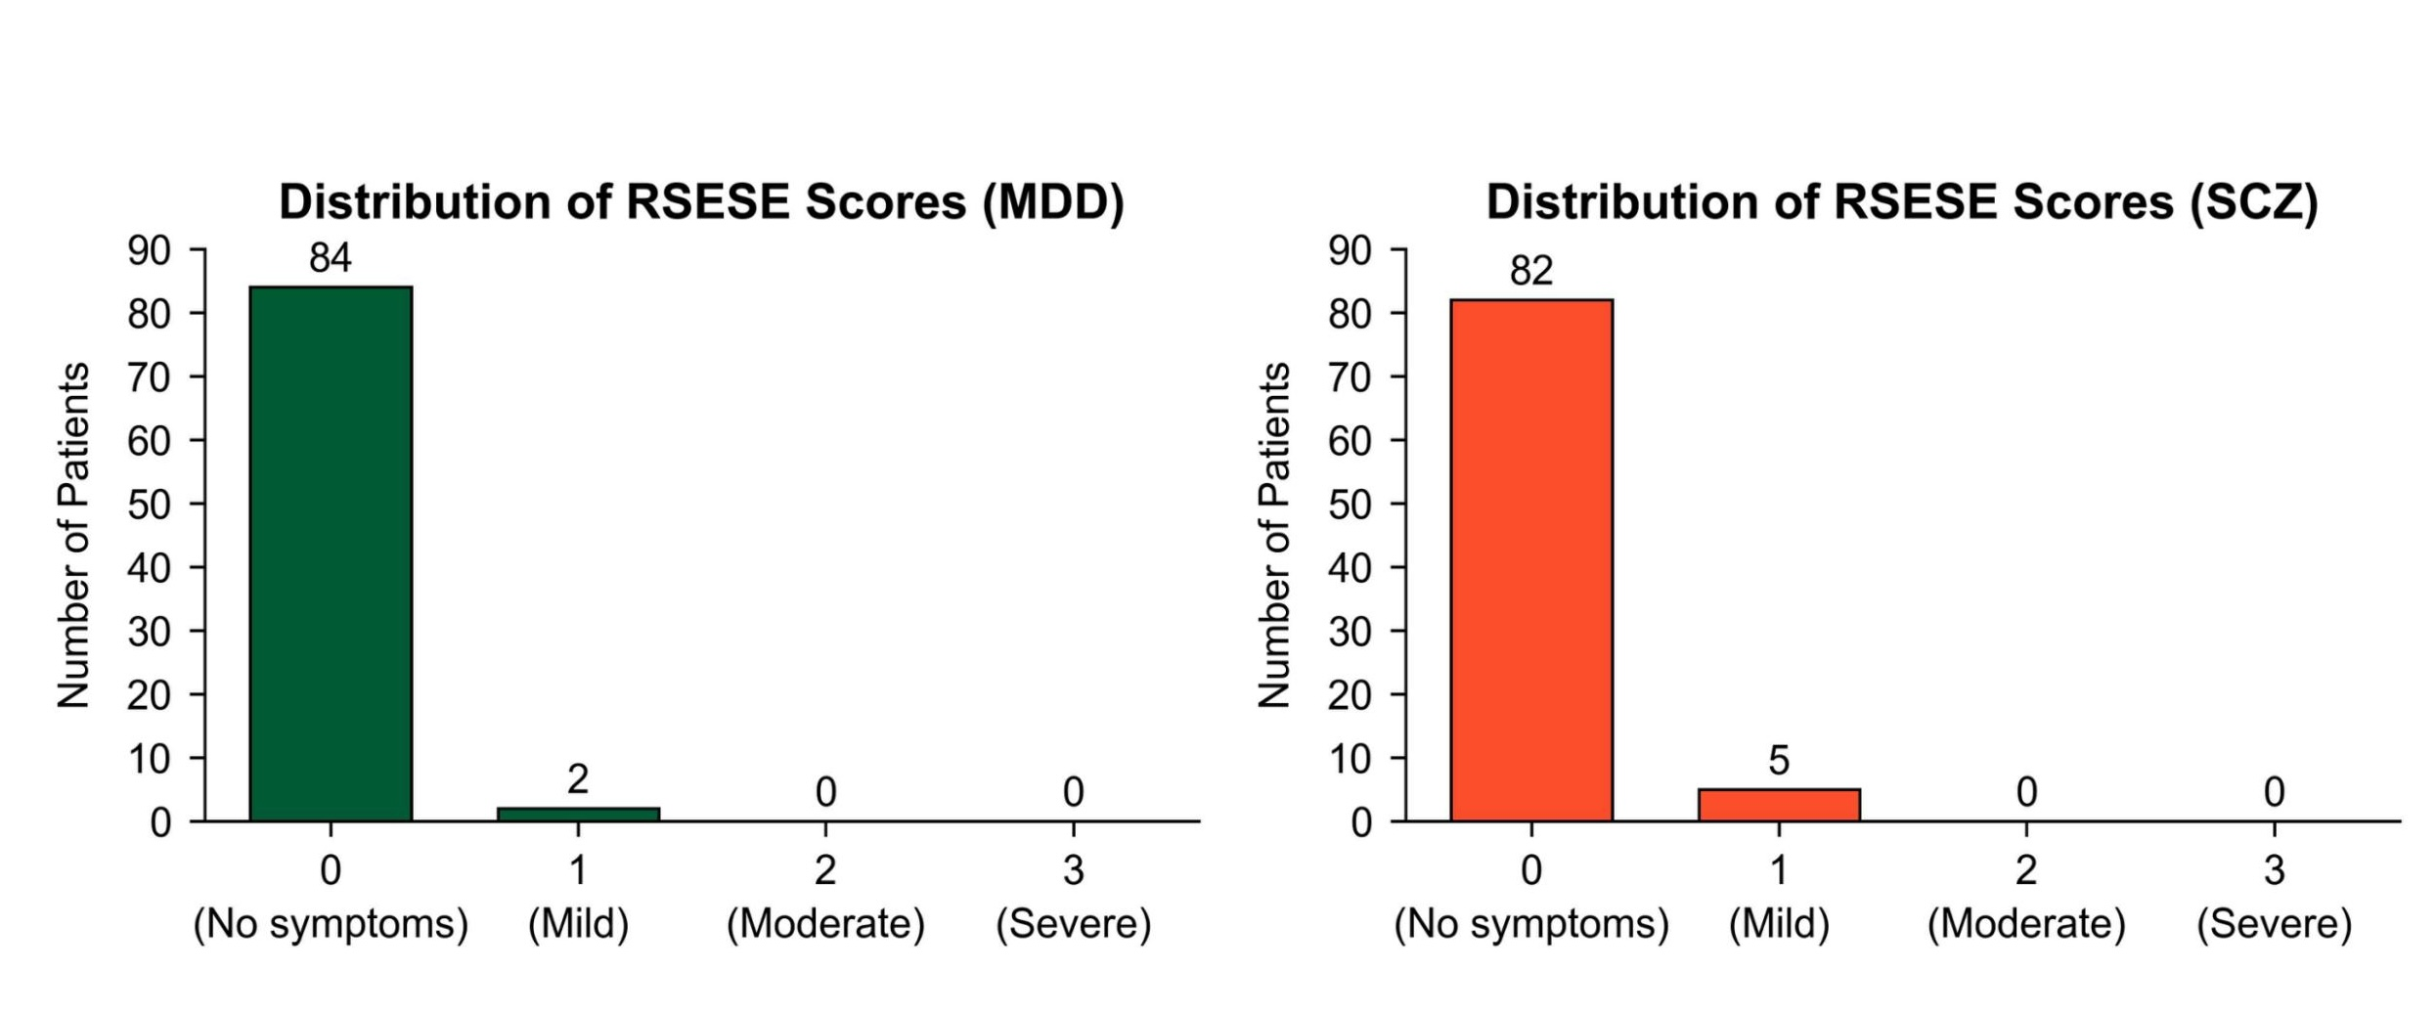
Note. RSESE = Rating Scale for Extrapyramidal Side Effects.

Supplemental References
Boyce, W., Torsheim, T., Currie, C., & Zambon, A. (2006). The family affluence scale as a measure of national wealth: Validation of an adolescent self-report measure. Social Indicators Research, 78(3), 473–487. https://doi.org/10.1007/s11205-005-1607-6
Dienes, Z. (2016). How Bayes factors change scientific practice. Journal of Mathematical Psychology, 72, 78–89. https://doi.org/10.1016/j.jmp.2015.10.003
Kruschke, J. K., & Liddell, T. M. (2018). The Bayesian New Statistics: Hypothesis testing, estimation, meta-analysis, and power analysis from a Bayesian perspective. Psychonomic Bulletin & Review, 25(1), 178–206. https://doi.org/10.3758/s13423-016-1221-4
Letkiewicz, A. M., Wakschlag, L. S., Briggs-Gowan, M. J., Cochran, A. L., Wang, L., Norton, E. S., & Shankman, S. A. (2024). Preadolescent externalizing and internalizing symptoms are differentially related to drift-diffusion model parameters and neural activation during a go/no-go task. Journal of Psychiatric Research, 178, 405–413. https://doi.org/10.1016/j.jpsychires.2024.08.038
Pedregosa, F., Varoquaux, G., Gramfort, A., Michel, V., Thirion, B., Grisel, O., Blondel, M., Prettenhofer, P., Weiss, R., & Dubourg, V. (2011). Scikit-learn: Machine learning in Python. The Journal of Machine Learning Research, 12, 2825–2830.
Szul, M. J., Bompas, A., Sumner, P., & Zhang, J. (2020). The validity and consistency of continuous joystick response in perceptual decision-making. Behavior Research Methods, 52(2), 681–693. https://doi.org/10.3758/s13428-019-01269-3
Wu, J., Li, J., Eickhoff, S. B., Scheinost, D., & Genon, S. (2023). The challenges and prospects of brain-based prediction of behaviour. Nature Human Behaviour, 7(8), Article 8. https://doi.org/10.1038/s41562-023-01670-1
Yang, H., & van Vugt, M. (2025). “Sticky” thinking disrupts decision making for individuals with a tendency toward worry and depression. Emotion, 25(4), 997–1010. https://doi.org/10.1037/emo0001449
Zhao, X., Wang, Y., & Maes, J. H. R. (2022). The effect of working memory capacity and training on intertemporal decision making in children from low-socioeconomic-status families. Journal of Experimental Child Psychology, 216, 105347. https://doi.org/10.1016/j.jecp.2021.105347

