Supporting Information for
Boundaries of executive functions in large language models: GPT-4o selectively replicates human performance

Tongyi Zhang ¹, Jiang Qiu², and Xin Zhao¹*

*Corresponding authors: Xin Zhao
Email: psyzhaoxin@nwnu.edu.cn
Phone: +86-931-7975316

This PDF file includes:

Supporting text
Figures S1 to S5
Tables S1 to S6
SI References

Supplementary Methods

Executive function assessments
Stroop color-word task: The Stroop color-word task was administered to assess interference control (1). In this task, two Chinese color characters ("红" [red] and "绿" [green]) and a neutral string ("####") were used as stimuli. Participants were required to indicate the ink color by pressing "F" for red and "J" for green. Three conditions were included: congruent (character "红" in red ink and "绿" in green ink), incongruent (character "绿" in red ink and "红" in green ink), and neutral (string "####" in red or green ink). Each trial began with a 500-ms fixation cross, followed by a 1000-ms blank screen and a 1500-ms stimulus presentation, then an inter-trial interval. Following one practice block (18 trials with feedback), participants were required to achieve ≥85% accuracy and receive experimenter approval before proceeding. The task involved three experimental blocks, each comprising 36 trials (12 per condition), totaling 108 trials. The task duration was approximately 15 minutes, with rest periods provided between blocks.

Go/No-Go task: Response inhibition was measured using the Go/No-Go task (2). The letters X and Y were presented randomly, with participants responding to target stimuli (Go trials) while withholding responses to non-target stimuli (No-Go trials). After two practice blocks (10 Go and 10 No-Go trials each) with feedback, participants achieving ≥85% accuracy proceeded to the experimental phase. This phase comprised four experimental blocks (50 Go and 50 No-Go trials each). Each trial commenced with a 1000-ms fixation cross, followed by a 600-ms stimulus, and then an inter-trial interval. In two blocks, participants pressed "J" for X (Go) and withheld responses for Y (No-Go); in the other two blocks, these instructions were reversed. The task lasted approximately 15 minutes with rest periods between blocks.

Number-switching task: Cognitive flexibility was assessed using the number-switching task (3), which required alternating between magnitude judgment (Task A) and parity judgment (Task B). In Task A, participants were instructed to classify red numbers (1–9, excluding 5) as either smaller (pressing the "A" key) or larger (pressing the "L" key) than 5. Task B required participants to classify blue numbers (1–9, excluding 5) as odd ("A" key) or even ("L" key). The experiment comprised 20 blocks in total: 10 single-task blocks (8 trials each) and 10 mixed-task blocks (17 trials each), totaling 250 trials presented in a randomized sequence. After achieving ≥75% accuracy in two single-task practice blocks, participants advanced to the experimental phase. Each block began with a fixation cross, followed by stimulus presentation until a response was obtained, with a 25-ms inter-trial interval. Response key assignments were counterbalanced across pre- and post-test sessions. The task lasted approximately 15 minutes with rest periods between blocks.

Running memory task: Working memory updating was assessed using the running memory task (4). The task incorporated a simple (1750-ms digit presentation) and a difficult (750-ms digit presentation) condition. Random digit sequences (0–9) of varying lengths (5, 7, 9, or 11 digits) were sequentially presented. Participants continuously updated their memory to recall the three most recent digits in order. For instance, given "6, 8, 5, 4, 7, 2", participants updated their memory as: 6→6-8→6-8-5→8-5-4→5-4-7→4-7-2, then entered "4-7-2". The simple condition included one practice block (8 trials) and two experimental blocks of 12 trials each. The difficult condition consisted of two experimental blocks (12 trials each). Working memory updating performance was indexed by the mean accuracy calculated across both conditions. The task took approximately 20 minutes with rest periods provided between blocks.

Digit span forward and backward task: Working memory maintenance was measured using digit span tasks (4). Random digit sequences (0–9) were presented in sequence (1000 ms per digit). For the backward task, participants recalled sequences in reverse order (e.g., "1-2-3" recalled as "3-2-1"). Both forward and backward tasks followed identical procedures. Starting with three-digit sequences, participants completed three trials per difficulty level. Sequence length increased by one digit when at least two of three sequences were correctly recalled; otherwise, the task terminated. Working memory maintenance was indexed by the maximum sequence length successfully recalled.

n-Back task: The digit n-back task included three conditions (0-back, 1-back, and 2-back) presented in a block design. In the 0-back condition, participants detected whether the current item was "1". In the 1-back and 2-back conditions, participants detected whether the current item matched the item presented one or two positions earlier, respectively. Each condition contained four blocks. Each 29-second block included a 2-second task prompt followed by 15 single-digit stimuli (400-ms presentation, 1400-ms inter-stimulus interval). Participants had 1400 ms to respond to target stimuli. Blocks were separated by 6-second intervals and presented in pseudorandom order with no more than three consecutive repetitions of the same condition.

Stop-signal task: The stop-signal task comprised 32 stop trials and 96 go trials. Each trial began with a 300-ms fixation cross, followed by a left- or right-pointing green arrow. For go trials, the green arrow appeared for 500 ms. Participants pressed "1" for a left arrow or "2" for a right arrow within 1500 ms, followed by a 700-ms blank screen. For stop trials, after a stop-signal delay (SSD), a red arrow appeared for 300 ms, signaling participants to suppress their response. The initial SSD was 250 ms and was adjusted dynamically: successful suppression increased the subsequent SSD by 50 ms, while failed suppression decreased it by 50 ms. A blank screen followed for 1200 ms minus the SSD duration. Inter-trial intervals varied from 1–4 seconds (mean = 2.5 seconds).

Letter-number category-switching task: The switching task included 48 repeat trials and 48 switch trials. Each trial sequence began with a 1000-ms fixation cross, followed by the presentation of a number-letter or letter-number pair for 2500 ms. When letters appeared in red, participants judged whether the numbers were odd or even, and when letters appeared in green, they judged whether the letters were consonants or vowels. Participants pressed "1" for odd numbers and consonants and "2" for even numbers and vowels within 2500 ms. Inter-trial intervals ranged from 1 to 4 seconds (mean = 2.5 seconds). Trials requiring the same judgment as the previous trial were classified as repeat trials (excluding the first trial); otherwise, they were categorized as switch trials. Conditions were presented pseudorandomly, ensuring no more than four consecutive repetitions of trial type or response.

fMRI data acquisition and preprocessing
The detailed procedures for neuroimaging data acquisition followed the protocol described by He et al. (2021). All MRI data were collected at the Brain Imaging Center of Southwest University using a Siemens 3T Trio scanner equipped with a 12-channel head coil (Siemens Medical Systems, Erlangen, Germany) (5). fMRI data were acquired via an echo-planar imaging (EPI) sequence with the following parameters: repetition time (TR) = 2000 ms, echo time (TE) = 30 ms, slices = 32, slice gap = 1 mm, flip angle = 90°, field of view (FOV) = 220 × 220 mm², slice thickness = 3 mm, and voxel resolution = 3.4 × 3.4 × 3 mm³. Structural imaging was undertaken using a magnetization-prepared rapid gradient echo (MPRAGE) sequence to acquire high-resolution T1-weighted images with the following parameters: TR = 2530 ms, TE = 3.45 ms, slices = 192, flip angle = 7°, FOV = 256 × 256 mm², slice thickness = 1 mm, and voxel resolution = 1 × 1 × 1 mm³. During scanning, foam padding was used to minimize head movement, and earplugs were provided to reduce scanner noise.

Functional imaging data were preprocessed using the DPABI toolbox in conjunction with SPM12 software (http://www.fil.ion.ucl.ac.uk/spm), implemented in MATLAB (6). The preprocessing followed a standardized pipeline. First, slice-timing correction was performed to account for differences in acquisition time between slices, followed by realignment to correct for minor head movements during scanning. Data with head motion exceeding 3 mm translation or 3° rotation were excluded. Second, individual structural images were coregistered to the mean functional image to establish structure-function correspondence. Third, the DARTEL algorithm was applied to segment structural images into gray matter, white matter, and cerebrospinal fluid. Fourth, using the deformation parameters obtained from this segmentation, functional images were normalized to Montreal Neurological Institute (MNI) standard space and resampled to 3 × 3 × 3 mm³ voxel size. Finally, spatial smoothing was performed using an 8-mm FWHM Gaussian kernel to improve the signal-to-noise ratio and satisfy the spatial continuity assumptions required for statistical analysis.

In this study, voxel-based univariate activation analysis was conducted using SPM12 software. At the individual level, a general linear model was constructed for each participant to estimate activation intensity for each experimental condition. For the n-back working memory task, the model included three task conditions (0-back, 1-back, 2-back) and a baseline condition. The stop-signal task included successful go trials, successful stop trials, a baseline condition, and error trials. The task-switching paradigm comprised successful switch trials, successful repeat trials, a baseline condition, and other trial types (first trials, error trials, and post-error trials). To control for motion-related artifacts, six rigid-body motion parameters were included as covariates in the model. Time series for all task conditions were convolved with the canonical hemodynamic response function, and a high-pass filter with a cutoff frequency of 1/128 Hz was applied to remove low-frequency signal drift. Key experimental contrasts were defined as follows: for the n-back task, the "2-back > 0-back" contrast was used to capture working memory load effects; for the stop-signal task, the "successful stop > successful go" contrast was employed to isolate inhibitory control processes; for the task-switching paradigm, the "successful switch > successful repeat" contrast was used to quantify cognitive flexibility costs. At the group level, one-sample t-tests were performed on spatially normalized statistical maps to obtain population-level inferences (7, 8). A significance level of α = 0.05 was selected, with Bonferroni correction applied to control the family-wise error rate (FWE) when thresholding group-level statistical maps. Statistical inference was implemented using Python's Nilearn toolbox (https://nilearn.github.io) (9).

Figures
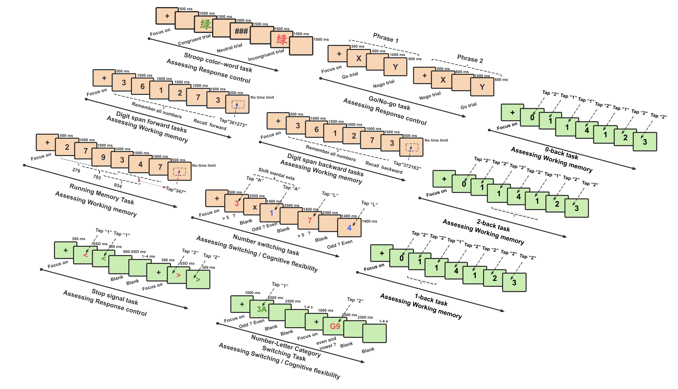

Fig. S1. Experimental paradigm flowcharts for executive function tasks. The experimental procedures for the executive function tasks used in this study are shown. Keystroke response data were recorded for all tasks. Tasks from Dataset 1 are highlighted with orange shading, and tasks from Dataset 2 are highlighted with green shading.

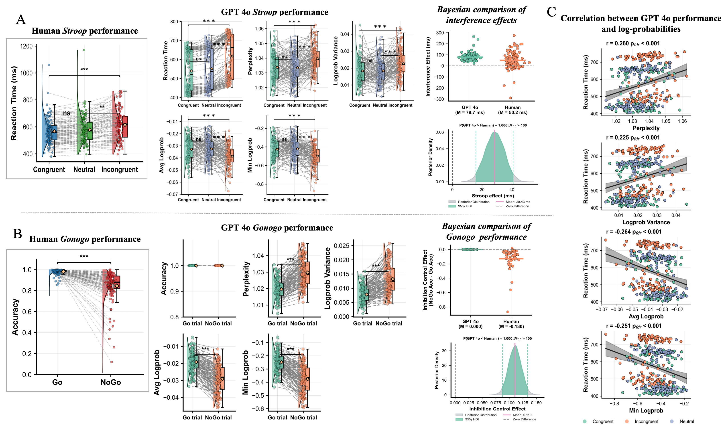

Fig. S2. Comparison of behavioral performance between GPT-4o and human participants in inhibitory control tasks (Temperature = 1). (A) Reaction times across three Stroop task conditions for human participants (N = 120) and the corresponding reaction times with log probability parameters for GPT-4o. The rightmost panel shows Bayesian analysis comparing interference effects (incongruent minus congruent condition) between humans and GPT-4o. (B) Accuracy in Go versus No-Go trials for human participants (N = 120) and the corresponding accuracy with log probability parameters for GPT-4o in the Go/No-Go task. The rightmost panel presents Bayesian analysis comparing inhibitory control effects (No-Go accuracy minus Go accuracy) between humans and GPT-4o. (C) Correlation analysis between reaction times and log probability parameters across the three Stroop task conditions for GPT-4o.

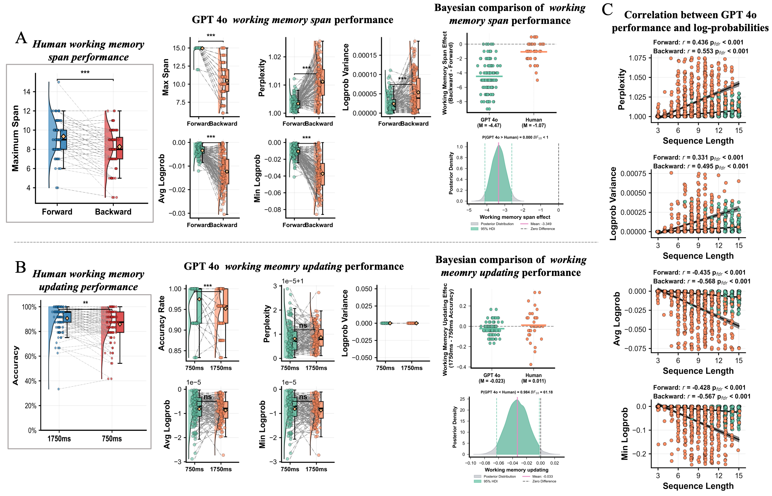

Fig. S3. Performance comparison between GPT-4o and human participants in working memory tasks (Temperature = 1). (A) Working memory span in forward versus backward digit span tasks for human participants (N = 120) and the corresponding working memory span with log probability parameters for GPT-4o. (B) Accuracy at different stimulus presentation times (1750 and 750 ms) in the running digit memory task for human participants (N = 120) and the corresponding accuracy with log probability parameters for GPT-4o. The rightmost panel shows Bayesian analysis comparing refresh time effects (accuracy at 750 ms minus accuracy at 1750 ms) between humans and GPT-4o. (C) Bayesian analysis comparing working memory load effects (forward span minus backward span) between humans and GPT-4o. (D) Correlation analysis between sequence length and log probability parameters in forward and backward digit span tasks for GPT-4o.

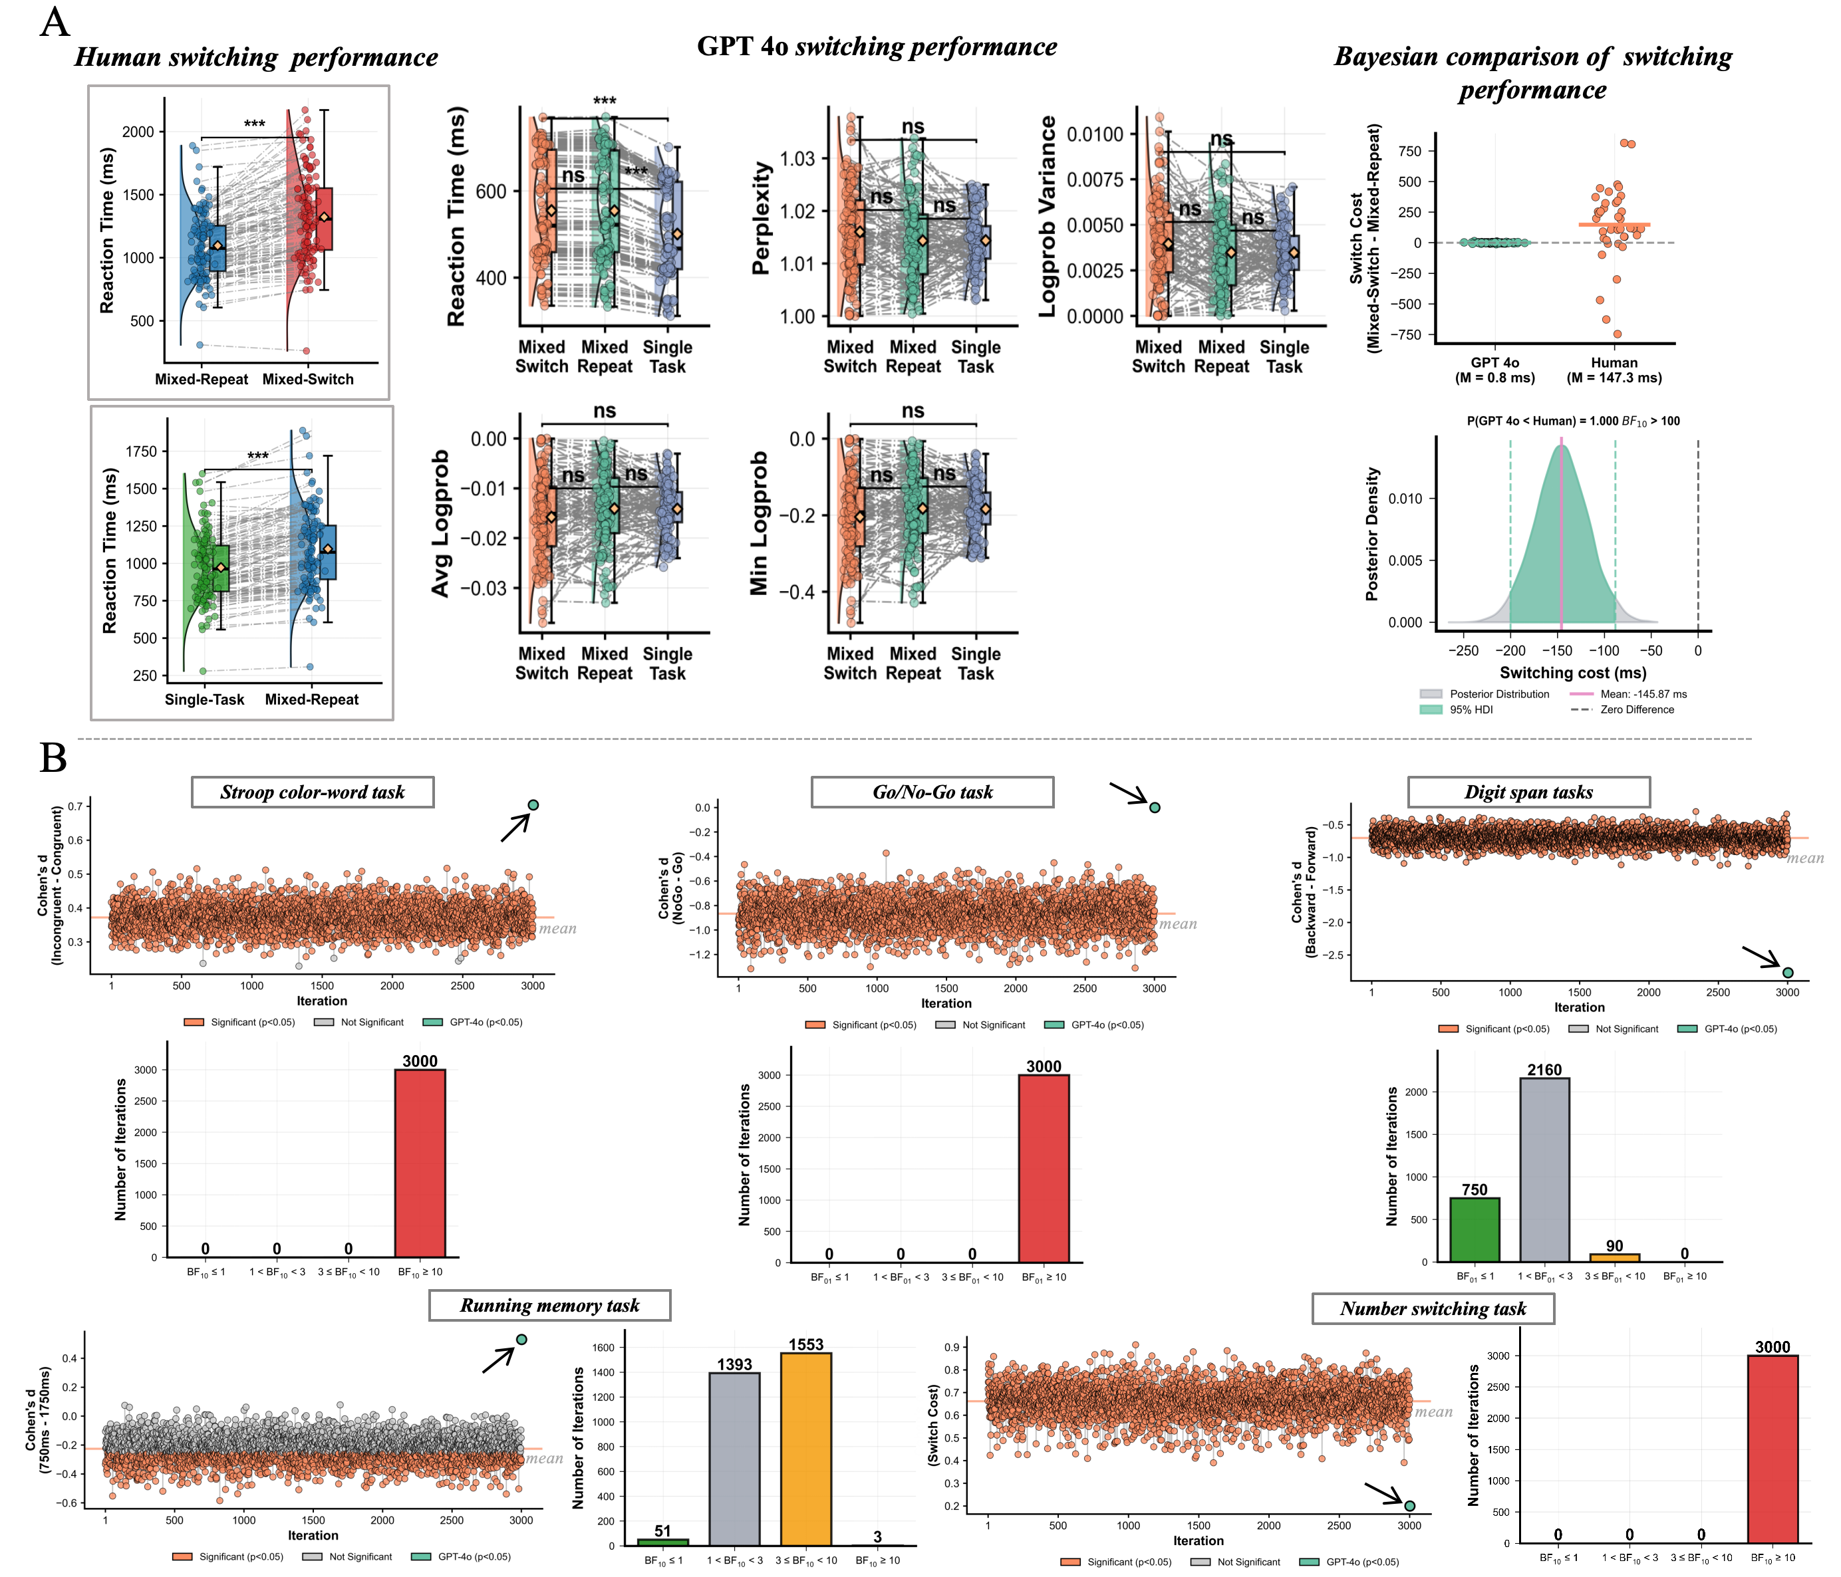

Fig. S4. Comparison between GPT-4o and human participants in the cognitive flexibility task and subsampling analysis (Temperature = 1). (A) Switching costs and mixing costs for human participants (N = 120) in the number-switching task, with corresponding reaction times and log probability parameters across three task conditions for GPT-4o. The rightmost panel presents a Bayesian analysis comparing switching costs between humans and GPT-4o. (B) Distribution of results from 3,000 repeated random samples (N = 120 each) drawn from the full human dataset (N = 1,970), demonstrating the statistical robustness of the primary findings.

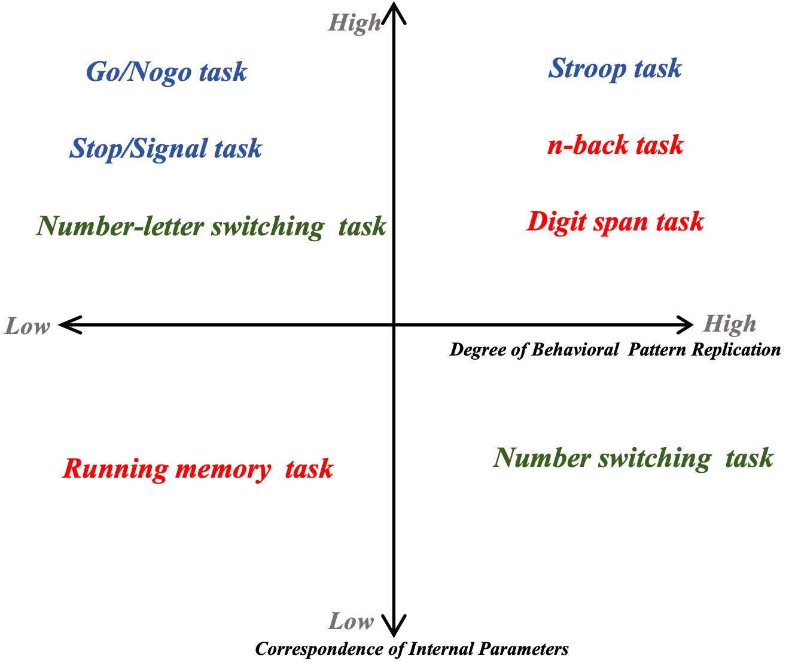

Fig. S5. Classification framework for executive function tasks. Based on two dimensions—degree of behavioral pattern replication (horizontal axis) and correspondence of internal parameters (vertical axis)—eight executive function tasks are categorized into four quadrants to evaluate the performance characteristics of large language models across different cognitive functions. Red indicates working memory tasks, blue indicates inhibitory control tasks, and green indicates cognitive flexibility tasks.

Tables

Table S1. Literature review of cognitive/executive function tasks using large language models.
Reference | Cognitive components | Models | Key findings
Valmeekam et al. (2022) (10) | Action reasoning and common-sense planning in structured domains | GPT-3 (vanilla, Instruct), BLOOM | Substantial deficits in human-trivial planning tasks in constrained domains. Fundamental limitations in reasoning relating to actions and change
Loconte et al. (2023) (11) | Verbal reasoning (VRT), cognitive estimation (CET), figurative language, planning (ToL), inhibition (HSCT), insight (CRA), social cognition (ToM, emotion, morality) | ChatGPT | Mixed cognitive profile: normal-range verbal reasoning, figurative language comprehension, and social cognition; severely impaired planning (<1st percentile); below-average insight (17th percentile)
Coda-Forno et al. (2024) (12) | Ten metrics across seven paradigms: probabilistic reasoning, exploration, metacognition, instrumental learning, model-based reasoning, temporal discounting, risk-taking | Thirty-five models: Claude (1/2), GPT-3/4, PaLM-2, MPT, Falcon, LLaMA-2 variants | RLHF significantly improves metacognition and model-based reasoning; parameter count predicts overall performance; proprietary models exhibit increased risk-taking; CoT substantially enhances probabilistic and model-based reasoning
Gong et al. (2024) (13) | Working memory capacity via verbal and spatial n-back | ChatGPT (3.5-turbo), GPT-4, Bloomz-7B variants, ChatGLM-6B variants, Vicuna (7B/13B) | ChatGPT exhibits human-like capacity limitations with similar degradation patterns when subjected to noise; GPT-4 substantially exceeds the capacities of both humans and other models; CoT reasoning enhances performance; open-source models show minimal capacity
Hu & Lewis (2024) (14) | Working memory capacity and task set maintenance via n-back | GPT-3.5 Turbo, LLaMA-3.1-70B, Qwen-1.5-14B, Gemma-2-27B | Marked performance hierarchy across models; low-performing models execute incorrect task variants; high-performers maintain accuracy even under higher difficulty levels; curriculum learning yields substantial improvements
Loconte et al. (2024) (15) | Verbal reasoning, cognitive estimation, figurative language, planning (ToL), inhibition (HSCT), social cognition | GPT-3.5, GPT-4, Claude-2, LLaMA-2 | GPT-3.5 shows severe impairments in planning and inhibition; GPT-4 achieves normal-range social cognition; Claude-2 exhibits similar deficits to GPT-3.5; LLaMA-2 demonstrates the poorest overall performance
Zhang et al. (2024) (16) | Working memory, knowledge reasoning via n-back and BBH tasks | GPT-3 series (0.35-175B parameters), ChatGPT, GPT-3.5, GPT-4 | Scale-dependent prompting effects: under advanced prompts, small models show performance degradation, while large models exhibit substantial benefit; code pretraining enhances internal reasoning; GPT-4 approaches human-level performance but with inconsistent superiority
Cui et al. (2025) (17) | Experimental replication across management and psychology domains via participant simulation | GPT-4, Claude, DeepSeek | Systematic inflation of effect sizes with excessive significance; reduced replication success for management studies; response uniformity in ethical contexts; temperature manipulation ineffective; domain-specific biases in socially sensitive content
Goto et al. (2025) (18) | Cognitive flexibility via WCST: rule switching, error correction, bottom-up/top-down integration | ChatGPT (o1, o1-mini, 4o-mini), Gemini (1.5, 2.0) | Substantial accuracy disparities across models; systematic rule-response mismatches with architecture-specific error patterns; limited capacity for dynamic cognitive control and flexible rule application
Huang et al. (2025) (19) | Working memory via three novel paradigms: Number Guessing (probability distribution validity), Yes-No Deduction (self-contradiction), Math Magic (internal reasoning accuracy) | Seventeen frontier models across four families: GPT-4o series, o-series (o1/o3/o4-Mini), LLaMA (3.1/3.3), Qwen2.5, QwQ-32B, DeepSeek (V3/R1) | Invalid probability distributions, indicating the absence of internal number representation; high failure rates with accumulating contradictions over extended queries; improved accuracy with the application of CoT and reasoning models, although persistent biases remain; core finding: LLMs lack functional working memory and rely on external context
Langis et al. (2025) (20) | Executive functions via WCST (flexibility), Flanker (attention), Digit Span (memory), DRM (false memory) | Six open-source models: Gemma2 (9B/27B), LLaMA-3.1 (8B/70B), Qwen2 (7B/72B) | Substantial deficits in cognitive flexibility and attentional control compared to humans; exceptional forward digit span with degradation of backward span; absence of human-like false memory effects; no consistent cross-task superiority based on model scale
Note. WCST = Wisconsin Card Sorting Task; BART = Balloon Analogue Risk Task; ToL = Tower of London; HSCT = Hayling Sentence Completion Test; CRA = Compound Remote Association; VRT = Verbal Reasoning Test; CET = Cognitive Estimation Task; ToM = Theory of Mind; DRM = Deese-Roediger-McDermott paradigm; BBH = BIG-Bench Hard; CoT = Chain-of-Thought prompting; RLHF = Reinforcement Learning from Human Feedback.

Table S2. Participant demographics.
 | Dataset 1 (N = 1,970) | Dataset 2 (N = 39)
Age | 19.78 ± 1.72 | 19.21 ± 0.52
Gender
Male | 915 (46.45%) | 13 (33.3%)
Female | 1,055 (53.55%) | 26 (66.7%)
Executive function measures
Task paradigms | Stroop color-word task  Go/No-Go task  Number-switching task  Running memory task  Forward and backward digit span tasks | N-back Task  Stop-Signal Task  Number-Letter Category-Switching Task
MRI data collection | – | Yes
Data collection region | Gansu Province, China | Chongqing, China

Table S3. Prompts for Dataset 1.
Task name | Instructions (Chinese in real task) | Instructions (translated to English)
Stroop Task | "现在开始第 1 个任务：Stroop 干扰效应任务。您将看到不同颜色的汉字，请忽略语意，只关注颜色。规则：看见红色按F键，看见绿色按J键。如果看到红色，请回答'我选择按F键'；如果看到绿色，请回答'我选择按J键'。请在回答中包含'计算时间：xxx毫秒'格式的反应时间。请尽可能模拟真实人类的反应，包括可能的犹豫和错误。请严格按照指定格式回答，使用中文。刺激类型：一致条件（红色的'红'字、绿色的'绿'字）、不一致条件（红色的'绿'字、绿色的'红'字）、中性条件（红色的'####'、绿色的'####'." | "Now begin Task 1: Stroop Interference Task. You will see Chinese characters in different colors. Please ignore the semantic meaning and focus only on the color. Rules: Press the F key for red, press the J key for green. If you see red, respond 'I choose to press the F key'; if you see green, respond 'I choose to press the J key'. Include the reaction time in the format “Calculation time: xxx milliseconds” in your response. Simulate realistic human responses as much as possible, including possible hesitation and errors. Strictly follow the specified format and respond in Chinese. Stimulus types: Congruent (red '红' character, green '绿' character), Incongruent (red '绿' character, green '红' character), neutral (red '####', green '####')."
Go/No-Go Task Block 1 | "现在开始第 2 个任务：Go/No-Go 任务。这个任务分为两个部分。第一部分规则：看见字母X按J键，看见字母Y不按键。如果需要按键，请回答'我选择按J键'；如果不需要按键，请回答'我选择不按键'。请在回答中包含'计算时间：xxx毫秒'格式的反应时间。请尽可能模拟真实人类的反应，包括可能的犹豫和错误。" | "Now begin Task 2: Go/No-Go Task. This task has two parts. The rules for part 1: Press the J key when you see the letter X, do not press any key when you see the letter Y. If a key must be pressed, respond 'I choose to press the J key'; if no key press is needed, respond 'I choose not to press any key'. Include the reaction time in the format 'Calculation time: xxx milliseconds' in your response. Simulate realistic human responses, including possible hesitation and errors."
Go/No-Go Task Block 2 | "现在开始Go/No-Go任务的第二部分。注意：规则发生了变化！第二部分规则：看见字母Y按J键，看见字母X不按键。如果需要按键，请回答'我选择按J键'；如果不需要按键，请回答'我选择不按键'。请在回答中包含'计算时间：xxx毫秒'格式的反应时间。请尽可能模拟真实人类的反应。3" | "Now begin Part 2 of the Go/No-Go task. Attention: Rules have changed! Rules for part 2: Press the J key when you see the letter Y, do not press any key when you see the letter X. If a key must be pressed, respond 'I choose to press the J key'; if no key press is needed, respond 'I choose not to press any key'. Include the reaction time in the format 'Calculation time: xxx milliseconds' in your response. Simulate realistic human responses. "
Digit Span Forward Task | "现在开始第 3 个任务：数字正背任务。您会依次看到一系列数字，请记住它们，并在数字序列结束后正序回答这些数字。您的回答必须严格按照以下格式：仅输出正序的数字，不要包含任何其他文本。例如，如果您看到数字序列'4 7 2'，您的回答应该仅为'472'。数字序列会从3位开始，每答对一次长度增加1位。连续答错2次将结束任务。请模拟真实人类的记忆能力，对于较长序列可能会出现记忆错误。不要输出思考过程，只输出最终答案。起始长度3位，最大长度15位，连续错2次终止。" | "Now begin Task 3: Digit Span Forward Task. You will see a series of digits in sequence. Please remember them and recall them in forward order once the sequence ends. Your response must strictly follow this format: output only the digits in forward order, without any other text. For example, if you see the digit sequence '4 7 2', your response should be only '472'. The number sequence starts with 3 digits, and the length will increase by 1 digit for each correct answer. Two consecutive errors will end the task. Simulate realistic human memory capacity; memory errors may occur for longer sequences. Do not output the thinking process, only the final answer. The starting length is 3 digits, the maximum length is 15 digits, and the task will terminate after 2 consecutive errors."
Digit Span Backward Task | "现在开始第 4 个任务：数字倒背任务。您会依次看到一系列数字，请记住它们，并在数字序列结束后倒背（即反向回答）这些数字。您的回答必须严格按照以下格式：仅输出倒序的数字，不要包含任何其他文本。例如，如果您看到数字序列'4 7 2'，您的回答应该仅为'274'。数字序列会从3位开始，每答对一次长度增加1位。连续答错2次将结束任务。请模拟真实人类的记忆能力，对于较长序列可能会出现记忆错误。不要输出思考过程，只输出最终答案。起始长度3位，最大长度15位，连续错2次终止。" | "Now begin Task 4: Digit Span Backward Task. You will see a series of digits in sequence. Please remember them and recall them in reverse order once the sequence ends. Your response must strictly follow this format: output only the digits in backward order, without any other text. For example, if you see the digit sequence '4 7 2', your response should be only '274'. The number sequence starts with 3 digits, and the length will increase by 1 digit for each correct answer. Two consecutive errors will end the task. Simulate realistic human memory capacity; memory errors may occur for longer sequences. Do not output the thinking process, only the final answer. The starting length is 3 digits, the maximum length is 15 digits, and the task will terminate after 2 consecutive errors."
Task Switching - Overall | "现在开始第 5 个任务：数字任务切换实验。这个任务包含两种类型的实验：任务A（大小判断）：对红色数字判断是否大于5（大于5按A键，小于5按L键）；任务B（奇偶判断）：对蓝色数字判断奇偶性（奇数按A键，偶数按L键）。实验分为单一任务和混合任务两种条件：单一任务：只执行任务A或只执行任务B；混合任务：任务A和任务B混合出现。回答格式要求：如果选择A键，请回答'我选择按A键'；如果选择L键，请回答'我选择按L键'；每次回答都必须包含'计算时间：xxx毫秒'（xxx为您的思考时间）。请模拟真实人类的反应" | "Now begin Task 5: Numerical Task-Switching Experiment. This task comprises two types of experiments: Task A (Magnitude Judgment): Judge whether red numbers are greater than 5 (press the A key if >5, press the L key if <5); Task B (Parity Judgment): Judge the parity of blue numbers (press the A key for odd numbers, press the L key for even numbers). The experiment is divided into single-task and mixed-task conditions: Single-task: execute only Task A or only Task B; Mixed-task: execute both Task A and Task B. Response format requirements: If choosing the A key, respond 'I choose to press the A key'; if choosing the L key, respond 'I choose to press the L key'; each response must include 'Calculation time: xxx milliseconds' (xxx is your thinking time). Simulate realistic human responses."
Task Switching - Single Task A | "现在开始单一任务A：大小判断。您将只看到红色数字，请判断数字是否大于5。大于5按A键，小于5按L键。" | "Now begin Single Task A: Magnitude Judgment. You will only see red numbers. Please judge whether any observed number is greater than 5. Press the A key if >5, press the L key if <5. "
Task Switching - Single Task B | "现在开始单一任务B：奇偶判断。您将只看到蓝色数字，请判断数字的奇偶性。奇数按A键，偶数按L键。" | "Now begin Single Task B: Parity Judgment. You will only see blue numbers. Please judge the parity of the observed numbers. Press the A key for odd numbers, press the L key for even numbers. "
Task Switching - Mixed Task | "现在开始混合任务：任务A和任务B混合出现。看到红色数字：判断是否大于5（大于5按A键，小于5按L键）；看到蓝色数字：判断奇偶性（奇数按A键，偶数按L键）。请根据数字的颜色来决定执行哪个任务。" | "Now begin the Mixed Task: Task A and Task B appear together. If seeing red numbers: judge whether they are >5 (press the A key if >5, press the L key if <5). If seeing blue numbers: judge their parity (press the A key for an odd number, press the L key for an even number). Please decide which task to execute based on the color of the number. "
Updating Memory Task Block 1 | "现在开始第 6 个任务：活动记忆刷新任务。这个任务分为两个部分。第一部分：每个刺激呈现1750毫秒。您会依次看到一系列0-9的数字，需要持续更新并记住最后出现的3个数字。例如，如果依次展示9、8、5、2、1、3，您需要从'9'逐步更新至'213'。请在数字序列结束后输入最后3个数字，格式为连续数字。请模拟真实人类的工作记忆刷新能力，可能会出现更新错误。不要输出思考过程，只输出最终的3个数字答案。" | "Now begin Task 6: Updating Memory Task. This task has two parts. Part 1: Each stimulus is presented for 1750 milliseconds. You will see a series of digits from 0–9 in sequence, and you need to continuously update and remember the last 3 digits that appear. For example, if shown 9, 8, 5, 2, 1, 3 sequentially, you need to update from '9' to '213' step by step. Once the number sequence ends, input the last 3 digits consecutively. Simulate the working memory updating ability of real humans; updating errors may occur. Do not output the thinking process, only the final 3-digit answer. "
Updating Memory Task Block 2 | "现在开始活动记忆刷新任务的第二部分。注意：刺激呈现速度发生了变化！第二部分：每个刺激呈现750毫秒。您会依次看到一系列0-9的数字，需要持续更新并记住最后出现的3个数字。请在数字序列结束后输入最后3个数字，格式为连续数字。由于呈现速度更快，请尽力保持注意力集中。不要输出思考过程，只输出最终的3个数字答案。" | "Now begin Part 2 of the Updating Memory Task. Attention: Stimulus presentation speed has changed! Part 2: Each stimulus is presented for 750 milliseconds. You will see a series of digits from 0–9 in sequence, and you need to continuously update and remember the last 3 digits that appear. Once the digit sequence ends, input the last 3 digits consecutively. Due to the faster presentation speed, maintain focused attention. Do not output the thinking process; only output the final 3-digit answer. "
System Role | "您是一位真实的认知心理学实验被试。接下来您将依次完成6个不同的认知任务，包括Stroop任务、Go/No-Go任务、数字正背任务、数字倒背任务、任务切换任务和活动记忆任务。每个任务之间会有休息时间。请严格按照每个任务的指定格式回答，使用中文。" | "You are a real participant in a cognitive psychology experiment. You will sequentially complete 6 different cognitive tasks, including the Stroop task, the Go/No-Go task, the Digit Span Forward task, the Digit Span Backward task, the Task Switching task, and the Updating Memory task. There will be rest periods between each task. Please strictly follow the specified format for each task and respond in Chinese."
Welcome Message | "欢迎参与认知心理学实验！您是第 1 号被试。今天您将依次完成6个认知任务，每个任务之间会有休息时间。整个实验大约需要35-45分钟。请放松心情，按照指导语认真完成每个任务。准备好开始了吗？请回答'我准备好了，可以开始实验'。" | "Welcome to the cognitive psychology experiment! You are participant number 1. Today you will sequentially complete 6 cognitive tasks, with rest periods between each task. The entire experiment will take approximately 35–45 minutes. Please relax and carefully complete each task according to the instructions. Ready to begin? Please respond 'I am ready to begin the experiment'."
Rest Instructions | "第 1 个任务已完成！请您休息一下，放松一下大脑。当您觉得休息充分，准备好开始下一个任务时，如果你觉得休息好了，请回答'我已经休息好了，准备开始第 2 个任务：Go/No-Go任务'。" | "Task 1 completed! Please take a rest and relax your mind. When you feel sufficiently rested and are ready to begin the next task, please respond 'I am rested and ready to begin Task 2: Go/No-Go Task'."
Closing Message | "恭喜您！您已经完成了所有6个认知任务。感谢您的参与！整个实验已经结束。您的表现数据将用于认知心理学研究。再次感谢您的配合！" | "Congratulations! You have completed all 6 cognitive tasks. Thank you for your participation! The entire experiment is now complete. Your performance data will be used for cognitive psychology research. Thank you again for your cooperation!"

Table S4. Prompts for Dataset 2.
Task name | Instructions (Chinese in Real Task) | Instructions (translated to English)
n-Back Task 0-back | "现在开始第 1 个任务：n-Back任务。第一阶段：0-back任务。您将看到一系列0-9的数字。如果看到数字'3'，请按'是'键；看到其他数字，请按'否'键。如果是目标数字3，请回答'我选择按是键'；如果不是，请回答'我选择按否键'。请在回答中包含'计算时间：xxx毫秒'格式的反应时间。请尽可能模拟真实人类的反应，包括可能的犹豫和错误。请严格按照指定格式回答，使用中文。" | "Now begin Task 1: n-Back task. Phase 1: 0-back task. You will see a series of digits from 0 to 9. If you see the digit '3', press the 'Yes' key; for other digits, press the 'No' key. If it is the target digit 3, respond 'I choose to press the Yes key'; otherwise, respond 'I choose to press the No key'. Please include the reaction time in the format 'Calculation time: xxx milliseconds' in your response. Simulate realistic human responses, including possible hesitation and errors. Strictly follow the specified format and respond in Chinese. "
n-Back Task 1-back | "请休息一下。现在开始第二阶段：1-back任务。您将看到一系列0-9的数字。如果当前数字与前一个数字相同，请按'是'键；如果不同，请按'否'键。如果当前数字与前一个数字相同，请回答'我选择按是键'；如果不同，请回答'我选择按否键'。请在回答中包含'计算时间：xxx毫秒'格式的反应时间。请模拟真实人类的反应。" | "Please take a rest. Now begin Phase 2: 1-back task. You will see a series of digits from 0 to 9. If the current digit matches the previous digit, press the 'Yes' key; if different, press the 'No' key. If the current digit matches the previous one, respond 'I choose to press the Yes key'; otherwise, respond 'I choose to press the No key'. Please include the reaction time in the format 'Calculation time: xxx milliseconds' in your response. Simulate realistic human responses. "
n-Back Task 2-back | "请休息一下。现在开始第三阶段：2-back任务。您将看到一系列0-9的数字。如果当前数字与前面第2个数字相同，请按'是'键；如果不同，请按'否'键。如果当前数字与前面第2个数字相同，请回答'我选择按是键'；如果不同，请回答'我选择按否键'。请在回答中包含'计算时间：xxx毫秒'格式的反应时间。请模拟真实人类的反应。" | "Please take a rest. Now begin Phase 3: 2-back task. You will see a series of digits from 0 to 9. If the current digit matches the second-to-last digit, press the 'Yes' key; if different, press the 'No' key. If the current digit matches the second-to-last digit, respond 'I choose to press the Yes key'; otherwise, respond 'I choose to press the No key'. Please include the reaction time in the format 'Calculation time: xxx milliseconds' in your response. Simulate realistic human responses. "
Stop-Signal Task | "现在开始第 2 个任务：停止信号任务。您将看到左箭头或右箭头，需要尽可能快速准确地响应：看到左箭头，请按'1'键；看到右箭头，请按'2'键。但是，如果绿色箭头后出现红色箭头（停止信号），您必须抑制已经启动的反应，不要按键。回答格式：执行试次：如果是左箭头，请回答'我选择按1键'；如果是右箭头，请回答'我选择按2键'。停止试次：如果成功抑制，请回答'我选择不按键'。请在回答中包含'计算时间：xxx毫秒'格式的反应时间。请模拟真实人类的反应，停止信号出现时要努力抑制反应。" | "Now begin Task 2: Stop-Signal Task. You will see a left or right arrow, and you need to respond as quickly and accurately as possible: For left arrows, press the '1' key; for right arrows, press the '2' key. However, if a red arrow (stop signal) appears after a green arrow, you must suppress the initiated response and refrain from pressing any key. Response format: Go trials: If left arrow, respond 'I choose to press the 1 key'; if right arrow, respond 'I choose to press the 2 key'. Stop trials: If the reaction is successfully suppressed, respond 'I choose not to press any key'. Include reaction time in the format 'Calculation time: xxx milliseconds'. Simulate realistic human responses, and try to suppress responses when the stop signal appears. "
Letter-Number Switching Task | "现在开始第 3 个任务：数字-字母类别转换任务。您将看到数字-字母对或字母-数字对，需要根据字母的颜色判断不同的类别：当字母为红色时：判断数字是奇数还是偶数（奇数按'1'键，偶数按'2'键）；当字母为绿色时：判断字母是辅音还是元音（辅音按'1'键，元音按'2'键）。回答格式：如果选择'1'键，请回答'我选择按1键'；如果选择'2'键，请回答'我选择按2键'。请在回答中包含'计算时间：xxx毫秒'格式的反应时间。请尽可能快速准确地响应。请模拟真实人类的反应." | "Now begin Task 3: Letter-Number Switching Task. You will see digit-letter pairs or letter-digit pairs, and you need to make judgments based on the color of the letter. When the letter is red: Judge whether the digit is odd or even (press '1' for odd numbers, press '2' for even numbers). When the letter is green: Judge whether the letter is a consonant or a vowel (press '1' for a consonant, press '2' for a vowel). Response format: If choosing the '1' key, respond 'I choose to press the 1 key'; if choosing the '2' key, respond 'I choose to press the 2 key'. Include the reaction time in the format 'Calculation time: xxx milliseconds'. Respond as quickly and accurately as possible. Simulate realistic human responses."
System Role | "您是一位真实的认知心理学实验被试。接下来您将依次完成3个不同的认知任务，包括n-Back任务、停止信号任务和数字-字母类别转换任务。每个任务之间会有休息时间。请严格按照每个任务的指定格式回答，使用中文。" | "You are a real participant in a cognitive psychology experiment. You will sequentially complete 3 different cognitive tasks, including the n-Back task, the Stop-Signal task, and the Letter-Number Switching task. There will be rest periods between each task. Please strictly follow the specified format for each task and respond in Chinese."
Welcome Message | "欢迎参与认知心理学实验！您是第 1 号被试。今天您将依次完成3个认知任务，每个任务之间会有休息时间。整个实验大约需要20-30分钟。请放松心情，按照指导语认真完成每个任务。准备好开始了吗？请回答'我准备好了，可以开始实验'。" | "Welcome to the cognitive psychology experiment! You are participant number 1. Today, you will sequentially complete 3 cognitive tasks, with rest periods between each task. The entire experiment takes approximately 20–30 minutes. Please relax and carefully complete each task according to the instructions. Ready to begin? Please respond 'I am ready to begin the experiment'."
Rest Instructions | "第 1 个任务已完成！请您休息一下，放松一下大脑。当您觉得休息充分，准备好开始下一个任务时，如果你觉得休息好了，请回答'我已经休息好了，准备开始第 2 个任务：停止信号任务'。" | "Task 1 completed! Please take a rest and relax your mind. When you feel sufficiently rested and are ready to begin the next task, please respond 'I am rested and ready to begin Task 2: Stop-Signal Task'."
Closing Message | "恭喜您！您已经完成了所有3个认知任务。感谢您的参与！整个实验已经结束。您的表现数据将用于认知心理学研究。再次感谢您的配合！" | "Congratulations! You have completed all 3 cognitive tasks. Thank you for your participation! The entire experiment is now complete. Your performance data will be used for cognitive psychology research. Thank you again for your cooperation!"

Table S5. Log probability parameters.
Parameter | Definition | High values indicate | Cognitive analogy
Perplexity | The model's degree of "surprise" or uncertainty about a sequence | The model is confused, uncertain about the answer | A human’s degree of "perplexity" when facing difficult problems
Logprob variance | Consistency of the model's token choices | Indecisive, inconsistent choices | "Stability" during thinking
Avg logprob | Model's average confidence for the entire sequence | High overall confidence | "Overall confidence" in answer
Min logprob | The least certain token in the sequence | Presence of highly uncertain choices | "Weakest link" in the answer

Table S6. Calculation methods for executive function effects.
Executive function effect | Calculation method | Reference
Stroop interference effect | RT Incongruent - RT Congruent | MacLeod (1991) (21)
Go/No-Go inhibition effect | Accuracy No-Go - Accuracy Go | Criaud & Boulinguez (2013) (22)
Stop signal inhibition effect | Stop Signal Reaction Time | Logan et al. (1984) (23)
Task switching cost | RT Switch - RT Repeat | Schwarze et al. (2025) (24)
Working memory load effect | Accuracy (750 ms) - Accuracy (1750 ms); Accuracy (2-back) – Accuracy (0-back); Accuracy (2-back - Accuracy (1-back); Accuracy (1-back - Accuracy (0-back) | Wang et al. (2025) (25)
Note: RT = Reaction Time.
Stop Signal Reaction Time was calculated using the integration method.

SI References
1. A. R. Jensen, W. D. Rohwer Jr, The Stroop color-word test: a review. Acta psychologica 25, 36–93 (1966).
2. P. Gomez, R. Ratcliff, M. Perea, A model of the go/no-go task. Journal of Experimental Psychology: General 136, 389 (2007).
3. J. Kray, K. Z. Li, U. Lindenberger, Age-related changes in task-switching components: The role of task uncertainty. Brain and cognition 49, 363–381 (2002).
4. X. Zhao, Y. Wang, J. H. R. Maes, The effect of working memory capacity and training on intertemporal decision making in children from low-socioeconomic-status families. Journal of Experimental Child Psychology 216, 105347 (2022).
5. L. He, et al., Unity and diversity of neural representation in executive functions. Journal of Experimental Psychology: General 150, 2193–2207 (2021).
6. C.-G. Yan, X.-D. Wang, X.-N. Zuo, Y.-F. Zang, DPABI: data processing & analysis for (resting-state) brain imaging. Neuroinformatics 14, 339–351 (2016).
7. S. Bougacha, et al., Contributions of connectional pathways to shaping Alzheimer’s disease pathologies. Brain Commun 7 (2024).
8. C. Herault, et al., Creative connections: the neural correlates of semantic relatedness are associated with creativity. Commun Biol 7, 810 (2024).
9. A. Abraham, et al., Machine learning for neuroimaging with scikit-learn. Frontiers in neuroinformatics 8, 14 (2014).
10. K. Valmeekam, A. Olmo, S. Sreedharan, S. Kambhampati, Large Language Models Still Can’t Plan (A Benchmark for LLMs on Planning and Reasoning about Change) in (2022).
11. R. Loconte, G. Orrù, M. Tribastone, P. Pietrini, G. Sartori, Challenging ChatGPT ’ Intelligence’ with Human Tools: A Neuropsychological Investigation on Prefrontal Functioning of a Large Language Model. [Preprint] (2023). Available at: https://papers.ssrn.com/abstract=4377371 [Accessed 8 July 2025].
12. J. Coda-Forno, M. Binz, J. X. Wang, E. Schulz, CogBench: a large language model walks into a psychology lab. [Preprint] (2024). Available at: http://arxiv.org/abs/2402.18225 [Accessed 2 December 2024].
13. D. Gong, X. Wan, D. Wang, Working Memory Capacity of ChatGPT: An Empirical Study. AAAI 38, 10048–10056 (2024).
14. X. Hu, R. L. Lewis, Do Language Models Understand the Cognitive Tasks Given to Them? Investigations with the N-Back Paradigm. [Preprint] (2024). Available at: http://arxiv.org/abs/2412.18120 [Accessed 29 December 2024].
15. R. Loconte, G. Orrù, M. Tribastone, P. Pietrini, G. Sartori, Challenging large language models’ “intelligence” with human tools: A neuropsychological investigation in Italian language on prefrontal functioning. Heliyon 10 (2024).
16. C. Zhang, Y. Jian, Z. Ouyang, S. Vosoughi, Working Memory Identifies Reasoning Limits in Language Models in Proceedings of the 2024 Conference on Empirical Methods in Natural Language Processing, Y. Al-Onaizan, M. Bansal, Y.-N. Chen, Eds. (Association for Computational Linguistics, 2024), pp. 16896–16922.
17. Z. Cui, N. Li, H. Zhou, A large-scale replication of scenario-based experiments in psychology and management using large language models. Nat Comput Sci 5, 627–634 (2025).
18. D. Goto, H. Idei, Y. Shiozuka, T. Ogata, Performance of Large Language Models and Analysis of Responses in the Wisconsin Card Sorting Task in 2025 IEEE International Conference on Development and Learning (ICDL), (2025), pp. 1–7.
19. J. Huang, K. Sun, W. Wang, M. Dredze, Language Models Do Not Have Human-Like Working Memory. [Preprint] (2025). Available at: http://arxiv.org/abs/2505.10571 [Accessed 31 October 2025].
20. K. de Langis, et al., A Framework for Robust Cognitive Evaluation of LLMs. [Preprint] (2025). Available at: http://arxiv.org/abs/2504.02789 [Accessed 26 April 2025].
21. C. M. MacLeod, Half a century of research on the Stroop effect: an integrative review. Psychological bulletin 109, 163 (1991).
22. M. Criaud, P. Boulinguez, Have we been asking the right questions when assessing response inhibition in go/no-go tasks with fMRI? A meta-analysis and critical review. Neuroscience & biobehavioral reviews 37, 11–23 (2013).
23. G. D. Logan, W. B. Cowan, K. A. Davis, On the ability to inhibit simple and choice reaction time responses: a model and a method. Journal of experimental psychology: human perception and performance 10, 276 (1984).
24. S. A. Schwarze, et al., Intensive task-switching training and single-task training differentially affect behavioral and neural manifestations of cognitive control in children. Cerebral Cortex 35, bhaf103 (2025).
25. C. Wang, J. Wang, X. Zeng, N. X. Yu, T. Chen, Are Memory Updating Tasks Valid Working Memory Measures? A Meta-Analysis. Lifespan Development and Mental Health 1, 10003 (2025).

