1. Introduction and Problem Context
In recent years, online video platforms such as YouTube have become central channels for information dissemination, entertainment consumption, and cultural production. Among the various mechanisms shaping content visibility, the “trending” system plays a critical role in determining which videos gain widespread exposure within a short period of time. However, the underlying dynamics of how videos become trending remain only partially understood, particularly in the context of large-scale, cross-country data.
This project aims to investigate the factors influencing how quickly a video becomes trending, as well as how visibility is distributed across different channels and regions. Specifically, the analysis focuses on the concept of trending lag, defined as the time difference between video publication and its appearance on the trending list. By combining large-scale data processing, statistical modeling, and visualization techniques, this study seeks to uncover both content-level and channel-level drivers of trending performance.
In addition to understanding individual video performance, the project also addresses a broader structural question: whether visibility on the platform is evenly distributed or concentrated among a small number of highly influential channels. This perspective connects the analysis to wider discussions of algorithmic amplification and digital inequality, where platform design may reinforce existing disparities in attention and reach.
The dataset used in this study consists of approximately 17GB of global YouTube trending video records, including video metadata, channel information, engagement metrics, and country-level indicators. Due to the scale and complexity of the dataset, significant effort was devoted to data cleaning, transformation, and efficient storage, enabling robust statistical analysis across multiple dimensions.
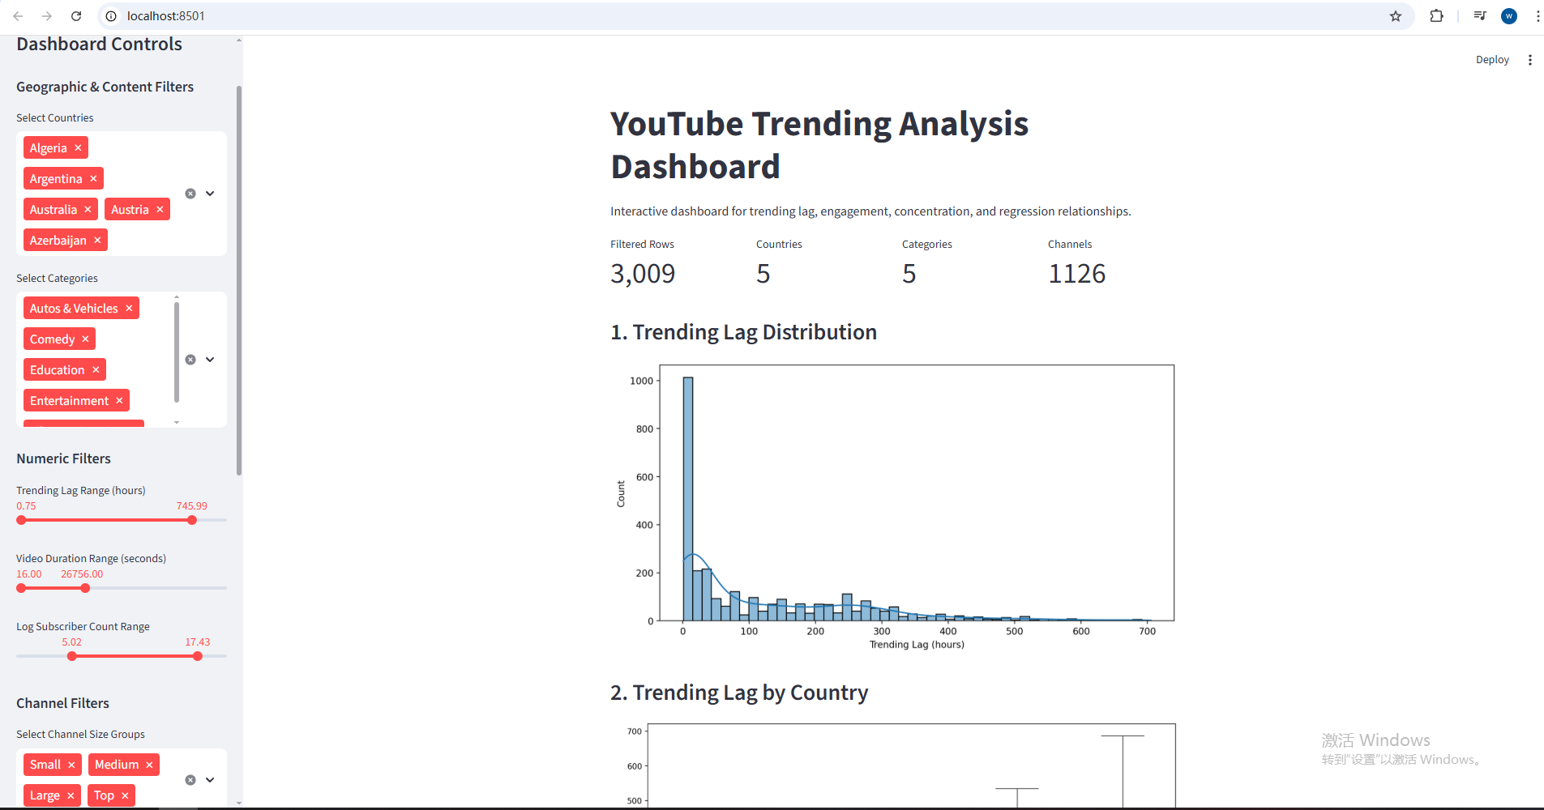

2. Target Audience and User Needs
A key consideration in this project is that different audiences may have distinct goals when interpreting the results of trending video analysis. Therefore, it is essential to explicitly identify user needs and align the analytical outputs accordingly. This ensures that the findings are not only technically rigorous but also practically meaningful.
For data analysts and researchers, the primary need is to understand the statistical relationships between variables such as subscriber count, engagement ratios, and trending speed. These users require interpretable models, diagnostic validation, and clear evidence of causal or associative patterns. In this context, regression analysis and partial effect plots provide critical insights into the independent impact of each factor.
For platform researchers and policymakers, the focus shifts toward systemic patterns, particularly the distribution of visibility across channels. Their key concern lies in whether the platform disproportionately favors already popular creators, thereby amplifying inequality. Metrics such as the Gini coefficient, Herfindahl-Hirschman Index (HHI), and concentration curves directly address these concerns by quantifying how attention is distributed.
For content creators and practitioners, the main interest lies in actionable insights. These users seek to understand which characteristics—such as video duration, content category, or engagement patterns—are associated with faster trending performance. Visualizations comparing categories and channel sizes help translate statistical findings into practical strategies.
Finally, for a general audience interested in social media dynamics, interpretability and clarity are essential. Interactive dashboards and visual summaries allow non-technical users to explore patterns such as cross-country differences and engagement intensity without requiring deep statistical knowledge.
To support these diverse user groups, this project adopts a layered analytical approach, combining statistical modeling with intuitive visualizations. Each analytical component is designed to correspond to a specific user need, ensuring that the results can be effectively interpreted and applied.

3. Data Preparation and Feature Engineering
The dataset used in this study consists of approximately 17GB of global YouTube trending video records. Due to its size and complexity, a scalable data processing strategy was required to ensure efficient handling and transformation.
To address memory limitations, the dataset was processed using a chunk-based loading approach, where data was read and transformed in manageable portions. This method enabled the analysis to be performed on standard computing resources without requiring high-memory infrastructure. After initial processing, the cleaned dataset was stored in Parquet format, significantly improving subsequent data loading speed and computational efficiency.
During the data cleaning stage, several preprocessing steps were applied to ensure consistency and usability. Missing values were handled by removing incomplete observations for key variables, while data types were standardized across columns. Special attention was given to time-related variables, where timestamp fields were converted into consistent datetime formats and timezone inconsistencies were resolved.
A key transformation involved converting video duration from ISO 8601 string format into numeric values measured in seconds. This allowed duration to be used as a continuous variable in statistical models. Additionally, the core dependent variable, trending lag, was constructed as the difference between the video publication time and the trending appearance time, measured in hours. This variable serves as the primary indicator of how quickly content gains visibility.
To capture audience interaction, engagement ratios were constructed, including the ratio of likes to views and comments to views. These normalized measures allow for meaningful comparisons across videos with different scales of exposure.
At the channel level, several variables were engineered to represent channel authority. Subscriber counts were log-transformed to reduce skewness and stabilize variance, while channel age was calculated as the time difference between the channel creation date and the video publication date. These transformations ensure that large-scale differences across channels do not dominate the statistical analysis.
Finally, skewed variables such as view counts and engagement metrics were transformed using logarithmic scaling where appropriate. This step improves model stability and ensures that extreme values do not disproportionately influence regression results.
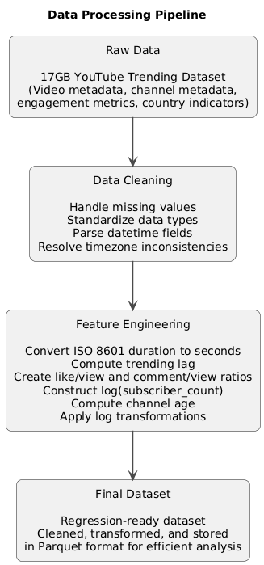

4. Methodology
To investigate the factors influencing trending performance, this study employs a combination of statistical modeling, comparative analysis, and inequality measurement techniques.
The primary analytical approach is multiple linear regression, where trending lag is modeled as the dependent variable. Independent variables include channel-level attributes such as log-transformed subscriber count, video-level features such as duration and content category, and engagement indicators such as like-to-view and comment-to-view ratios. In addition, country-level indicators are incorporated to capture regional differences in platform dynamics.
This modeling framework allows for the estimation of the independent contribution of each factor while controlling for the influence of other variables. By including country fixed effects, the model accounts for structural differences across regions, ensuring that comparisons are not biased by geographic variation.
To further explore interaction effects, additional models incorporate interaction terms between subscriber count and engagement metrics. This enables the analysis to capture whether the impact of audience engagement differs depending on the size of the channel, providing deeper insight into platform dynamics.
Model diagnostics were conducted to validate the reliability of the regression results. Multicollinearity among predictors was assessed using Variance Inflation Factor (VIF), ensuring that independent variables are not excessively correlated. Heteroskedasticity was tested using the Breusch–Pagan test, which evaluates whether the variance of residuals is constant across observations. Residual plots and Q-Q plots were also examined to assess model assumptions and the distribution of errors.
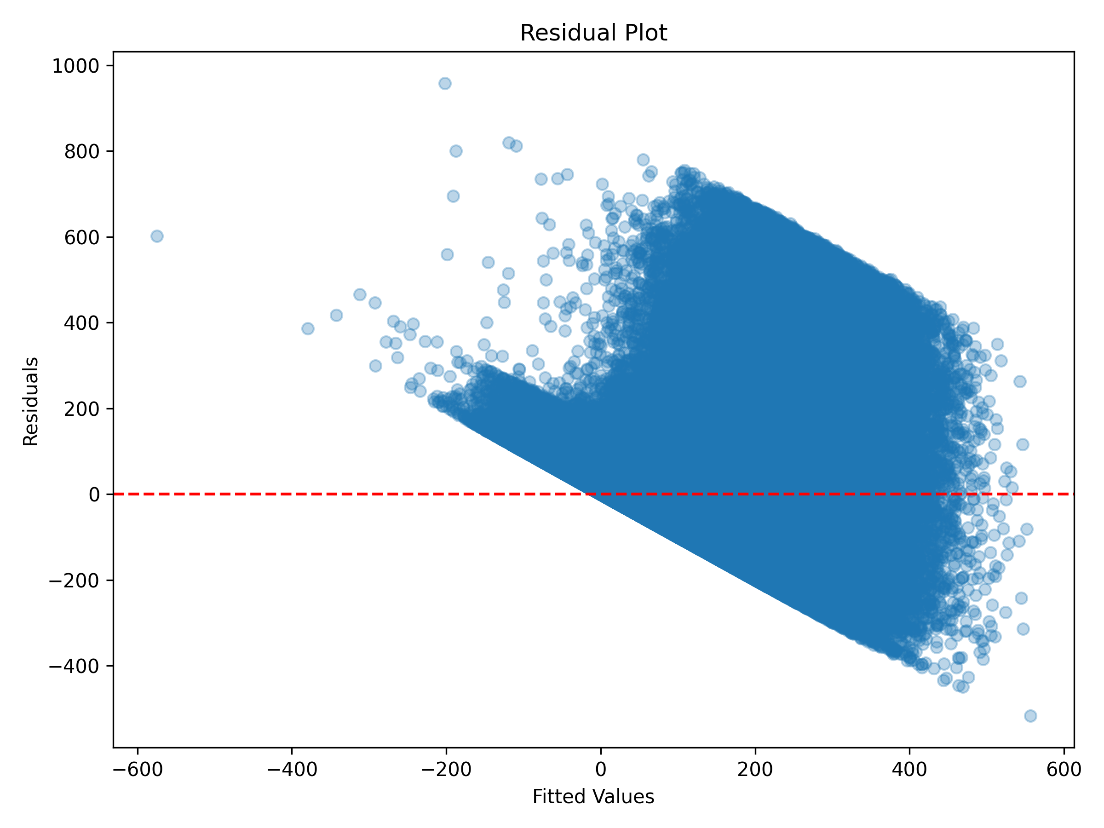
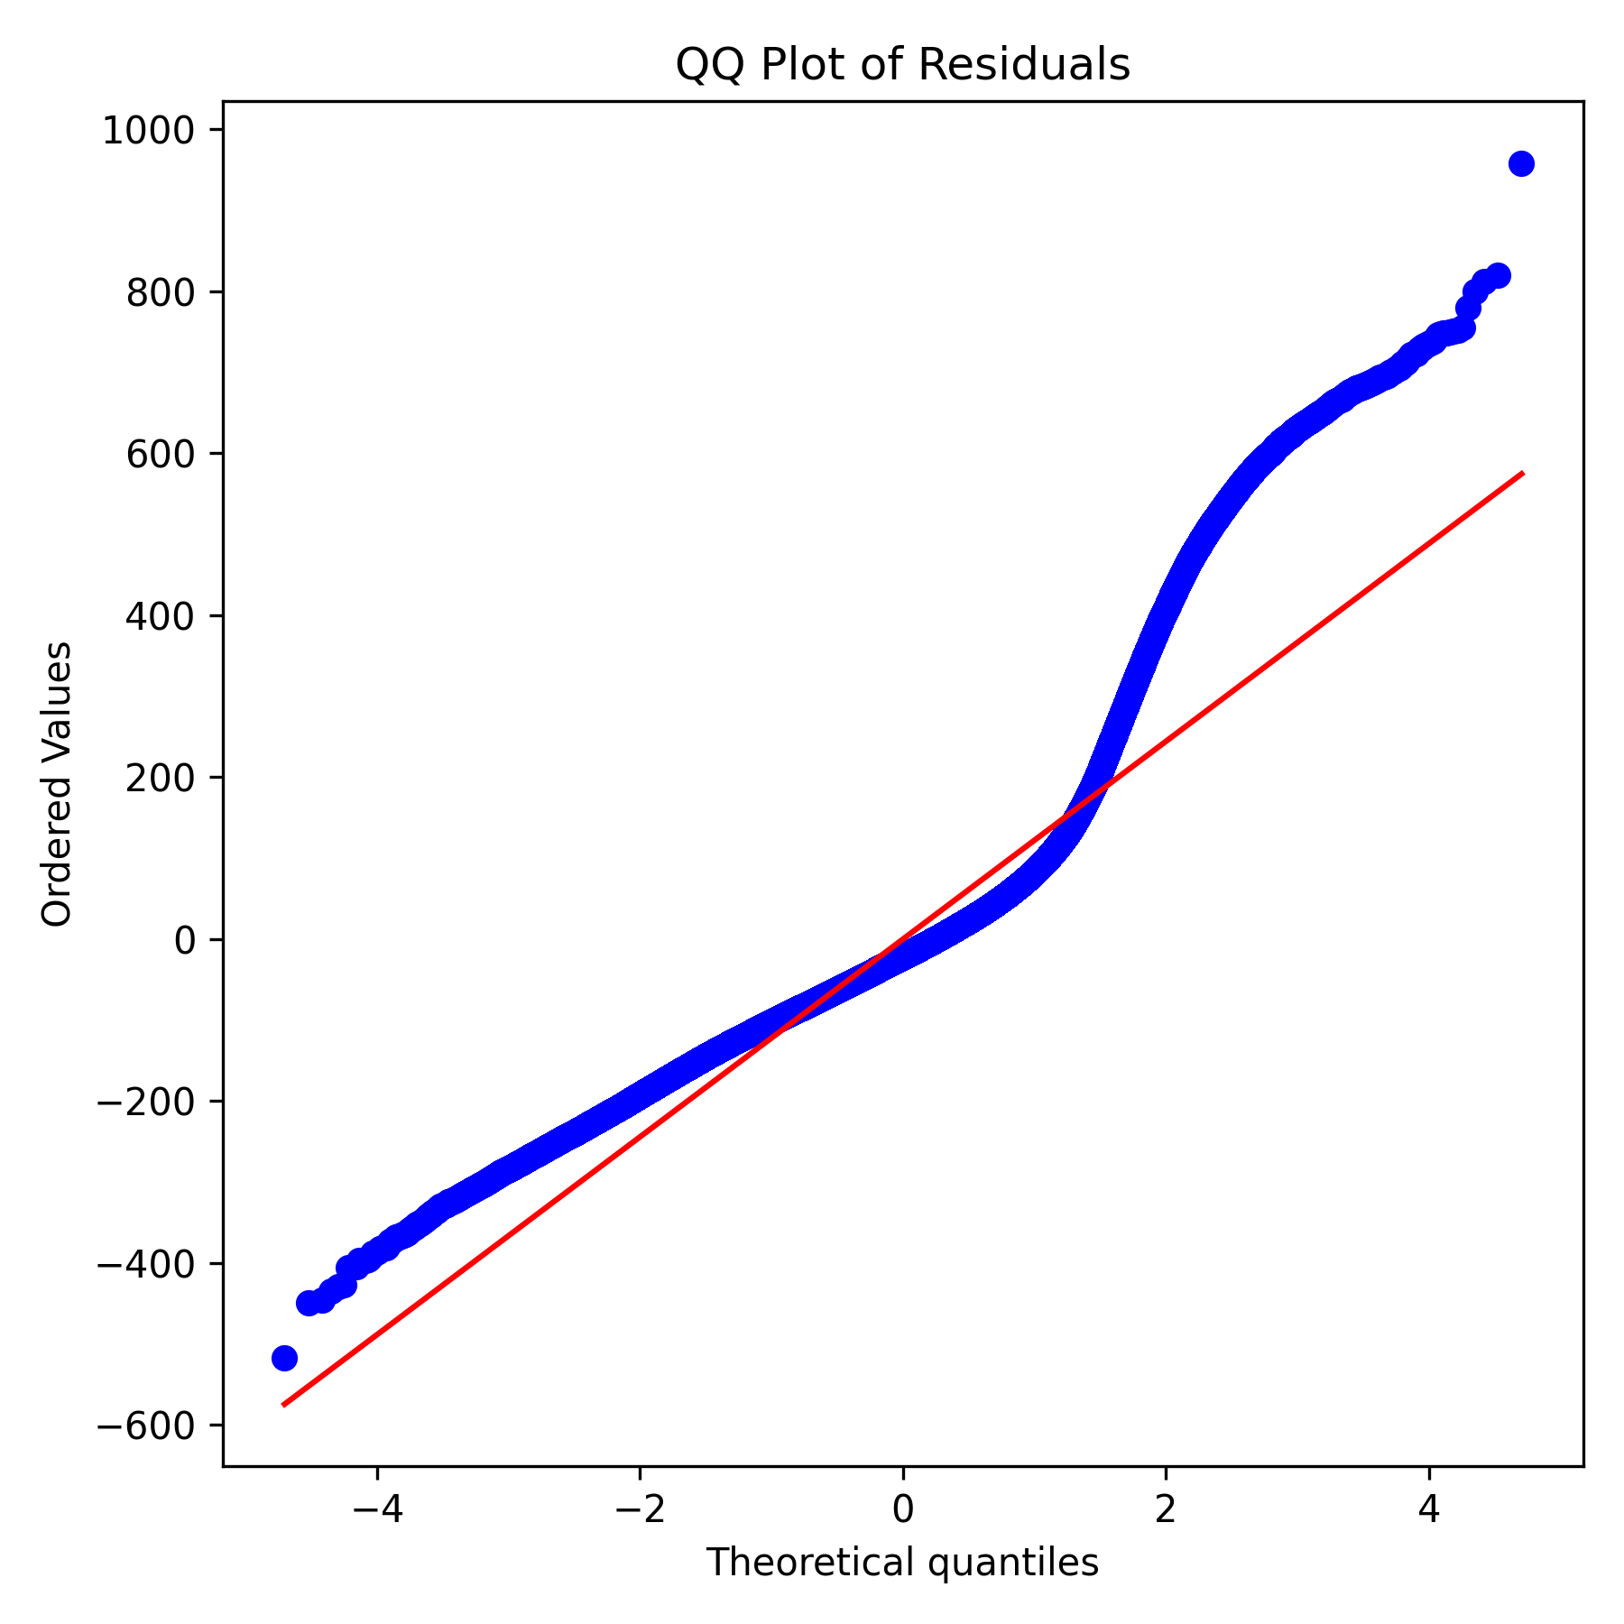
In addition to regression analysis, partial effect plots were used to visualize the independent impact of key variables while controlling for others. These plots provide an intuitive representation of how individual factors influence trending lag, complementing the numerical regression results.
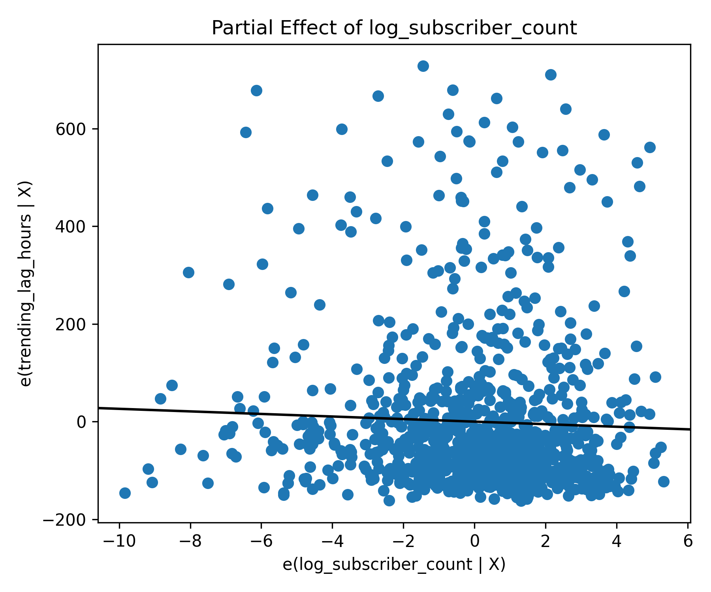
To examine cross-country differences, comparative analysis was conducted using descriptive statistics and visualizations. These include boxplots of trending lag across countries and categories, as well as engagement comparisons across regions.
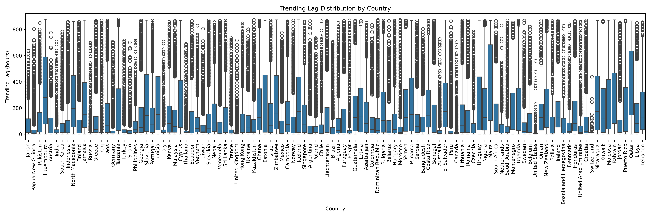
Finally, to evaluate the distribution of visibility across channels, inequality and concentration metrics were computed. The Gini coefficient was used to measure overall inequality in trending exposure, while the Herfindahl–Hirschman Index (HHI) was used to assess concentration among dominant channels. In addition, concentration curves were constructed to visualize how cumulative visibility is distributed across the channel population.
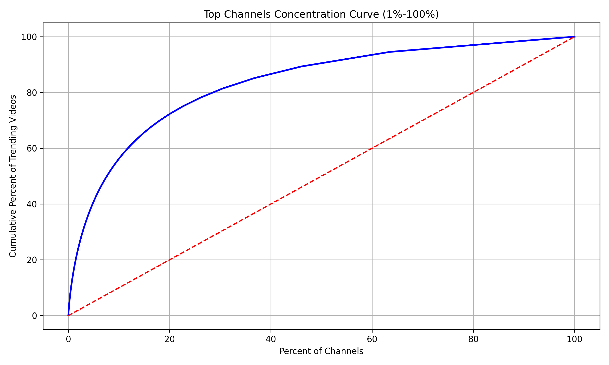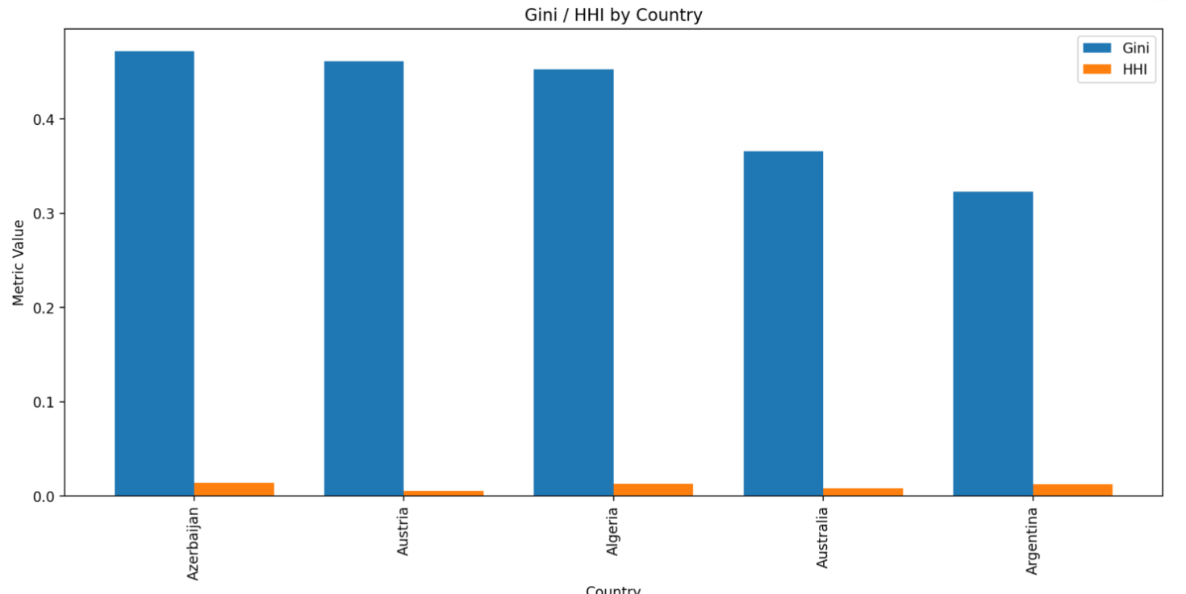

5. Results
The analysis reveals several key patterns in how videos achieve trending status.
First, the distribution of trending lag is highly skewed, indicating that while some videos gain visibility almost immediately, others take significantly longer to appear on trending lists. This suggests that trending dynamics are not uniform and may depend on a combination of content and channel characteristics.
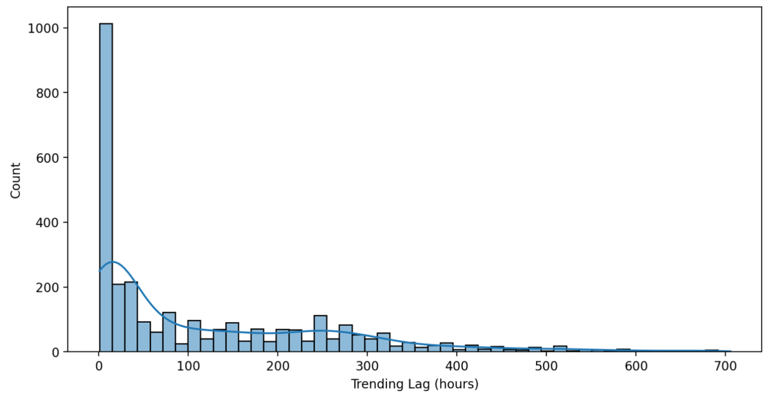
Second, clear differences emerge across countries. Some regions exhibit consistently shorter trending lag, suggesting faster content propagation and potentially more active or responsive user bases. These variations highlight the importance of incorporating regional factors into the analysis.
Third, content category plays a significant role in trending performance. Certain categories tend to trend more quickly than others, indicating that audience preferences and platform algorithms may prioritize specific types of content.
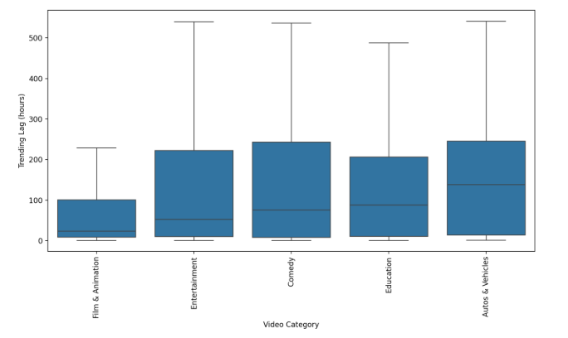
Fourth, channel size has a strong relationship with trending speed. Larger channels, as measured by subscriber count or total views, generally experience shorter trending lag. This suggests that established creators may benefit from structural advantages in gaining visibility.
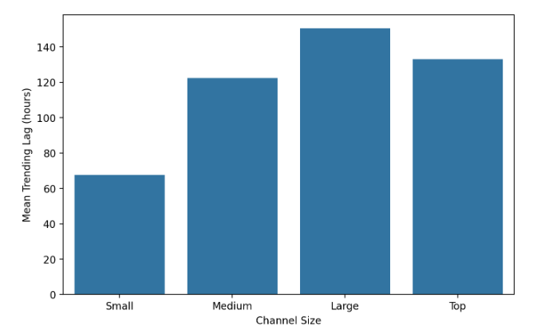
Finally, engagement metrics show meaningful variation across countries, reflecting differences in audience behavior. Regions with higher engagement ratios may indicate stronger viewer interaction, which could influence algorithmic promotion.

Concentration & Interaction
Beyond individual video characteristics, the analysis reveals strong evidence of concentration in trending visibility across channels.
The concentration curve demonstrates that a relatively small proportion of channels accounts for a disproportionately large share of trending videos. Specifically, the top percentile of channels contributes a substantial fraction of total trending content, indicating a highly unequal distribution of visibility.
This pattern is further supported by quantitative metrics. The Gini coefficient indicates a high level of inequality in the distribution of trending exposure, while the Herfindahl–Hirschman Index (HHI) suggests that visibility is concentrated among a limited number of dominant channels. These results confirm that trending visibility is not evenly distributed across the platform.
When examining concentration across countries, additional variation becomes evident. Some regions exhibit higher concentration levels than others, suggesting that platform dynamics and audience behavior may differ geographically. This indicates that inequality in visibility is not uniform but influenced by regional factors.
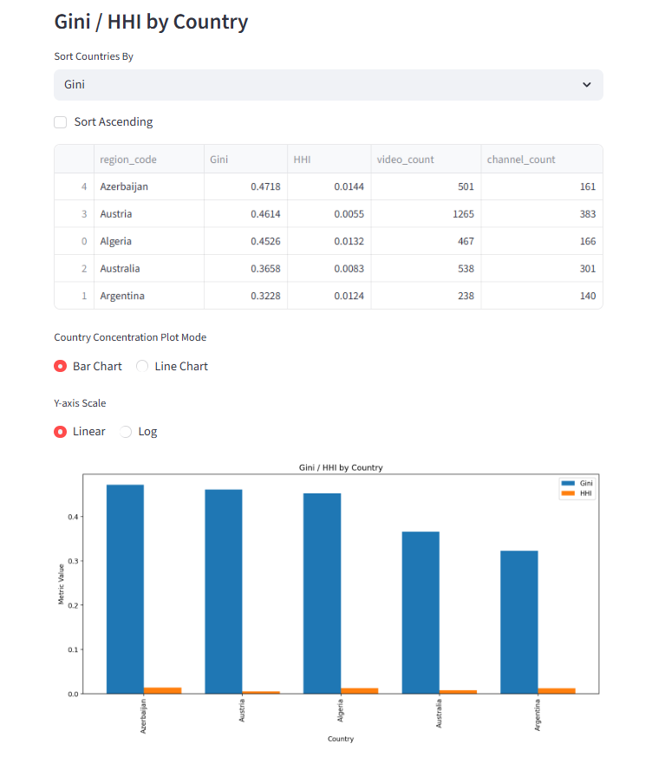
Further analysis of concentration across different variable ranges reveals that inequality is not constant. For example, when segmenting videos by subscriber count or duration, the concentration metrics change systematically. This suggests that certain segments of the platform—particularly those involving larger or more established channels—are more prone to concentrated visibility.
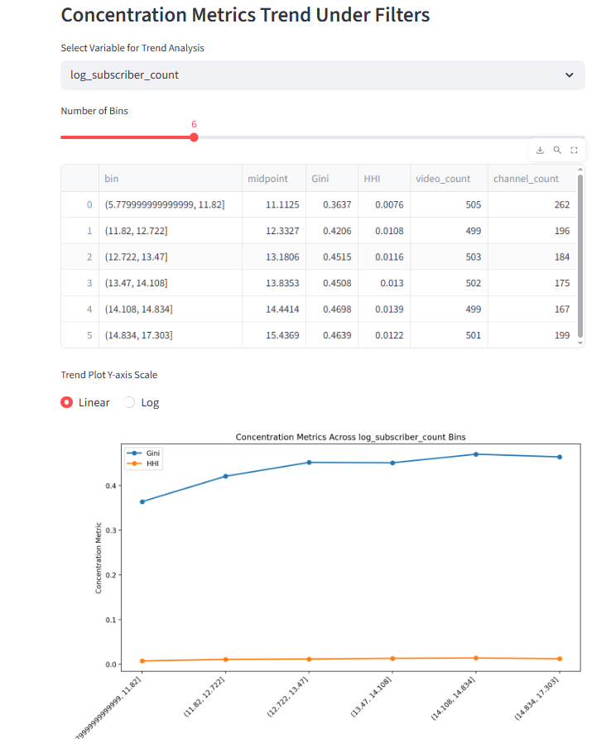
In addition to concentration analysis, interaction effects provide deeper insight into how different factors jointly influence trending performance. The interaction between subscriber count and engagement metrics indicates that the effect of engagement is not uniform across channels. In particular, engagement appears to have a stronger impact for larger channels, suggesting that audience interaction may amplify existing advantages.
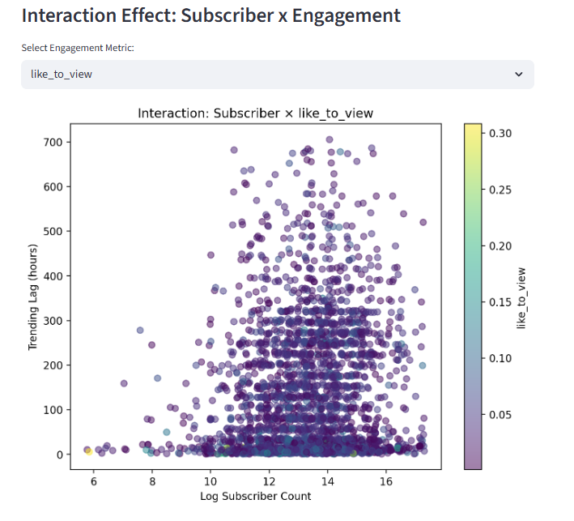
Partial effect plots further confirm these findings by isolating the independent contribution of each variable. These plots show that even after controlling for other factors, subscriber count and engagement retain significant influence on trending lag. This reinforces the robustness of the regression results.

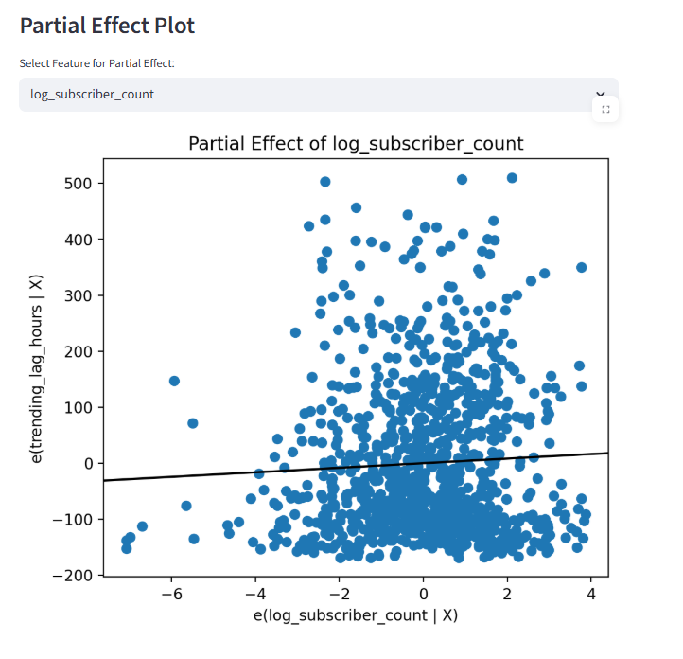

6. Discussion
The findings of this study provide important insights into the dynamics of content visibility on large-scale online platforms.
One of the most significant observations is the strong concentration of trending visibility among a small number of channels. This suggests that the platform may inherently favor already popular creators, reinforcing existing inequalities in exposure. Such patterns are consistent with the concept of algorithmic amplification, where initial advantages—such as a large subscriber base—lead to disproportionately higher visibility.
The relationship between channel size and trending speed further supports this interpretation. Larger channels consistently achieve shorter trending lag, indicating that they are more likely to be promoted quickly after publication. This may be due to both algorithmic mechanisms and audience behavior, where established creators receive immediate engagement that accelerates their visibility.
At the same time, engagement metrics such as likes-to-views and comments-to-views play a meaningful role. However, the interaction analysis suggests that engagement alone is not sufficient; its impact depends on channel size. This implies that smaller creators may face structural barriers, as similar levels of engagement do not translate into equivalent visibility outcomes.
Cross-country differences add another layer of complexity. Variations in trending lag and engagement patterns indicate that platform dynamics are influenced by regional user behavior and possibly localized algorithmic adjustments. This highlights the importance of considering geographic context when analyzing global platform data.
From a broader perspective, these findings contribute to ongoing discussions about digital inequality. The unequal distribution of trending visibility suggests that attention on the platform is not purely merit-based but shaped by structural and algorithmic factors. This raises important questions about fairness, discoverability, and the opportunities available to emerging creators.

7. Conclusion
This project provides a comprehensive analysis of YouTube trending dynamics using large-scale data and statistical modeling techniques. By combining data engineering, regression analysis, and visualization, the study identifies key factors influencing how quickly videos become trending and how visibility is distributed across channels.
The results show that both content characteristics and channel authority significantly affect trending performance. At the same time, visibility is highly concentrated among a small number of channels, indicating substantial inequality in exposure.
These findings highlight the importance of considering both individual-level factors and structural dynamics when analyzing platform behavior. Future work could extend this analysis by incorporating additional variables, exploring causal mechanisms, or examining longitudinal changes in trending patterns.

