- 导入代码后报错解决
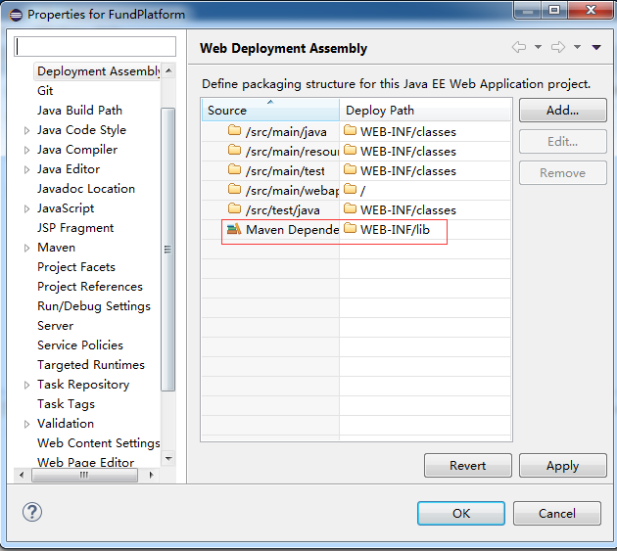
将maven依赖添加到发布中，不然在ecplise中发布到tomcat，缺少jar
- 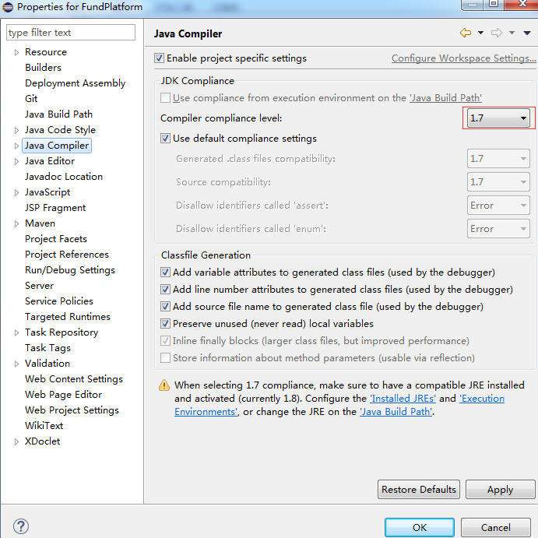

参考
- https://blog.csdn.net/qq_24232123/article/details/77528395?locationNum=2&fps=1
- https://blog.csdn.net/qq_24232123/article/details/77530981

