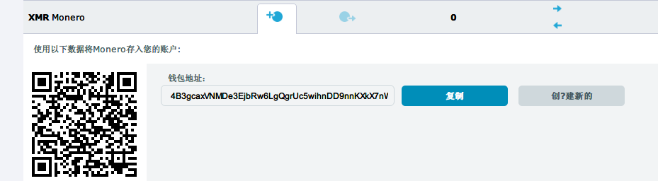

4B3gcaxVNMDe3EjbRw6LgQgrUc5wihnDD9nnKXkX7nWdHKh1vrcrKoYjXqrT3anyZ22j7DEE74GkbVcQFyH2nNiC3f2mqaY

4a6065059c92343c049a0efa658e459189479aed9aced5d69f3c95fd4cbbf5ea

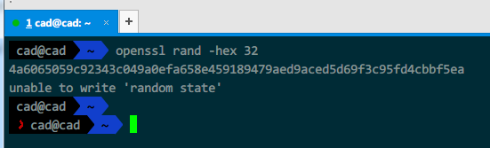

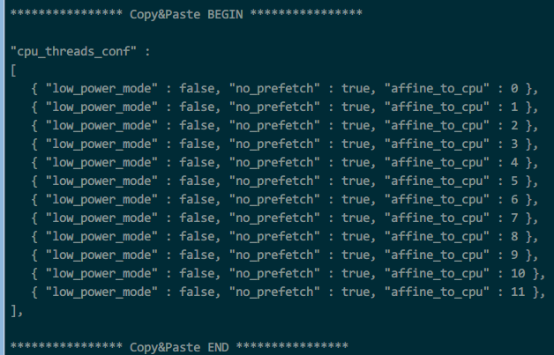

"cpu_threads_conf" :

[

{ "low_power_mode" : false, "no_prefetch" : true, "affine_to_cpu" : 0 },

{ "low_power_mode" : false, "no_prefetch" : true, "affine_to_cpu" : 1 },

{ "low_power_mode" : false, "no_prefetch" : true, "affine_to_cpu" : 2 },

{ "low_power_mode" : false, "no_prefetch" : true, "affine_to_cpu" : 3 },

{ "low_power_mode" : false, "no_prefetch" : true, "affine_to_cpu" : 4 },

{ "low_power_mode" : false, "no_prefetch" : true, "affine_to_cpu" : 5 },

{ "low_power_mode" : false, "no_prefetch" : true, "affine_to_cpu" : 6 },

{ "low_power_mode" : false, "no_prefetch" : true, "affine_to_cpu" : 7 },

{ "low_power_mode" : false, "no_prefetch" : true, "affine_to_cpu" : 8 },

{ "low_power_mode" : false, "no_prefetch" : true, "affine_to_cpu" : 9 },

{ "low_power_mode" : false, "no_prefetch" : true, "affine_to_cpu" : 10 },

{ "low_power_mode" : false, "no_prefetch" : true, "affine_to_cpu" : 11 },

],