Analysis and Visualization of the Network of Moderators and their Subreddits

Reddit is one of the biggest single organs of discussion and deliberation on the web. It is also completely moderated by volunteers. Are some skilled ones doing all the work? Do moderators looking to recruit new moderators draw from people they've already worked with, or from their subscribers? What large networks of subreddits with the same moderators are there? I looked at a network of reddit moderators and the subreddits they moderate and failed to answer most of these questions.

Data:

By asking reddit.com admin Deimorz nicely, I obtained a CSV (Comma Separated Values) formatted list of moderators and the subreddits they moderate. (See Appendix 3 for example subset of the raw data.) I'm not sure how old this data is, but it has /r/unlimitedbreadsticks so I'm thinking fairly recent. There are 38378 moderators, 20761 subreddits, for a total of 59139 nodes and 653541 edges. I'm thinking it's not the entire data set because when I crawled for subscribers I got like 300000 subreddits.

Procedure:

- I cleaned the data set (moderators.csv), added /u/ in front of users and /r/ in front of subreddits so that /r/username subreddits wouldn't mess with the bipartiteness of the graph, and separated it into a file for edges and a file for nodes, so that I could add an attribute (bipartite) to the nodes, which makes it easier to make projections in NetworkX.
- Opened a new gephi project file. Went to "Data Laboratory" and used "Import Spreadsheet" to import the nodes first, making sure "force nodes to be created as new ones" was unchecked. Then imported the edges. Saved the result as moderators.gefx making our hub-and-spokey affiliation network.
- I wanted to split this into two projections, one that would connect moderators together based on how many subreddits they moderate in common, and another that would connect subreddits together based on common moderators. I wrote a python script to do this which makes use of the NetworkX library, "networkxprojection.py". (I originally planned to use the Gephi multimodal networks plugin, but it was very memory-inefficient and this network is big.) My script spits out two unweighted networks and two weighted ones in gml format, I basically just used the weighted ones. The weights are simple and not normalized. It also spits out some average degree measurements for each class, which are hard to do in gephi.
- Now that I had these projected gmls, I loaded them into gephi again and poked at them. For each GML, the original and the two projections: I ran modularity with resolution 1.0, then partitioned by modularity class, layout by ForceAtlas2, calculated average path length (takes forever), sized nodes by # subscribers, and checked out the huge connected component, etc.

Results:

Original graph:

The original moderator and subreddits graph shows a large connected component and a belt of disconnected small cliques. The average degree displayed in Gephi is misleading, because it doesn't distinguish between moderators and subreddits, and I could not find how to get the average degree of each class of node in Gephi. So I used networkX for this. There are about three big modules: circlejerk/braveryjerk, SFWporn, and celebrity worship. The fempire and other networks are also visible.

Metric | Result (w/ Automod) | Result (w/o automod)
Size of giant connected component | 50.56% of nodes | 49.63% of nodes (549 fewer nodes)
Largest detected module | 4.51% of nodes | 4.04% of nodes
Average shortest path | 8.994 | 9.747
Network diameter | 33 | 33
Avg. subreddits moderated per moderator | These were incorrect | 1.642
Avg. moderators per subreddit | So I removed them | 3.035
Modularity | 0.928 | 0.933

Moderators:

The modules are clearer in the projection of moderators that share subreddits. There are again many big cliques that kind of stand out, but are mostly just the "anyone who posts is made a moderator" subs. The /r/gratefuldead mods stand out for having a lot of mods of which only a few mod anything else in general reddit. But mostly we see a large spread-out community of mods of mainstream, popular subreddits, and a somewhat separate community made up of mods of subreddits which satirize reddit, e.g. /r/circlejerk, /r/braveryjerk, etc. There are a number of very high degree hubs in this network. Some are special users such as AutoModerator, a moderator python bot which performs menial tasks and which anyone can add to their subreddit and be benefited by, and which may have confounded community finding. Others appear to be simply very active users.

Metric | Result (w/ Automod) | Result (w/o Automod)
Size of giant connected component | 51.88% of nodes | 50.75% of nodes
Largest detected module | 9.25% of nodes | 8.38% of nodes
Average shortest path | 4.72 | 5.104
Network diameter | 16 | 16
Avg. unweighted degree | 9.956 | 9.854
Avg. weighted degree | 12.302 | 12.157
Modularity | 0.841 | 0.847
Average Clustering Coefficient | 0.895 | 0.894

Subreddits:

Visualization of the graph of subreddits shows five clear modules of subreddits: satire of reddit, pornography, celebrity worship, SFWporn (high resolution pictures of cars and rocks and stuff). Then there is a big clump of random relatively normal, unrelated stuff, which I'm going to guess is connected by AutoModerator and thus perhaps should be ignored..

Metric | Result (w/ automod) | Result (w/o automod)
Size of giant connected component | 48.45% | 47.56%
Largest detected module | 10.94% | 12.59%
Average shortest path | 4.058 | 4.416
Network diameter | 16 | 16
Avg. unweighted degree | 35.094 | 22.288
Avg. weighted degree | 47.008 | 34.008
Modularity | 0.676 | 0.698
Average Clustering Coefficient | 0.766 | 0.753
Conclusion:
I think that my analysis did provide new insights. Community analysis of subreddits found that there are at least four general categories of subject matter have prompted the creation of many specific subreddits moderated by the same people: celebrity worship, SFWPorn, satire of reddit, and pornography. Looking at the projected graph of moderators, we found that there are in fact many high-degree hub users. And our layout of the graph of moderators and partition by modularity-determined community showed that there are two large communities of moderators: mainstream redditors, and those that make fun of them.

Also the defaults and other biggest subreddits are modded by an incestuous group of power mods, but I don't think that's really a new insight.

Similar work:

http://blog.yasiv.com/2012/07/visualizing-communities-of-redditcom.html
http://www.reddit.com/r/TheoryOfReddit/comments/1cz60o/what_can_we_learn_from_rfindbostonbombers/
http://www.hiiamchris.com/posts/1
http://www.reddit.com/r/TheoryOfReddit/comments/1ava66/has_anyone_ever_made_a_graph_of_how_all_the/
http://www.reddit.com/r/TheoryOfReddit/comments/1d6mkt/the_surface_of_reddit/
http://www.reddit.com/r/TheoryOfReddit/comments/og1l1/moderator_statistics_round_2_this_time_down_to/
http://www.reddit.com/r/TheoryOfReddit/comments/x52u7/moderator_statistics_for_500subscriber_subreddits/
http://www.reddit.com/r/TheoryOfReddit/comments/o75r7/data_and_statistics_for_moderators_of/
http://ajverster.github.io/blog/2013/04/01/redditinteractionmap/
http://www.reddit.com/r/TheoryOfReddit/comments/1hiage/an_interactive_map_of_reddit_take_2/
http://www.reddit.com/r/TheoryOfReddit/comments/1hm9ni/has_anyone_made_an_analysis_of_overlaps_in/
http://www.reddit.com/r/TheoryOfReddit/comments/1hoqt8/a_quick_look_at_overlap_in_moderator_teams_in_the/
http://www.reddit.com/r/TheoryOfReddit/comments/1hpbx4/moderator_team_overlaps_in_largest_subreddits/

##split up subreddit and moderator graph

import networkx as nx
from networkx.algorithms import bipartite
G = nx.read_gml("C:\\Users\\Theseus\\Documents\\moderatorproject\\combined2.gml").to_undirected()

for n,d in G.nodes(data=True):
if d['Class']=="Moderator":
d['bipartite']=1
else:
d['bipartite']=0

top_nodes = set(n for n,d in G.nodes(data=True) if d['bipartite']==0)
bottom_nodes = set(G) - top_nodes

def mymean(degreeiter):
Sum = 0.0
n = 0
for n,d in degreeiter:
Sum += d
n += 1
return float(Sum)/n

print "is bottom_nodes a bipartite set?",bipartite.is_bipartite_node_set(G, bottom_nodes)
print "is top_nodesa bipartite set?",bipartite.is_bipartite_node_set(G, top_nodes)

print len(bottom_nodes)," bottom nodes",len(top_nodes)," top nodes"

print "Average subreddits moderated per moderator: ",mymean(G.degree_iter(bottom_nodes))
print "Average moderators per subreddit: ",mymean(G.degree_iter(top_nodes))
nx.write_gml(G,"C:\\Users\\Theseus\\Documents\\moderatorproject\\untouched.gml")
print "gml exported"

pg1 = bipartite.projected_graph(G, bottom_nodes)
print "Unweighted moderator to moderator projection made"
print "Average unweighted degree: ",mymean(pg1.degree_iter())
nx.write_gml(pg1,"C:\\Users\\Theseus\\Documents\\moderatorproject\\bottoms.gml")
print "gml exported"

pg2 = bipartite.projected_graph(G, top_nodes)
print "Unweighted subreddit to subreddit projection made"
print "Average unweighted degree: ",mymean(pg2.degree_iter())
nx.write_gml(pg2,"C:\\Users\\Theseus\\Documents\\moderatorproject\\tops.gml")
print "gml exported"

wpg1 = bipartite.weighted_projected_graph(G, bottom_nodes)
print "Weighted bottom node projection made"
print "Average weighted moderator-moderator degree: ",mymean(wpg1.degree_iter(weight='weight'))
nx.write_gml(wpg1,"C:\\Users\\Theseus\\Documents\\moderatorproject\\weightedbottoms.gml")
print "gml exported"

wpg2 = bipartite.weighted_projected_graph(G, top_nodes)
print "Weighted top node projection made"
print "Average weighted subreddit-subreddit degree: ",mymean(wpg2.degree_iter(weight='weight'))
nx.write_gml(wpg2,"C:\\Users\\Theseus\\Documents\\moderatorproject\\weightedtops.gml")
print "gml exported"

print "done"

Appendix B: Figures

Full sizes available at: http://imgur.com/O5dQYoC,ukhASqZ,kURTdTv

Fig. 1, subreddit hub and moderator spoke unseparated graph
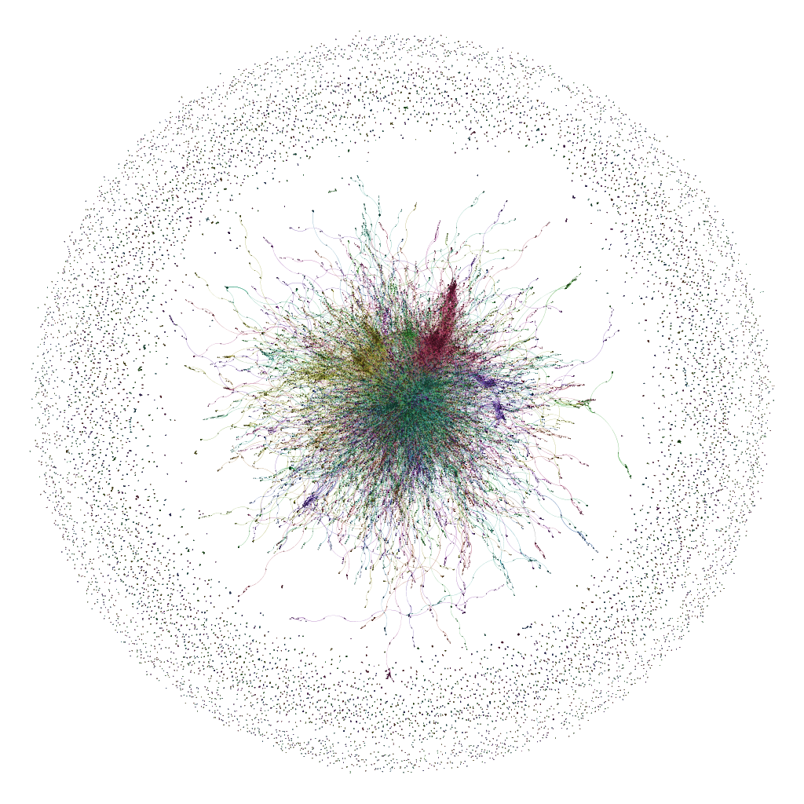

Fig. 2, projection of relationships between moderators by common subreddits
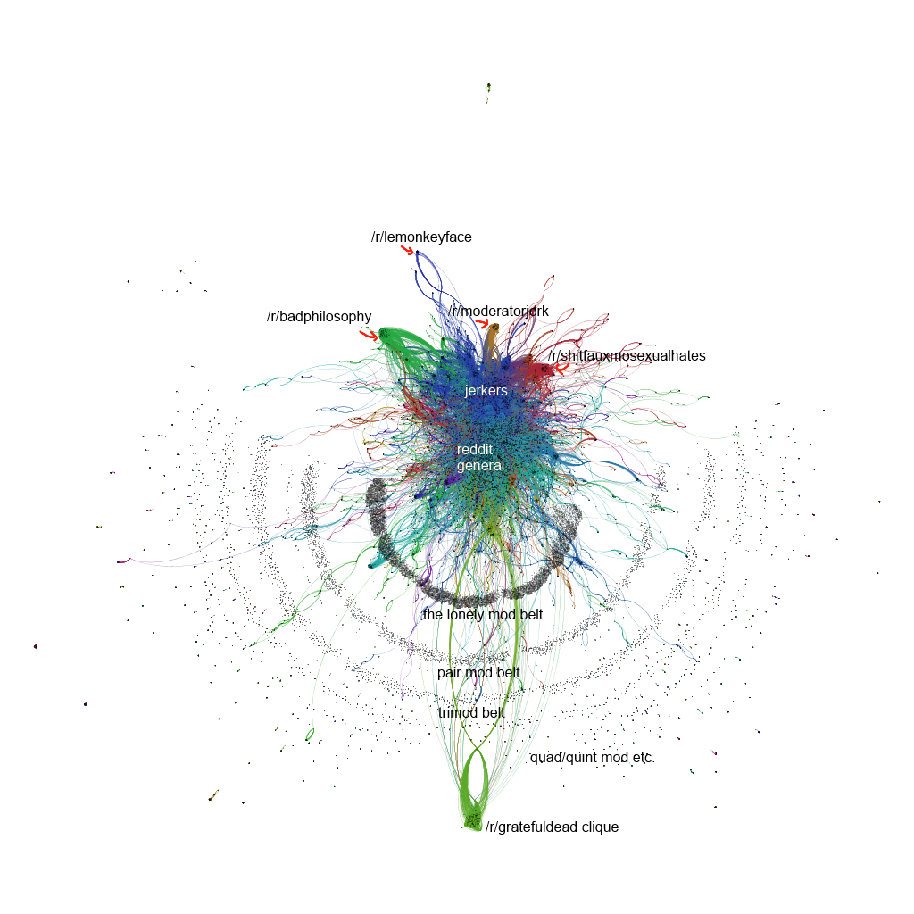

Fig. 3, projection of relationships between subreddits by shared moderators
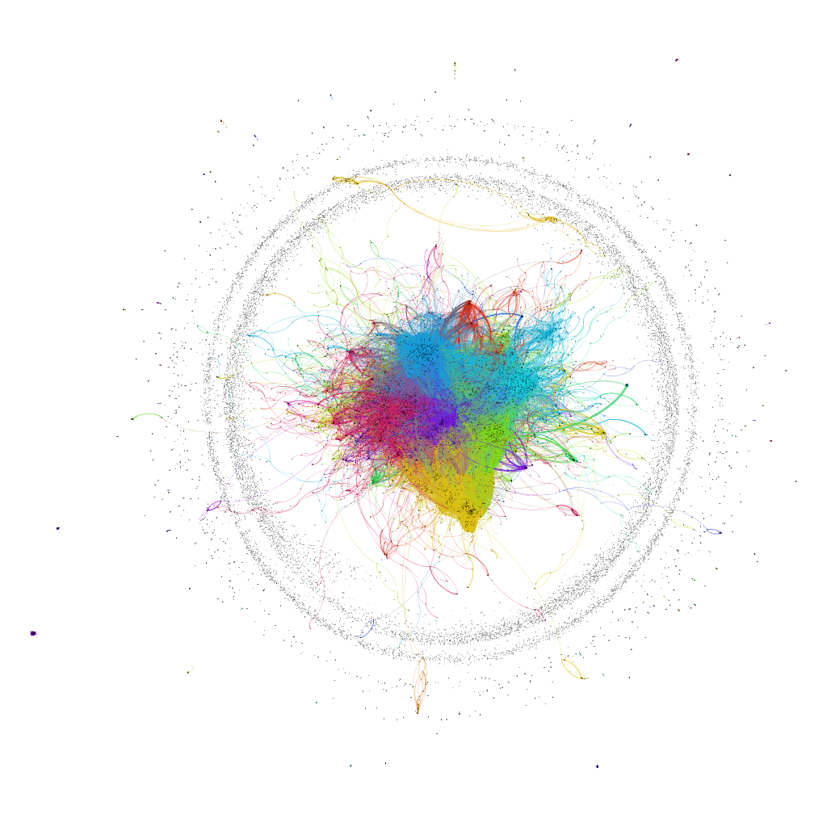
Appendix 3: Sample data

This data was given to me in CSV but I am presenting it here in a table for ease of viewing.

