**THE UNIVERSITY OF DODOMA**



**COLLEGE OF INFORMATICS AND VIRTUAL EDUCATION**

**Department of Computer Science and Engineering**

Industrial Training Report

**At the Department of Information System and Technology**

**TANZANIA AIRPORT AUTHORITY**

**DAR ES SALAAM**

**By:**

**Student Name:** SAFINA A SARUMBO

**Student Reg#:** T/UDOM/2017/11352

**Course Code:** CS 230

**Submitted to:**

DR.MANYLIZU.

2018/2019

TABLE OF CONTENTS.

ACKNOWLEDGEMENT iv

ABSTRACT v

CHAPTER ONE 1

1. INTRODUCTION 1

1.1 TAA MISSION 1

1.2 TAA VISION 1

CHAPTER TWO 2

2. INSTALL NETWORK PRINTER 2

2.1 PRINTER SUPPLY MEMORY ERROR 3

2.2 ETHERNET TERMINATION 5

2.2.1 STRAIGHT THROUGH CABLE 6

2.2.2 CROSSOVER CABLE 6

CHAPTER THREE 8

3. DOMAIN 8

CHAPTER FOUR 9

4. PC MAINTENANCE & TROUBLESHOOTING 9

4.1 PC MAINTENANCE 9

4.2 TROUBLESHOOTING 9

4.3 HARD DRIVE INSTALLATION 9

CHAPTER FIVE 10

5. PRESENTATION OF TRAINING FINDING 10

5.1 OVERVIEW OF THE ORGANIZATION 10

CHAPTER SIX 11

6. RECOMMENDATION AND CONCLUSION 11

6.1 RECOMMENDATION 11

6.2 CONCLUSION 11

CHAPTER SEVEN 12

7. REFERENCES 12

CHAPTER EIGHT 13

8. APPENDIXES 13

8.1 ACRONYM 13

LIST OF FIGURES AND LIST OF TABLES

Figure 1: TAA Organization Structure 1

Figure 2: Devices and Printer 2

Figure 3: Printer supply memory error 3

Figure 4: Open the toner cartridge door 4

Figure 5: Remove the toner cartridge 4

Figure 6: Reinstall the toner cartridge 4

Figure 7: Straight-through 6

Figure 8: Crossover 6

Figure 9: Difference between Straight and Cross Over 7

## ACKNOWLEDGEMENT

I thank the almighty God for giving me strength and ability to hold well my studies as well as field practices as an IT student to the extend am now producing this field report .

I wish to acknowledge the indispensable and outstanding assistance given to me by various individuals. Their efforts and encouragement contributed much to the success of this practical training. Many contributed in one way or another and I am highly appreciating their contribution though it was my pleasure to mention them all but the list is too long hence I mention these few;

Firstly ,special thanks go to the Manager of IT Mr.Lewis Mtoi for allowing me to carry out this practical training and for his advice in the time I had been there, the advice which led me to the improvement of initial draft of this report. Nevertheless, I extend my sincere gratitude to my industrial trainee madam NEEMA KAPOMA and all staff member on ICT DEPARTMENT for their constructive ideals and mentoring spirit they had on me.

Secondly, I wish to acknowledge the untiring support provided to me by my beloved parents all the time. I always pray to the almighty God so that he may grand them many years with full of blessings in this earth and an everlasting life in the heaven

Lastly but not least grateful thanks go to my supervisor Dr.MANYILIZU for great support during my field trainings. I will be not thankful if I don’t extend these thanks to my fellow student with whom I had shared ideas here and there. Their cooperation will never be forgotten in my mind.

## ABSTRACT

This practical training report is about, “Network and Pc Maintenance”, taken at TANZANIA AIRPORTS AUTHORITY as a case study attended. It was conducted for six (6) weeks effectively from 29th July 2019 to 6th August 2019.

On the training of this Practical study there was a responsibility to take on the personnel’s competencies and awareness on networking (i.e. reducing network errors, network security) and installation user application programs; Example: Microsoft Office Version (2007), Adobe Reader Version (9) etc., It was not only that but also installation of Operating system (OS) Example: Window XP Professional Service Park Two, Window 7, Maintaining and troubleshooting PC problems.

I also cooperated with my fellow students in exchanging ideals in different aspects of IT according to the different activities allocated to us by our supervisors. For example, I had to learn HTML programming language from my fellow students as it was inevitable language to be used

# CHAPTER ONE

## 1. INTRODUCTION

### 1.1 TAA MISSION

TAA mission is to provide high quality airport services and facilities in the most cost-effective manner.

### 1.2 TAA VISION

TAA see themselves as a model in the provision of airport facilities and services in Eastern Africa.

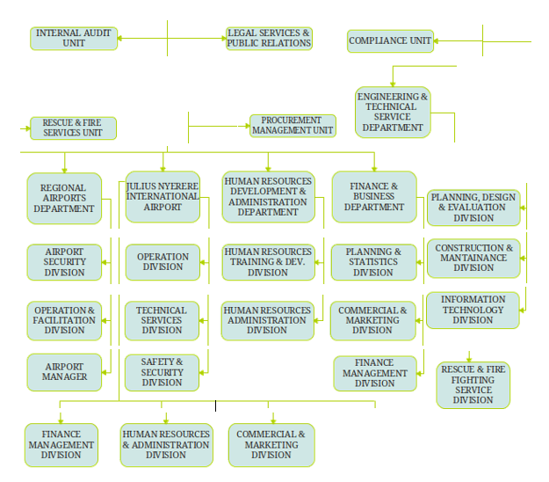

Figure 1: TAA Organization Structure

# CHAPTER TWO

## 2. INSTALL NETWORK PRINTER

1. Open Devices and Printers by clicking the **Start** button, and then, on the Start menu, clicking **Devices and Printers**.

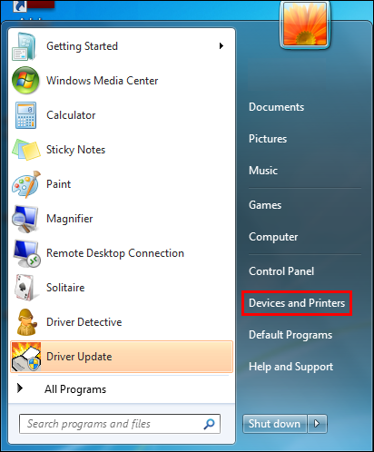

Figure 2: Devices and Printer

1. Click **Add a printer**.
2. This will open the Add Printer Wizard. Click **Add a Network, wireless or Bluetooth printer**. Click Next to continue.
3. The next window will contain a list of all networked printers on both the Hill and River Campus. You can sort the list by location or printer name. Select the printer you would like to install, and then Click **Next**.
4. The first time you install a network printer, it will take a minute or two to install the drivers. Be patient as the software installs the drivers and configures the printer.

Should this be your default printer? If it should, then check the box next to **Set as default printer**. If this printer SHOULD NOT be your default printer, uncheck the box next to **Set as default printer**.

1. Complete the additional steps in the wizard, and then click **Finish**.

### 2.1 PRINTER SUPPLY MEMORY ERROR

At this chapter I will explain what cause the supply memory error at the printer and how I was solved in order for the printer to print again .A supply memory error is caused when the metal contacts / chip on a toner cartridge doesn’t correctly connect with the corresponding contacts inside the printer. So according to that printer cannot detect the toner cartridge is installed and displays the ‘Supply Memory Error’ message on the printer display panel. The error can also be caused by faulty compatible cartridges where the microchip data is out of date. But this type of problem will sometimes happen after you have replaced an empty cartridge with a new toner.so this error is occur mostly at HP LaserJet Pro and multifunction printer models, particularly the HP M1212nf printer and LaserJet Pro M277dw printer models

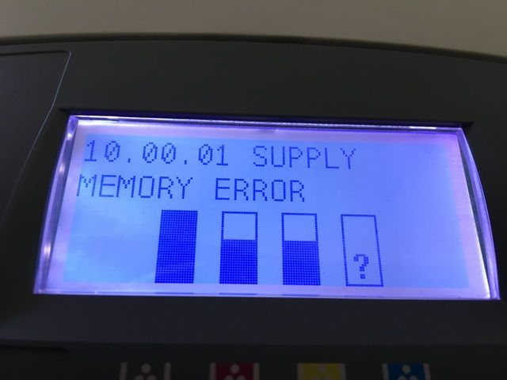

Figure 3: Printer supply memory error

Let see what causes a HP Supply Memory?

There are 4 different thing which causes the HP supply memory error problem, stopping it from working and luckily.(1)Lose packaging, jammed paper or protective strips that haven’t been removed(2) Squashed metal contacts that no longer connect the toner to the printer(3) Broken plastic pieces the cause the toner to be out of position.(4) Out of date printer software / firmware.

Also after see the thing which influence the supply memory error to occur let see on how I was solved this error.

The firstly step by which I was done is to Press the release button to open the toner cartridge door.

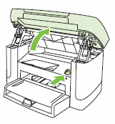

Figure 4: Open the toner cartridge door

Second step by which I was done is to remove the toner cartridge.

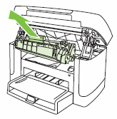

Figure 5: Remove the toner cartridge

The third step I was Reinstall the toner cartridge, and then I was close the toner cartridge door. To make sure I press the toner cartridge until you hear a click.

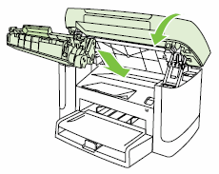

Figure 6: Reinstall the toner cartridge

So after reinstall the toner cartridge I was disconnect the power cord from the printer and unplug the power cord from the power source. Also I was Wait 60 seconds and Reconnect the power cord to a wall outlet and to the printer.so due to that step by which I was fallow it is influence the printer to print and the problem is solved.

### 2.2 ETHERNET TERMINATION

Ethernet terminating cable is a useful skill for anybody interesting in networking and cabling .but in organization we done an Ethernet terminating for the purpose of establish the network. Also during termination, the are different equipment which are

• Jacket/sheath Cutter or wire stripper:

This tool will safely cut the jacket off the wires inside without cutting the wires. You will measure out about two inches of the cable to cut the jacket off by twisting the cutter around the cable. This tool is often combined with the RJ45 Crimping tool.

• RJ45 Modular Data plugs:

These are crimped over the wire ends for plugging into a wall jack/switch port, or Ethernet card/connection on your device.

• RJ45 Crimping This is needed to crimp the RJ45 modular data plug onto the wire making a connection on each of the pins of the data plug.

• Wire Cutters:

These are used for cutting the ends of the wires after placing them in the proper order.

• Wire Boots:

These are optional, a wrap for the exposed wires.

• Ethernet Testing tool:

Test your cable before you use it. This will save you time in finding problems connecting to your network and money in replacing switch ports or devices/Ethernet cards

Also, Ethernet cable terminating can be wired as straight through or crossover. But all of this method we have used in organization for purpose of establish the network. But a straight through is mostly used to connect computer and computer to bub or switch and crossover Ethernet is more commonly used to connect a computer to computer.so according to that let see how does the crossover is doffer from straight through and its color arrangement.

### 2.2.1 STRAIGHT THROUGH CABLE

A straight through cable this is a type of twisted pair cable that we were used in LAN in order to connect a computer to network hub such as router and also this this cable alternatively to the wireless connection where one or more computer access a router though signal.

**Note:** The straight through cable uses a wired standard. Also both end uses T568A or T568B wiring standard. Also in the straight through the wired pin match.

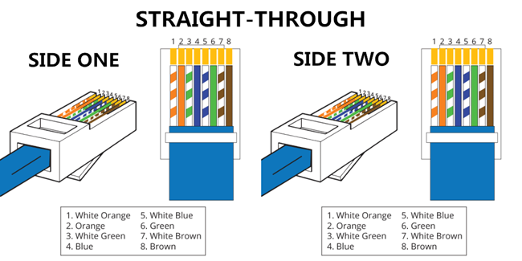

Figure 7: Straight-through

### 2.2.2 CROSSOVER CABLE

A cross over cable also is among which we were used in organization to connect computing devices in organization .the RJ45 crossover cable is uses two different wiring standard .According to that the one end of Ethernet it uses T568A and other end is uses T568B wiring standard .But Ethernet cable crossover is transmit and receive signal, crossover it used to connect two devices of the same type e.g. computer and computer or switches and to each other

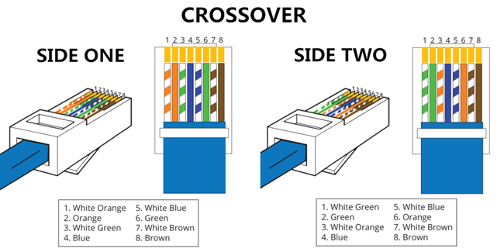

Figure 8: Crossover

Finally Straight through and crossover cables are wired differently from each other. One easy way to tell what you have is to look at the order of the colored wires inside the RJ45 connector. If the order of the wires is the same on both ends, then you have a straight through cable. If not, then it’s most likely a crossover cable or was wired wrong. At present, the straight through cable is much more popular than crossover cable and is widely used by people.

**In summary**: difference between straight-through and cross over

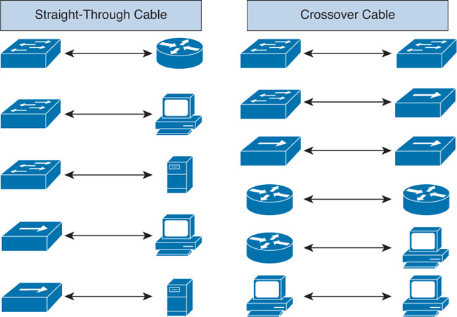

Figure 9: Difference between Straight and Cross Over

# CHAPTER THREE

## 3. DOMAIN

* One or computers are servers. Network administrators use servers to control the security and permissions for all computers on the domain. This makes it easy to make changes because the changes are automatically made to all computers. Domain users must provide a password or other credentials each time they access the domain.
* If you have a user account on the domain, you can log on to any computer on the domain without needing an account on that computer.

1. Click on **Start**> then right click on **Computer** and click on **Properties**
2. The basic system information page will open, under **Computer name, domain, and workgroup settings**, click on **Change Settings**
3. On the **System Properties** page, click on **Change.**
4. Under **Member of**, select the radio button beside **Domain: ,** type the name of the domain you want your Windows 7 to join and then click **OK**
5. A pop-up box requesting to enter credentials of an account with rights to join the domain (with rights to create computer accounts  
   Close System properties page, and on the **You must restart your computer** pop up message box, click on **Restart Now**
6. Once your machine is rebooted, press CTRL + ALT + Del to log on
7. As you can see, the user that last logged on to the system was a local account user ( machine name\username ), and we need to log on to the machine with a domain user account, to do this, click on **Switch User**

# CHAPTER FOUR

## 4. PC MAINTENANCE & TROUBLESHOOTING

### 4.1 PC MAINTENANCE

This is a process of keeping a maximum level of machine in good working condition; while it tasks carried out in order to keep a system running such as repairing faults, replacing of components.

### 4.2 TROUBLESHOOTING

Means the step that identification a problem and to implementing the solution of a computer, troubleshooting it’s done by following step in order to solve the problem.

* TROUBLESHOOT STEPS.

According to troubleshooting steps there are series of logical steps speeds up that used to troubleshoot problem on your computer, which you want to follow: There as;

1. Identify the problem.
2. Gather the information.
3. Developing a solution.
4. Implement the solution.
5. Evaluate problem and problem solved.
6. Documentation the problem and solution.

### 4.3 HARD DRIVE INSTALLATION

A hard disk drive (HDD) is an example of an internal drive.

HDD installation steps:

1. Position the HDD so that it aligns with the 3.5inch drive bay.
2. Insert the HDD into the drive bay so that the screw holes in the drive line up with screw holes in the case

# CHAPTER FIVE

## 5. PRESENTATION OF TRAINING FINDING

This chapter presents the information of the Field practical training which was found as I was doing my field trainings at the organization. All the information gathered is presented and interpreted using descriptive means. Besides, network and PC maintenance.

### 5.1 OVERVIEW OF THE ORGANIZATION

The organization had already adopted or implemented modern technologies in most of their systems such as network.

The following are some of the success of the organization on the field of network within and out of the organization:-

The following are the respondent’s comments in regard to successfulness of network engines mentioned above:-

**Internet**

It is able to take advantage of the Internet technology and make data available to Internet applications.

1. **Security**

Making data and applications more secure

1. **Availability**

It achieves higher level of scalability, reliability, and performance

1. **Sharing of a resource**

It facilitates proper communication internally as well as externally in the logic that managers and staffs can easily query and analyze social security history information with much higher speed and security.

# CHAPTER SIX

## 6. RECOMMENDATION AND CONCLUSION

### 6.1 RECOMMENDATION

* College has to encourage employers to accommodate the field students by selecting person who can educate the importance of field students in the offices.
* The college must increase periods of teaching students practically to let them have enough knowledge and competence in this world of competition.

### 6.2 CONCLUSION

As I have gone for the field trainings, I have found that it is important for all students to go for the field attachments for it will make them to be more competent in performing work practically hence improving their understanding capacity.

Basing on the TANZANIA AIRPORTS AUTHORITY as the main place I have done my field practices, I find is the best place for IT students to learn how information technology links with the government in making plans and utilization of national resources effectively. Despite the fact of the highs the organization proud of, there are some challenges facing the organization such as lack of frequent work trains to the IT personnel available in an organization in order to make them cope with the changes of technology. If such challenges will be properly worked on by the managers, I hope the government will always enjoy the fruits of information technology in the country

# CHAPTER SEVEN

## 7. REFERENCES

* [**www.mof.go.tz**](http://www.mof.go.tz)
* [**www.google.com**](http://www.google.com)
* [**www.cisco.com**](http://www.cisco.com)
* [**www.computerhope.com**](http://www.computerhope.com)
* [**www.w3schools.com**](http://www.w3schools.com)

# CHAPTER EIGHT

## 8. APPENDIXES

### 8.1 ACRONYM

* **PC-** Personal computer
* **IT**-Information Technology
* **TAA-**Tanzania Airports Authority