- Simple Test
cd /path/to/emac/sim
./runsim

- Choose different test cases for testing.
cd /path/to/emac/sim/script
wish runcase.tcl
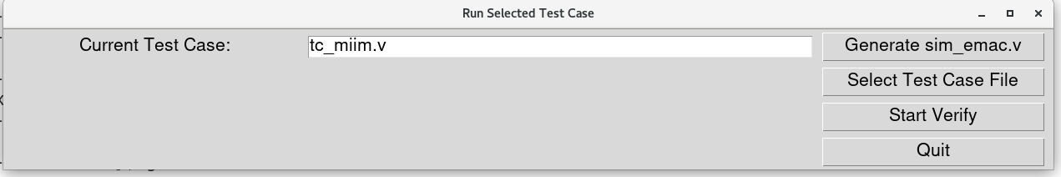
Click the “Select Test Case File” button.
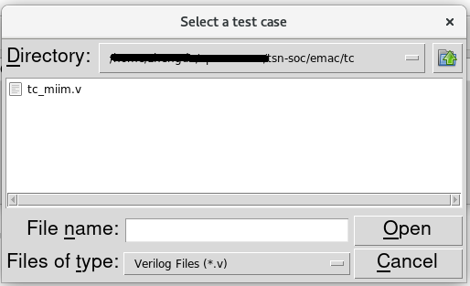
Choose the desired test case such as “tc_miim.v”, then close the pop - up dialog box.
Click the “Start Verify” button to execute the simulation.
