WS4: Antibiotics and bacterial growth
Name: ________________ Class: ________ No.: ________

Topic notes
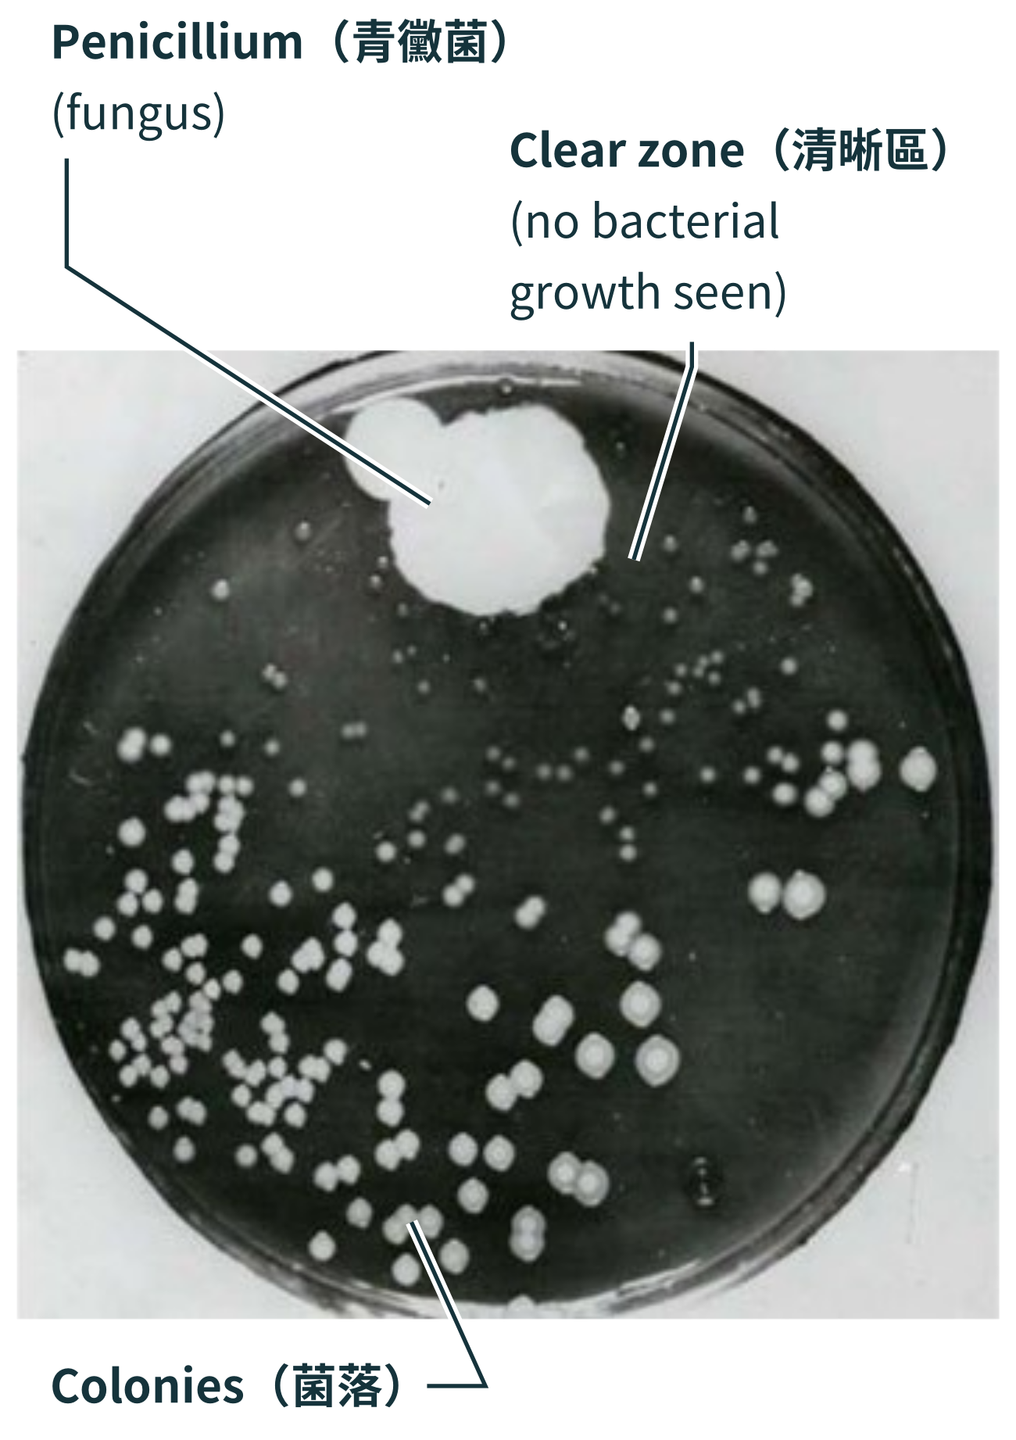  (A visible group of many bacteriathat have multiplied on the agar.) | • Antibiotics may inhibit growth or kill some bacteria. They treat bacterial infections, not viral infections.  • Individual bacteria differ in antibiotic resistance. Antibiotics make survival harder for susceptible bacteria; resistant bacteria are more likely to survive, reproduce and pass on resistance traits. As their proportion increases, the original antibiotic may become less effective.  • Antibiotic overuse or misuse increases selection pressure, promoting the survival and reproduction of resistant bacteria and potentially making infections harder to treat.
A. Experimental principle: antibiotic（抗生素） diffusion and clear-zone（清晰區） formation
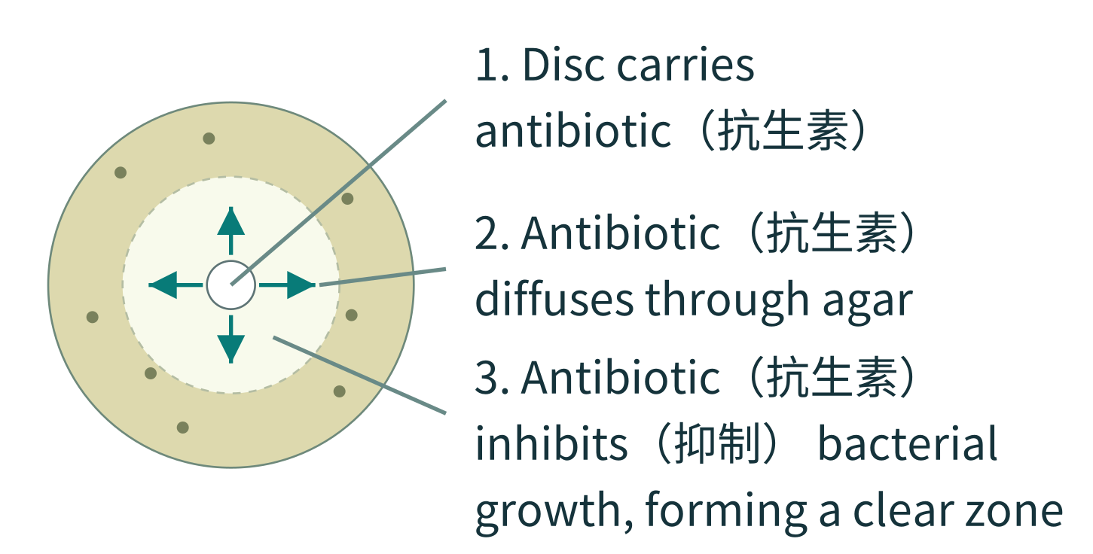 | • Antibiotic diffuses outward from a disc; concentration falls with distance. A clear zone forms where it can inhibit bacterial growth. (No visible growth does not prove all bacteria have died.)

Part 1 | Research context and fair comparison
A patient’s wound infection has not clearly improved after initial antibiotic（抗生素） treatment. Laboratory testing identifies methicillin-resistant Staphylococcus aureus (MRSA)（耐甲氧西林金黃葡萄球菌）. As a researcher, investigate how samples X, Y and Z affect visible growth of these bacteria in a virtual laboratory.
MRSA resists methicillin; this does not mean it resists all antibiotics.
Under the stated simulation conditions, how do X, Y and Z affect visible growth of these MRSA（耐甲氧西林金黃葡萄球菌） bacteria?

1.1 Identify the variables
Independent variable（The factor you change） | Dependent variable（The outcome you observe/measure） | Controlled variables（The factors kept the same）
□ Disc size  ☑ Sample in the disc  □ Composition of the agar plate（瓊脂板）  □ Visible clear zone（清晰區） and its total diameter  □ Type of bacteria used  □ Initial bacterial distribution  □ Preset sample preparation | □ Disc size  □ Sample in the disc  □ Composition of the agar plate（瓊脂板）  ☑ Visible clear zone（清晰區） and its total diameter  □ Type of bacteria used  □ Initial bacterial distribution  □ Preset sample preparation | ☑ Disc size  □ Sample in the disc  ☑ Composition of the agar plate（瓊脂板）  □ Visible clear zone（清晰區） and its total diameter  ☑ Type of bacteria used  ☑ Initial bacterial distribution  ☑ Preset sample preparation

1.2 What are the assumptions of this investigation?
An assumption is a condition we have not proved but take as true, to help make the experiment results valid.
Select all applicable assumptions; you may choose more than one.
☑ Bacteria are initially distributed evenly on each agar plate（瓊脂板）.
☑ Equipment does not introduce contamination.
☑ All plates use the same simulated observation conditions.
□ If no colonies（菌落） form near a disc, this means all bacteria at that location have died.

1.3 If you want to find out whether antibiotics（抗生素） affect bacterial growth, how would you design a control group?
(Hint: The control group provides a baseline for comparison. It helps check whether changes in the experiment are caused by the independent variable rather than other external factors. Therefore, the control group does not receive the treatment being tested.)
Reference answer: Use a matching carrier-only disc without antibiotic（抗生素） to check carrier/disc effects, with other conditions the same. Call it a water control only if every carrier is water.

1.4 There are 4 test samples: antibiotics X, Y, Z and the control. How many tests does each sample need in total? Why?
Reference answer: Accept a feasible number. Independent plates help examine consistency and variation; the number itself earns no ability mark.

Part 2 | Results, measurement, calculation and analysis

2.1 Measure and record the total clear-zone（清晰區） diameter (mm).
Three independent plates | Shared simulation: 30°C, 24 h | Disc diameter 6 mm
Use a ruler to measure the total diameter through the centre, including the disc. Record 0 mm if there is no clear zone outside the disc. Reading tolerance: ±1 mm.
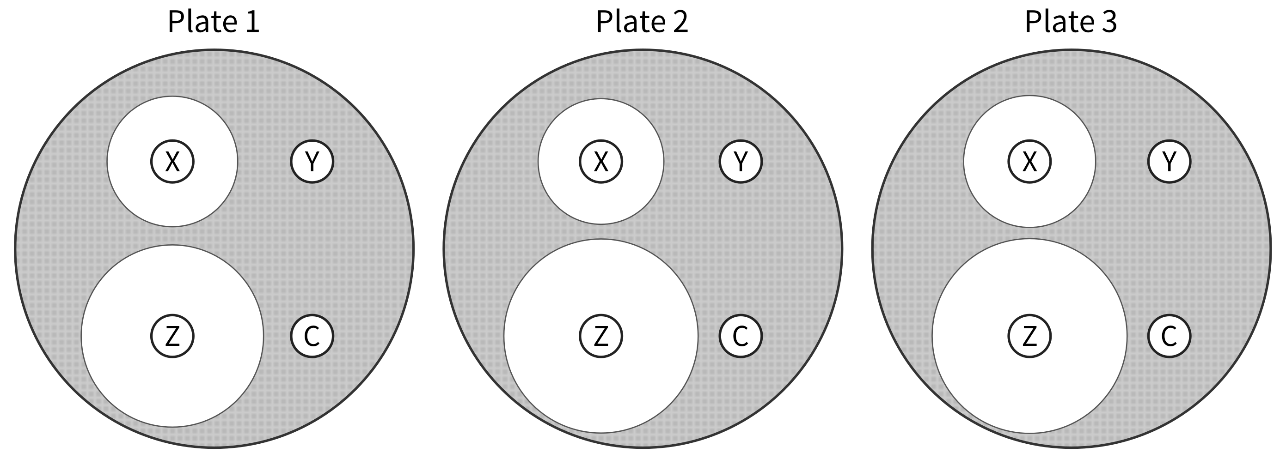
 |  | Sample X | Sample Y | Sample Z | Sample C
Plate 1 | Clear zone present | ✓ / ✗ | ✓ / ✗ | ✓ / ✗ | ✓ / ✗
Plate 1 | Total diameter (mm) | 18.7 | 0 | 26.1 | 0
Plate 2 | Clear zone present | ✓ / ✗ | ✓ / ✗ | ✓ / ✗ | ✓ / ✗
Plate 2 | Total diameter (mm) | 18 | 0 | 27.8 | 0
Plate 3 | Clear zone present | ✓ / ✗ | ✓ / ✗ | ✓ / ✗ | ✓ / ✗
Plate 3 | Total diameter (mm) | 18.9 | 0 | 27.9 | 0

2.2 Mean total diameter calculation
Mean for X (mm) | Mean for Y (mm) | Mean for Z (mm) | Mean for C (control) (mm)
18.5 | 0.0 | 27.3 | 0.0

2.3 What does the appearance of a clear zone（清晰區） indicate?
□ A. All bacteria in the zone have died.
☑ B. Under these test conditions, there is no visible bacterial growth in the zone, indicating inhibition（抑制）.
□ C. Bacteria in the zone resist every antibiotic（抗生素）.
□ D. The sample has eliminated viruses on the agar plate（瓊脂板）.

2.4 What does the diameter of a clear zone（清晰區） represent?
□ A. The exact number of bacteria remaining on the plate.
□ B. Its effectiveness in patients; the largest diameter identifies the best treatment.
☑ C. The extent of the area with no visible bacterial growth under these conditions; diffusion and other factors also affect the diameter.
□ D. The antibiotic（抗生素） dose a patient should receive.

2.5 Draw a conclusion from your results:
Under these simulated conditions, (☑ X □ Y ☑ Z □ C □ No samples) can effectively inhibit（抑制） MRSA（耐甲氧西林金黃葡萄球菌） growth.
Comparing the mean total clear-zone diameters in this test, their inhibitory effects rank as follows. Rank only samples with visible clear zones. Cross out unused positions with “/”.
Z > X > ／ > ／

2.6 Why do experiments need to be repeated?
□ A. To ensure that every experiment produces exactly identical absolute values, with no variation whatsoever.
□ B. To prolong the experiment so scientists have more to describe when writing their reports.
☑ C. To reduce random error and assess the reproducibility（可重複性） of the results and the reliability（可靠性） of the data.
□ D. To make biological samples rapidly mutate and develop entirely new traits through repeated procedures.

2.7 If repeated results differ greatly, what should you do, and why?
□ A. Delete results that disagree with the original hypothesis so the results match.
□ B. Keep only the largest reading because it best represents inhibition（抑制）.
□ C. Calculate the mean immediately because averaging removes all procedural problems.
☑ D. First check spreading, disc positions and plate conditions, then repeat as needed to identify causes of variation and improve the comparison.

2.8 When comparing the clear zones（清晰區） around C (control) and X, Y and Z, what is the main role of C?
□ A. Ensure that all discs have clear zones（清晰區） of the same diameter.
□ B. Identify the best antibiotic（抗生素） for a patient.
☑ C. Provide an antibiotic（抗生素）-free comparison to help assess whether clear-zone（清晰區） formation is associated with the antibiotic（抗生素） sample.
□ D. Increase the amount of sample in the X, Y and Z discs to increase the accuracy（準確度） of the experimental results.

Part 3 | Integrated explanation
Choose an antibiotic（抗生素） sample from your experimental results that can inhibit（抑制） bacterial growth, and cite readings to support your judgement. Suppose this bacterial population initially contains a small number of bacteria resistant（具抗藥性的） to that antibiotic（抗生素）. How might its effectiveness change with continued use? Use the topic notes to explain how bacterial survival, reproduction（繁殖） and inheritance（遺傳） of resistance traits（抗藥性特徵） cause this change.
Reference answer: For example, X has readings 18.7, 18, 18.9 mm, supporting inhibition; accept Z with its readings too. A few resistant bacteria already exist. The antibiotic reduces survival of susceptible bacteria. Resistant bacteria are more likely to survive, reproduce and pass resistance traits to offspring. Their proportion may rise, so continued use may become less effective; complete failure is not inevitable.

