Topic notes

01 Bile: emulsifying lipids
In this model, X is bile. Made in the liver and stored in the gall bladder, bile contains no digestive enzymes. It emulsifies large oil droplets into small droplets, increasing the total surface area for lipase to act on. This is physical digestion: lipid molecules remain unchanged.
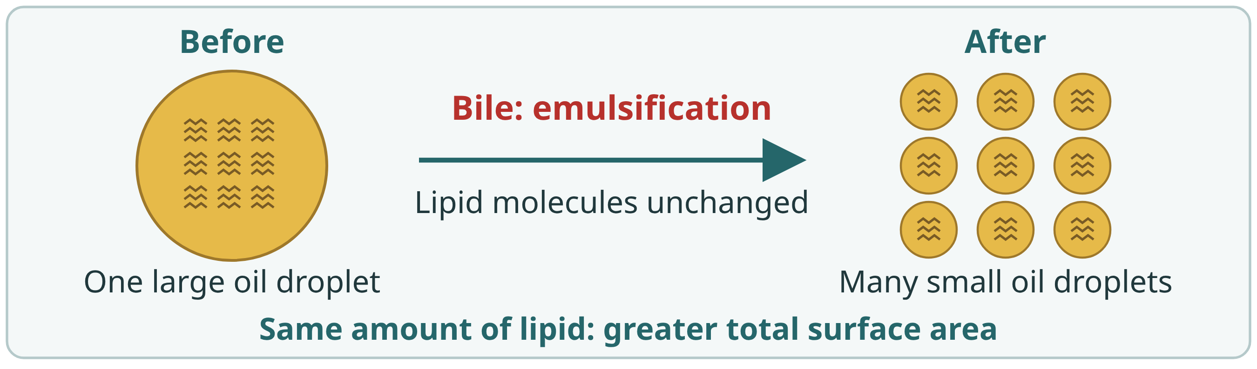

02 Lipase in pancreatic juice: chemical digestion
In this model, Y is pancreatic juice containing lipase. Lipase catalyses chemical digestion of lipids. Lipase is a protein; high heat can denature it and stop it working.
