Worksheet 1: Lipid Digestion and Fair Comparisons
Name: ________________ Class: ________ No.: ________
Read the topic notes first, then apply the concepts to analyse the results.

Topic notes

01 Bile: emulsifying lipids
Made in the liver and stored in the gall bladder, bile contains no digestive enzymes. It emulsifies large oil droplets into small droplets, increasing the total surface area for lipase to act on. This is physical digestion: lipid molecules remain unchanged.
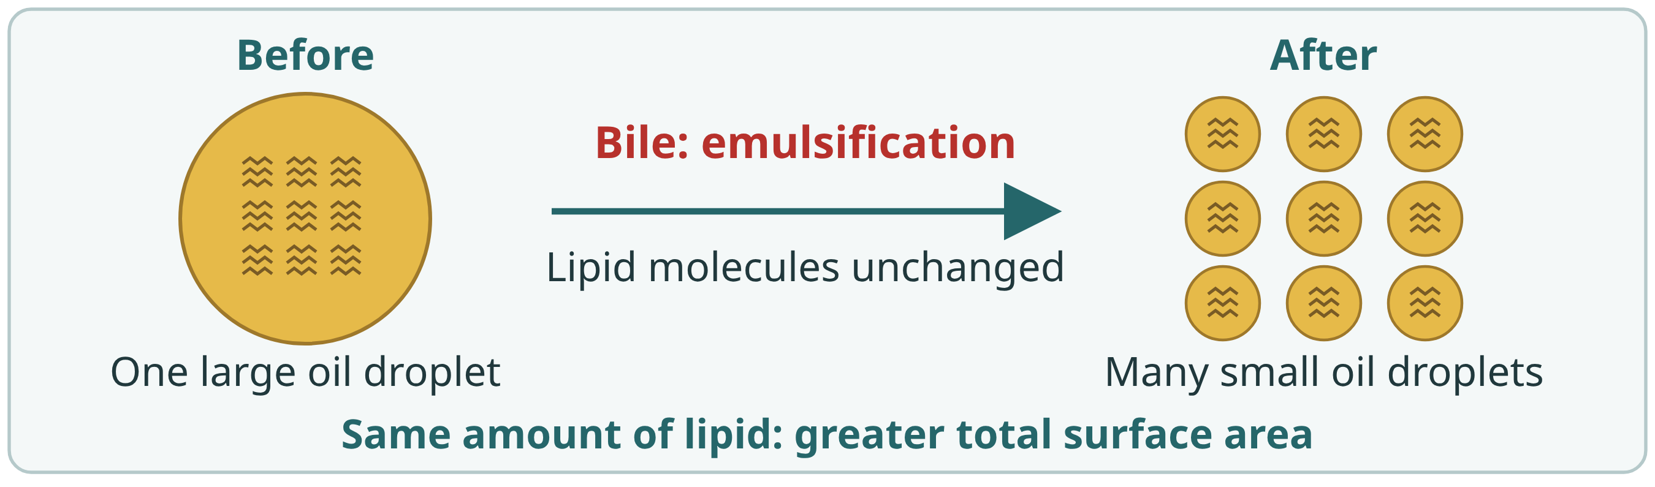

02 Lipase in pancreatic juice: chemical digestion
Pancreatic juice containing lipase. Lipase catalyses chemical digestion of lipids. This course uses a simplified complete-hydrolysis model: triglycerides form smaller glycerol and fatty-acid molecules for absorption. Lipase is a protein; high heat can denature it and stop it working.
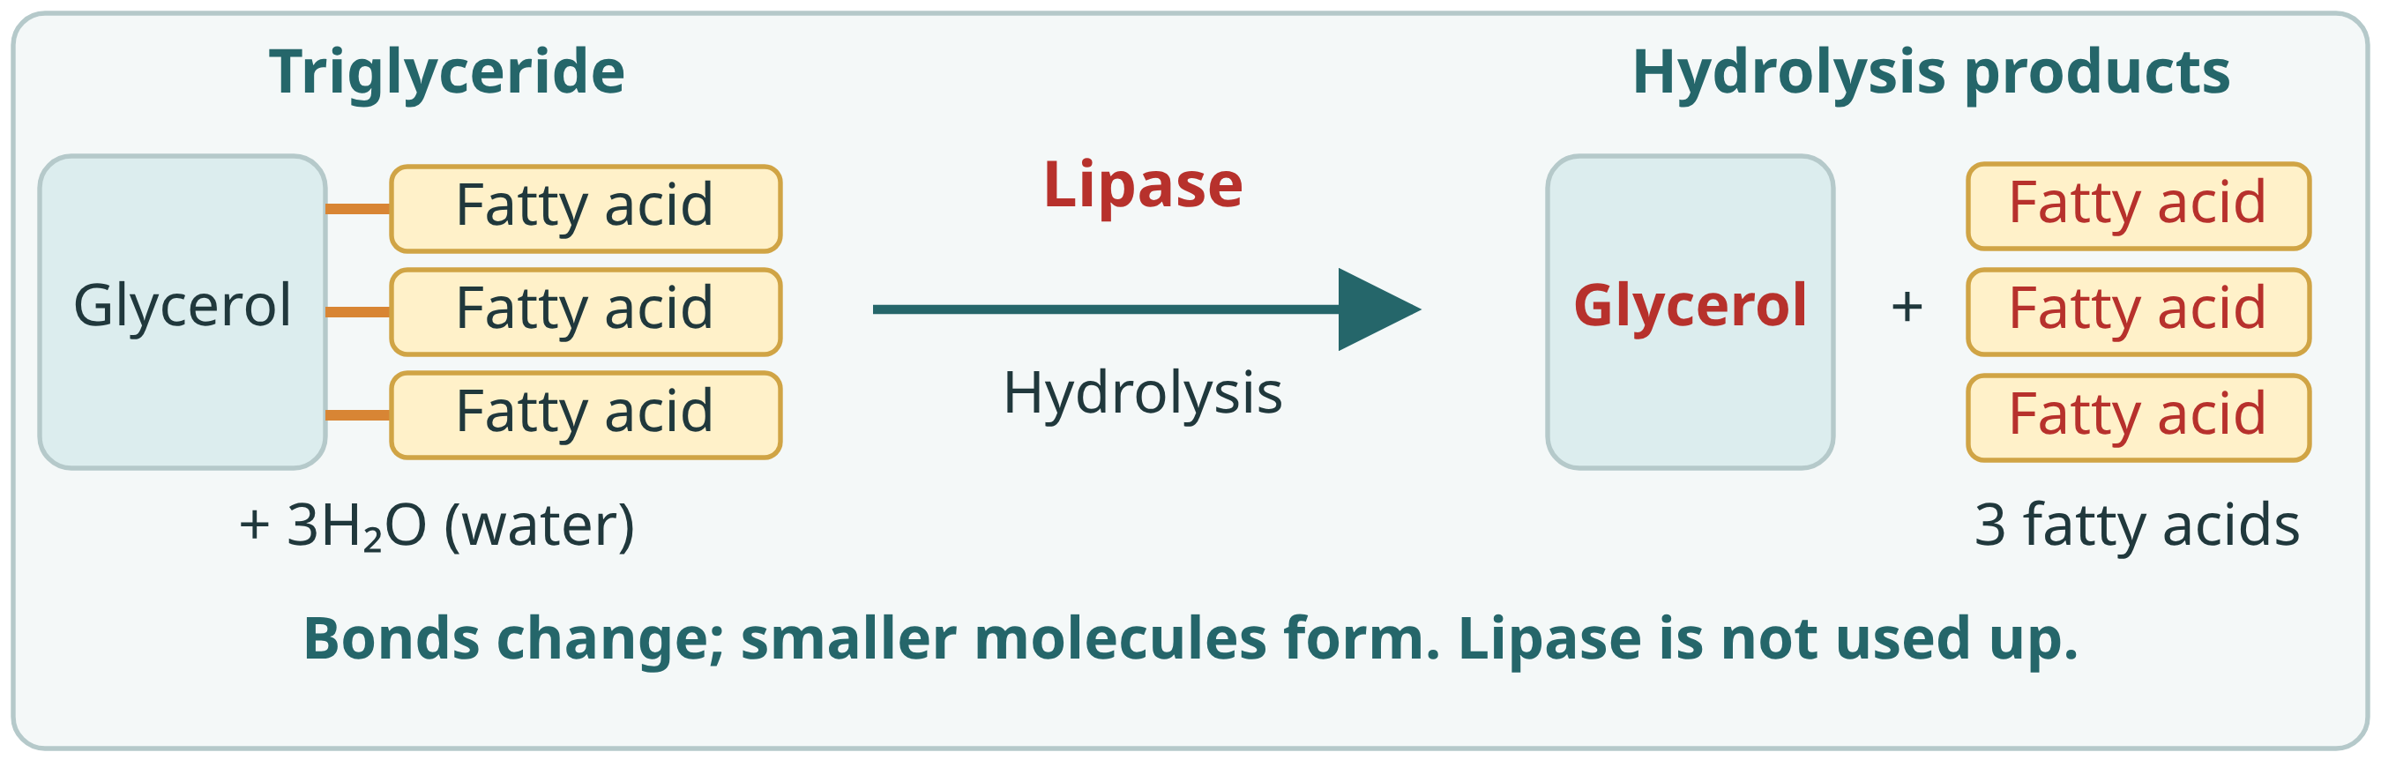
Context: lipids need digestion before absorption. What happens after adding digestive juice X or Y?
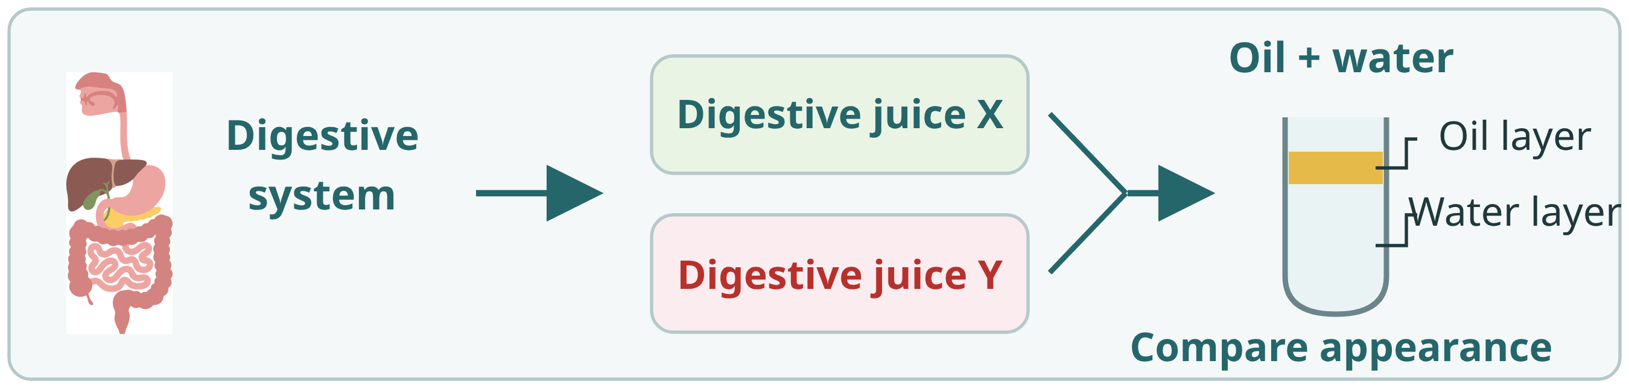

Part 1 | Context and fair comparisons
Researchers added 2 mL X or 2 mL Y to identical oil–water mixtures, shook them identically at 37°C, and compared appearances after one hour.

1. Identify the variables
Tick the appropriate factors in each row. You may choose more than one.
Variable type | Factors to choose from
Independent variable  Factor changed | □ Total volume of oil and water □ Reaction temperature  □ Reaction time □ Total volume of liquid added  □ Method of shaking □ Appearance of the mixture  ☑ Combination of digestive juices
Dependent variable  Outcome measured | □ Total volume of oil and water □ Reaction temperature  □ Reaction time □ Total volume of liquid added  □ Method of shaking ☑ Appearance of the mixture  □ Combination of digestive juices
Controlled variables  Kept the same | ☑ Total volume of oil and water ☑ Reaction temperature  ☑ Reaction time ☑ Total volume of liquid added  ☑ Method of shaking □ Appearance of the mixture  □ Combination of digestive juices

2. Select the assumptions for a fair comparison (choose all that apply)
(An assumption is a condition we have not proved but take as true, to help make the experiment results valid.)
☑ All sets start with the same amounts of oil and water, and receive the same total volume of added liquid.
□ The X setup may receive more total liquid than the Y setup.
☑ All sets are shaken in the same way.
☑ All sets are observed after the same reaction time.

3. Design a control group
Does this experiment need a control group? If so, how would you design the comparison setup?
(Hint: A control group provides a starting point for comparison. It helps you check that changes are caused by the independent variable, rather than other outside factors. The control group therefore does not receive the treatment being tested.)
Use an identical oil–water mixture with 2 mL water as a baseline, compared with X or Y; keep initial amounts, volume, temperature, time and shaking equal.

Part 2.1 | Analyse the individual actions of X and Y
Model results one hour after shaking.
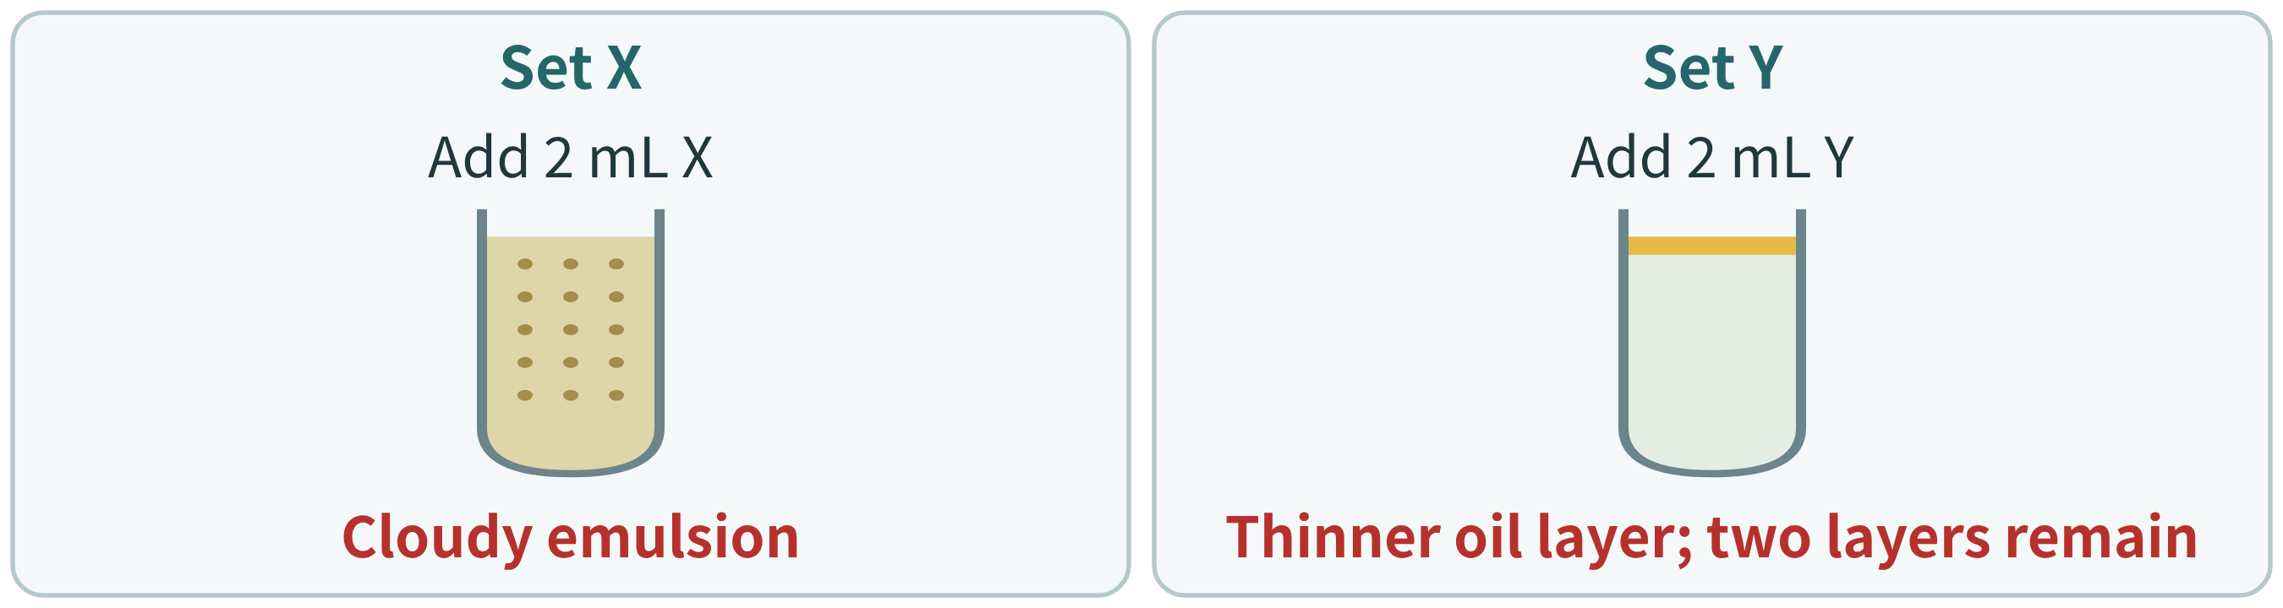

4. What does digestive juice X do?
Digestive juice X mainly causes lipids to form a (cloudy emulsion / clear solution).

Part 2.2 | Analyse how X helps Y act
Two fresh tubes received 1 mL X or water and identical shaking, then 1 mL Y each. Results show one hour later.
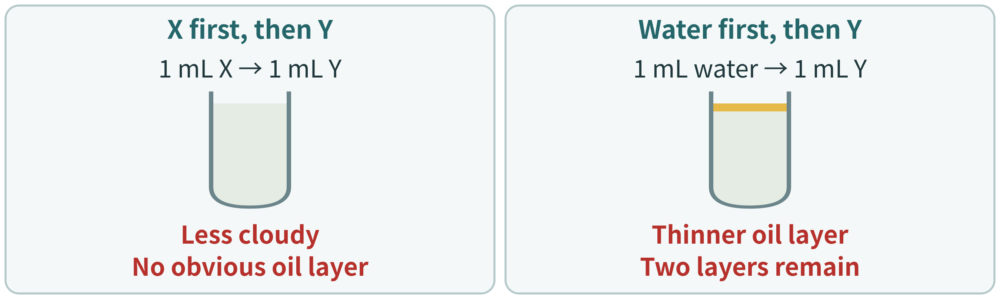

5. How does digestive juice X help Y act?
X disperses large oil droplets into small droplets. Their total surface area (increases / decreases), helping Y act.

6. What can this experiment tell us?
We observed only the oil layer, cloudiness or clarity, without testing digestion products. Which statement is most appropriate?
A. Appearance gives clues about the juices, but alone cannot prove that glycerol and fatty acids have formed.
B. A clear mixture fully proves that lipids have broken down into glycerol and fatty acids.

Part 2.3 | Effects of heating the juices
Use unboiled X then Y as the baseline. Boil one juice, cool to 37°C, then add 1 mL each of X and Y in the same order. Compare after one hour.
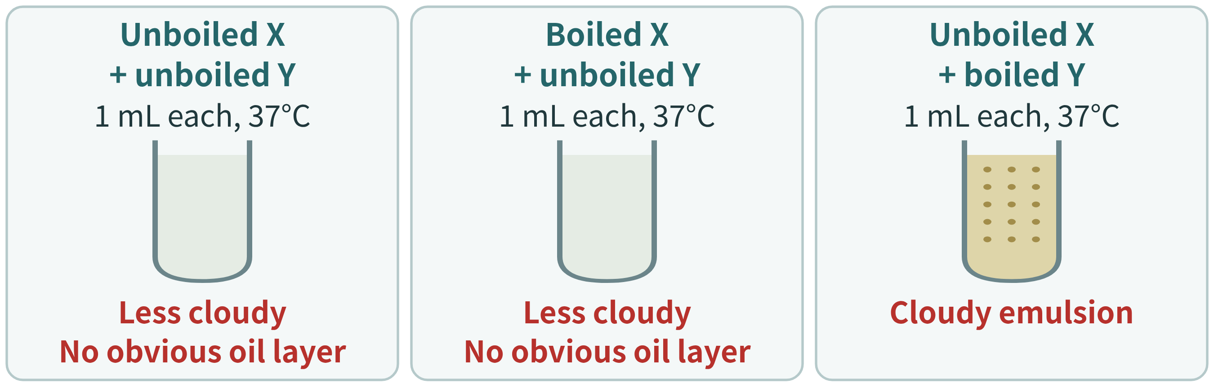

7. Extension conclusion
The juice that loses its action after boiling is (digestive juice X / digestive juice Y).

Part 3 | Integrated explanation
8. Using the experimental results and topic notes, explain how bile and lipase in pancreatic juice work together to help digest lipids, and how boiling affects their actions.
Bile physically emulsifies large droplets into small droplets without changing lipid molecules. The greater total surface area helps lipase act. Lipase in pancreatic juice catalyses chemical digestion into glycerol and fatty acids in this model. Lipase is a protein; boiling denatures it and stops its catalytic action even after cooling. Bile retains its emulsifying action after boiling.

