Worksheet 3: Phototropic growth in plants
Name: ________________ Class: ________ No.: ________

Topic notes
 | • Phototropism（向光性） is growth in response to light direction. Shoots usually grow towards light (positive phototropism（向光性）). The left diagram shows a bending coleoptile（胚芽鞘）: part of the seedling’s shoot that protects young leaves.  • The tip senses light from one side and contains auxin（生長素）, a chemical substance that is a plant hormone. More auxin（生長素） passes down the shaded side, stimulating cells in the elongation（延長） region to elongate（延長） and promote growth.  • Agar（瓊脂） allows chemical substances to pass through it.

Coleoptile（胚芽鞘）: more auxin（生長素） on the shaded right | Cell detail: more elongation（延長） on the right
Light from the left → shaded right side → more auxin（生長素） passes down this side
→ right-side cells elongate（延長） more → the shoot bends left.

Part 1 | Context and fair comparisons
A · No light blocked | B · Light blocked at the tip | C · Light blocked below the tip
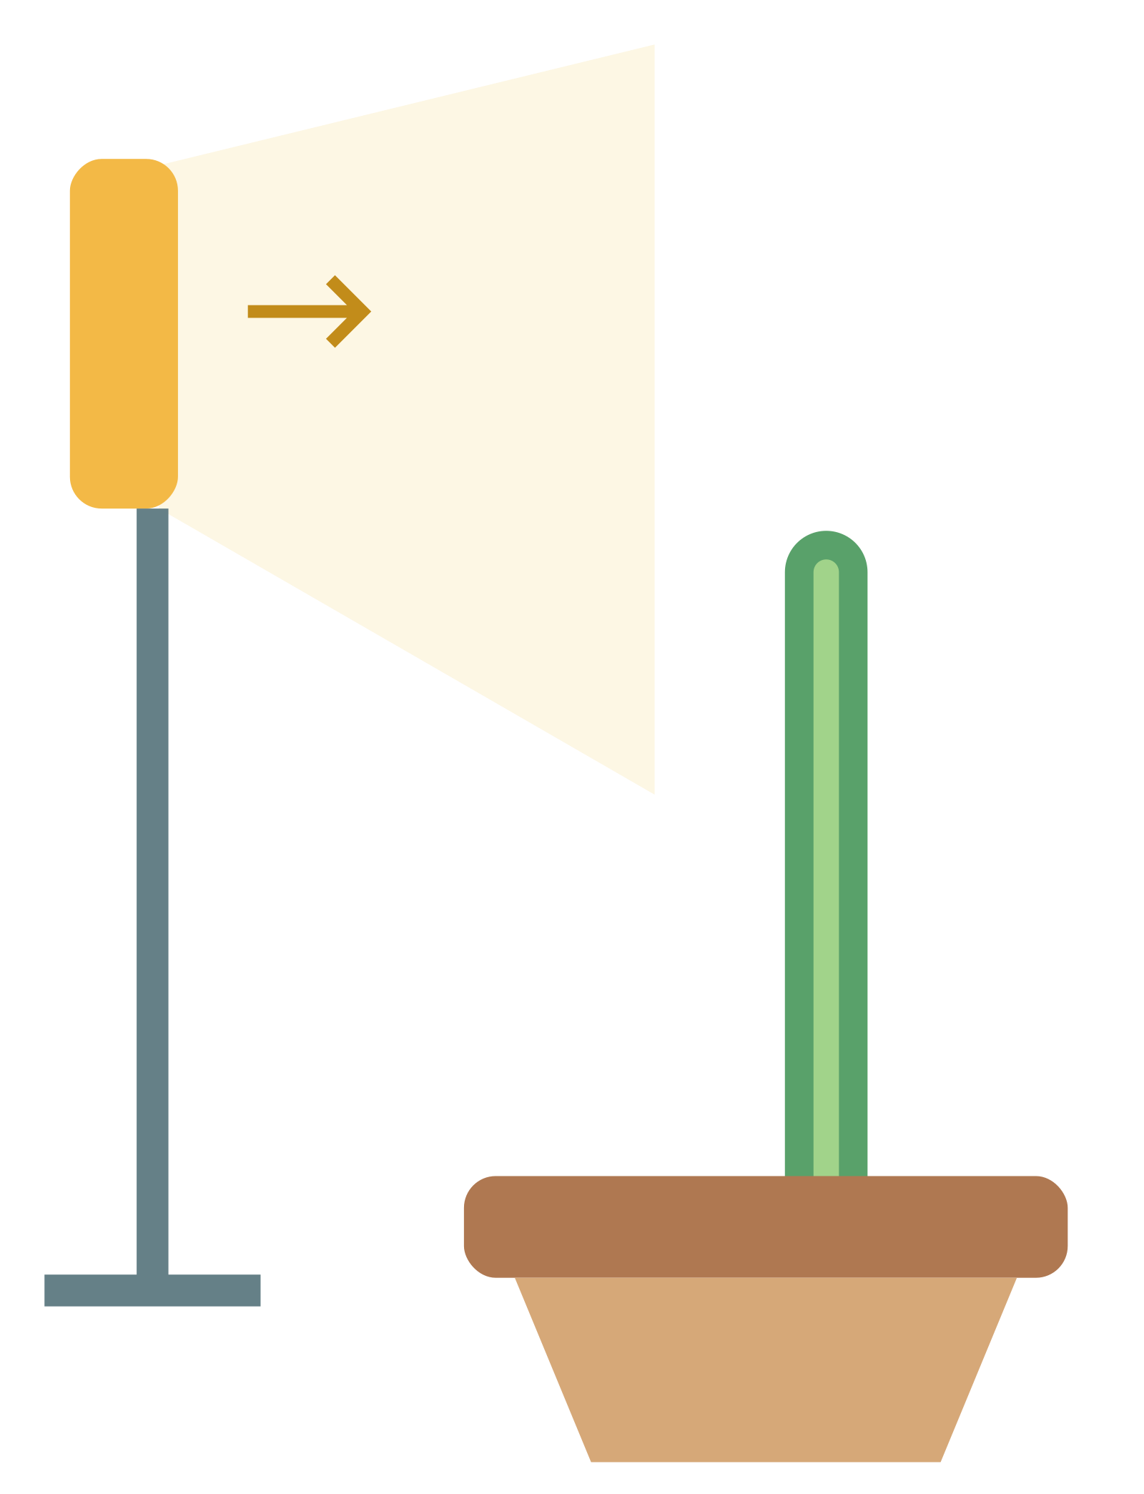 |  | 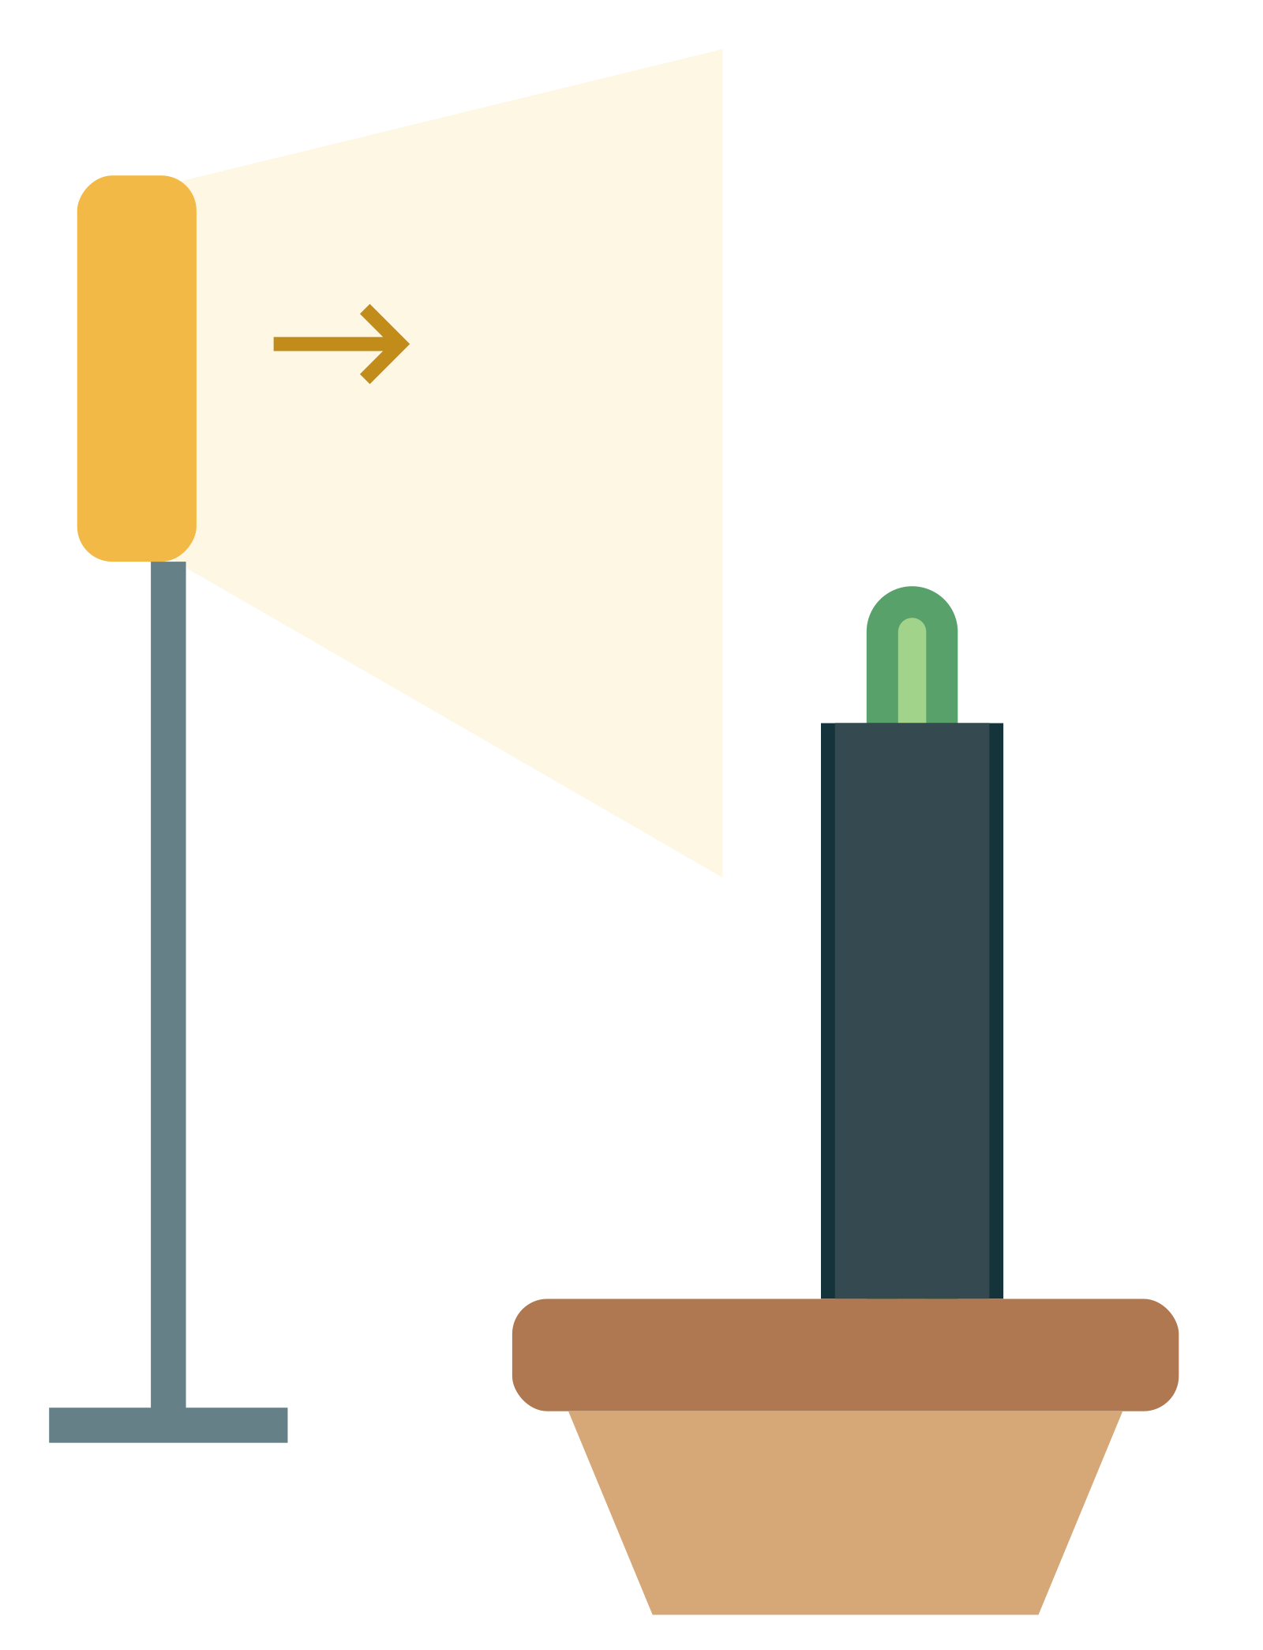
Light is on the left.

Part 1 | Context and fair comparisons (continued)
Identify the variables: tick the appropriate factors in each row. You may choose more than one.
Variable type | Factors to choose from
Independent variable(the factor changed on purpose) | □ Time exposed to light □ The coleoptile（胚芽鞘）’s bending response □ Light direction and intensity □ Coleoptile（胚芽鞘） type, starting height and growth stage □ Light-blocking treatment □ Temperature and water supply
Dependent variable(the result measured or observed) | □ Time exposed to light □ The coleoptile（胚芽鞘）’s bending response □ Light direction and intensity □ Coleoptile（胚芽鞘） type, starting height and growth stage □ Light-blocking treatment □ Temperature and water supply
Controlled variables(the factors kept the same) | □ Time exposed to light □ The coleoptile（胚芽鞘）’s bending response □ Light direction and intensity □ Coleoptile（胚芽鞘） type, starting height and growth stage □ Light-blocking treatment □ Temperature and water supply

What assumptions does this inquiry make?
An assumption is a condition we have not proved but take as true, to help make the experiment results valid.
Choose all suitable assumptions. You may choose more than one.
□ The coleoptiles（胚芽鞘） start in similar growth conditions.
□ The light-blocking cap and sleeve do not limit elongation（延長） or bending.
□ The treatments do not cause clear temperature differences between setups.
□ If the plants are the same type, their starting size does not need to be controlled.

Control group
To find out whether blocking light affects the coleoptile（胚芽鞘）'s growth direction, how would you design the control group?
(Hint: The control group provides a baseline for comparison. It helps you confirm that a change is caused by the independent variable rather than other external factors, so the control group does not receive the independent variable treatment.)

Part 2 | Results and analysis

2.1 Shading
Light is on the left. The sleeve covers below the exposed tip without restricting growth.
A · No light blocked | B · Light blocked at the tip | C · Light blocked below the tip
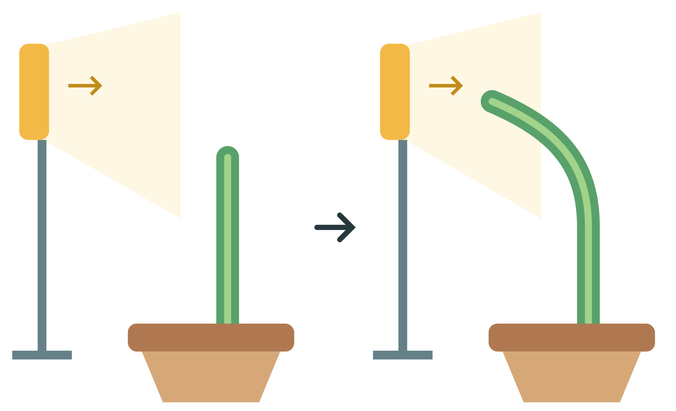 |  | 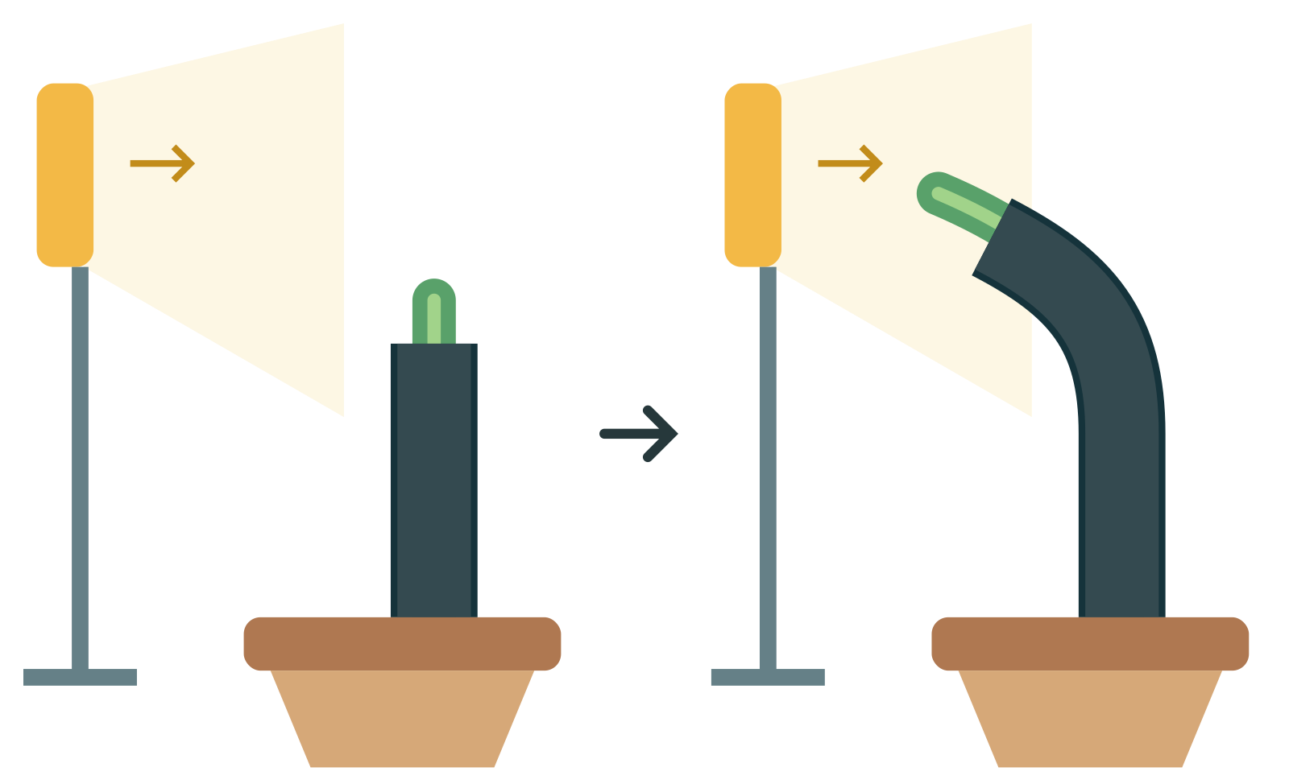
Setup | Bending direction
A | （Bends left ／ Bends right ／ No clear bending）
B | （Bends left ／ Bends right ／ No clear bending）
C | （Bends left ／ Bends right ／ No clear bending）
1. Compare A and B: after blocking light at the tip, what changes? （No clear bending towards the light. ／ It shows the same bending towards light.）
2. Compare A and C: when the lower part does not receive light directly, does the coleoptile（胚芽鞘） still bend? （It can still bend towards light. ／ No clear bending towards the light.）
3. Which part may sense light from one side? （Tip ／ Only the lower part）

2.2 Tip removal
A · No light blocked | D · Tip removed
 | 
Setup | Elongation（延長）
A | （Yes ／ No）
D | （Yes ／ No）
1. What does comparing elongation（延長） in A and D support? （The presence of the tip also affects the coleoptile（胚芽鞘）’s growth / elongation（延長）. ／ The presence of the tip does not affect the coleoptile（胚芽鞘）’s growth / elongation（延長）.）

2.3 Agar（瓊脂）
All cut-tip coleoptiles（胚芽鞘） start at similar sizes and stay in darkness. Blank agar（瓊脂） has not touched a tip; treated agar（瓊脂） has.
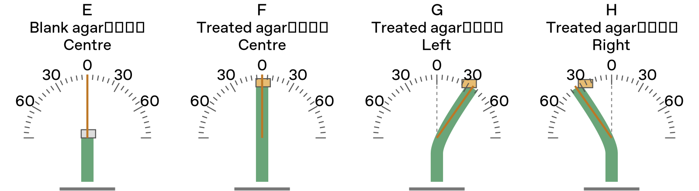
Dashed line: vertical 0°. Each small interval is 5°.
Setup | Angle (°) | Bending direction
E | ________ | （Bends left ／ Bends right ／ No clear bending）
F | ________ | （Bends left ／ Bends right ／ No clear bending）
G | ________ | （Bends left ／ Bends right ／ No clear bending）
H | ________ | （Bends left ／ Bends right ／ No clear bending）
1. What does the comparison of E and F support? （The tip may produce a growth-promoting effect that can be transferred. ／ All agar（瓊脂） produces the same growth-promoting effect.）
2. What does the comparison of F, G and H support? （The position of treated agar（瓊脂） affects the direction of coleoptile（胚芽鞘） bending. ／ The position of treated agar（瓊脂） does not affect the direction of coleoptile（胚芽鞘） bending.）
3. When treated agar（瓊脂） is placed on the left side of a coleoptile（胚芽鞘） with its tip removed, compared with the right side, the left side receives （more ／ less） substance X, causing cells on the left to elongate（延長） （more ／ less） and the coleoptile（胚芽鞘） to bend to the （left ／ right） side.

Part 3 | Integrated explanation
Use the experimental results and topic notes to explain why the coleoptile（胚芽鞘） in the diagram bends to the right.

