Worksheet 2: Transpiration and water transport
Name: ________________ Class: ________ No.: ________
Read the topic notes, then answer using the context and simulated results.

Topic notes

01 Transpiration: water loss as vapour
Water evaporates from water films on mesophyll cell surfaces into air spaces. Water vapour diffuses down a concentration gradient through stomata into the air: transpiration.
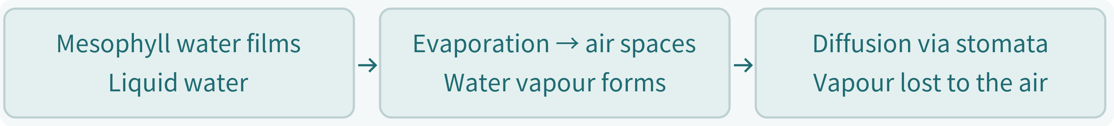

02 Transpiration pull: transport through xylem
Water loss lowers mesophyll water potential. Osmosis draws replacement water from neighbouring cells. Water is removed from xylem vessels, creating transpiration pull and drawing water upwards. With adequate water and other conditions equal, stronger light usually favours stomatal opening. A celery stalk is a petiole containing xylem.
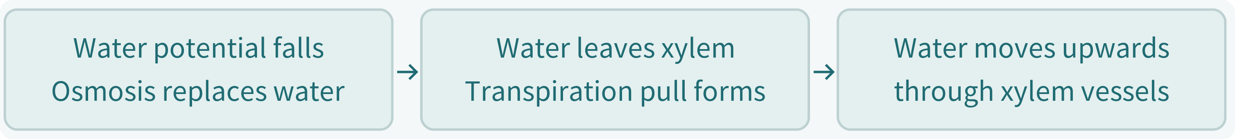

Part 1 | Context and fair comparison
The gardening club puts celery with leaves in red water. Will light and leaves affect water transport?


1. A comparison setup
How would you plan a comparison setup to find out whether leaves help with water transport?
(Hint: the control group provides a basis for comparison. It helps check whether the change in the experiment is caused by the independent variable rather than other external factors. The control group therefore does not receive the treatment being tested.)
(Hint: how is the control setup different from the experiment setup?)

2. Identify the variables
Tick the appropriate factors in each row. You may choose more than one per type.
Variable type | Factors
Independent variable  the factor changed on purpose | □ Light intensity (光強度) □ Height / average upward speed of the red water trace □ Temperature □ Humidity (濕度) and air movement □ Red water concentration and depth of immersion (浸入深度) □ Total leaf area of the setups with leaves □ Length and thickness of the celery stalks
Dependent variable  the result measured | □ Light intensity (光強度) □ Height / average upward speed of the red water trace □ Temperature □ Humidity (濕度) and air movement □ Red water concentration and depth of immersion (浸入深度) □ Total leaf area of the setups with leaves □ Length and thickness of the celery stalks
Controlled variables  the factors kept the same | □ Light intensity (光強度) □ Height / average upward speed of the red water trace □ Temperature □ Humidity (濕度) and air movement □ Red water concentration and depth of immersion (浸入深度) □ Total leaf area of the setups with leaves □ Length and thickness of the celery stalks

3. Select the assumptions for a fair comparison (select all that apply)
An assumption is a condition we have not proved but take as true, to help make the experiment results valid.
□ Changing the lamp distance does not make the setups have different temperatures.
□ Setups A, B and C have the same total leaf area.
□ Leaf area does not affect the results, so it does not need to be kept the same.
□ Humidity (濕度) and air movement are the same for all setups.

Part 2.1 | Read scales and calculate
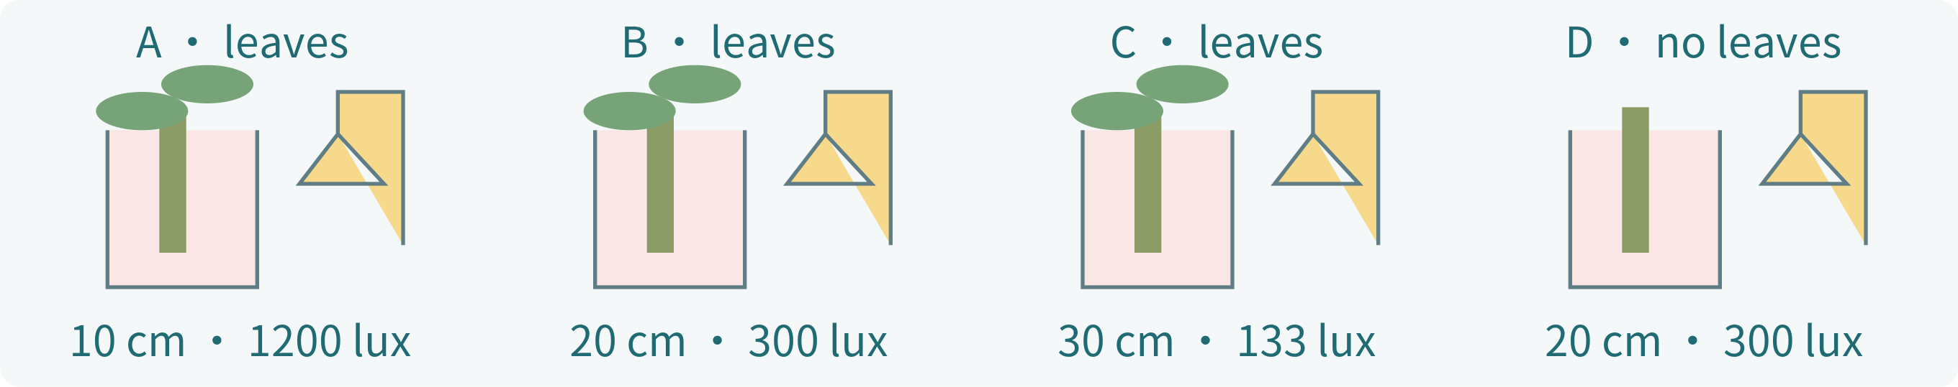
All setups: 25°C, equal humidity, air movement and dye concentration, 2 cm immersion, similar petiole dimensions; A/B/C have equal total leaf area.

4. Your measurement record
Read the height of each red trace at each time, to one decimal place (cm).
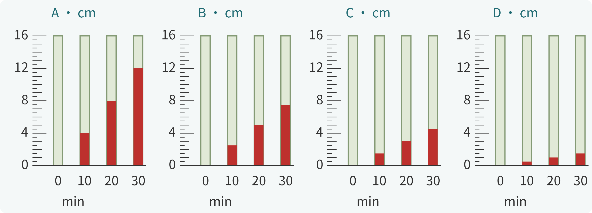
Time (min) | A | B | C | D
0
10
20
30

5. Calculate average upward speed
(30 min reading − 0 min reading) ÷ 30; give two decimal places (cm/min).
A | B | C | D

Part 2.2 | Graph

6. Light intensity and water-trace speed
Plot A/B/C/D using your calculations. Join A/B/C with a smooth trend line; show D separately.
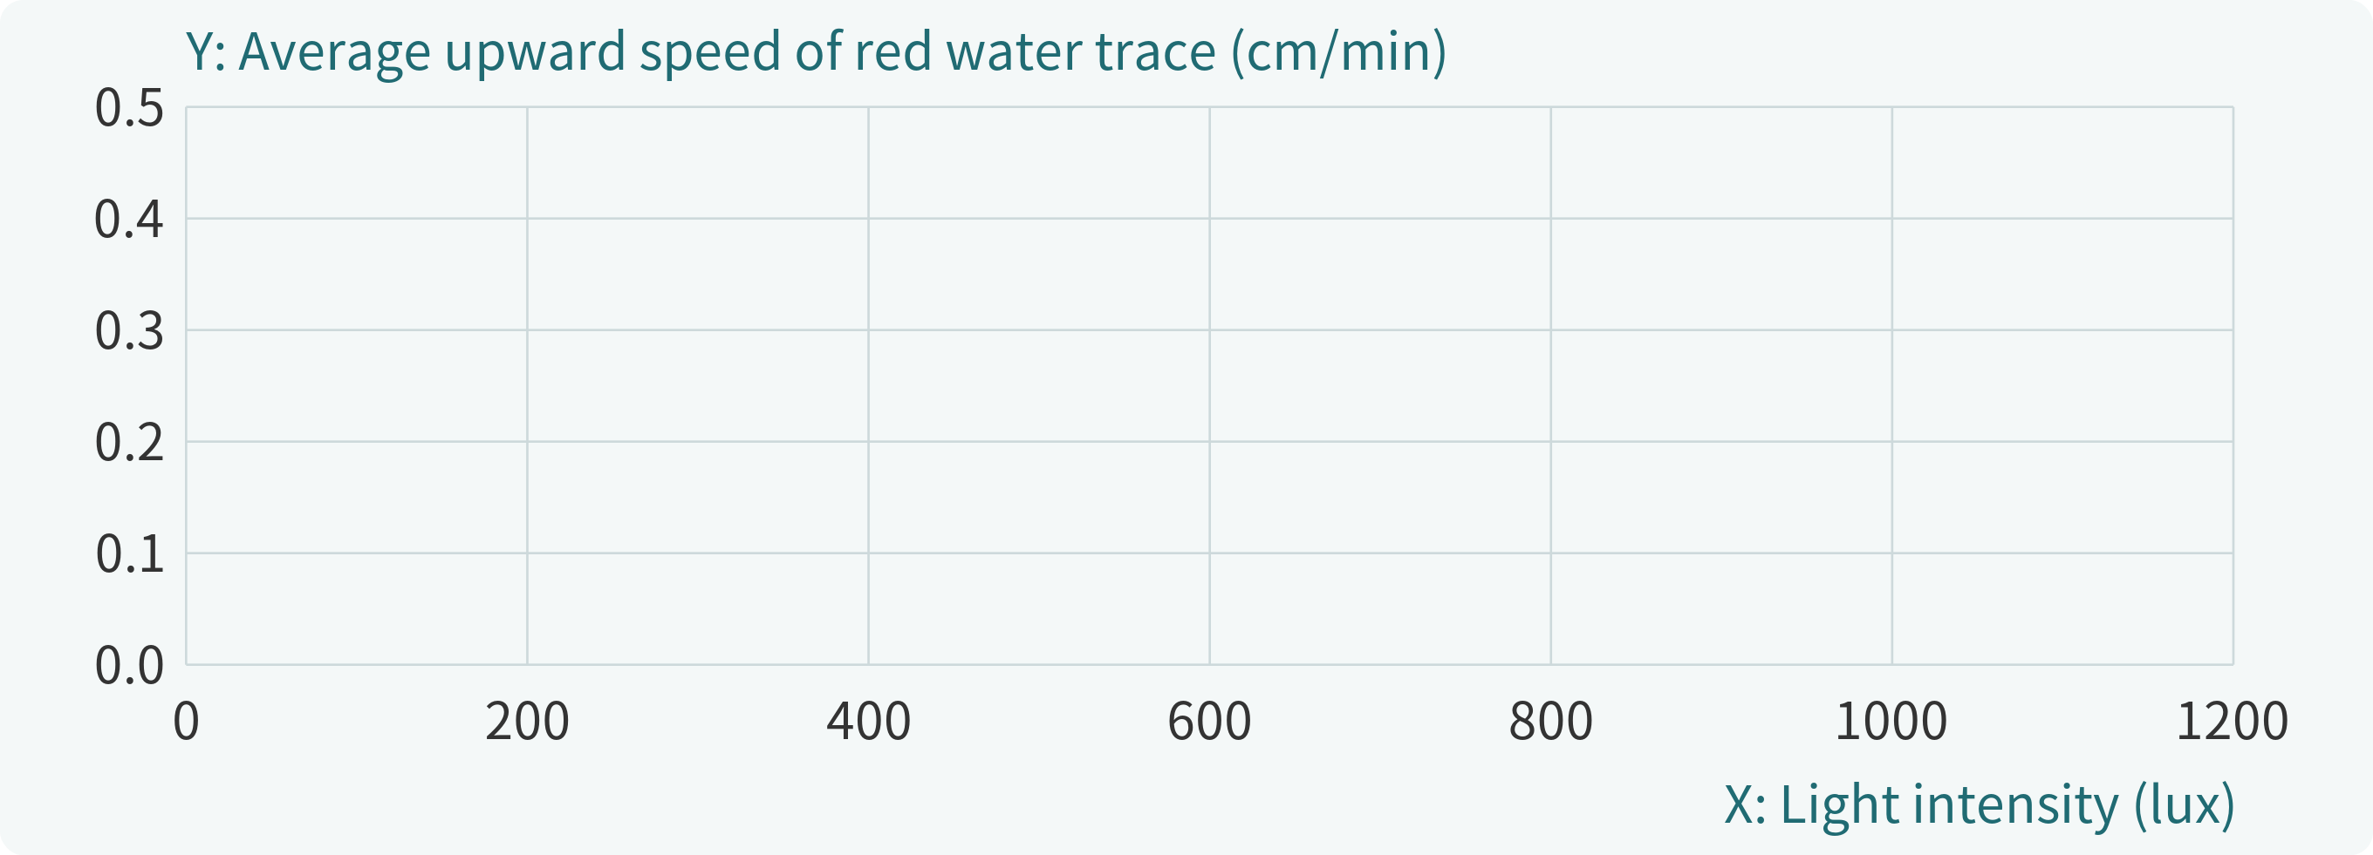

Part 2.3 | Analyse the results

7. How is light intensity (光強度) related to the upward speed of the water trace?
As light intensity (光強度) increases, the average upward speed of the red water trace usually will （increase / decrease / show no clear change / show no consistent trend）.

8. What is the role of leaves?
At the same light distance of 20 cm, the average upward speed of the water trace in Setup B (with leaves), compared with Setup D (without leaves), is （faster / slower / similar）.

9. What is the role of leaves?
This comparison supports the idea that leaves （help water move upwards / stop water moving upwards / have no effect on water moving upwards）.

10. What can this experiment tell us?
We measured only the height of the red water trace. We did not measure water vapour (水汽) lost from the leaves. Which statement is most suitable?
□ The red water trace gives an indirect clue about water uptake and upward water transport. Its speed is not the rate of water loss from leaves, or the transpiration rate (蒸騰速率).
□ The upward speed of the water trace is the rate of water vapour (水汽) loss from leaves and can be used directly as the transpiration rate (蒸騰速率).
□ If the setups with leaves are faster than the setup without leaves, this fully proves that water vapour (水汽) is lost only through stomata (氣孔).

Part 3 | Integrated explanation
11. Using the experimental results and topic notes, explain how light intensity and leaves affect water transport, and explain how transpiration and transpiration pull arise.

