Worksheet 2: Transpiration and water transport
Name: ________________ Class: ________ No.: ________

Topic notes
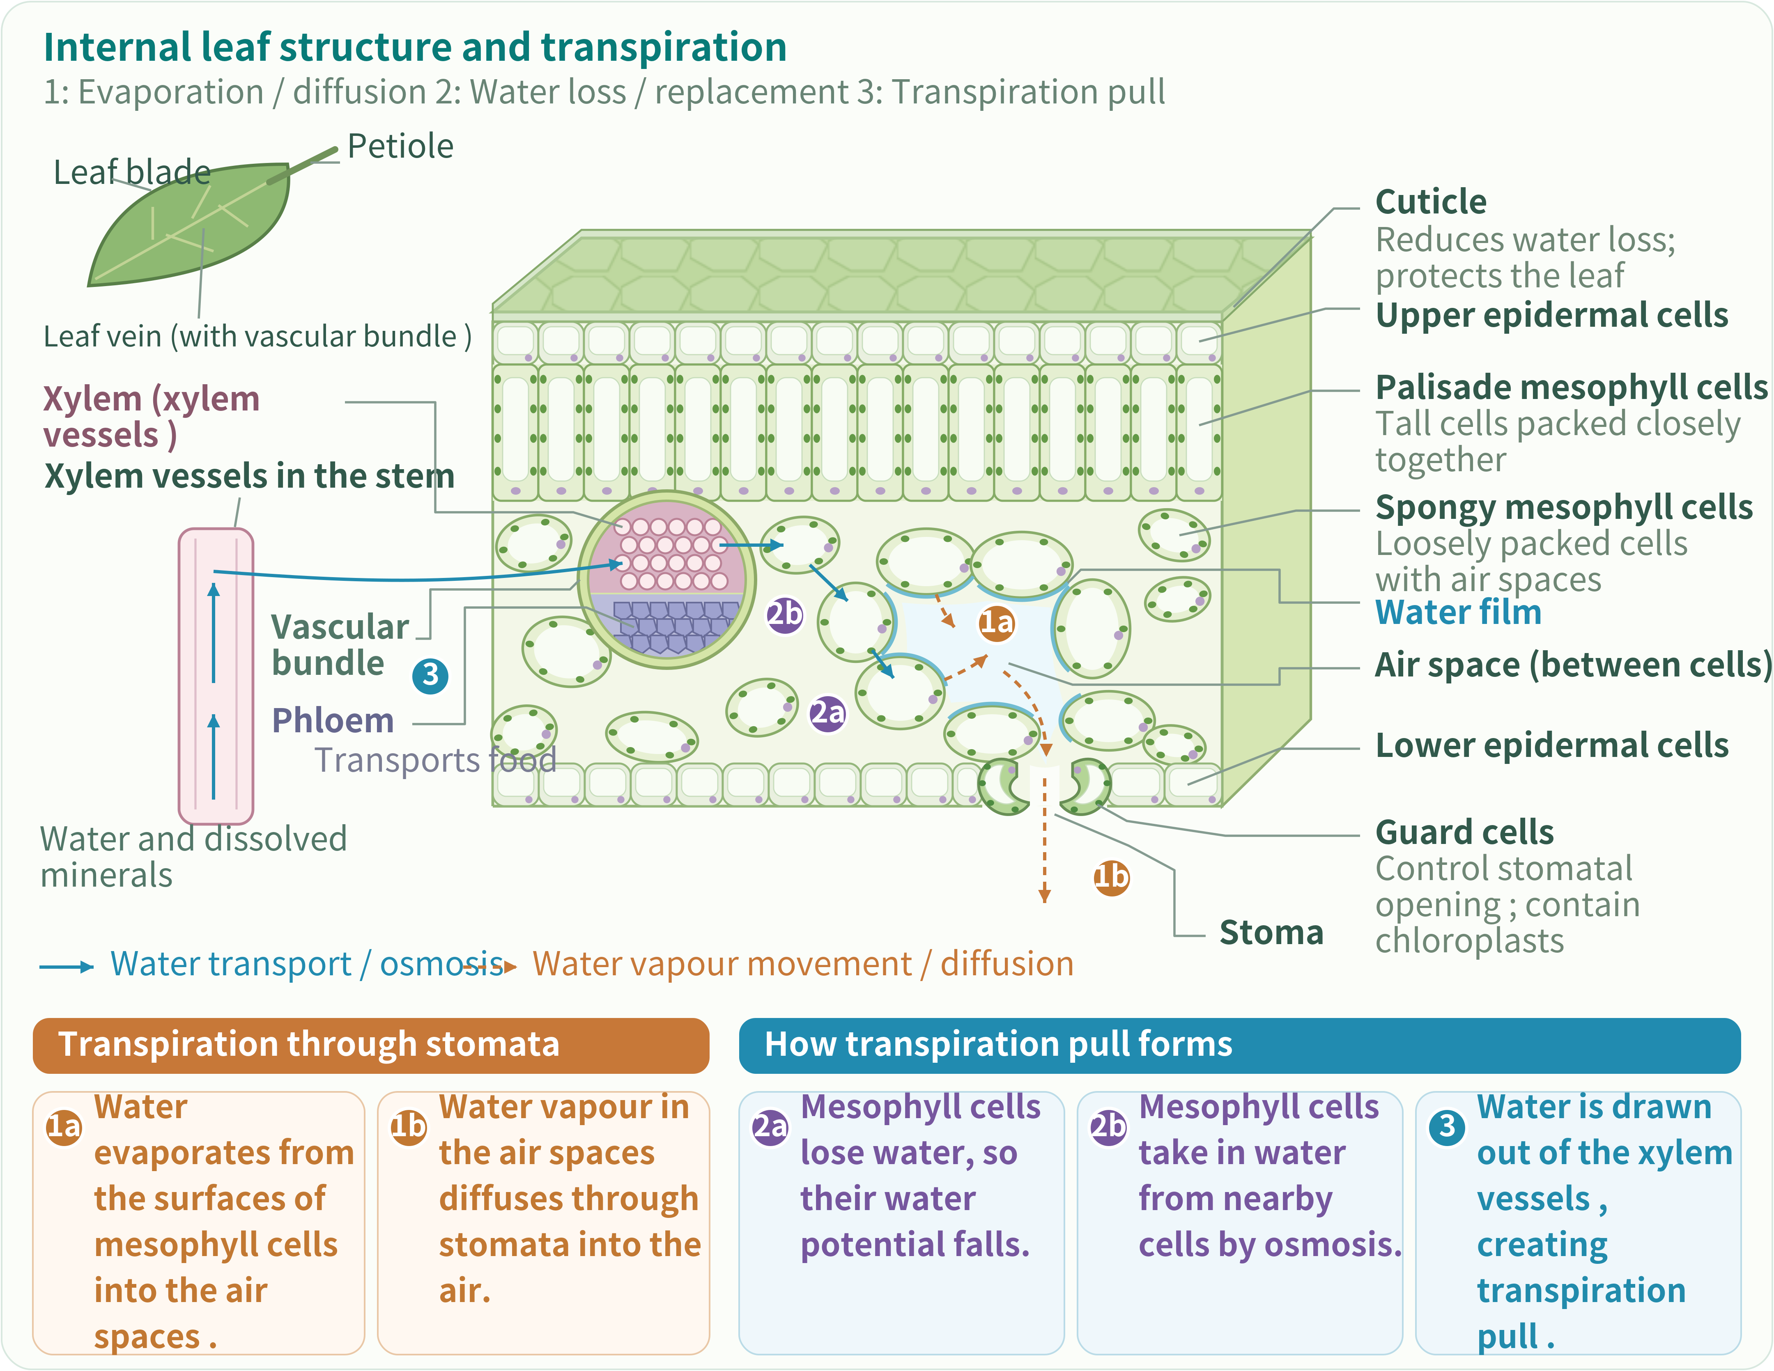
1. Transpiration: water films evaporate; vapour diffuses through stomata.
2. Water replacement: mesophyll water potential falls; osmosis draws in water.
3. Upward transport: removing xylem water creates transpiration pull.
With adequate water and other conditions equal, stronger light favours stomatal opening. A celery stalk is a petiole.

Part 1 | Light intensity and water transport
The gardening club asks: do light and leaves affect upward water transport?
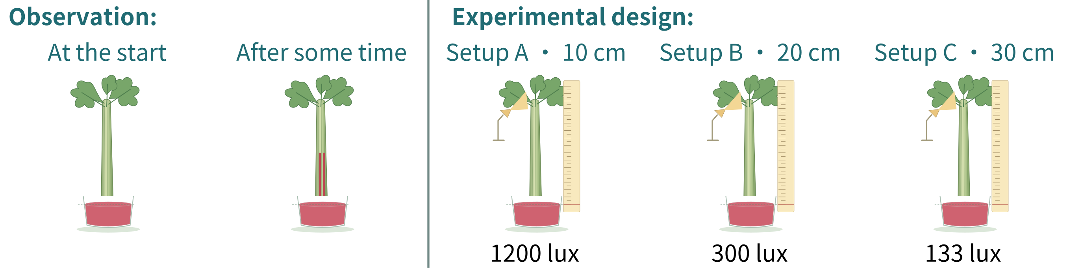

1. Identify variables: setup A, setup B and setup C
Tick the appropriate factors in each row. You may choose more than one per type.
Variable type | Factors
Independent variable  the factor changed on purpose | ☑ Light intensity (光強度) □ Height / average upward speed of the red water trace □ Temperature □ Humidity (濕度) and air movement □ Red water concentration and depth of immersion (浸入深度) □ Total leaf area of the setups with leaves □ Length and thickness of the celery stalks
Dependent variable  the result measured | □ Light intensity (光強度) ☑ Height / average upward speed of the red water trace □ Temperature □ Humidity (濕度) and air movement □ Red water concentration and depth of immersion (浸入深度) □ Total leaf area of the setups with leaves □ Length and thickness of the celery stalks
Controlled variables  the factors kept the same | □ Light intensity (光強度) □ Height / average upward speed of the red water trace ☑ Temperature ☑ Humidity (濕度) and air movement ☑ Red water concentration and depth of immersion (浸入深度) ☑ Total leaf area of the setups with leaves ☑ Length and thickness of the celery stalks

2. Select the assumptions for a fair comparison (select all that apply)
An assumption is a condition we have not proved but take as true, to help make the experiment results valid.
☑ Changing the lamp distance does not make the setups have different temperatures.
☑ Setups A, B and C have the same total leaf area.
□ Leaf area does not affect the results, so it does not need to be kept the same.
☑ Humidity (濕度) and air movement are the same for all setups.

3. Main investigation: setup A, setup B and setup C readings
Read each red-trace height at each time to one decimal place (cm).
Red water-trace height changes in setup A, setup B and setup C
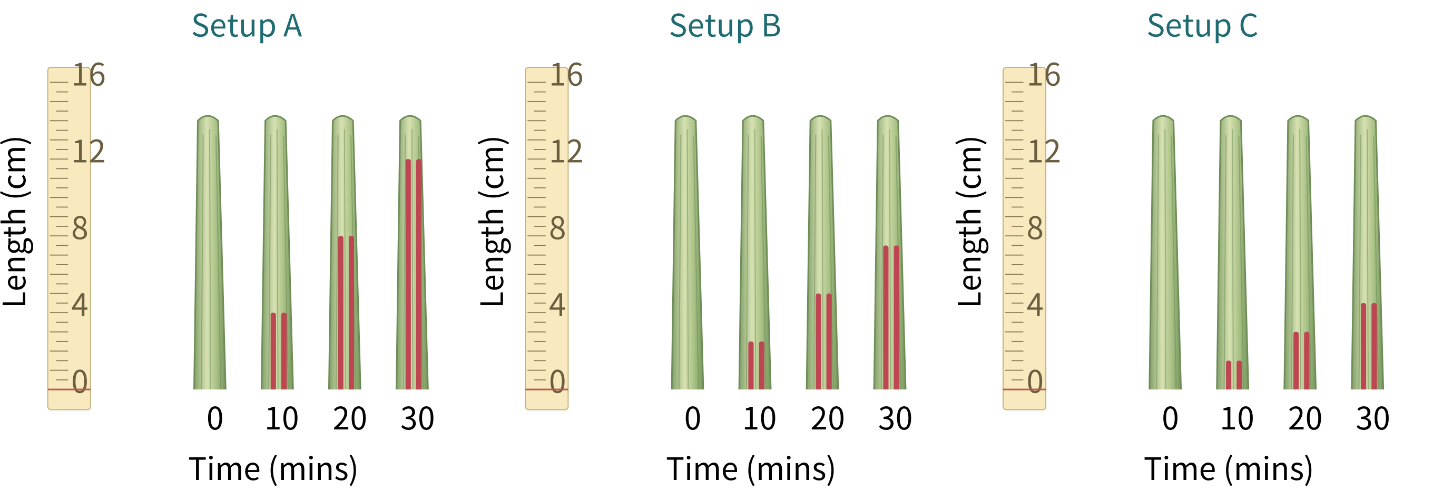
Time (mins) | 0 | 10 | 20 | 30
Setup A | 0.0 | 4.0 | 8.0 | 12.0
Setup B | 0.0 | 2.5 | 5.0 | 7.5
Setup C | 0.0 | 1.5 | 3.0 | 4.5

Part 2 | Leaves and water transport

4. Does the presence of leaves affect water uptake and upward water transport?
Does this extension investigation need a control setup? If so, how would you design the comparison?  (Hint: a control setup provides a comparison baseline. Keep conditions other than the factor being investigated the same.)  (Hint: how is the control setup different from the experiment setup?)  Reference answer: Compare leafy setup B with leafless setup D at the same 20 cm lamp distance, keeping other conditions equal. | 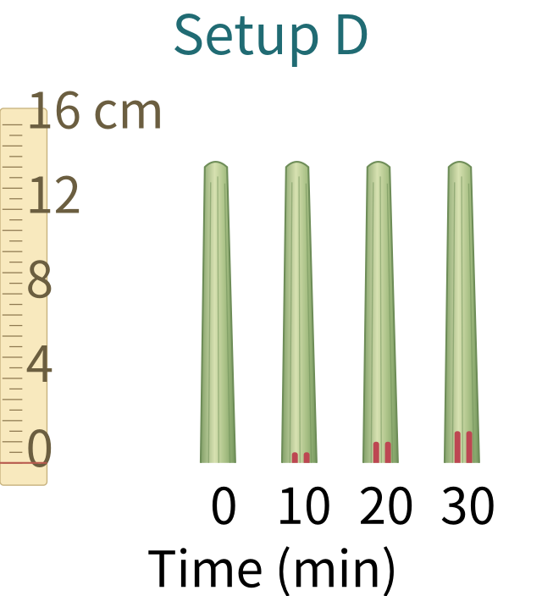

5. Extension readings
Reuse setup B from item 3. Read and record only leafless setup D (one decimal place, cm).
min | 0 | 10 | 20 | 30
Setup D | 0.0 | 0.5 | 1.0 | 1.5

6. Calculate the average upward speed of the top of the red water trace
(30 min reading − 0 min reading) ÷ 30; give two decimal places (cm/min).
Setup A | Setup B | Setup C | Setup D
0.40 | 0.25 | 0.15 | 0.05

7. Light intensity and water-trace speed
Plot setup A, setup B, setup C and setup D from your calculations. Join setup A, setup B and setup C with a smooth trend line; keep setup D separate.
Setup A: 1200 lux Setup B: 300 lux Setup C: 133 lux Setup D: 300 lux
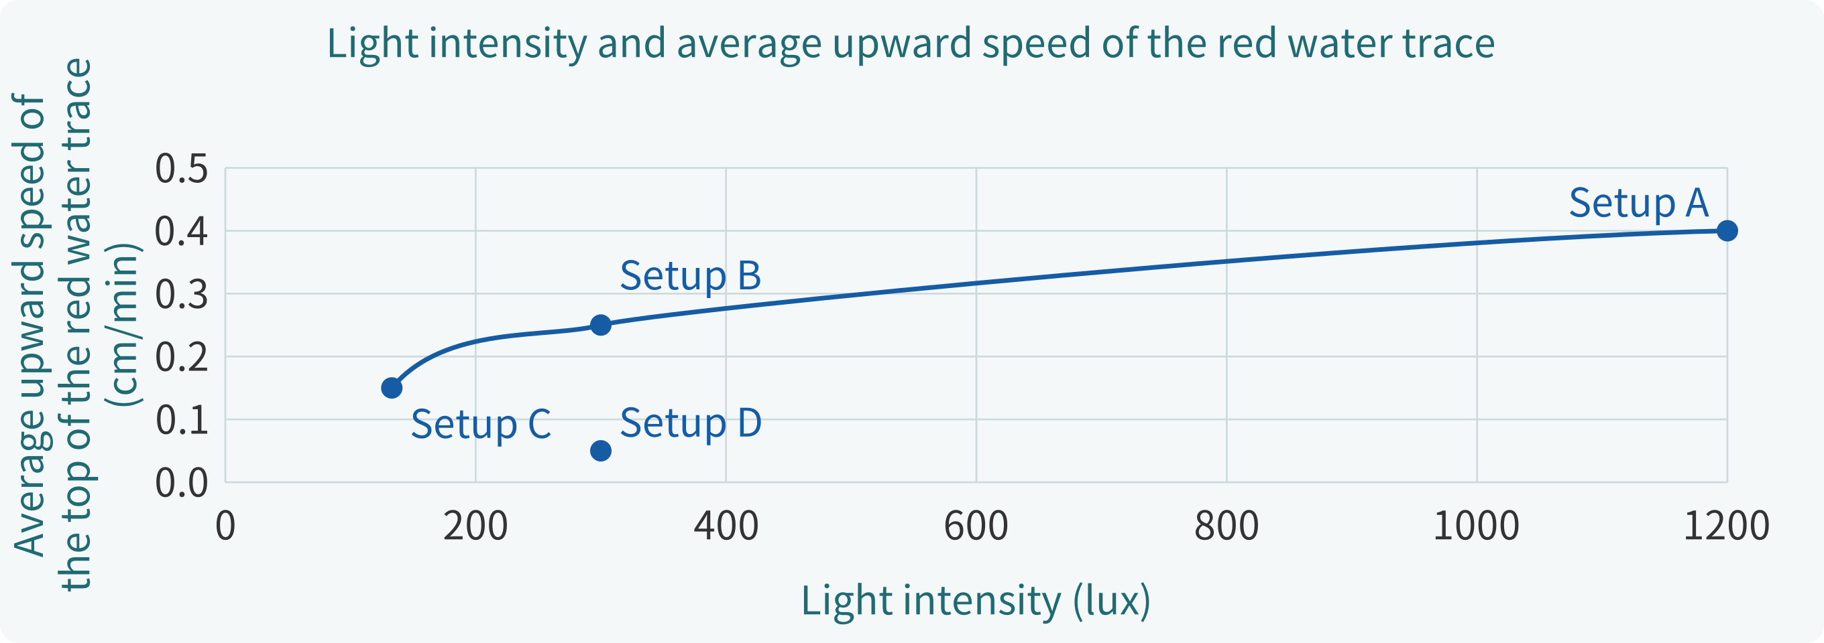

Part 2 | Results and analysis (continued)

8. How is light intensity (光強度) related to the upward speed of the water trace?
As light intensity (光強度) increases, the average upward speed of the red water trace usually will （increase / decrease / show no clear change / show no consistent trend）.

9. What is the role of leaves?
At the same 20 cm lamp distance, the red-trace speed in leafy setup B, compared with leafless setup D, is （faster / slower / similar）.

10. What is the role of leaves?
This comparison supports the idea that leaves （help water move upwards / stop water moving upwards / have no effect on water moving upwards）.

11. What can this experiment tell us?
We measured only the height of the red water trace. We did not measure water vapour (水汽) lost from the leaves. Which statement is most suitable?
☑ The red water trace indicates water uptake and upward water transport, but does not represent leaf transpiration rate (蒸騰速率) (the rate of water loss through stomata (氣孔)).
□ The upward speed of the water trace is the rate of water vapour (水汽) loss from leaves and can be used directly as the transpiration rate (蒸騰速率).
□ If the setups with leaves are faster than the setup without leaves, this fully proves that water vapour (水汽) is lost only through stomata (氣孔).

Part 3 | Integrated explanation
12. Using the experimental results and learning points, explain how light intensity (光強度) and leaves affect water transport, and explain how transpiration (蒸騰) and transpiration pull (蒸騰拉力) arise.
Reference answer: Other conditions equal, stronger light usually opens stomata, increasing transpiration and water transport. Water evaporates from mesophyll water films into air spaces; vapour diffuses down its concentration gradient through stomata: transpiration. Loss lowers mesophyll water potential; xylem replenishes water. Removal creates transpiration pull, drawing water up xylem vessels. Leaves provide the main transpiring surface, so leafy setup B has a faster trace than leafless setup D at equal distance.

