DOCUMENTATION API Rest MFI

I – DATA BASE :

Peaks Table:

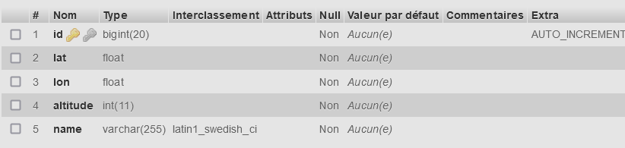

Datas :

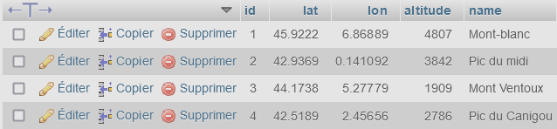

II – CRUD

function readPeak($id)

  {

      $sql="SELECT \* from peaks where id=$id";

      $stmt = $con->query($sql);

      $row=$stmt->fetchAll();

      if (!empty($row))

      {

        return $row[0];

      }

  }

  function createPeak($id)

  {

      $sql="INSERT INTO peaks ($lat, $lon, $altitude, $name)

              VALUES ('$lat', '$lon', '$altitude', '$name')";

      $con->exec($sql);

  }

  function updatePeak($lat, $lon, $altitude)

  {

      $sql="UPDATE peaks set lat='$lat', lon='$lon', altitude='$altitude', name='$name'";

      $stmt = $con->query($requete);

  }

  function deletePeak($id)

  {

      $sql="DELETE from peaks where id='$id'";

      $stmt = $con->query($requete);

  }

III – Api Link

Link to MFI/documentation.docx to root path of project.

<http://localhost/mfi/documentation.docx>

IV – Add 1 html/javascript page

Not done

V – Deployment on Docker and docker-composite

Not done

VI : Overview of api :

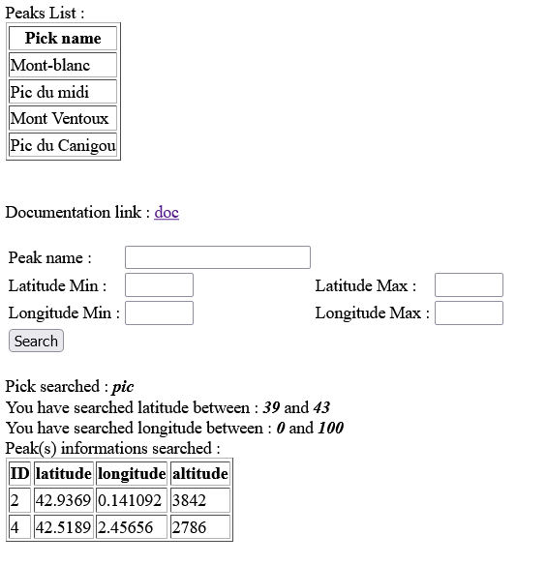

Address « Github » for all files :

<http://github.com/tzen31/mfi>