Configuration-Retaining Reachability Roadmaps for Dual-Topology Manipulation under Environment Updates
[AUTHOR NAME], [CO-AUTHOR NAME], and [SUPERVISOR NAME]
[Laboratory / Department / University], [City, Country] | [corresponding@email]
Draft status — confirmatory results integrated: Updated 25 August 2026. Frozen protocol v4 completed on the Jetson AGX Orin: 180 roadmap builds and 21,600 controller-free queries passed the full integrity audit. Development-only results remain excluded from confirmatory inference.

Abstract
We present a preview-only manipulation-planning architecture that intersects an environment graph containing semantic targets and obstacle primitives with a robot reachability graph whose nodes retain complete six-joint configurations. Candidate routes are filtered by cached swept-body capsules and then validated at interpolated states with MoveIt/FCL; rejected edges are disabled within the query and graph search repeats. We compare three 800-node constructions under shared connection and collision rules: a Growing Neural Gas (GNG)-quantized k-nearest-neighbour roadmap, a guarded hybrid with two anchors, 199 GNG prototypes, and 599 deterministic low-discrepancy samples, and a Halton/PRM baseline. The frozen controller-free evaluation spans 60 deterministic roadmap streams and 30 base trajectories crossed with point and segment obstacles, totaling 180 graph builds and 21,600 clear/dynamic queries. All integrity contracts passed with no timeout or infrastructure-error row. Dynamic exact-valid success was 73.8% for GNG, 77.4% for guarded GNG, and 80.5% for Halton/PRM. Guarded GNG improved the prespecified risk-difference estimate over GNG by 3.7 percentage points (fixed-catalog 95% CI 1.6–5.8; Holm-adjusted permutation p=.0032), but remained 3.1 points below Halton/PRM (CI −5.2 to −0.9; p=.0088). Thus deterministic guards mitigate a pure-GNG local-support failure, but do not establish superiority over the low-discrepancy baseline. Inference is conditional on the frozen catalog; perception robustness, controlled timing, and physical execution remain open.
Keywords — reachability roadmap, Growing Neural Gas, low-discrepancy sampling, manipulation planning, collision checking, ROS 2

I. Introduction
A target observed in Cartesian space is not automatically executable. Several inverse-kinematic branches can reach similar end-effector positions, but only some branches connect collision-free to the measured arm configuration. Capability maps summarize workspace access [4], [5], whereas probabilistic roadmaps amortize configuration-space search [2]. A manipulation system driven by an evolving RGB-D scene requires both ideas: semantic target selection in workspace and persistent, validated connectivity in configuration space.
We study a dual-topology architecture. The environment topology G_E represents target-labelled nodes and obstacle-bearing nodes or edges. The robot topology G_R represents collision-valid joint configurations, their end-effector poses, and validated local transitions. A scene target becomes actionable only when an overlapping robot node lies in the component connected to the current configuration. The implementation emits a trajectory preview on a private topic and deliberately exposes neither a controller publisher nor a FollowJointTrajectory action client.
The initial motivation was to use GNG to learn a useful configuration-space topology. Implementation audit showed that the present planner retains GNG prototypes but discards the learned GNG adjacency before rebuilding all methods with a shared validated k-nearest-neighbour rule. We therefore call the method a GNG-quantized PRM, not a topology-preserving GNG planner. This distinction is central to the research claim and to the design of the baselines.
This paper contributes:
- A typed dual-topology planning architecture that keeps full robot configurations and multiple kinematic branches behind end-effector positions.
- A two-stage obstacle-update mechanism combining cached full-body capsule sweeps with lazy, interpolated MoveIt/FCL validation and within-query edge rejection followed by graph re-search.
- An auditable guarded-GNG construction with exact node-composition telemetry under a fixed 800-node budget.
- A provenance-bound, controller-free multi-scene benchmark whose frozen 60-stream evaluation quantifies where guarded GNG helps and where Halton/PRM remains stronger.

II. Related Work

A. Roadmaps, Low-Discrepancy Sampling, and GNG
PRM separates roadmap construction from repeated online queries [2]. Halton sequences provide deterministic low-discrepancy coverage alternatives to pseudorandom sampling [3]. GNG incrementally learns prototypes and adjacency from an input distribution [1]. The comparison holds final node count, joint limits, local-connection rules, and collision predicates constant while varying node generation; it does not hold candidate information, edge count, collision workload, or wall-clock budget constant. Because learned GNG edges are not retained, our claims concern adaptive quantization rather than Fritzke's complete topology-learning algorithm.

B. Reachability and Experience Representations
Capability and reachability maps summarize where a manipulator can act [4], [5]. Sparse roadmap spanners limit graph growth while preserving useful paths [9], and E-Graphs or Thunder reuse prior planning experience [10], [11]. Our graph is closer to a persistent configuration-space roadmap than to a binary reachability volume: multiple nodes may share nearby end-effector positions while retaining distinct joint branches and transitions. It currently provides no asymptotic optimality or completeness guarantee.

C. Dynamic Environments and Sampling Bias
Lazy PRM postpones expensive checks until query time [6]. Dynamic Roadmaps cache environment-to-roadmap influence [7], and changing-environment PRM variants invalidate affected regions [8]. Our cached capsules serve as a conservative broad phase before exact FCL validation. Learned sampling can focus computation but can underrepresent rare useful regions; mixing learned and globally supportive samples is a common hedge against concentration [12]–[14]. Guarded GNG is one deterministic hybrid, not a probabilistic-completeness claim.

III. Problem Formulation
Let Q be the six-dimensional joint-limit box and Q_free the configurations accepted by kinematic and collision validity predicates. Robot node v_i stores joint vector q_i, its range-normalized form, and end-effector pose x_i=FK(q_i). Normalization prevents joints with wider numerical ranges from dominating neighbour selection.
d_Q(q_i,q_j) = sqrt( sum_k ((q_i,k-q_j,k)/(q_k^max-q_k^min))^2 ) (1)
The world-frame environment graph G_E=(V_E,E_E) partitions semantic target candidates T from point or segment obstacles O. Given target t and measured start q_s, the planner searches unblocked robot nodes within Cartesian radius r_I that belong to the start component.
I(t) = {v_i in V_R | ||p_i-p_t||_2 <= r_I, free(v_i), connected(v_i,v_start)} (2)
Dijkstra search minimizes accumulated roadmap cost to a candidate in I(t). A preview is exact-valid only when every interpolated state passes detailed robot and environment collision checks. Time parameterization, dynamics, controller tracking, and moving-obstacle prediction are outside the current interface.

IV. System and Roadmap Construction
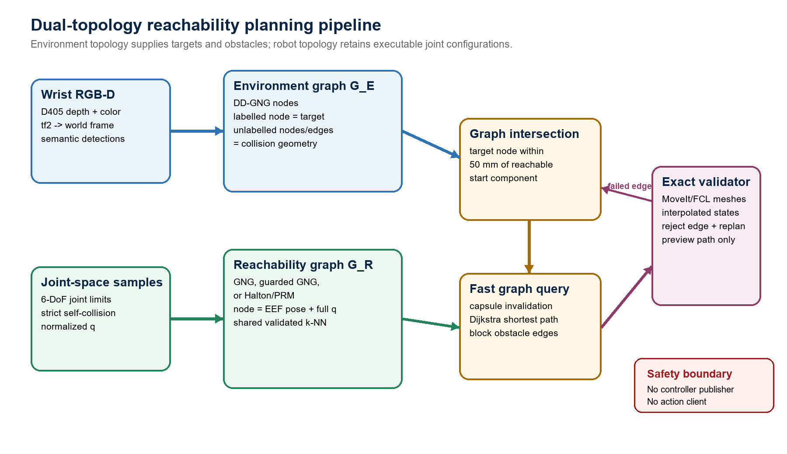
Fig. 1. Dual-topology pipeline. Environment targets intersect configuration-retaining robot nodes; cached capsule invalidation precedes lazy MoveIt/FCL route validation. Output remains preview-only.

A. Environment and Robot Topologies
In the full system, a wrist-mounted RealSense D405 supplies a world-frame point cloud to DD-GNG. Stable environment nodes retain position, semantic class, confidence, and edges. Target-labelled nodes become goal hypotheses; non-target nodes and segments become collision primitives, with a small exclusion around the selected target. Perception and reachability are separate ROS 2 processes, so the roadmap benchmark can run without opening the camera or launching hardware interfaces. The present experiments inject synthetic, oracle-validated environments and do not evaluate perception.

B. Three Node-Budget-Matched Roadmaps
All constructions begin with two fixed anchors and end at exactly 800 nodes. Pure GNG is trained from 4,000 valid normalized configurations and retains 798 prototypes. Guarded GNG retains 199 prototypes and adds 599 deterministic raw valid samples selected across the same candidate stream. Halton/PRM adds 798 digit-permuted Halton samples directly. Every method then uses the same validated k-NN connection stage. Runtime telemetry reports anchor, prototype-budget, retained-prototype, requested-guard, retained-guard, fill, training-sample, candidate-attempt, edge, and component counts.
The comparison is node-budget matched but not candidate-information- or compute-budget matched: both GNG variants inspect 4,000 accepted training configurations, whereas Halton fills its graph directly. The 75% guard fraction was selected on development failures and is frozen for confirmatory evaluation; it is not inferred as a generally optimal mixture.

C. Cached Broad Phase and Exact Replanning
Roadmap nodes and interpolated edges cache capsules spanning the arm, end effector, fingers, and camera payload. Environment updates use point-to-segment and segment-to-segment distances to invalidate candidates without rebuilding the roadmap.
blocked(c,o) iff distance(axis(c),o) < radius(c)+clearance (3)
A surviving route is reconstructed in a MoveIt PlanningScene and checked with FCL over interpolated states. If exact validation rejects an edge, the edge is disabled for that environment and Dijkstra search repeats, up to twenty times. The query response includes its scene, stream, method, graph revision, target, start state, validity flags, and diagnostic counters; stale or mismatched responses are rejected.

V. Implementation and Confirmatory Evaluation
The ROS 2 Humble C++ implementation runs on the robot's NVIDIA Jetson AGX Orin. MoveIt RobotModel/RobotState provide kinematics and self-collision state; PlanningScene and FCL validate detailed meshes. Benchmark processes use isolated ROS domains with localhost-only discovery and launch neither MoveGroup, ros2_control, a camera process, nor a controller endpoint. Preflight checks require clean domains and exactly one expected graph publisher, plan publisher, and query subscriber.

Table I. Frozen roadmap and query parameters.
Parameter | Value | Role
Roadmap nodes / GNG signals | 800 / 4000 | Fixed nodes; accepted GNG training configurations
Guard fraction / composition | 0.75 | Two anchors + 199 prototypes + 599 guards
k-NN candidates / max d_Q | 10 / 0.75 | Shared local connection rule
Max Cartesian edge / target radius | 0.14 / 0.05 m | Local displacement / graph intersection
Clearance / environment radii | 0.035 / 0.012 / 0.006 m | Capsule margin / point / segment
Body step / exact step / replans | 0.08 / 0.05 / 20 | Cached sweep / exact interpolation / search bound

A. Evidence Ladder
Development proceeded in three explicitly separated stages. First, offsets 0–49 exposed eight pure-GNG failures and were used to select the 75% guard fraction. Second, offsets 50–99 evaluated one anchored start-target task; although held out from fraction selection, these data subsequently informed instrumentation and study design and are therefore treated as development evidence for the final paper. Third, a six-stream, six-scene integration smoke exercised atomic multi-scene queries, provenance, correlation, and analysis plumbing. None of these stages is pooled with the frozen confirmatory run.
Table II. Evidence stages and permitted interpretation.
Stage | Scale | Purpose | Claim boundary
Guard selection | 8 selected failures | Choose 0.75 fraction | Selection only
Anchored offsets | 150 builds; 300 queries | Diagnose one fixed task | Development evidence
Multi-scene smoke | 18 builds; 216 queries | Validate pipeline | Descriptive only
Frozen confirmatory v4 | 180 builds; 21,600 queries | Test two hypotheses | Audit PASS

B. Frozen Multi-Scene Design
Catalog om6dof_icra_scene_catalog_v4 contains 30 deterministic base start-target trajectories crossed with point and segment obstacles. Within each pair, start joints, target source joints, and target position are identical. Normalized joint distance defines ten low-, ten medium-, and ten high-difficulty bases. An independent oracle accepts a scene only when the clear direct interpolation is valid, the dynamic obstacle blocks that interpolation under both capsule and exact checks, endpoints and a detour state remain valid, and the two-leg detour is collision-free.
Roadmap stream labels 100–159 are fixed deterministic digit-permuted Halton stream keys, not ordinary random seeds. The six method orders occur ten times each. Scene order is rotated identically across methods, and clear/dynamic phase order is parity-counterbalanced. Each query atomically includes start state, target, complete environment, scene ID, and query ID. The design yields 60 streams × 3 methods × 60 scenes × 2 phases = 21,600 queries.

C. Confirmatory Statistical Plan
The primary endpoint is dynamic-scene exact-valid success. For each guarded-versus-baseline pair, the method difference is averaged over the fixed 60-scene catalog within stream, then averaged over 60 streams. Only guarded GNG minus pure GNG and guarded GNG minus Halton/PRM are confirmatory; Holm correction covers exactly these two hypotheses.
d_s = (1/60) sum_j (Y_guarded,s,j - Y_baseline,s,j); Delta = (1/60) sum_s d_s (4)
Uncertainty uses 50,000 paired whole-stream bootstrap resamples with shared indices across contrasts. A two-sided studentized sign-flip permutation test flips the complete 60-scene method-difference vector per stream for 100,000 Monte Carlo draws. The interval is conditional on the frozen catalog; it does not imply unrestricted scene-population generalization. Build time uses all paired streams, while success-conditional latency and cost use only joint-success cells. Path-change comparisons require common clear-and-dynamic success for both methods.

VI. Confirmatory Results
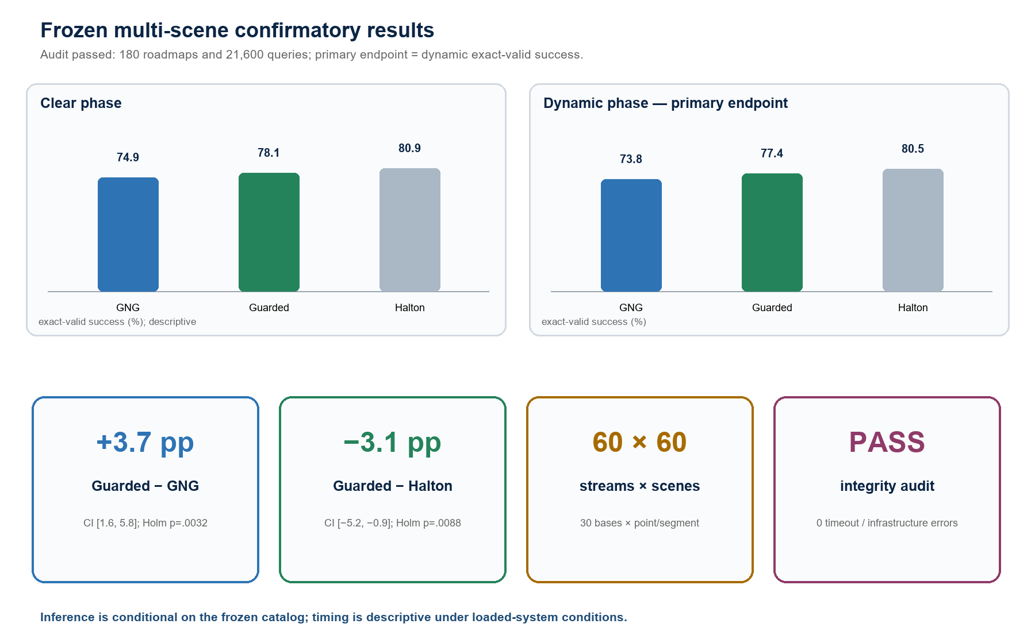
Fig. 2. Frozen multi-scene results. Guarded GNG improved dynamic exact-valid success over pure GNG, while Halton/PRM remained higher than guarded GNG.
Table III. Per-method results over 60 streams × 60 fixed scenes. Success intervals resample whole roadmap streams; other values are descriptive.
Method | Clear exact-valid | Dynamic exact-valid | Retention | Build ms, median [IQR]
GNG | 74.9% [73.8, 76.1] | 73.8% [72.6, 75.0] | 98.4% | 1721.5 [1708.1, 1743.5]
Guarded GNG | 78.1% [76.3, 79.9] | 77.4% [75.7, 79.2] | 99.1% | 1594.1 [1576.6, 1618.3]
Halton/PRM | 80.9% [79.3, 82.6] | 80.5% [78.9, 82.1] | 99.5% | 1393.8 [1377.7, 1411.2]
Audit PASS: 180 graph builds and 21,600 paired phase queries; no timeout or infrastructure-error row. Timing was collected under loaded-system conditions and is descriptive.

A. Prespecified Primary Endpoint
The primary endpoint was dynamic exact-valid success risk difference averaged over the fixed catalog within each stream and then over 60 streams. Guarded GNG exceeded pure GNG by 3.7 percentage points, and the paired whole-stream interval excluded zero. The studentized stream-level sign-flip test remained significant after the prespecified two-hypothesis Holm correction. Against Halton/PRM, however, guarded GNG was 3.1 points lower, with an interval also excluding zero. Both null hypotheses were rejected, but in opposite directions; the result supports mitigation of pure GNG's local-support failure rather than overall guarded-GNG superiority.
Table IV. Prespecified dynamic-success contrasts. Effects are guarded GNG minus comparator; intervals condition on the frozen catalog.
Comparison | Method rates | Risk difference | 95% CI | Permutation p / Holm p
Guarded − GNG | 77.4% vs 73.8% | +3.7 pp | [+1.6, +5.8] pp | .0016 / .0032
Guarded − Halton | 77.4% vs 80.5% | −3.1 pp | [−5.2, −0.9] pp | .0088 / .0088

B. Secondary Descriptive Outcomes
Conditional clear-to-dynamic retention was high for all methods (98.4%, 99.1%, and 99.5% for GNG, guarded GNG, and Halton/PRM), so most failures arose before obstacle-conditioned retention. Among exact-valid paths, median dynamic planning time was 11.739, 12.572, and 12.930 ms, respectively; corresponding median path costs were 12.227, 14.835, and 15.665. GNG therefore returned shorter successful paths under the present cost, despite lower success coverage. Median roadmap build time was 1721.5 ms for GNG, 1594.1 ms for guarded GNG, and 1393.8 ms for Halton/PRM. These timing and cost results are descriptive because the AGX shared resources with background workloads and success-conditioned supports differ.
Point and segment obstacle strata showed similar guarded-minus-GNG effects (+3.4 and +3.9 points). Descriptively, the effect was concentrated in the high-difficulty stratum (+9.7 points), whereas low and medium strata showed +0.7 and +0.6 points. Guarded GNG remained below Halton/PRM in every prespecified descriptive stratum (−2.8 to −3.2 points across difficulty levels). These subgroup estimates were not multiplicity-tested and should be treated as mechanism-generating evidence.

VII. Reproducibility, Safety, and Claim Boundaries
Frozen protocol v4 bound the catalog-generation contract, source snapshot, analyzer, and execution checklist before v4 outcome collection. The source manifest, catalog, source snapshot, protocol, runner, node, model inputs, raw rows, and logs are linked by SHA-256. Runtime checks compare the exact expanded URDF, SRDF, parameter, launch, message, source, and node-binary hashes. Resume is fail-closed: only complete runs with identical configuration and provenance may be skipped. The final bundle passed all analyzer contracts, and the deployed package completed 123 tests with zero failure.
Table V. Frozen confirmatory safeguards.
Risk | Enforced safeguard
Method/config mislabelling | Runtime method, node composition, stream, start, target, and effective parameters must echo the request.
Stale ROS response | Atomic query IDs, scene IDs, revisions, method identity, and exact endpoint counts must match.
Domain contamination | Clean-domain preflight, localhost-only discovery, and exactly one expected publisher/subscriber.
Model drift | Actual expanded URDF, SRDF, parameter file, and node binary hashes must match the frozen catalog/bundle.
Unsafe actuation | Preview-only launch; no controller topic publisher or trajectory action client; benchmark domains are isolated.
Selective reruns | Partial or corrupt outputs fail closed; difficult scenes and streams cannot be deleted or retuned in frozen protocol v4.

VIII. Discussion and Limitations
The confirmatory result separates global connectivity from target-conditioned support. Guarded GNG recovers 3.7 percentage points of dynamic success relative to pure GNG, consistent with deterministic guards supplying alternatives near target regions that adaptive quantization underrepresents. Yet Halton/PRM remains 3.1 points higher than guarded GNG, showing that the tested hybrid does not outperform a direct low-discrepancy roadmap at the same final node count. Pure GNG's lower successful-path cost suggests a different advantage: compact routes within the subset of tasks it connects. A stronger successor should preserve or repair learned topology while explicitly protecting local target support, rather than merely increasing the global guard fraction.
The primary intervals deliberately condition on the frozen catalog. A secondary two-way stream-by-base-trajectory bootstrap widened the guarded-minus-GNG interval to −2.7 to +10.3 points and the guarded-minus-Halton interval to −6.8 to +0.6 points; both include zero. The experiment therefore supports conclusions for the fixed test catalog but does not yet establish performance over a broader population of manipulation scenes.
Table VI. Current claim boundaries and required follow-up experiments.
Limitation | Implication / next experiment
Inference scope | Primary intervals condition on a frozen 60-scene catalog (30 deterministic base trajectories) and stream-key mechanism; unrestricted scene-population generalization is not claimed.
Synthetic environments | Oracle point/segment primitives do not measure depth noise, semantic error, DD-GNG drift, latency, or transform uncertainty.
Target representation | The current intersection emphasizes end-effector position; systematic orientation-constrained and task-space tolerance studies remain.
Budget fairness | Methods match final node count and local rules, not candidate information, edge count, collision-check workload, or wall-clock budget.
GNG fidelity | Only prototypes are retained; learned GNG adjacency is discarded. Topology-preserving or topology-repair variants require a separate method.
Baselines | RRTConnect, PRM*, SPARS, and repair-based roadmaps are not yet evaluated under matched collision and compute contracts.
Timing | Integration runs share AGX resources with background processes. Paper-grade timing needs fixed clocks, warm-up, temperature/load logs, and no unrelated high-CPU workload.
Physical execution | No trajectory is sent to hardware. Dynamics, calibration, controller tracking, emergency-stop procedures, and safe human-proximate trials remain unevaluated.
Immediate next milestone: Run controlled idle-system timing, add topology-preserving or targeted-repair ablations, compare against RRTConnect/PRM*/SPARS under explicit compute contracts, and then perform perception-in-the-loop and safety-approved physical validation. Keep these studies separate from the completed v4 confirmatory endpoint.

IX. Conclusion
This work develops a dual-topology, preview-only reachability planner that connects semantic environment targets to configuration-retaining robot roadmaps and combines fast capsule invalidation with lazy exact MoveIt/FCL validation. In the frozen 60-stream, 60-scene evaluation, deterministic guards significantly improved dynamic exact-valid success over pure GNG by 3.7 percentage points, but guarded GNG remained 3.1 points below Halton/PRM. The central finding is therefore not method superiority: guarding mitigates a local-support weakness of GNG quantization, while direct low-discrepancy sampling retains higher task success under the tested node budget. The next algorithmic step is topology-aware local repair, followed by controlled timing, perception-in-the-loop evaluation, and safety-approved physical execution.

References
[1] B. Fritzke, 'A Growing Neural Gas Network Learns Topologies,' in Advances in Neural Information Processing Systems 7, pp. 625–632, 1995.
[2] L. E. Kavraki, P. Svestka, J.-C. Latombe, and M. H. Overmars, 'Probabilistic Roadmaps for Path Planning in High-Dimensional Configuration Spaces,' IEEE Transactions on Robotics and Automation, vol. 12, no. 4, pp. 566–580, 1996, doi: 10.1109/70.508439.
[3] M. S. Branicky, S. M. LaValle, K. Olson, and L. Yang, 'Quasi-Randomized Path Planning,' in Proc. IEEE International Conference on Robotics and Automation, pp. 1481–1487, 2001, doi: 10.1109/ROBOT.2001.932820.
[4] F. Zacharias, C. Borst, and G. Hirzinger, 'Capturing Robot Workspace Structure: Representing Robot Capabilities,' in Proc. IEEE/RSJ International Conference on Intelligent Robots and Systems, pp. 3229–3236, 2007, doi: 10.1109/IROS.2007.4399105.
[5] O. Porges, T. Stouraitis, C. Borst, and M. A. Roa, 'Reachability and Capability Analysis for Manipulation Tasks,' in ROBOT2013: First Iberian Robotics Conference, pp. 703–718, 2014, doi: 10.1007/978-3-319-03653-3_50.
[6] R. Bohlin and L. E. Kavraki, 'Path Planning Using Lazy PRM,' in Proc. IEEE International Conference on Robotics and Automation, pp. 521–528, 2000, doi: 10.1109/ROBOT.2000.844107.
[7] M. Kallmann and M. J. Mataric, 'Motion Planning Using Dynamic Roadmaps,' in Proc. IEEE International Conference on Robotics and Automation, pp. 4399–4404, 2004, doi: 10.1109/ROBOT.2004.1302410.
[8] L. Jaillet and T. Simeon, 'A PRM-Based Motion Planner for Dynamically Changing Environments,' in Proc. IEEE/RSJ International Conference on Intelligent Robots and Systems, pp. 1606–1611, 2004, doi: 10.1109/IROS.2004.1389625.
[9] A. Dobson and K. E. Bekris, 'Sparse Roadmap Spanners for Asymptotically Near-Optimal Motion Planning,' International Journal of Robotics Research, vol. 33, no. 1, pp. 18–47, 2014, doi: 10.1177/0278364913498292.
[10] M. Phillips, B. Cohen, S. Chitta, and M. Likhachev, 'E-Graphs: Bootstrapping Planning with Experience Graphs,' in Robotics: Science and Systems VIII, 2012, doi: 10.15607/RSS.2012.VIII.043.
[11] D. Coleman, I. A. Sucan, M. Moll, K. Okada, and N. Correll, 'Experience-Based Planning with Sparse Roadmap Spanners,' in Proc. IEEE International Conference on Robotics and Automation, pp. 900–905, 2015, doi: 10.1109/ICRA.2015.7139284.
[12] B. Ichter, J. Harrison, and M. Pavone, 'Learning Sampling Distributions for Robot Motion Planning,' in Proc. IEEE International Conference on Robotics and Automation, pp. 7087–7094, 2018, doi: 10.1109/ICRA.2018.8460730.
[13] A. H. Qureshi, A. Simeonov, M. J. Bency, and M. C. Yip, 'Motion Planning Networks,' in Proc. IEEE International Conference on Robotics and Automation, pp. 2118–2124, 2019, doi: 10.1109/ICRA.2019.8793889.
[14] C. Chamzas, Z. Kingston, C. Quintero-Pena, A. Shrivastava, and L. E. Kavraki, 'Learning Sampling Distributions Using Local 3D Workspace Decompositions for Motion Planning in High Dimensions,' in Proc. IEEE International Conference on Robotics and Automation, pp. 1283–1289, 2021, doi: 10.1109/ICRA48506.2021.9561104.
[15] D. Coleman, I. A. Sucan, S. Chitta, and N. Correll, 'Reducing the Barrier to Entry of Complex Robotic Software: a MoveIt! Case Study,' Journal of Software Engineering for Robotics, vol. 5, no. 1, pp. 3–16, 2014, doi: 10.6092/JOSER_2014_05_01_p3.
[16] J. Pan, S. Chitta, and D. Manocha, 'FCL: A General Purpose Library for Collision and Proximity Queries,' in Proc. IEEE International Conference on Robotics and Automation, 2012, doi: 10.1109/ICRA.2012.6225337.

