Target-Robustness–Connectivity Trade-offs in GNG-Quantized Reachability Roadmaps with Two-Stage Collision Validation
[AUTHOR NAME], [CO-AUTHOR NAME], and [SUPERVISOR NAME]
[Laboratory / Department / University], [City, Country] | [corresponding@email]
Draft status: Working manuscript frozen on 23 August 2026. The reported experiment comprises 150 independently built roadmaps and 300 controller-free planning queries. It is a held-out fixed-task study, not yet a multi-scene or physical-robot evaluation.

Abstract
We study persistent end-effector reachability roadmaps for manipulation under obstacle-graph updates. A dual-topology ROS 2 architecture intersects semantic target nodes from a perception graph with a robot graph whose nodes retain complete six-joint configurations. Candidate routes are filtered by cached full-body capsule sweeps and then validated with interpolated MoveIt/FCL mesh checks; rejected edges are disabled and graph search is repeated. We compare three equal-size 800-node constructions: a Growing Neural Gas (GNG)-quantized k-nearest-neighbour roadmap, a guarded variant that reserves 75% of its node budget for deterministic low-discrepancy samples, and a Halton/PRM baseline. The guard fraction was chosen on eight development failures and frozen before evaluation on 50 paired held-out sample-stream offsets. On one fixed anchored start-target query with a synthetic midpoint point obstacle, obstacle-update success was 46/50 for GNG (92%, Wilson 95% CI 81.2–96.8), 49/50 for guarded GNG (98%, 89.5–99.6), and 49/50 for Halton/PRM (98%, 89.5–99.6); the global difference was not significant (Cochran Q(2)=3.00, p=.223). Guarded GNG improved the paired success estimate over GNG by 6 percentage points (paired-bootstrap 95% CI -2 to 14; Holm-adjusted exact McNemar p=.750) and tied Halton/PRM (0 points, -6 to 6; p=1.000). Pure GNG produced a median of one connected component versus twelve for both alternatives, yet failed more often after local invalidation. The fixed-task results suggest a target-robustness–connectivity trade-off rather than method superiority or general reachable-area coverage.
Keywords - reachability roadmap, Growing Neural Gas, low-discrepancy sampling, manipulation planning, collision checking, ROS 2

I. Introduction
A manipulation system that reasons from RGB-D observations must distinguish geometric reachability from executable connectivity. A Cartesian point may be reachable through several inverse-kinematic branches, yet only some branches can be joined collision-free to the measured arm configuration. Capability and reachability maps summarize workspace access [4], [5], while probabilistic roadmaps amortize configuration-space exploration across queries [2]. Neither representation alone directly answers whether a semantically selected scene target remains connected after the observed obstacle graph changes.
We investigate a dual-topology architecture. An environment topology G_E compresses the observed workspace into target-labelled nodes and obstacle-bearing nodes and edges. A robot topology G_R stores collision-valid joint configurations, their end-effector poses, and validated local transitions. A target becomes actionable only when an overlapping G_R node lies in the component connected to the measured start. The implementation is deliberately preview-only: it publishes a joint trajectory on a private visualization topic and has no controller publisher or FollowJointTrajectory action client.
The initial hypothesis was that GNG's distribution-adaptive prototypes would improve roadmap topology. Source inspection revealed an important qualification: the current implementation retains GNG prototypes but discards the learned GNG adjacency before constructing a shared k-nearest-neighbour graph. We therefore use the precise term GNG-quantized k-NN roadmap and do not claim that Fritzke's learned edges are preserved [1]. The benchmark further exposed a tension between global graph connectivity and local support near an obstacle-conditioned target.
This working paper contributes:
- A typed dual-topology planning architecture that retains full configurations at robot nodes and intersects them with semantic environment targets.
- A two-stage obstacle-update mechanism combining cached swept-body capsules with lazy interpolated MoveIt/FCL validation and persistent edge rejection.
- A guarded-GNG construction that mixes learned prototypes with deterministic raw valid samples under a fixed node budget.
- A development/held-out-offset evaluation over 150 roadmap builds with paired confidence intervals and nonparametric tests, revealing a target-robustness–connectivity hypothesis rather than an unsupported superiority claim.

II. Related Work

A. Roadmaps, Low-Discrepancy Sampling, and GNG
PRM separates an offline roadmap phase from online start-goal queries [2]. Low-discrepancy sequences, including Halton sampling, provide deterministic space-filling alternatives to pseudorandom sampling [3]. GNG incrementally learns prototypes and adjacency for an input distribution [1]. Our comparison isolates the effect of node generation: all three methods share joint limits, validity predicates, an 800-node cap, k-nearest-neighbour construction, edge-length thresholds, and interpolated edge checking. Because the GNG adjacency is rebuilt, this study evaluates adaptive quantization rather than the complete original GNG graph.

B. Reachability and Experience Representations
Capability maps represent directional end-effector access throughout the workspace [4], and reachability maps support manipulation-task analysis [5]. Sparse roadmap spanners preserve coverage and path quality while limiting graph growth [9]. E-Graphs and Thunder reuse previous motion experience [10], [11]. Our robot graph differs from a binary reachability volume by preserving configuration-space transitions and multiple branches at similar end-effector positions; however, it currently provides no asymptotic optimality or completeness guarantee.

C. Environment Updates and Learned Bias
Lazy PRM postpones expensive validation until a candidate path is queried [6]. Dynamic Roadmaps cache how workspace regions affect roadmap elements [7], while changing-environment PRM variants invalidate and reinforce affected regions [8]. Our capsule cache follows this broad design pattern and uses exact FCL checks only on shortlisted routes. Learned sampling can accelerate difficult planning problems, but mixtures with globally supportive sampling reduce the risk of an overly concentrated learned bias [12]–[14]. Guarded GNG is a deterministic instance of that principle, not a claim of probabilistic completeness. MoveIt supplies robot modelling and planning-scene infrastructure [15], and FCL supplies exact collision/proximity queries [16].

III. Problem Formulation
Let Q be the six-dimensional joint-limit box and Q_free the subset accepted by the robot validity predicate. A robot node v_i stores the physical joint vector q_i, its range-normalized form, and end-effector pose x_i=FK(q_i). Normalization prevents a joint with a wider numerical range from dominating neighbour selection.
d_Q(q_i,q_j) = sqrt( sum_k ((q_i,k-q_j,k)/(q_k^max-q_k^min))^2 ) (1)
The environment graph G_E=(V_E,E_E) is expressed in the world frame. Semantic labels partition target candidates T from obstacle primitives O. For target t, the query considers unblocked robot nodes within Cartesian intersection radius r_I that lie in the start component.
I(t) = {v_i in V_R | ||p_i-p_t||_2 <= r_I, free(v_i), connected(v_i,v_start)} (2)
Dijkstra search minimizes accumulated roadmap cost to a candidate in I(t). A returned preview is valid only if every interpolated route state passes exact self- and environment-collision checks. The system does not claim kinodynamic feasibility: time parameterization, torque limits, closed-loop tracking, moving-obstacle prediction, and execution are outside the present interface.

IV. System and Roadmap Construction
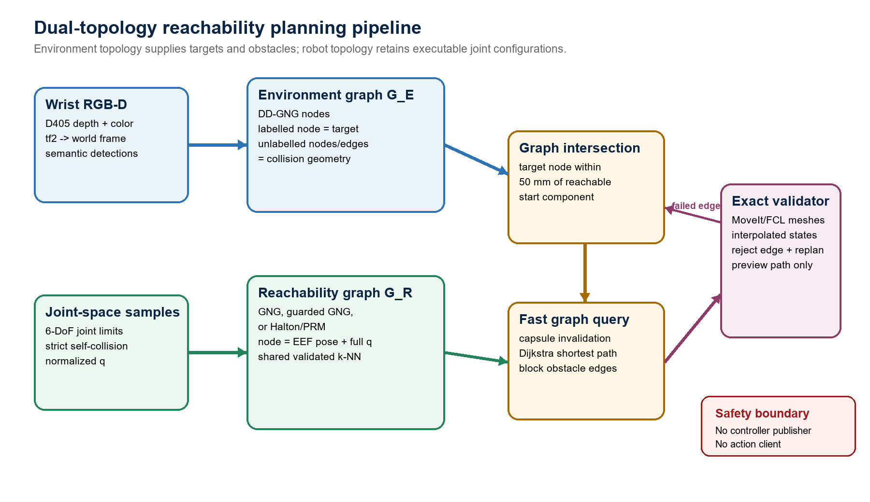
Fig. 1. Dual-topology pipeline. Environment targets intersect configuration-retaining robot nodes; capsule invalidation precedes exact MoveIt/FCL route validation. Output is preview-only.

A. Environment and Robot Topologies
In the full system, a wrist-mounted RealSense D405 is deprojected with live depth intrinsics and transformed into the world frame at the image timestamp. DD-GNG maintains stable three-dimensional nodes, semantic class, confidence, and edges. Target-labelled nodes are goal hypotheses; other nodes and segments become collision geometry, except for a small exclusion region around the selected target. Perception and reachability run as separate ROS 2 processes so roadmap experiments can be isolated from the camera and hardware interfaces. The present benchmark injects a synthetic target and obstacle and therefore does not evaluate DD-GNG perception.

B. Three Equal-Budget Roadmaps
Valid configurations are first generated within URDF limits and rejected on failed forward kinematics or strict self-collision. Pure GNG is trained on 4000 valid normalized signals, grows prototypes toward the node cap, and maps prototypes back to physical joint configurations. Halton/PRM accepts deterministic low-discrepancy valid configurations directly. Both are subsequently connected by the same k-NN stage.
Guarded GNG reserves 75% of the same 800-node budget for deterministic raw valid samples selected by stratified indices across the valid-sample stream; the remainder is populated by GNG prototypes. In the tested construction this is approximately two fixed anchors, 599 guards, and 199 prototypes. Duplicate filtering can shift the category count, but the final node cap remains identical. Guarded and pure GNG inspect a 4000-candidate pool, whereas Halton/PRM accepts only enough candidates to fill its graph; the methods are node-budget matched, not sample- or compute-budget matched. The 75% fraction was selected only on a development set and was frozen before held-out evaluation.

C. Cached Broad Phase and Exact Replanning
Each roadmap node and interpolated edge stores capsules spanning the moving arm, end effector, fingers, and camera payload. After an environment update, point-to-segment and segment-to-segment distances mark blocked nodes and edges without rebuilding the roadmap.
blocked(c,o) iff distance(axis(c),o) < radius(c)+clearance (3)
The surviving route is checked against robot meshes and environment spheres/cylinders in a MoveIt PlanningScene using FCL. States are interpolated at normalized-joint step 0.05. If an exact check rejects an edge, that edge is disabled for the current environment and Dijkstra search repeats, up to twenty times. This is a discrete obstacle-update planner: it does not predict continuous obstacle motion.

V. Implementation and Experimental Design
The C++ implementation runs on ROS 2 Humble on the robot's AGX computer. MoveIt RobotModel/RobotState provide kinematics and collision state; PlanningScene and FCL validate detailed geometry. Each benchmark process ran in an isolated ROS domain, published a synthetic joint state, and never launched MoveGroup, ros2_control, the camera, a controller publisher, or a trajectory action client.
Table I. Fixed roadmap and query parameters.
Parameter | Value | Role
Roadmap nodes | 800 | Equal final node budget for all methods
GNG training signals | 4000 | Valid normalized configurations
Guard fraction | 0.75 | Frozen after development ablation
Neighbour candidates | 10 | Shared k-NN connection stage
Max normalized q distance | 0.75 | Reject long local connections
Max Cartesian edge length | 0.14 m | Restrict end-effector displacement
Target intersection radius | 0.05 m | Environment-to-robot overlap
Obstacle clearance | 0.035 m | Capsule broad-phase margin
Body / exact step | 0.08 / 0.05 | Cached sweep / exact interpolation
Environment radii | 0.012 / 0.006 m | Node sphere / edge cylinder
Maximum exact replans | 20 | Bound edge removal and re-search

A. Development and Held-Out Protocol
A matched development benchmark on deterministic offsets 0–49 exposed eight obstacle-update failures for pure GNG (offsets 6, 9, 16, 18, 35, 37, 44, and 47). Start and target were privileged anchor nodes inserted before sampling. Geometric diagnosis showed that the anchored home target node was always removed by the synthetic midpoint point obstacle: its minimum capsule margin was -6.04 mm, whereas the start state was only +0.119 mm outside the broad-phase threshold. Success therefore required an alternative node within the 50 mm target-intersection ball. The selected failure set was used only to choose the guard fraction; it was not reused for held-out claims.
Table II. Development-only guard-fraction ablation on the eight selected pure-GNG failure offsets.
Construction | Success | Interpretation
Pure GNG (0%) | 0/8 | Development failure set by definition
Guarded GNG (10%) | 1/8 | Insufficient local support
Guarded GNG (25%) | 4/8 | Partial recovery
Guarded GNG (50%) | 7/8 | One remaining failure
Guarded GNG (75%) | 8/8 | Selected and then frozen
Held-out offsets 50–99 then generated 50 matched blocks, each containing all three methods with the same anchored target, fixed midpoint obstacle, Halton offset, node cap, and validity rules. All six method orders were cycled, but 50 is not divisible by six, leaving a small position imbalance. This produced 150 roadmap builds, 150 clear-scene queries, and 150 obstacle-update queries. Clear-scene success was 150/150. The result and exact-valid flags agreed on every query; exact-valid is the reported success criterion.

B. Statistical Analysis
Obstacle-update success was the primary outcome. We report Wilson binomial intervals, Cochran's Q across the three paired methods, paired-bootstrap risk-difference intervals, and exact McNemar tests for the two prespecified guarded-GNG comparisons with Holm correction. Continuous paired outcomes use bootstrap intervals and Wilcoxon signed-rank tests with Holm correction within each metric; rank-biserial correlation reports paired effect direction. Timing after obstacle update is compared only on jointly successful offset pairs to avoid changing the analysis population by method. Medians and interquartile ranges are primary descriptive summaries because timing distributions are skewed. An exact sign test was used as a sensitivity check where Wilcoxon symmetry was questionable.

VI. Held-Out Results
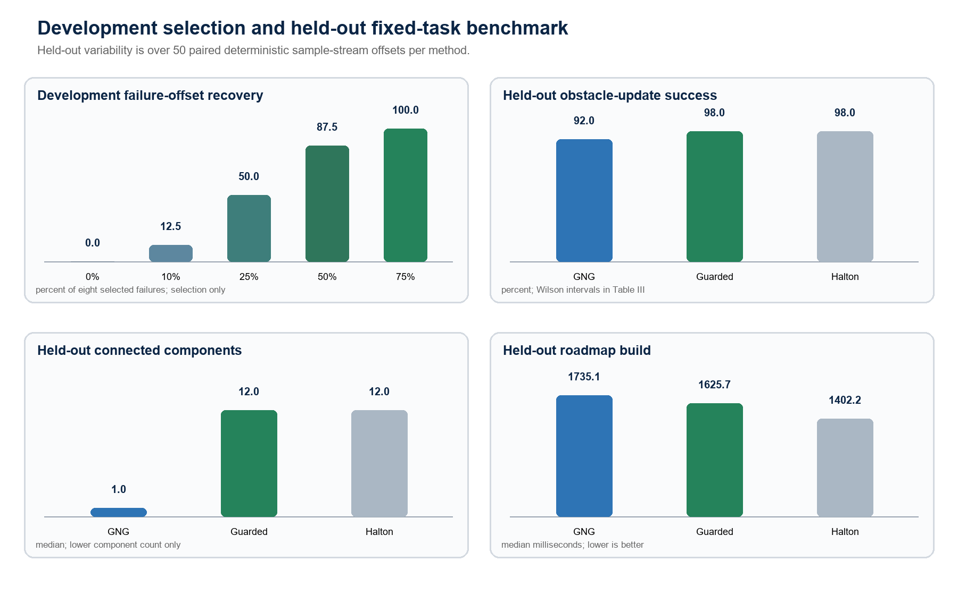
Fig. 2. Development selection and held-out fixed-task results. The left panel is conditional on eight selected GNG failures and is not confirmatory. Held-out panels summarize deterministic offsets 50–99; success intervals and paired contrasts appear in Tables III–IV.
Table III. Held-out benchmark across 50 matched deterministic sample-stream offsets. Continuous outcomes are median [IQR].
Metric | GNG | Guarded GNG | Halton/PRM
Obstacle-update success | 46/50 (92%) | 49/50 (98%) | 49/50 (98%)
Wilson 95% CI | 81.2–96.8% | 89.5–99.6% | 89.5–99.6%
Connected components | 1 [1, 2] | 12 [10, 13] | 12 [10, 14]
Validated edges | 4541 [4516, 4567] | 3627 [3571, 3667] | 3257 [3233, 3278]
Build time (ms) | 1735.14 [1715.49, 1745.79] | 1625.67 [1604.22, 1645.90] | 1402.22 [1382.43, 1418.06]
Clear query (ms) | 3.088 [2.892, 3.341] | 2.936 [2.761, 3.234] | 3.348 [3.006, 4.615]
Obstacle query (ms)* | 19.233 [16.036, 25.165] | 18.556 [15.748, 27.415] | 26.554 [17.829, 37.446]
Successful runs with >=1 replan | 1/46 | 4/49 | 7/49
Total exact replans | 2 | 8 | 12
*Each method's successful queries only (n=46, 49, and 49); these marginal summaries are not directly comparable. Pairwise timing inference uses only jointly successful offsets.
Table IV. Prespecified guarded-GNG paired effects on held-out offsets. Differences are guarded minus comparator with paired-bootstrap 95% CIs; success uses exact McNemar Holm correction across the two primary contrasts, while continuous Wilcoxon p-values are Holm-adjusted within metric.
Outcome | Comparator | Guarded minus comparator (95% CI) | n | Holm p
Success risk difference | GNG | +6 pp [-2, 14] | 50 | .750
Success risk difference | Halton | 0 pp [-6, 6] | 50 | 1.000
Components | GNG | +10.60 [9.76, 11.48] | 50 | <.001
Components | Halton | -0.06 [-1.28, 1.18] | 50 | .768
Build time (ms) | GNG | -108.18 [-129.29, -87.60] | 50 | <.001
Build time (ms) | Halton | +224.43 [206.08, 242.70] | 50 | <.001
Clear query (ms) | GNG | -0.267 [-0.551, -0.011] | 50 | .091
Clear query (ms) | Halton | -0.732 [-1.035, -0.446] | 50 | <.001
Obstacle query (ms) | GNG | +2.734 [-0.716, 6.717] | 45 | .134
Obstacle query (ms) | Halton | -3.626 [-7.228, 0.148] | 48 | .125

A. Primary Outcome
The global success test did not reject equality across methods (Cochran Q(2)=3.00, p=.223). Guarded GNG succeeded on three more offsets than pure GNG, with discordant outcomes 4:1, but the paired interval included both a small loss and a meaningful gain. Against Halton/PRM, discordances were 1:1. The data therefore support feasibility and a promising point estimate, not superiority. Failures were target_intersection_blocked_or_disconnected: offsets 70, 76, 93, and 95 for GNG; offset 69 for guarded GNG; and offset 96 for Halton/PRM.

B. Connectivity, Cost, and Lazy Exact Validation
Pure GNG formed approximately one to two large components and 1285 more edges than Halton/PRM on average. Guarding increased raw low-discrepancy support but raised the component count by 10.60 relative to GNG, making it statistically indistinguishable from Halton/PRM on this measure. Guarded GNG built 108 ms faster than pure GNG but 224 ms slower than Halton/PRM. Thus the 75% guard behaves as a hybrid tilted strongly toward local sample support and relinquishes pure GNG's low-component-count characteristic.
The exact-rejection branch was exercised: pure GNG required exact replanning in one held-out offset (two rejected edges), guarded GNG in four offsets (eight events), and Halton/PRM in seven offsets (twelve events). These paths ultimately validated, showing that capsule filtering and exact mesh checking are not redundant. Obstacle-update timing differences for guarded GNG were inconclusive against both comparators on jointly successful offsets.

VII. Discussion and Limitations
The central result is that global component count and obstacle-conditioned local target support are different objectives. GNG prototypes efficiently connect the dominant valid-configuration distribution, yet may underrepresent a small target neighbourhood after the nominal target branch is pruned. Deterministic guards recover local alternatives but fragment the graph under the present shared edge thresholds. Because workspace coverage and dispersion were not measured, broader coverage claims remain a hypothesis. A stronger next method should preserve selected GNG adjacency, add multiple target anchors at query time, or repair disconnected guard nodes toward the start component rather than increasing the guard fraction globally.
Limitation | Implication / next experiment
Scene generalization | All held-out offsets share one anchored start, target, midpoint point obstacle, and clearance geometry. Offsets measure construction variability, not generalization across tasks or scenes.
Development selection | The 75% fraction was chosen on eight observed GNG failures. It is cleanly separated from offsets 50–99, but additional held-out scenes are needed before fixing it as a general default.
Budget fairness | Methods have equal nodes and shared local rules, but not equal candidate information, edge counts, build time, or collision-check workload. Future comparisons should include node-, edge-, candidate-, and wall-clock-matched budgets.
Stress geometry | The anchored home target is always broad-phase blocked, making the query intentionally dependent on a nearby alternative. A task matrix must include clear, narrow-passage, edge-only, and target-adjacent obstacles.
Perception | The benchmark uses synthetic graph primitives and does not measure depth noise, semantic error, DD-GNG update delay, or transform uncertainty.
Baselines | RRTConnect, PRM*, SPARS, and topology-repair variants are not yet included under matched collision and time budgets.
Timing | One clear and one obstacle-update query were timed per build under normal AGX background load; method-position counts were slightly imbalanced. Repeated within-build timing and controlled load are needed.
Implementation fidelity | Pure GNG trains 800 prototypes before two are truncated by fixed anchors, and the runner records requested rather than echoed runtime parameters. Correct these issues and rerun before submission.
Deployment default | The evaluated 75%-guarded configuration is explicit benchmark input; the package default remains pure GNG with a different guard fraction. Deployment claims must state the effective runtime parameters.
Provenance | The benchmark source is hashed but remains based on a dirty parent worktree. Archive a commit/tag plus URDF, SRDF, MoveIt/FCL, compiler, and dependency versions.
Execution and safety | No physical trajectory was sent. Velocity, acceleration, torque, controller tracking, calibration error, emergency-stop procedure, and human-safe trials remain unevaluated.
Immediate ICRA-critical next experiment: Freeze the algorithms and evaluate a preregistered matrix of unseen start-target pairs and obstacle scenes. Use independent scrambled streams with paired offsets within each scene, include RRTConnect and a sparse-roadmap baseline, report success as the primary endpoint, and separate construction, invalidation, graph-search, and exact-validation time. Only then add controlled physical executions.

VIII. Conclusion
This work presents a dual-topology, preview-only reachability planner with configuration-retaining robot nodes, semantic environment targets, cached capsule invalidation, and lazy MoveIt/FCL edge rejection. Across 50 paired held-out deterministic offsets, a 75%-guarded GNG construction raised the obstacle-update success point estimate from 92% to 98% and matched Halton/PRM, but neither paired comparison was statistically significant. Pure GNG retained a much lower component count, while guarded GNG became structurally similar to the low-discrepancy baseline. The defensible fixed-task conclusion is a target-robustness–connectivity hypothesis, not general coverage or method superiority. The next research step is not more tuning on these offsets, but topology-aware repair and evaluation on unseen multi-scene tasks under matched computational budgets.

References
[1] B. Fritzke, 'A Growing Neural Gas Network Learns Topologies,' in Advances in Neural Information Processing Systems 7, pp. 625–632, 1995.
[2] L. E. Kavraki, P. Svestka, J.-C. Latombe, and M. H. Overmars, 'Probabilistic Roadmaps for Path Planning in High-Dimensional Configuration Spaces,' IEEE Transactions on Robotics and Automation, vol. 12, no. 4, pp. 566–580, 1996, doi: 10.1109/70.508439.
[3] M. S. Branicky, S. M. LaValle, K. Olson, and L. Yang, 'Quasi-Randomized Path Planning,' in Proc. IEEE International Conference on Robotics and Automation, pp. 1481–1487, 2001, doi: 10.1109/ROBOT.2001.932820.
[4] F. Zacharias, C. Borst, and G. Hirzinger, 'Capturing Robot Workspace Structure: Representing Robot Capabilities,' in Proc. IEEE/RSJ International Conference on Intelligent Robots and Systems, pp. 3229–3236, 2007, doi: 10.1109/IROS.2007.4399105.
[5] O. Porges, T. Stouraitis, C. Borst, and M. A. Roa, 'Reachability and Capability Analysis for Manipulation Tasks,' in ROBOT2013: First Iberian Robotics Conference, pp. 703–718, 2014, doi: 10.1007/978-3-319-03653-3_50.
[6] R. Bohlin and L. E. Kavraki, 'Path Planning Using Lazy PRM,' in Proc. IEEE International Conference on Robotics and Automation, pp. 521–528, 2000, doi: 10.1109/ROBOT.2000.844107.
[7] M. Kallmann and M. J. Mataric, 'Motion Planning Using Dynamic Roadmaps,' in Proc. IEEE International Conference on Robotics and Automation, pp. 4399–4404, 2004, doi: 10.1109/ROBOT.2004.1302410.
[8] L. Jaillet and T. Simeon, 'A PRM-Based Motion Planner for Dynamically Changing Environments,' in Proc. IEEE/RSJ International Conference on Intelligent Robots and Systems, pp. 1606–1611, 2004, doi: 10.1109/IROS.2004.1389625.
[9] A. Dobson and K. E. Bekris, 'Sparse Roadmap Spanners for Asymptotically Near-Optimal Motion Planning,' International Journal of Robotics Research, vol. 33, no. 1, pp. 18–47, 2014, doi: 10.1177/0278364913498292.
[10] M. Phillips, B. Cohen, S. Chitta, and M. Likhachev, 'E-Graphs: Bootstrapping Planning with Experience Graphs,' in Robotics: Science and Systems VIII, 2012, doi: 10.15607/RSS.2012.VIII.043.
[11] D. Coleman, I. A. Sucan, M. Moll, K. Okada, and N. Correll, 'Experience-Based Planning with Sparse Roadmap Spanners,' in Proc. IEEE International Conference on Robotics and Automation, pp. 900–905, 2015, doi: 10.1109/ICRA.2015.7139284.
[12] B. Ichter, J. Harrison, and M. Pavone, 'Learning Sampling Distributions for Robot Motion Planning,' in Proc. IEEE International Conference on Robotics and Automation, pp. 7087–7094, 2018, doi: 10.1109/ICRA.2018.8460730.
[13] A. H. Qureshi, A. Simeonov, M. J. Bency, and M. C. Yip, 'Motion Planning Networks,' in Proc. IEEE International Conference on Robotics and Automation, pp. 2118–2124, 2019, doi: 10.1109/ICRA.2019.8793889.
[14] C. Chamzas, Z. Kingston, C. Quintero-Pena, A. Shrivastava, and L. E. Kavraki, 'Learning Sampling Distributions Using Local 3D Workspace Decompositions for Motion Planning in High Dimensions,' in Proc. IEEE International Conference on Robotics and Automation, pp. 1283–1289, 2021, doi: 10.1109/ICRA48506.2021.9561104.
[15] D. Coleman, I. A. Sucan, S. Chitta, and N. Correll, 'Reducing the Barrier to Entry of Complex Robotic Software: a MoveIt! Case Study,' Journal of Software Engineering for Robotics, vol. 5, no. 1, pp. 3–16, 2014, doi: 10.6092/JOSER_2014_05_01_p3.
[16] J. Pan, S. Chitta, and D. Manocha, 'FCL: A General Purpose Library for Collision and Proximity Queries,' in Proc. IEEE International Conference on Robotics and Automation, 2012, doi: 10.1109/ICRA.2012.6225337.

