Configuration-Retaining Reachability Roadmaps for Dual-Topology Manipulation under Environment Updates
[AUTHOR NAME], [CO-AUTHOR NAME], and [SUPERVISOR NAME]
[Laboratory / Department / University], [City, Country] | [corresponding@email]
Draft status — pre-confirmatory: Updated 24 August 2026. The 50-offset anchored benchmark and the six-stream multi-scene smoke are development evidence only. The frozen 60-stream × 60-scene confirmatory evaluation has not yet been executed; no final superiority claim is made in this draft.

Abstract
We present a preview-only manipulation-planning architecture that intersects two topological representations: an environment graph containing semantic targets and obstacle primitives, and a robot reachability graph whose nodes retain complete six-joint configurations. Candidate routes are first filtered using cached swept-body capsules and then validated at interpolated states with MoveIt/FCL; rejected edges are disabled within the current query and graph search repeats. We compare three 800-node constructions under shared connection and collision rules: a Growing Neural Gas (GNG)-quantized k-nearest-neighbour roadmap, a guarded hybrid containing 199 GNG prototypes and 599 deterministic low-discrepancy samples in addition to two anchors, and a Halton/PRM baseline. A controller-free development smoke spanning six streams and six scenes passed all integrity checks and produced dynamic exact-valid success in 17/36, 26/36, and 28/36 queries, respectively. These small-sample values are descriptive only. Before outcome collection, we froze a paired evaluation over 60 roadmap streams and 30 base trajectories crossed with point and segment obstacles, totaling 180 graph builds and 21,600 atomic clear/dynamic queries. The primary endpoint is dynamic exact-valid success, with whole-stream bootstrap intervals, studentized stream-level sign-flip tests, and Holm correction for two prespecified guarded-GNG contrasts. The contribution at this stage is a reproducible system and evaluation contract; method superiority, perception robustness, and physical execution remain open until the frozen study is completed.
Keywords — reachability roadmap, Growing Neural Gas, low-discrepancy sampling, manipulation planning, collision checking, ROS 2

I. Introduction
A target observed in Cartesian space is not automatically executable. Several inverse-kinematic branches can reach similar end-effector positions, but only some branches connect collision-free to the measured arm configuration. Capability maps summarize workspace access [4], [5], whereas probabilistic roadmaps amortize configuration-space search [2]. A manipulation system driven by an evolving RGB-D scene requires both ideas: semantic target selection in workspace and persistent, validated connectivity in configuration space.
We study a dual-topology architecture. The environment topology G_E represents target-labelled nodes and obstacle-bearing nodes or edges. The robot topology G_R represents collision-valid joint configurations, their end-effector poses, and validated local transitions. A scene target becomes actionable only when an overlapping robot node lies in the component connected to the current configuration. The implementation emits a trajectory preview on a private topic and deliberately exposes neither a controller publisher nor a FollowJointTrajectory action client.
The initial motivation was to use GNG to learn a useful configuration-space topology. Implementation audit showed that the present planner retains GNG prototypes but discards the learned GNG adjacency before rebuilding all methods with a shared validated k-nearest-neighbour rule. We therefore call the method a GNG-quantized PRM, not a topology-preserving GNG planner. This distinction is central to the research claim and to the design of the baselines.
This pre-confirmatory manuscript contributes:
- A typed dual-topology planning architecture that keeps full robot configurations and multiple kinematic branches behind end-effector positions.
- A two-stage obstacle-update mechanism combining cached full-body capsule sweeps with lazy, interpolated MoveIt/FCL validation and within-query edge rejection followed by graph re-search.
- An auditable guarded-GNG construction with exact node-composition telemetry under a fixed 800-node budget.
- A provenance-bound, controller-free multi-scene benchmark and a frozen confirmatory analysis contract that separates development, smoke, and final evidence.

II. Related Work

A. Roadmaps, Low-Discrepancy Sampling, and GNG
PRM separates roadmap construction from repeated online queries [2]. Halton sequences provide deterministic low-discrepancy coverage alternatives to pseudorandom sampling [3]. GNG incrementally learns prototypes and adjacency from an input distribution [1]. The comparison holds final node count, joint limits, local-connection rules, and collision predicates constant while varying node generation; it does not hold candidate information, edge count, collision workload, or wall-clock budget constant. Because learned GNG edges are not retained, our claims concern adaptive quantization rather than Fritzke's complete topology-learning algorithm.

B. Reachability and Experience Representations
Capability and reachability maps summarize where a manipulator can act [4], [5]. Sparse roadmap spanners limit graph growth while preserving useful paths [9], and E-Graphs or Thunder reuse prior planning experience [10], [11]. Our graph is closer to a persistent configuration-space roadmap than to a binary reachability volume: multiple nodes may share nearby end-effector positions while retaining distinct joint branches and transitions. It currently provides no asymptotic optimality or completeness guarantee.

C. Dynamic Environments and Sampling Bias
Lazy PRM postpones expensive checks until query time [6]. Dynamic Roadmaps cache environment-to-roadmap influence [7], and changing-environment PRM variants invalidate affected regions [8]. Our cached capsules serve as a conservative broad phase before exact FCL validation. Learned sampling can focus computation but can underrepresent rare useful regions; mixing learned and globally supportive samples is a common hedge against concentration [12]–[14]. Guarded GNG is one deterministic hybrid, not a probabilistic-completeness claim.

III. Problem Formulation
Let Q be the six-dimensional joint-limit box and Q_free the configurations accepted by kinematic and collision validity predicates. Robot node v_i stores joint vector q_i, its range-normalized form, and end-effector pose x_i=FK(q_i). Normalization prevents joints with wider numerical ranges from dominating neighbour selection.
d_Q(q_i,q_j) = sqrt( sum_k ((q_i,k-q_j,k)/(q_k^max-q_k^min))^2 ) (1)
The world-frame environment graph G_E=(V_E,E_E) partitions semantic target candidates T from point or segment obstacles O. Given target t and measured start q_s, the planner searches unblocked robot nodes within Cartesian radius r_I that belong to the start component.
I(t) = {v_i in V_R | ||p_i-p_t||_2 <= r_I, free(v_i), connected(v_i,v_start)} (2)
Dijkstra search minimizes accumulated roadmap cost to a candidate in I(t). A preview is exact-valid only when every interpolated state passes detailed robot and environment collision checks. Time parameterization, dynamics, controller tracking, and moving-obstacle prediction are outside the current interface.

IV. System and Roadmap Construction
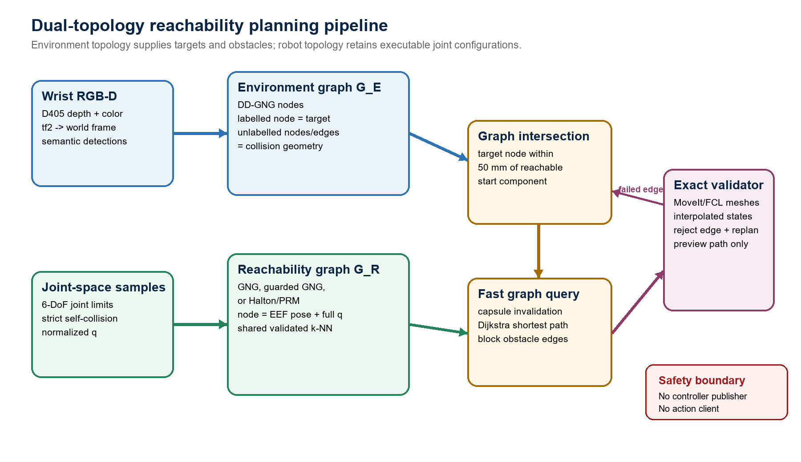
Fig. 1. Dual-topology pipeline. Environment targets intersect configuration-retaining robot nodes; cached capsule invalidation precedes lazy MoveIt/FCL route validation. Output remains preview-only.

A. Environment and Robot Topologies
In the full system, a wrist-mounted RealSense D405 supplies a world-frame point cloud to DD-GNG. Stable environment nodes retain position, semantic class, confidence, and edges. Target-labelled nodes become goal hypotheses; non-target nodes and segments become collision primitives, with a small exclusion around the selected target. Perception and reachability are separate ROS 2 processes, so the roadmap benchmark can run without opening the camera or launching hardware interfaces. The experiments in this draft inject synthetic, oracle-validated environments and do not evaluate perception.

B. Three Node-Budget-Matched Roadmaps
All constructions begin with two fixed anchors and end at exactly 800 nodes. Pure GNG is trained from 4,000 valid normalized configurations and retains 798 prototypes. Guarded GNG retains 199 prototypes and adds 599 deterministic raw valid samples selected across the same candidate stream. Halton/PRM adds 798 digit-permuted Halton samples directly. Every method then uses the same validated k-NN connection stage. Runtime telemetry reports anchor, prototype-budget, retained-prototype, requested-guard, retained-guard, fill, training-sample, candidate-attempt, edge, and component counts.
The comparison is node-budget matched but not candidate-information- or compute-budget matched: both GNG variants inspect 4,000 accepted training configurations, whereas Halton fills its graph directly. The 75% guard fraction was selected on development failures and is frozen for confirmatory evaluation; it is not inferred as a generally optimal mixture.

C. Cached Broad Phase and Exact Replanning
Roadmap nodes and interpolated edges cache capsules spanning the arm, end effector, fingers, and camera payload. Environment updates use point-to-segment and segment-to-segment distances to invalidate candidates without rebuilding the roadmap.
blocked(c,o) iff distance(axis(c),o) < radius(c)+clearance (3)
A surviving route is reconstructed in a MoveIt PlanningScene and checked with FCL over interpolated states. If exact validation rejects an edge, the edge is disabled for that environment and Dijkstra search repeats, up to twenty times. The query response includes its scene, stream, method, graph revision, target, start state, validity flags, and diagnostic counters; stale or mismatched responses are rejected.

V. Implementation and Evaluation Contract
The ROS 2 Humble C++ implementation runs on the robot's NVIDIA Jetson AGX Orin. MoveIt RobotModel/RobotState provide kinematics and self-collision state; PlanningScene and FCL validate detailed meshes. Benchmark processes use isolated ROS domains with localhost-only discovery and launch neither MoveGroup, ros2_control, a camera process, nor a controller endpoint. Preflight checks require clean domains and exactly one expected graph publisher, plan publisher, and query subscriber.

Table I. Frozen roadmap and query parameters.
Parameter | Value | Role
Roadmap nodes / GNG signals | 800 / 4000 | Fixed nodes; accepted GNG training configurations
Guard fraction / composition | 0.75 | Two anchors + 199 prototypes + 599 guards
k-NN candidates / max d_Q | 10 / 0.75 | Shared local connection rule
Max Cartesian edge / target radius | 0.14 / 0.05 m | Local displacement / graph intersection
Clearance / environment radii | 0.035 / 0.012 / 0.006 m | Capsule margin / point / segment
Body step / exact step / replans | 0.08 / 0.05 / 20 | Cached sweep / exact interpolation / search bound

A. Evidence Ladder
Development proceeded in three explicitly separated stages. First, offsets 0–49 exposed eight pure-GNG failures and were used to select the 75% guard fraction. Second, offsets 50–99 evaluated one anchored start-target task; although held out from fraction selection, these data subsequently informed instrumentation and study design and are therefore treated as development evidence for the final paper. Third, a six-stream, six-scene integration smoke exercised atomic multi-scene queries, provenance, correlation, and analysis plumbing. Neither stage is pooled with the frozen confirmatory run.
Table II. Evidence stages and permitted interpretation.
Stage | Scale | Purpose | Claim boundary
Guard selection | 8 selected failures | Choose 0.75 fraction | Selection only
Anchored offsets | 150 builds; 300 queries | Diagnose one fixed task | Development evidence
Multi-scene smoke | 18 builds; 216 queries | Validate pipeline | Descriptive only
Frozen confirmatory | 180 builds; 21,600 queries | Test two hypotheses | Results pending

B. Frozen Multi-Scene Design
Catalog om6dof_icra_scene_catalog_v1 contains 30 deterministic base start-target trajectories crossed with point and segment obstacles. Within each pair, start joints, target source joints, and target position are identical. Normalized joint distance defines ten low-, ten medium-, and ten high-difficulty bases. An independent oracle accepts a scene only when the clear direct interpolation is valid, the dynamic obstacle blocks that interpolation under both capsule and exact checks, endpoints and a detour state remain valid, and the two-leg detour is collision-free.
Roadmap stream labels 100–159 are fixed deterministic digit-permuted Halton stream keys, not ordinary random seeds. The six method orders occur ten times each. Scene order is rotated identically across methods, and clear/dynamic phase order is parity-counterbalanced. Each query atomically includes start state, target, complete environment, scene ID, and query ID. The design yields 60 streams × 3 methods × 60 scenes × 2 phases = 21,600 queries.

C. Confirmatory Statistical Plan
The primary endpoint is dynamic-scene exact-valid success. For each guarded-versus-baseline pair, the method difference is averaged over the fixed 60-scene catalog within stream, then averaged over 60 streams. Only guarded GNG minus pure GNG and guarded GNG minus Halton/PRM are confirmatory; Holm correction covers exactly these two hypotheses.
d_s = (1/60) sum_j (Y_guarded,s,j - Y_baseline,s,j); Delta = (1/60) sum_s d_s (4)
Uncertainty uses 50,000 paired whole-stream bootstrap resamples with shared indices across contrasts. A two-sided studentized sign-flip permutation test flips the complete 60-scene method-difference vector per stream for 100,000 Monte Carlo draws. The interval is conditional on the frozen catalog; it does not imply unrestricted scene-population generalization. Build time uses all paired streams, while success-conditional latency and cost use only joint-success cells. Path-change comparisons require common clear-and-dynamic success for both methods.

VI. Current Development Evidence
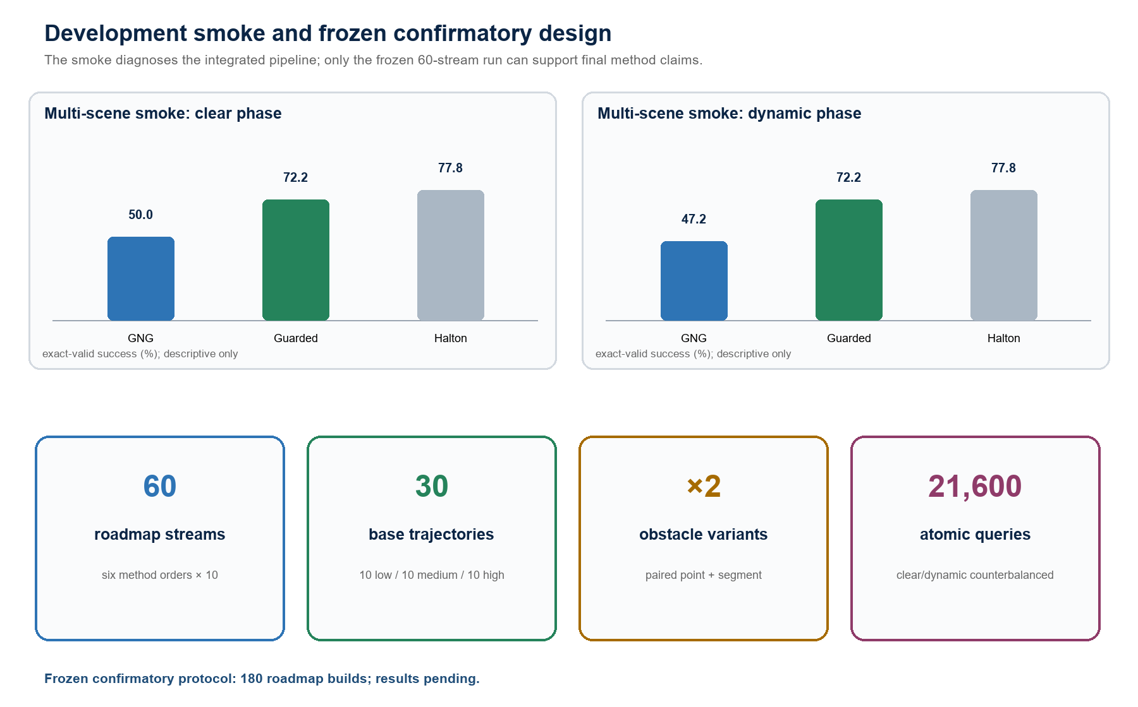
Fig. 2. Multi-scene development smoke and the frozen confirmatory scale. Smoke outcomes are descriptive only; confirmatory outcomes are pending.
Table III. Development-only multi-scene smoke; six streams × six scenes. Values are descriptive.
Method | Clear exact-valid | Dynamic exact-valid | Retention | Build ms, median [IQR]
GNG | 18/36 (50.0%) | 17/36 (47.2%) | 17/18 (94.4%) | 1711.7 [1708.6, 1722.1]
Guarded GNG | 26/36 (72.2%) | 26/36 (72.2%) | 26/26 (100%) | 1574.0 [1572.1, 1589.1]
Halton/PRM | 28/36 (77.8%) | 28/36 (77.8%) | 28/28 (100%) | 1382.8 [1368.0, 1393.1]
Integration smoke only: 18 graph builds and 216 phase queries under loaded-system conditions. Confidence intervals and p-values are not confirmatory evidence.

A. Multi-Scene Integration Smoke
The smoke used six roadmap streams and six scenes representing three base trajectories paired across point and segment obstacles. All 18 graph builds and 216 phase queries satisfied correlation, provenance, target/start echo, validity-agreement, and safety contracts, with no timeout or infrastructure-error row. The principal observation is not a method ranking, but that arbitrary multi-scene targets were markedly more difficult than the privileged anchored development task. Only six stream clusters were available, so the observed differences remain unstable diagnostics.

B. Development Interpretation
The original anchored benchmark diagnosed a local-support failure after its seeded target branch was blocked, and it motivated deterministic guards. The multi-scene smoke then showed that low global component count is not sufficient for arbitrary non-anchored targets. Together these stages motivate—but do not establish—the hypothesis that adaptive quantization can leave sparse support near some target regions while guards trade compact connectivity for local alternatives. The frozen study is designed to test that mechanism across heterogeneous tasks.
Confirmatory results placeholder: The frozen 60-stream × 60-scene run has not been executed. Replace this box with the two prespecified risk differences, 95% paired stream-cluster intervals, raw and Holm-adjusted permutation p-values, and descriptive subgroup results only after the provenance-bound run passes all contracts.

VII. Reproducibility, Safety, and Claim Boundaries
The candidate bundle freezes the protocol, catalog-generation contract, source snapshot, analyzer, and execution checklist before confirmatory outcomes. The curated source manifest, source snapshot, and protocol are bound by SHA-256; the runtime additionally checks exact expanded URDF, SRDF, parameter, launch, message, source, and node-binary hashes. Resume is fail-closed: only complete runs with an identical configuration and provenance may be skipped. Raw graphs, queries, logs, run configuration, catalog, source snapshot, and analysis outputs are copied into the result bundle and hashed.
Table IV. Frozen confirmatory safeguards.
Risk | Enforced safeguard
Method/config mislabelling | Runtime method, node composition, stream, start, target, and effective parameters must echo the request.
Stale ROS response | Atomic query IDs, scene IDs, revisions, method identity, and exact endpoint counts must match.
Domain contamination | Clean-domain preflight, localhost-only discovery, and exactly one expected publisher/subscriber.
Model drift | Actual expanded URDF, SRDF, parameter file, and node binary hashes must match the frozen catalog/bundle.
Unsafe actuation | Preview-only launch; no controller topic publisher or trajectory action client; benchmark domains are isolated.
Selective reruns | Partial or corrupt outputs fail closed; difficult scenes and streams cannot be deleted or retuned in protocol v1.

VIII. Discussion and Limitations
Development runs indicate that a low global component count is not sufficient for success on arbitrary non-anchored targets. The smoke motivates the hypothesis that adaptive quantization can leave sparse local support near some target regions, while deterministic guards may exchange compact connectivity for local alternatives under the shared edge thresholds. The frozen experiment tests whether that pattern persists across heterogeneous tasks; until those outcomes exist, it remains a mechanistic hypothesis rather than a performance conclusion.
Table V. Current claim boundaries and required follow-up experiments.
Limitation | Implication / next experiment
Confirmatory status | The 60-stream study is frozen but pending. Development and smoke outcomes cannot be promoted to final evidence.
Fixed catalog | Primary intervals condition on 30 deterministic base trajectories; unrestricted scene-population generalization is not claimed.
Synthetic environments | Oracle point/segment primitives do not measure depth noise, semantic error, DD-GNG drift, latency, or transform uncertainty.
Target representation | The current intersection emphasizes end-effector position; systematic orientation-constrained and task-space tolerance studies remain.
Budget fairness | Methods match final node count and local rules, not candidate information, edge count, collision-check workload, or wall-clock budget.
GNG fidelity | Only prototypes are retained; learned GNG adjacency is discarded. Topology-preserving or topology-repair variants require a separate method.
Baselines | RRTConnect, PRM*, SPARS, and repair-based roadmaps are not yet evaluated under matched collision and compute contracts.
Timing | Integration runs share AGX resources with background processes. Paper-grade timing needs fixed clocks, warm-up, temperature/load logs, and no unrelated high-CPU workload.
Physical execution | No trajectory is sent to hardware. Dynamics, calibration, controller tracking, emergency-stop procedures, and safe human-proximate trials remain unevaluated.
Immediate next milestone: Deploy the frozen candidate without changing protocol v1, regenerate and verify the 60-scene catalog on the AGX, run streams 100–159 in isolated domains, audit all 180 graph rows and 21,600 query rows, then insert confirmatory estimates into Section VI. Run controlled timing and physical validation as separate experiments.

IX. Conclusion
This work develops a dual-topology, preview-only reachability planner that connects semantic environment targets to configuration-retaining robot roadmaps and combines fast capsule invalidation with lazy exact MoveIt/FCL validation. The guarded-GNG hybrid addresses a failure mode in which a globally connected GNG-quantized roadmap lacks local alternatives near an obstacle-pruned target. Development diagnostics and the multi-scene smoke demonstrate pipeline feasibility and motivate the hypothesis, but do not establish superiority. The principal deliverable of this draft is therefore the implemented planner plus a frozen, provenance-bound 60-stream multi-scene evaluation contract. Final algorithmic claims depend on completing that experiment, followed by perception-in-the-loop and controlled physical validation.

References
[1] B. Fritzke, 'A Growing Neural Gas Network Learns Topologies,' in Advances in Neural Information Processing Systems 7, pp. 625–632, 1995.
[2] L. E. Kavraki, P. Svestka, J.-C. Latombe, and M. H. Overmars, 'Probabilistic Roadmaps for Path Planning in High-Dimensional Configuration Spaces,' IEEE Transactions on Robotics and Automation, vol. 12, no. 4, pp. 566–580, 1996, doi: 10.1109/70.508439.
[3] M. S. Branicky, S. M. LaValle, K. Olson, and L. Yang, 'Quasi-Randomized Path Planning,' in Proc. IEEE International Conference on Robotics and Automation, pp. 1481–1487, 2001, doi: 10.1109/ROBOT.2001.932820.
[4] F. Zacharias, C. Borst, and G. Hirzinger, 'Capturing Robot Workspace Structure: Representing Robot Capabilities,' in Proc. IEEE/RSJ International Conference on Intelligent Robots and Systems, pp. 3229–3236, 2007, doi: 10.1109/IROS.2007.4399105.
[5] O. Porges, T. Stouraitis, C. Borst, and M. A. Roa, 'Reachability and Capability Analysis for Manipulation Tasks,' in ROBOT2013: First Iberian Robotics Conference, pp. 703–718, 2014, doi: 10.1007/978-3-319-03653-3_50.
[6] R. Bohlin and L. E. Kavraki, 'Path Planning Using Lazy PRM,' in Proc. IEEE International Conference on Robotics and Automation, pp. 521–528, 2000, doi: 10.1109/ROBOT.2000.844107.
[7] M. Kallmann and M. J. Mataric, 'Motion Planning Using Dynamic Roadmaps,' in Proc. IEEE International Conference on Robotics and Automation, pp. 4399–4404, 2004, doi: 10.1109/ROBOT.2004.1302410.
[8] L. Jaillet and T. Simeon, 'A PRM-Based Motion Planner for Dynamically Changing Environments,' in Proc. IEEE/RSJ International Conference on Intelligent Robots and Systems, pp. 1606–1611, 2004, doi: 10.1109/IROS.2004.1389625.
[9] A. Dobson and K. E. Bekris, 'Sparse Roadmap Spanners for Asymptotically Near-Optimal Motion Planning,' International Journal of Robotics Research, vol. 33, no. 1, pp. 18–47, 2014, doi: 10.1177/0278364913498292.
[10] M. Phillips, B. Cohen, S. Chitta, and M. Likhachev, 'E-Graphs: Bootstrapping Planning with Experience Graphs,' in Robotics: Science and Systems VIII, 2012, doi: 10.15607/RSS.2012.VIII.043.
[11] D. Coleman, I. A. Sucan, M. Moll, K. Okada, and N. Correll, 'Experience-Based Planning with Sparse Roadmap Spanners,' in Proc. IEEE International Conference on Robotics and Automation, pp. 900–905, 2015, doi: 10.1109/ICRA.2015.7139284.
[12] B. Ichter, J. Harrison, and M. Pavone, 'Learning Sampling Distributions for Robot Motion Planning,' in Proc. IEEE International Conference on Robotics and Automation, pp. 7087–7094, 2018, doi: 10.1109/ICRA.2018.8460730.
[13] A. H. Qureshi, A. Simeonov, M. J. Bency, and M. C. Yip, 'Motion Planning Networks,' in Proc. IEEE International Conference on Robotics and Automation, pp. 2118–2124, 2019, doi: 10.1109/ICRA.2019.8793889.
[14] C. Chamzas, Z. Kingston, C. Quintero-Pena, A. Shrivastava, and L. E. Kavraki, 'Learning Sampling Distributions Using Local 3D Workspace Decompositions for Motion Planning in High Dimensions,' in Proc. IEEE International Conference on Robotics and Automation, pp. 1283–1289, 2021, doi: 10.1109/ICRA48506.2021.9561104.
[15] D. Coleman, I. A. Sucan, S. Chitta, and N. Correll, 'Reducing the Barrier to Entry of Complex Robotic Software: a MoveIt! Case Study,' Journal of Software Engineering for Robotics, vol. 5, no. 1, pp. 3–16, 2014, doi: 10.6092/JOSER_2014_05_01_p3.
[16] J. Pan, S. Chitta, and D. Manocha, 'FCL: A General Purpose Library for Collision and Proximity Queries,' in Proc. IEEE International Conference on Robotics and Automation, 2012, doi: 10.1109/ICRA.2012.6225337.

