Topology-Preserving End-Effector Reachability Roadmaps with Two-Stage Collision Validation
[AUTHOR NAME], [CO-AUTHOR NAME], and [SUPERVISOR NAME]
[Laboratory / Department / University], [City, Country] | [corresponding@email]
Draft status: Working manuscript based on the implementation and pilot data frozen on 24 August 2026. The current evaluation uses three deterministic seeds per method and is not yet an ICRA-ready statistical study.

Abstract
We present a dual-topology planning architecture for target-directed manipulation in which a learned environment graph is intersected with a configuration-aware end-effector reachability graph. The environment is represented by a Dynamic Density Growing Neural Gas (DD-GNG) graph built from wrist-mounted RGB-D observations; semantically labelled nodes act as target hypotheses, while unlabelled nodes and edges define obstacle geometry. The robot roadmap is learned in normalized six-dimensional joint space using Growing Neural Gas (GNG), while retaining the full joint configuration and end-effector pose at every node. Runtime updates first invalidate roadmap nodes and edges using cached swept-body capsules, then validate the shortlisted path against exact robot meshes and DD-GNG-derived geometry in a MoveIt/FCL PlanningScene. A rejected exact-collision edge is disabled and graph search is repeated. In a preliminary controller-free benchmark with 800 nodes and three seeds per method, GNG produced 2.0 +/- 1.0 connected components versus 12.0 +/- 3.46 for a matched Halton/PRM baseline. Mean clear-scene query time was 6.89 ms versus 13.14 ms, and dynamic-obstacle query time was 13.86 ms versus 35.19 ms. All twelve method-seed-scenario queries returned exact-validated preview paths. These results are promising but descriptive: the current pilot does not establish statistical significance, test the exact-rejection replan branch, or evaluate physical trajectory execution.
Keywords - reachability graph, Growing Neural Gas, manipulation planning, dynamic obstacles, collision checking, topological planning

I. Introduction
A manipulation system operating from live RGB-D observations must answer two coupled questions: where can the robot end effector reach, and which of those reachable configurations remain connected to the current arm state after the environment changes? Conventional single-query planners answer these questions jointly for each request, whereas roadmap methods amortize configuration-space exploration across multiple queries [2]. A persistent roadmap is attractive for interactive manipulation, but a Cartesian point alone is not an executable robot state: multiple inverse-kinematic branches may place the end effector at nearly the same position while belonging to different collision-free components.
This work investigates a dual-topology alternative. A perception topology G_E compresses the observed workspace into semantically labelled target nodes and obstacle-bearing nodes and edges. A robot topology G_R compresses valid joint configurations while retaining the complete configuration associated with each end-effector pose. A target becomes actionable only when its environment node lies within a tolerance of a reachable node that belongs to the component attached to the measured robot state. The output is deliberately a preview joint path rather than an execution command.
The current implementation makes three contributions:
- A configuration-retaining GNG reachability roadmap that learns the topology of valid normalized joint samples and preserves multiple inverse-kinematic branches at similar Cartesian locations.
- A fast environment-update mechanism that compares DD-GNG obstacle nodes and edges with cached swept capsules for the complete moving body, avoiding roadmap reconstruction after every perception update.
- A two-stage safety gate in which capsule-safe paths are interpolated and checked with MoveIt/FCL meshes; rejected roadmap edges are persisted for the current environment and Dijkstra search is repeated.
The preliminary evaluation compares GNG against an equal-budget deterministic Halton/PRM construction. The manuscript intentionally separates observed pilot evidence from planned evaluation.

II. Related Work

A. Sampling-Based Motion Planning
Probabilistic roadmaps (PRMs) preprocess collision-free configurations and feasible local connections, then answer subsequent queries through graph search [2]. Rapidly exploring random trees (RRTs) provide an influential single-query alternative with strong exploratory bias in high-dimensional spaces [3]. Our current baseline is a deterministic Halton/PRM variant because it shares the same node budget, k-nearest connection rule, edge interpolation, and collision predicate as the proposed GNG roadmap. RRTConnect remains a required baseline for the full study.

B. Growing Neural Gas and Topological Roadmaps
GNG incrementally introduces units and connections to learn topological relations in an input distribution [1]. Prior work has used GNG for topological environment maps [7] and topology-informed navigation roadmaps over uncertain occupancy maps [6]. In contrast, the present robot graph learns a distribution of valid manipulator joint configurations, stores the corresponding end-effector pose, and is intersected online with a separately learned RGB-D environment topology. This distinction is important: environment-space connectivity alone does not encode manipulator joint limits, self-collision, or disconnected inverse-kinematic branches.

C. Collision Checking in Manipulation
MoveIt provides a reusable planning architecture for complex robot systems [4], while the Flexible Collision Library (FCL) supplies collision and proximity queries over articulated and mesh geometry [5]. Exact geometry is valuable but expensive when applied indiscriminately to every roadmap edge after each environment update. Our design therefore uses conservative cached capsule sweeps as a broad phase and reserves mesh-level FCL validation for the shortlisted path.

III. Problem Formulation
Let Q be the six-dimensional joint-limit box and Q_free be the subset satisfying joint limits and strict self-collision constraints. Each robot-graph node v_i stores a normalized configuration q_i in Q_free, the physical joint vector, and a forward-kinematic end-effector pose x_i = FK(q_i). The normalization uses each joint range so that no joint dominates nearest-neighbour selection solely because of units or span.
d_Q(q_i,q_j) = sqrt( sum_k ((q_i,k - q_j,k)/(q_k^max-q_k^min))^2 ) (1)
The environment graph G_E = (V_E, E_E) is expressed in the world frame. A semantic label partitions V_E into target candidates T and obstacle samples O; unlabelled environment edges are treated as obstacle segments. For target t in T, the intersection candidate set contains robot nodes within radius r_I that remain unblocked and connected to the node attached to the measured configuration q_0.
I(t) = { v_i in V_R | ||p_i-p_t||_2 <= r_I, free(v_i), connected(v_i,v_start) } (2)
The planner selects a candidate in I(t) and minimizes accumulated roadmap edge cost using Dijkstra search. A plan is considered valid only when every interpolated state on the resulting route passes the exact second-stage collision test. The current system does not claim dynamic or kinodynamic feasibility because velocity, acceleration, torque, and closed-loop execution are outside the present preview interface.

IV. Method
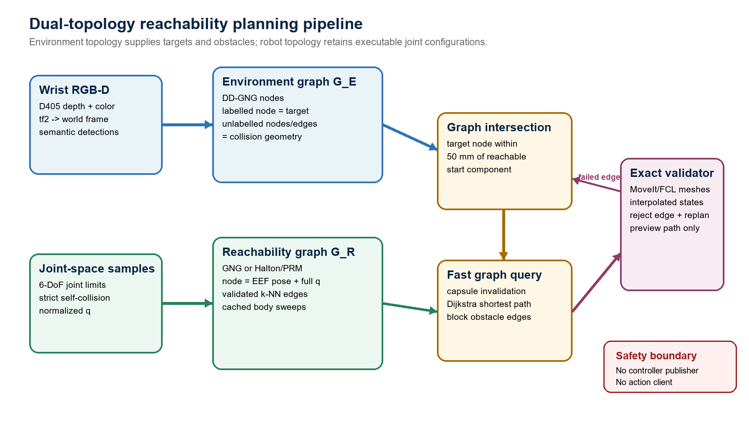
Fig. 1. Dual-topology pipeline. Environment and reachability graphs meet at a target intersection; capsule filtering precedes exact MoveIt/FCL validation. The output remains preview-only.

A. Environment Topology
A wrist-mounted Intel RealSense D405 provides aligned depth and colour. Depth samples are deprojected using live intrinsics and transformed into the world frame using tf2 at the frame timestamp. DD-GNG maintains a compact graph whose stable node identifiers, three-dimensional positions, semantic class, confidence, and edges are published as a typed ROS 2 message. Robot-body points are removed before graph learning using the same link capsule model used by the broad-phase planner. Semantically labelled nodes form target hypotheses; all other nodes and edges are collision geometry, except for a small exclusion region around the selected target.

B. Configuration-Aware GNG Roadmap
Candidate joint vectors are generated inside URDF limits and rejected if MoveIt forward kinematics fails or strict self-collision is detected. GNG is trained over normalized valid configurations and grows to the requested node budget. Each learned prototype is mapped back to physical joints and stores FK pose plus the complete six-joint vector. For the controlled baseline, a Halton sequence generates the same number of accepted nodes. Both methods then share an identical connection stage: ten nearest neighbours are considered, normalized joint distance is capped at 0.75, Cartesian end-effector separation is capped at 0.14 m, and every candidate edge is interpolated and collision checked.

C. Cached Full-Body Invalidation
For every roadmap node and edge, the system caches capsules spanning link2 through link7, the end effector, both fingers, and the D405 payload over interpolated configurations. The fixed-base link1 segment is omitted by default so that a known support surface does not invalidate the whole roadmap. After an environment update, point-to-segment and segment-to-segment distance tests mark blocked nodes and edges without repeating forward kinematics or reconstructing G_R.
blocked(c,o) iff distance(axis(c), o) < radius(c) + clearance (3)

D. Exact Mesh Validation and Replanning
The broad phase produces a candidate route. The environment graph is then materialized in a MoveIt PlanningScene: nodes become spheres and edges become cylinders aligned with their three-dimensional segments. The robot collision model includes the fused wrist bracket and D405 mesh. Every route edge is interpolated at a normalized-joint step of 0.05 and checked against the exact robot and environment geometry using FCL. On collision, the offending roadmap edge is disabled, Dijkstra search is repeated, and the process continues for at most twenty replans. Exact-blocked edges persist until the environment graph changes.
A valid plan message reports graph method, start and goal identifiers, blocked-node and blocked-edge counts, graph cost, planning time, exact state checks, exact replan count, exact-validation time, a joint-path preview, and an end-effector path. It does not publish to a FollowJointTrajectory controller or create a controller action client.

V. Implementation and Parameters
The implementation runs as ROS 2 Humble C++ nodes on the robot's AGX computer. MoveIt RobotModel/RobotState provide kinematics and self-collision checks; MoveIt PlanningScene and FCL provide exact environment collision checking. Perception and reachability are separate processes so the roadmap benchmark can run without opening the camera, MoveGroup, controller manager, or hardware interface. The live deployment at the data freeze used GNG with 800 nodes, 4518 edges, three connected components, and a measured build time of approximately 1.72 s.
Table I. Principal parameters used for the current pilot.
Parameter | Value | Role
Roadmap nodes | 800 | Equal node budget for GNG and Halton/PRM
GNG training samples | 4000 | Valid normalized joint-space signals
GNG epochs / insertion | 4 / 20 | Growth schedule
Neighbour candidates | 10 | Shared k-NN connection stage
Max normalized joint distance | 0.75 | Reject long local connections
Max Cartesian edge length | 0.14 m | Restrict EEF displacement
Target intersection radius | 0.05 m | Environment-to-robot graph overlap
Obstacle clearance | 0.035 m | Capsule broad-phase margin
Body interpolation step | 0.08 | Cached capsule edge sweep
Exact interpolation step | 0.05 | MoveIt/FCL route validation
Environment primitive radii | 0.012 / 0.006 m | Point spheres / edge cylinders
Maximum exact replans | 20 | Bound edge rejection and graph re-search
Source: current topo_gng.yaml configuration snapshot.

VI. Preliminary Evaluation

A. Questions and Protocol
The pilot asks whether a GNG-quantized roadmap improves connectivity and repeated query latency relative to an equal-size deterministic Halton/PRM baseline. For each method and seed, an isolated ROS domain launches only the reachability node, publishes a synthetic home joint state, selects a target at a known roadmap node, and records a clear-scene plan. It then inserts a synthetic obstacle on the original route and records the updated plan. The experiment uses seeds 0-2, yielding six roadmap builds and twelve planning queries. This design verifies repeatability and message instrumentation but is too small for inferential statistics.

B. Pilot Results
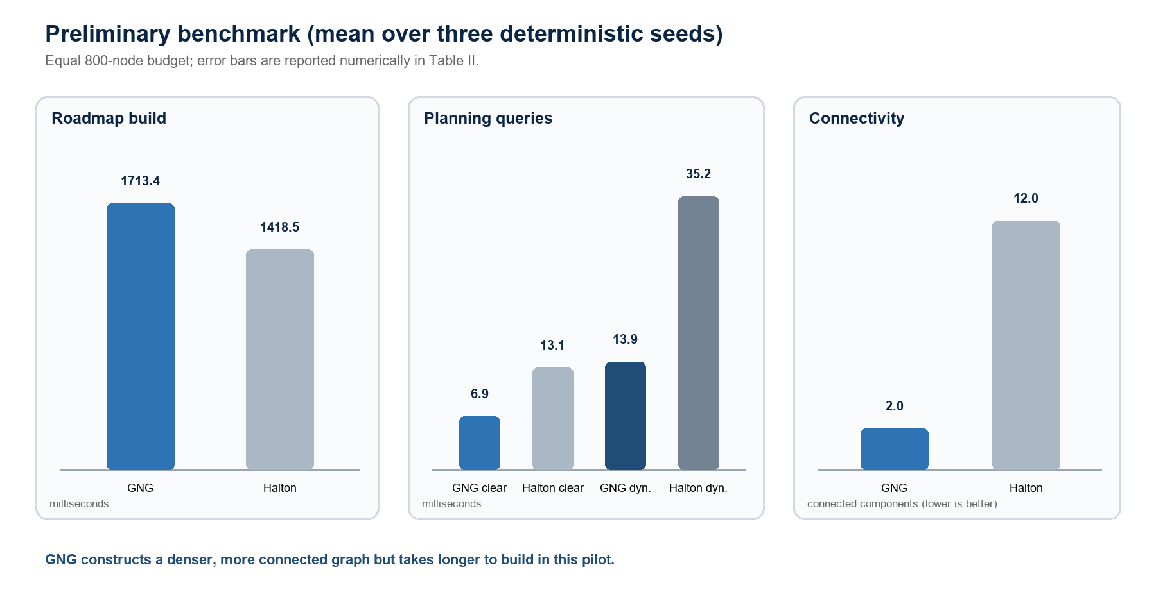
Fig. 2. Descriptive pilot means. GNG required more roadmap construction time but produced fewer connected components and lower query latency.
Table II. Pilot results, mean +/- sample standard deviation over three seeds.
Metric | GNG | Halton/PRM
Roadmap nodes | 800 | 800
Roadmap edges | 4541.7 +/- 29.6 | 3260.0 +/- 38.0
Connected components | 2.00 +/- 1.00 | 12.00 +/- 3.46
Build time (ms) | 1713.44 +/- 33.78 | 1418.50 +/- 28.22
Clear planning time (ms) | 6.89 +/- 1.02 | 13.14 +/- 5.99
Clear exact state checks | 250.0 +/- 40.7 | 322.0 +/- 58.8
Clear exact time (ms) | 5.41 +/- 0.78 | 11.90 +/- 5.69
Dynamic blocked nodes | 18.7 +/- 6.7 | 26.7 +/- 11.8
Dynamic blocked edges | 181.3 +/- 69.6 | 130.0 +/- 49.6
Dynamic planning time (ms) | 13.86 +/- 6.43 | 35.19 +/- 0.58
Dynamic exact state checks | 258.0 +/- 33.2 | 339.7 +/- 65.4
Dynamic exact time (ms) | 9.12 +/- 4.17 | 20.94 +/- 8.03
Clear / dynamic success | 3/3 / 3/3 | 3/3 / 3/3
Observed exact replans | 0 | 0
Source: reachability_benchmark_pilot_20260824.csv. These are descriptive pilot statistics; n = 3 roadmaps per method.
Under the equal node budget, GNG generated approximately 39% more validated edges and reduced the mean component count from 12 to 2. Its roadmap build was approximately 21% slower, consistent with an additional learning stage. In return, mean clear-scene query time was approximately 48% lower and mean dynamic-obstacle query time approximately 61% lower than Halton/PRM. GNG also required fewer exact state checks in both conditions. These comparisons are effect-size descriptions of the six-run pilot, not evidence of population-level superiority.
All twelve queries produced paths with exact_collision_valid=true. However, exact_replans remained zero: the injected obstacle was already conservative enough to be captured by the capsule broad phase. Consequently, the pilot confirms that exact validation runs on candidate trajectories but does not experimentally exercise the branch that rejects a capsule-safe edge and reruns Dijkstra.

VII. Limitations and Planned Evaluation
Gap | Required experiment or change
Statistical scale | Increase to at least 50 deterministic seeds per method and report confidence intervals, paired effect sizes, and nonparametric significance tests where justified.
Planner baselines | Add MoveIt/OMPL RRTConnect and, if computationally feasible, PRM* using the same collision model, start-goal pairs, and wall-clock limits.
Exact-replan stress case | Generate thin or offset obstacles that pass the capsule broad phase but intersect a robot or D405 mesh, then measure edge rejection count and recovery latency.
Ablation | Compare capsule-only, FCL-only, and two-stage validation; vary 200, 400, 800, and 1600 roadmap nodes; remove environment edges; and disable strict collision handling.
Physical validation | Measure predicted-versus-observed reachability and collision-free execution across repeated real-robot trials with velocity, acceleration, emergency-stop, and human safety procedures.
Dynamic validity | The current graph invalidates updated geometry but does not predict obstacle motion or enforce time-parameterized clearance. Dynamic-scene claims must remain limited to re-querying after graph updates.
Perception uncertainty | DD-GNG geometry is treated deterministically after construction. Future work should propagate depth, segmentation, and transform uncertainty into collision margins or probabilistic risk.

VIII. Conclusion
This draft introduced a dual-topology manipulation architecture in which a learned semantic environment graph intersects a configuration-aware GNG reachability roadmap. Cached full-body capsule sweeps support rapid invalidation after environment updates, while a MoveIt/FCL second stage validates exact robot geometry and can remove offending roadmap edges before replanning. A small deterministic pilot suggests that the GNG roadmap trades higher construction time for substantially improved connectivity and lower repeated-query latency relative to an equal-size Halton/PRM baseline. The result is technically encouraging but not publication-conclusive. The immediate path to a defensible ICRA submission is a preregistered large-seed benchmark, RRTConnect comparison, exact-rejection stress test, ablation study, and controlled real-robot validation.

References
[1] B. Fritzke, 'A Growing Neural Gas Network Learns Topologies,' in Advances in Neural Information Processing Systems 7, pp. 625-632, 1995.
[2] L. E. Kavraki, P. Svestka, J.-C. Latombe, and M. H. Overmars, 'Probabilistic Roadmaps for Path Planning in High-Dimensional Configuration Spaces,' IEEE Transactions on Robotics and Automation, vol. 12, no. 4, pp. 566-580, 1996, doi: 10.1109/70.508439.
[3] S. M. LaValle, 'Rapidly-Exploring Random Trees: A New Tool for Path Planning,' Technical Report 98-11, Iowa State University, 1998.
[4] D. Coleman, I. A. Sucan, S. Chitta, and N. Correll, 'Reducing the Barrier to Entry of Complex Robotic Software: a MoveIt! Case Study,' Journal of Software Engineering for Robotics, vol. 5, no. 1, pp. 3-16, 2014, doi: 10.6092/JOSER_2014_05_01_p3.
[5] J. Pan, S. Chitta, and D. Manocha, 'FCL: A General Purpose Library for Collision and Proximity Queries,' in Proc. IEEE International Conference on Robotics and Automation, 2012, doi: 10.1109/ICRA.2012.6225337.
[6] M. Saroya, G. Best, and G. A. Hollinger, 'Roadmap Learning for Probabilistic Occupancy Maps With Topology-Informed Growing Neural Gas,' IEEE Robotics and Automation Letters, 2021, doi: 10.1109/LRA.2021.3068886.
[7] Y. Toda et al., 'Growing Neural Gas Based Topological Environmental Map Building and Path Planning in Unknown Environment,' Journal of Japan Society for Fuzzy Theory and Intelligent Informatics, vol. 33, no. 4, pp. 872-884, 2021, doi: 10.3156/jsoft.33.4_872.

