Homework 5:
ER Diagram:
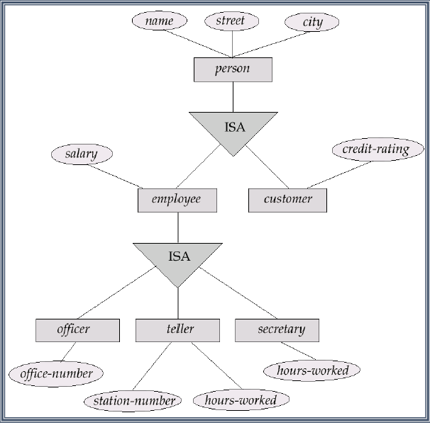

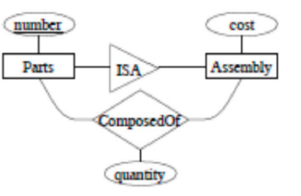
Parts(number); Assembly(number, cost); ComposedOf(assembly_number, part_number, cost);
Normalization:
• 1NF: flat tables: no structured fields
• 2NF: Relations are 2NF when they are 1NF and no non-key
attribute is partially FD on a key (i.e. FD on a subset of key)
• 3NF: Relations are 3NF when they are 2NF and and no nonkey
attribute is transitively FD on a key
• BCNF: Relations are BCNF if for every non-trivial X->A,
X is a key or a superset of a key
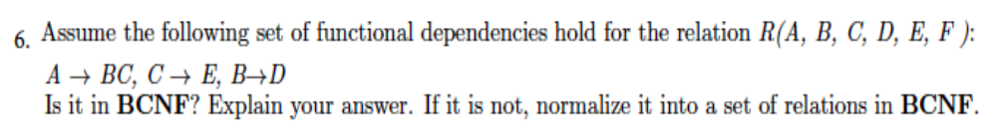
Answer:
Single attributes on right sides, and minimal left sides:
A->B, A->C; C->E, B->D. Here all right sides are minimal.
Decompose using FDs that violate BCNF (Considered from left to right):
A+= {A,B, C, E, D} F is missing and A is not a key, BCNF is violated.
A+ is used in the decomposition and we obtain two relations:
1: (A,B, C, D, E), 2:(A,F) Table 2 is BCNF with Key A, F.
For table 1, A is key, no violation. Is C a key? compute C+= {C, E} . C is not a key, we must
decompose 2 into: 1.1 (C, E), 1.2 (A, B, C, D)). 1.1 is BCNF with key C.
In table 1.2, we test B->D and get B+={B, D}. Since A and C are missing, we must
decompose 1.2 into: 1.2.1: (B, D),with Key B, and 1.2.2: {A, B, C} with key A.
They are both BCNF. Oure final BCNF decomposition include tables 2, 1.1, 1.2.1 & 1.2.2.
==================================================================
Given the attribute set R = ABCDEFGH and the functional dependency set F = {BC→GH, AD→E, A→H,E →BCF, G→H}, decompose R into BCNF by decomposing in the order of the given functional Dependencies.

Idea: for each LH you want to identify the full closure...
BC -> {BCGH}
AD: {ADEHBCFGH} (roughly in order) -> all!
A : {AH}
E: {EBCFGH} (missing A, D)
G: {GH}
We go in order: BC->GH violates bc BC is not a key
Result: ABCDEF (removed GH), BCGH
Next we look at AD-> E: it was a key of the initial relation, so it must also be a key of the ABCDEF relation. no need to do anything
A -> H: Does not apply because no relation contains A and H. If you were keeping track of which FDs apply to which relation, you’d notice we ‘lost’ this one.
E->BCF: this only applies to the first relation (ABCDEF) and is unable to provide A or D (only EBCF) so it violates BCNF as it is not a super key
Result: ADE, EBCF, BCGH (unchanged)
G->H: this only applies to the last relation (BCGH) and G is not a super key, so we need to decompose:
Result: ADE (unchanged), EBCF (unchanged), GH, BCG
Final: ADE, EBCF, GH, BCG
BCNF vs 3NF (X->Y)
• BCNF: X must be a superkey
• 3NF: X is superkey or Y is prime (member of a key)

HW 6
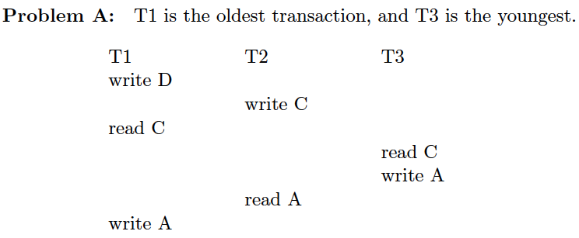

if it is (ii) show the schedule up to the deadlock. So T2 sets a lock-X C just before write C, and because of 2PL it must keep until it is done with its read A. Thus when T1 does lock-S C it stops with a wait-for arc T1 ! T2. Ditto for T3 that sets the wait-for arc T3 ! T2. There is no cycle: thus no deadlock. T2 completes. Then T3 and T1 will complete also.

If we use a wait-die deadlock prevention strategy will the resulting transactions (i)
complete, or (ii) deadlock1? If your answer is (i), show a completed schedule; if it is (ii)
show the schedule up to the deadlock.
Answer: Obviously there is going to be no deadlock since Wait-Die prevents deadlocks.
Here, T1 will wait for the older transaction to release C. But T3 is younger than T2; so
when it requests C it will actually die. Again a correct completion sequence is T2, T1, T3.
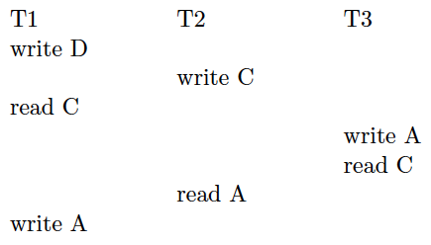

If we do not use any deadlock prevention strategy, will the resulting transactions (i)
complete, or (ii) deadlock1? If your answer is (i), show a completed schedule; if it is (ii)
show the schedule up to the deadlock.
Answer: So T2 sets a lock-X C just before write C, and because of 2PL it must keep until
it is done with its read A. Thus when T1 does lock-S C it stops with a wait-for arc T1 !
T2. Next, T3 does lock-X A, and then by requesting lock-s C it sets a wait-for arc T3 !
T2. Thua, so far, no cycles and no deadlock. But then T2 does lock-S A and sets a wait-for
arc: T2 ! T3. Thus we now have deadlock as per the directed cycle T3 !T2 in the
wait-for graph.

If we use a Wound-Wait deadlock prevention strategy will the resulting transactions (i)
complete, or (ii) deadlock1? If your answer is (i), show a completed schedule; if it is (ii)
show the schedule up to the deadlock.
Answer: Obviously there is going to be no deadlock since Wound-Wait prevents deadlocks.
Here, T1 is the older transaction requesting C held by the younger T2. Thus T1 wounds T2
which dies releasing C. Then T3 locks A and C and completes releasing them both. Finally
T2 restarts and completes. Thus the correct completion sequence is T3, T1 and _nally T2.
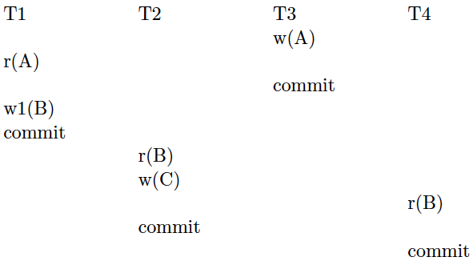
(c) Is the schedule recoverable? If not, can we make it recoverable by moving a single
commit operation to a di_erent position?
(c) Dirty data with current schedule: A and B. A is written by T3 and read by T1 after T1
commits. Then, the recovery process will undo w1(B) and generate a schedule that could
not have been generated by an equivalent serial schedule (unrecoverability of schedules).
(d) Is the schedule cascadeless? If not, can we make it cascadeless by moving a single
commit operation to a di_erent position?
d) Dirty data with current schedule: A and B. A is written by T3 and read by T1 after
T1 commits|no cascading of rollback is needed because of A. However, B is read by T1
and T4 before they commit: thus we have a cascade of rollbacks if T1 fails. To make this
schedule recoverable and cascadeless, we must delay the commit of T1 until T2 and T4
commit.

Three problems of concurrency:
Dirty Reads: Read the variable before it is commit, the variable could abort.
Unrepeatable read: read the value after write, two read are different.
Lost update: two T one write A 11 one write A 60.
Conflict Serializability:
Simple and efficient method for determining conflict serializability of a schedule.
○ Consider some schedule S.
○ Create a dependency graph G from S.
○ The vertices consist of the individual transactions 𝑇i, and we construct an edge from 𝑇i to 𝑇j if:
■ 𝑇i executes write(X) before 𝑇j executes read(X)
■ 𝑇i executes read(X) before 𝑇j executes write(X)
■ 𝑇i executes write(X) before 𝑇j executes write(X)
1) If an edge 𝑇i -> 𝑇j exists in graph, then in any serial schedule S1 equivalent to S, 𝑇i must appear
before 𝑇j.
2) If there are no cycles in the graph, then S is conflict serializable.
Deadlock Prevention
• Disallow deadlocks from ever occurring: given two transactions, old
one To and new one Tn.
• Wait-Die
oIf To is waiting for a lock from Tn, it just waits.
oIf Tn is waiting for a lock from To, it kills himself.
• Wound-Wait
oIf To is waiting for a lock from Tn, it kills Tn.
oIf Tn is waiting for a lock from To, it just waits.
oIf you die, you restart with original timestamp.
Deadlock Detection
• Waits-for graph of all transactions.
oG = (V,E)
oV is a set of Transactions
oE is a set of arcs between transactions: A →B
oA →B if A is waiting for B to release a lock on some data item.
• If cycle exists, shoot one of the transactions in the cycle.
• Strict 2PL
All x-locks held by transaction are only released at the end of the transaction.
• Rigorous 2PL
All locks held by transaction are only released at the end of the transaction.
==================================================================
Practice Final
Q1: Draw the ER diagram from which this schema could have been produced
Emp(eid, name, level); Dept(did, location, mgr); Works in(eid, did)

Q2. The SQL-specified relational schema is BCNF, but does it have a minimal relation count: i.e., can you join any of the two table above and still have a BCNF schema? If your answer is yes, show a BCNF schema with minimal relation count (Instead of SQL, just show the relations with the keys underlined)
Emp(eid, name, level); Dept(did, location, mgr); Works in(eid, did) The first and the last table have the same key. They can be joined without loosing any FD. (FK constraints are also preserved.)
Emp(eid, name, level, did); Dept(did, location, mgr)

Q3. Assume now that Managers have an additional attribute (say CostCenter) which regular employees do not have (however managers are still considered to work in the department they manage). Also, assume that a department can only have one manager and an employee can only be the manager of one department. Redraw the ER diagram to model our company under these new assumptions.

Q4. Still working under the assumptions used in Q3, revise the original SQL schema so that all the FD constraints are expressed by the keys. (You can simply show the relations with their keys underlined—use different underlinings for different keys in the same relation.)
Using mgrid to denote the employee number of a manager, we can have three relations:
Emp(eid, name, level, did); Dept(did, location, mgrid); Mgr(mgrid, CostCenter)
The following schema with fewer tables is preferable (Other schemas could be OK too)
Emp(eid, name, level, did); Dept(did, location, mgrid, CostCenter)
Consider the relational scheme
R(A, B, C, D, E) with the following FDs:
1. AB → C 2. C → B 3. C → D 4. C → E 5. D → E 6. B → D
Q1. Is any of these FDs trivial? No trivial FD here
Q2. Is R(A, B, C, D, E) BCNF? (Explain the reasons for your answer.)
We must test all FDs . For instance if we test 5. D → E:
D+={D, E} A,B,C are not there, B is not a key… not BCNF.
Q3. Provide a lossless decomposition of the original schema into a BCNF schema (underline the keys of the BCNF relations)
Answer: Decomposing using an FD that failed BCNF, e.g. D → E, we get r1(D,E); r2(A,B,C,D)
In r2 we have B+ = {B,D,E}, no C: r2 not BCNF. Decompose r2 into r21(B,D); r22(A,B,C)
In r22 we have C+={C,B} no A: not BCNF. Decompose r22 into r221(B, C); r222(C, A).
Binary are BCNF. Final decomposition is:
r1(D, E); r21(B, D); r221(B, C); r222(C, A).
Q4. Is the BCNF decomposition you produced FD-preserving? (Explain the reasons for your answer.)
D → E FDs 2, 5 and 6 are preserved by the keys.
-FD 3 is the composition of 2 and 6.
-FD 4 is the composition of 3 and 5.
- FD 1 however, 1 is lost.
This lossless decompostion is not FD-preserving

Q1. Is this first schedule conflict-serializable? (Justify your answer using the applicable graph.)
Answer:The serializability graph has the following
arcs: T1 → T3 on D, and T3 → T1 on A.
This is a cycle and thus this is not a conflict-serializable schedule
Q2. If we do not use any deadlock prevention strategy, will the resulting transactions (i) complete, or (ii) deadlock? If your answer is (i), show a completed schedule; if your answer is (ii), then show the schedule up to the deadlock.
Also state clearly and concisely what happen to each transaction: e.g., abort, restart, wait- for resource, kill other transactions, etc.
Answer The sequence is:
T1: X-lock(D), T3 blocks on S-lock(D), T2: X-lock(C),
T1: blocks on S-lock(C), T2: S-lock(A) and completes.
Then T1 completes; finally, T3 completes as well.
Q3. If we use a wound-wait deadlock prevention strategy will the resulting transactions (i) complete, or (ii) deadlock? If your answer is (i), show a completed schedule (there could be more than one–any correct one will do); if your answer is (ii), then show the schedule up to the deadlock.
Answer The resulting schedule is as follows: T3 waits for T1 to release the lock on D. Then by writing on C, T1 forces T2 to roll back. Thus T1 completes first, ad then T3 completes and finally T2. (But if T2 is restated quickly, then T3 will wait for T2 to finish its read A, before it can complete.

Q4. Now assume that we are using a timestamp-based concurrency control method, with Thomas’ write rule. Which transactions will abort (and why) and which will complete?
Answer: T1 will abort on read-C which has a write-timestamp that of T2. Then T2 will abort on read A which has the write timestamp that of T3. T1 completes

==================================================================
Practice final
We are given the T(A,B,C,D,E)
(a) AD → CE (b) BC → D (c) AE → A (d) B → E
Q1. is any of the previous FDs trivial? Answer: C is trivial
Q2. Is this schema BCNF? (To receive credit you must justify your answer.)
• Answer: To check whether it is BCNF, let us try the FDs. E.g check (b)
• B+= {B, E } not a key, so this is not BCNF.
Q3. Is this schema 3NF
Answer: we cannot consider (c) since this is trivial. Then, none of the given FDs ha E
on the left side. So they cannot be part of a key.
Q4: Transform the given FDs into an equivalent set of elementary FDs
(no trivial FD, only one attribute on the right side, minimal left side).
Answer: (a) is replaced by a1: AD → C and a2: AD → E
Q5. Compute a lossless decompositions of T into BCNF relations where no two
relations share the same keys. (Show the keys by underlining the attributes in
the key. Use different underlining for different keys in the same relation)
Answer: We can start with B+= {B, E} and get: (B, E) (A, B, C, D)
Then using BC+= { B, C, D) we get (B,C, D) (B. C, A)
So: (B, E), (B,C, D) , and(B. C, A)
Q6. Can you reconstruct the original relation from those obtained in the
decomposition? (Answer: Yes via natural joins). Is your decomposition FD preserving?
• Answer: B->E, BC -> D are implied by the keys but AD -> C is lost.



