Tianyu Zhang

CS 161

HW 5

1.

(a). Valid

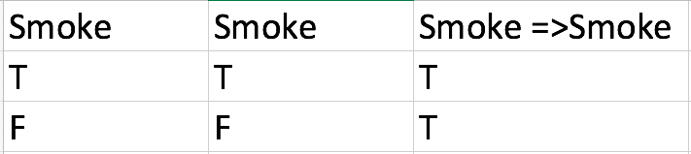

(b) Neither

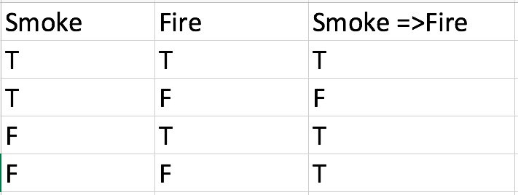

(c) Valid

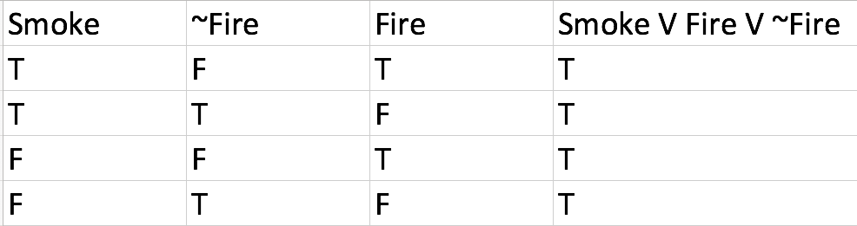

(d) Neither

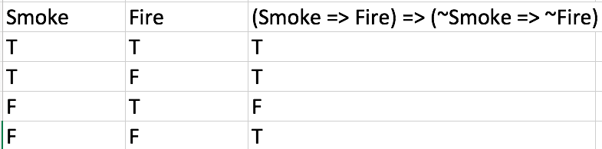

(e) Neither

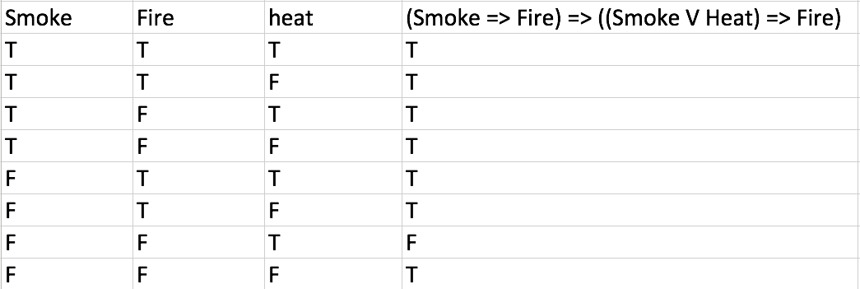

(f) Valid

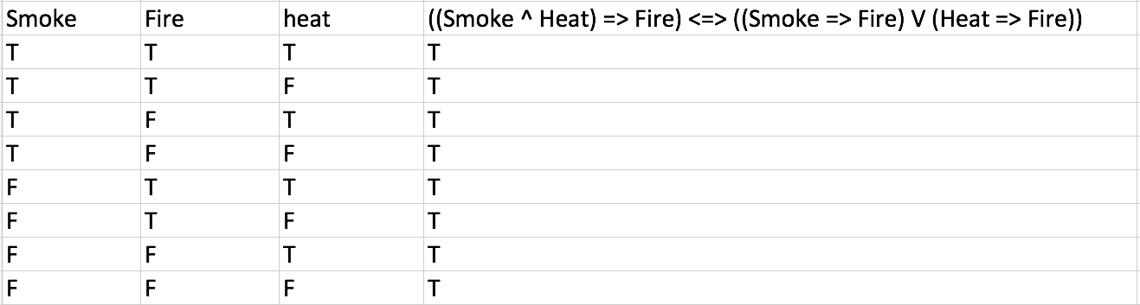

2.

(a).

{x/A,y/B,z/B}

(b).

No general unifier exists

(c).

{x/John,y/John}

(d).

No general unifier exists

3.

(a)

∀x (Food(x) → Likes(John, x))

Food(Apples)

Food(Chicken)

∀x ∃y (Eats(y,x) ^ ~Kill(x,y) → Food(x))

∃x ∀y (Kill(x,y) → ~Alive(y))

Eats(Bill, Peanuts) ^ Alive(Bill)

∀x (Eats(Bill, x) → Eats(Sue, x))

(b)

1. ~Food(x) v Likes(John, x)

2. Food(Apples)

3. Food(Chicken)

4. ~Eats(g(x),x) v Kill(x,g(x)) v Food(x)

5. ~Kill(g(y),y) v ~Alive(y)

6. Eats(Bill, Peanuts)

7. Alive(Bill)

8. ~Eats(Bill, x) v Eats(Sue, x)

(c)

9. Kill(Peanuts, Bill) v Food(Peanuts) Resolve 4 and 6, with unifier {x/Peanuts, y/Bill}

10. ~Kill(Peanuts, Bill) Resolve 5 and 7

11. Food(Peanuts) Resolve 9 and 10

12. Likes(John, Peanuts) Resolve 1 and 11

(d)

13. Eats(Sue, Peanuts) Resolve 6 and 8 with unifier {x/Peanuts}

Therefore, Sue eats peanuts.

(e)

First order:

∀x ∃y (~Eats(y,x) → Die(y))

∀y (Die(y) → ~Alive(y))

Alive(Bill)

CNF:

14. Eats(y,x) v Die(y)

15. ~Die(y) v ~Alive(y)

16. Alive(Bill)

Resolution:

17. ~Die(Bill) Resolve 15 and 16 with unifier {y/Bill}

18. Eats(Bill, x) Resolve 14 and 17

19. Eats(Sue, x) Resolve 8 and 18

Since the unifier has no value for x, we cannot conclude anything on what Sue eats.

4.

(a). knowledge base:

1. mythical => immortal

2. ¬mythical=> ¬immortal ^ Mammal

3. (immortal V Mammal) => horned

4. horned => magical

(b).

1. ¬ mythical V immortal

2. mythical V (¬ immortal ^ Mammal) = (mythical V immortal) ^ (mythical V Mammal)

3. ¬( immortal V Mammal ) V horned = (¬ immortal V horned) ^ (¬ mammal V horned)

4. ¬ horned V magical

(c).

The knowledge base entails that the unicorn is magical, and the unicorn is horned. However, with the current knowledge base, it is not possible to prove that the unicorn is mythical.

5. Mythical V Mammal from 2

6. ¬ mammal V horned from 3

7. mythical V horned from 5,6

8. ¬ immortal V horned from 3

9. ¬ mythical V horned from 1,7

10. horned from 7,9

11. magical from 10,4

5.

(a).

when a is valid then a is true in all model, so True|= a

when True|=a, then by definition, for every model in True is true, a is true. True is always true so a is always true.

(b).

False |= α iff for all models in which False is true, α is true.

Since there are no models where False is true, for any α, False |= α.

(c).

if α |= β then α ⇒ β is true when α = True, and it is also true when α = False by definition of implication. In that case, if α |= β then α ⇒ β is valid.

If α ⇒ β is valid, then if α is true and β is true, and we have α |= β, and if α is false, then α |= β because False|= β for any β. Thus, if α ⇒ β is valid then α |= β.

(d). from (c) we knowα |= β iff α ⇒ β is valid,

By implication elimination, α ⇒ β is valid iff ¬α ∨ β is valid. (¬α ∨β) ≡ ¬(α ∧ ¬β) , so ¬α ∨β is valid iff α ∧ ¬β is false over all models, so α ∧ ¬β is unsatisfiable.